

An Internship Report

On

**“Horilla - Human Resource Management Software”**

By

Sudheshna Shahabadi

(20211CSE0679)

**School of Computer Science and Engineering**

**Presidency University, Bengaluru.**

Under the guidance of,

Mr. Md Ziaur Rahman

Assistant Professor

School of CSE,

Presidency University, Bengaluru

**Contents**

1. Introduction
2. Objectives
3. Module
4. Timeline
5. Expected Outcomes
6. Conclusion

**Introduction**

The report summarises the Human Resource Management System (HRMS) Features webpage, focusing on its layout, functionality, and most important design features. The webpage is created to display the different features of the HRMS software, which seeks to simplify HR functions with an integrated management system.

The site features multiple sections, including a top banner encouraging the download of the HRMS mobile application, a navigation menu allowing quick access to various resources, a hero section specifying the primary advantages of the software, and a features grid listing detailed functionalities such as Employee Management, Asset Management, and Help Desk services. Moreover, the page also has an organized footer featuring navigation links, social media connectivity, and legal notice.

The report will examine the HTML structure, design decisions, and user experience features used in the webpage, as well as a critique of its effectiveness in displaying HRMS features.

**Objectives**

The key objectives are:

* Examine the Structure of the Webpage – For reviewing the HTML structure, i.e., how various sections like navigation, features, and footer are organized.
* Assess the Design and User Experience – To evaluate the aesthetic design, responsiveness, and usability of the webpage in offering an error-free user experience.
* Understand Functionality and Features – To analyse the various features offered, like Employee Management, Asset Management, and Help Desk, and how they help in making an effective HRMS platform.
* Identify Areas for Improvement – To point out any possible improvements in design, functionality, or accessibility that can make the webpage perform better and engage users more.

**Module**

Working Module of the HRMS Features Webpage:

The HRMS Features webpage is structured to provide a seamless and informative user experience. It consists of various sections, each serving a specific function to help users navigate and understand the software's capabilities.

1. Top Banner Section

* Displays an announcement about the HRMS Mobile App.
* Includes a "Download" button for app access.
* Features a close button to allow users to dismiss the banner.

2. Navigation Section

* Provides a menu with multiple options, such as Home, Features, Documentation, Blogs, Videos, and Contact Us.
* Enhances user experience by enabling easy navigation to different sections.
* Highlights the current active page (Features) for clarity.

3. Hero Section

* Introduces the HRMS Features with a main heading and subheading.
* Contains a brief description emphasizing the efficiency of the HRMS software.

4. Features Grid section

* Showcases HRMS key functionalities through multiple feature cards.
* Each card includes a Title & Description, Icon Representation, Clickable Feature Links, Images

5. Footer Section

* + Company Information – Displays the HRMS brand logo and a brief introduction.
  + Navigation Links – Offers quick access to important pages like Features, Documentation, Blogs, etc.
  + Feature Links – Lists different HRMS features such as Attendance, Payroll, and Recruitment.
  + Source & Legal Information – Provides links to GitHub, privacy policy, and legal terms.

6. Script and External Dependencies Section

* Uses external CSS (style.css) for styling.
* Incorporates Font Awesome icons for social media integration.
* Includes JavaScript (script.js) for dynamic interactions, such as handling navigation and banner behaviour.

**Timeline**

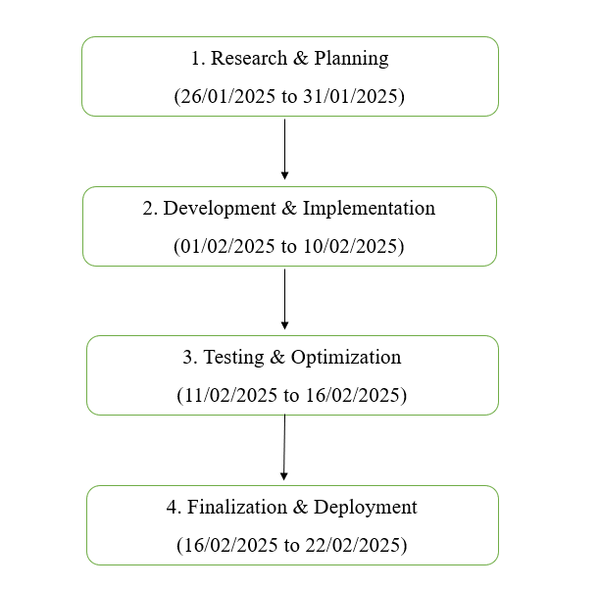

**Expected Outcomes**

The HRMS Features webpage should be interactive and user-friendly, providing a complete overview of the features available in the HRMS software.

The expected outcomes are:

1. Improved User Experience: A clean and well-structured layout that facilitates easy navigation through different HR features.

2. Feature Description Representation: Proper and straightforward definitions of various HRMS functions, like staff management, asset management, and support desk.

3. Engagement Enhancer: Features such as click-enabled feature cards and navigation menus for more interaction with users.

4. Effectiveness of Call-to-Action: The download button of the top banner and navigation links guide users toward further exploring the HRMS app and its features.

**Conclusion**

The HRMS Features webpage effectively offers an organized, visually appealing, and informative site for demonstrating the functionality of HRMS software. The effectively designed UI, simple navigation, and concise call-to-action features lead to a better user experience. Through the combination of feature descriptions, images, and interactive elements, the webpage effectively conveys the software's value to prospective users. Dynamic content refresh, more interactive features, and further user feedback mechanisms are potential future improvements that can enhance engagement and usability even more.