1.1 NT 驱动 1
1.2 1.2 wdm驱动 2
1.3 编程序加载NT驱动 3
1.4 Wdm驱动在注册表的保存 5
1.5 第四章,dmup驱动对象,设备对象信息 6
1.6 第五章,介绍一些数据结构 7
1.7 第七章, irp 7

Windows驱动开发技术详解
--- 张帆

NT 驱动
E:\ddkExam\chapter01\NT_Driver\1
函数说明:
RtlInitUnicodeString(UNICODE_STRING*, L”xxx”)
IoCreateDevice(PDRIVER_OBJECT, sizeof(DEVICE_EXTENSION), &devName, FILE_DEVICE_UNKNOWN, 0, TRUE, &pDevObj)
IoCreateSymbolLink(&symName, &devName)
设备名为 \Device\MyDDKDevice
符号链接为 \??\HelloDDK

删除设备和符号链接
IoDeleteSymbolLink(&linkName)
IoDeleteDevice(pDev)
完成IRP
Pirp->IoStatus.Status = NT_SUCCESS;
………………Information = 0;
IoCompleteRequest(pIrp, IO_NO_INCREMENT)

PDRIVER_OBJECT
DeviceObject
DeviceExtension
NextDevice
测试方法：
. driverStudio的DriverMonitor打开驱动，执行file->start driver即可加载驱动。
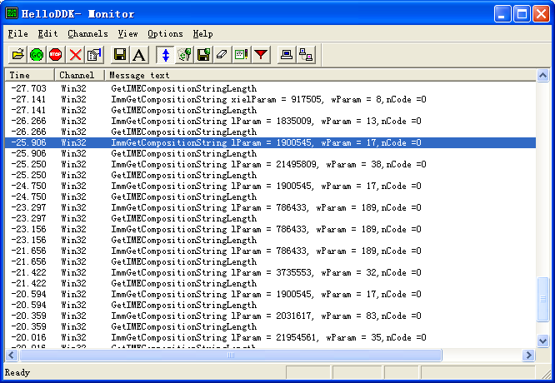
. 加载后在设备管理器，查看-》显示隐藏设备即可看到helloDDK
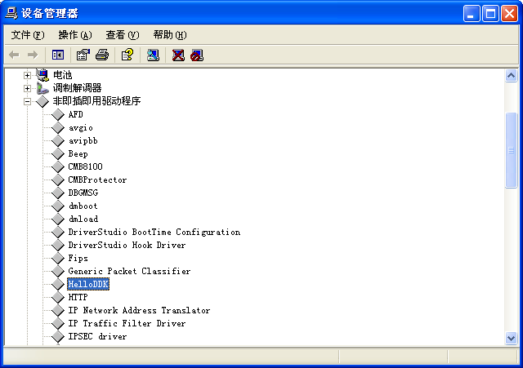

1.2 wdm驱动
和nt驱动区别:
. 头文件为wdm.h
. 多了 AddDevice, IRP_MJ_PNP, IRP_MN_REMOVE_DEVICE
AddDevice传入参数一为DRIVER_OBJECT,一为PhysicalDevObj

函数:
IOAttachDeviceToDeviceStack(fdo, PhysicalDevObj)
设备名为 \Device\MyWDMDevice
符号链接为 \DosDevice\HelloWDM
DefaultPnpHandler(pdx , irp)
{
PAGED_CODE(); //运行在APC_LEVEL
IoSkipCurrentStackLocation(irp);
Return IoCallDriver(pdx->nextStackDevice, irp)
}

IoDetachDevice(pdx->NextStackDevice)
测试方法：
打开EzDriverInstaller, open inf 文件, ADD new Device即可
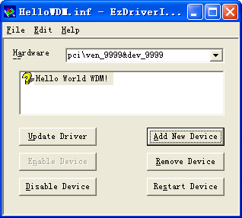

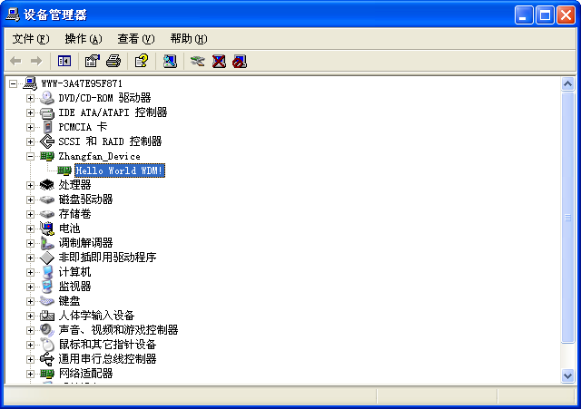

编程序加载NT驱动
chapter03\LoadNTDriver
1.首先用build编译E:\ddkExam\chapter03\LoadNTDriver\MyDriver
2,然后用vc编译E:\ddkExam\chapter03\LoadNTDriver\Test
3.自己修改注册表,将nt驱动注册
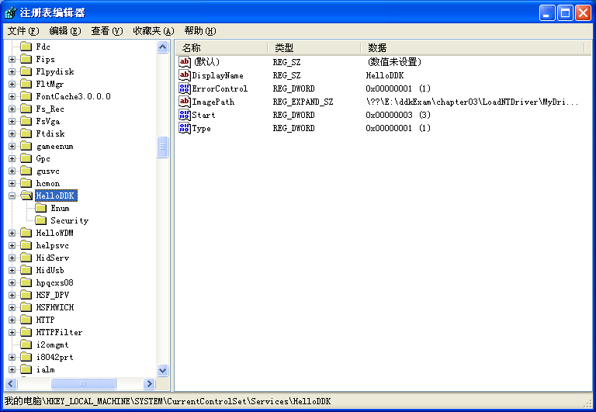
或者导入这个reg文件
Windows Registry Editor Version 5.00

[HKEY_LOCAL_MACHINE\SYSTEM\CurrentControlSet\Services\HelloDDK]
"Type"=dword:00000001
"Start"=dword:00000003
"ErrorControl"=dword:00000001
"ImagePath"=hex(2):5c,00,3f,00,3f,00,5c,00,45,00,3a,00,5c,00,64,00,64,00,6b,00,\
45,00,78,00,61,00,6d,00,5c,00,63,00,68,00,61,00,70,00,74,00,65,00,72,00,30,\
00,33,00,5c,00,4c,00,6f,00,61,00,64,00,4e,00,54,00,44,00,72,00,69,00,76,00,\
65,00,72,00,5c,00,4d,00,79,00,44,00,72,00,69,00,76,00,65,00,72,00,5c,00,6f,\
00,62,00,6a,00,63,00,68,00,6b,00,5f,00,77,00,78,00,70,00,5f,00,78,00,38,00,\
36,00,5c,00,69,00,33,00,38,00,36,00,5c,00,48,00,65,00,6c,00,6c,00,6f,00,44,\
00,44,00,4b,00,2e,00,73,00,79,00,73,00,00,00
"DisplayName"="HelloDDK"

[HKEY_LOCAL_MACHINE\SYSTEM\CurrentControlSet\Services\HelloDDK\Security]
"Security"=hex:01,00,14,80,90,00,00,00,9c,00,00,00,14,00,00,00,30,00,00,00,02,\
00,1c,00,01,00,00,00,02,80,14,00,ff,01,0f,00,01,01,00,00,00,00,00,01,00,00,\
00,00,02,00,60,00,04,00,00,00,00,00,14,00,fd,01,02,00,01,01,00,00,00,00,00,\
05,12,00,00,00,00,00,18,00,ff,01,0f,00,01,02,00,00,00,00,00,05,20,00,00,00,\
20,02,00,00,00,00,14,00,8d,01,02,00,01,01,00,00,00,00,00,05,0b,00,00,00,00,\
00,18,00,fd,01,02,00,01,02,00,00,00,00,00,05,20,00,00,00,23,02,00,00,01,01,\
00,00,00,00,00,05,12,00,00,00,01,01,00,00,00,00,00,05,12,00,00,00

[HKEY_LOCAL_MACHINE\SYSTEM\CurrentControlSet\Services\HelloDDK\Enum]
"0"="Root\\LEGACY_HELLODDK\\0000"
"Count"=dword:00000001
"NextInstance"=dword:00000001

4.执行test程序,启动驱动 (相当于net start HelloDDK)

Wdm驱动在注册表的保存
有三个子键, 硬件子键, 类子键, 服务子键
类子键
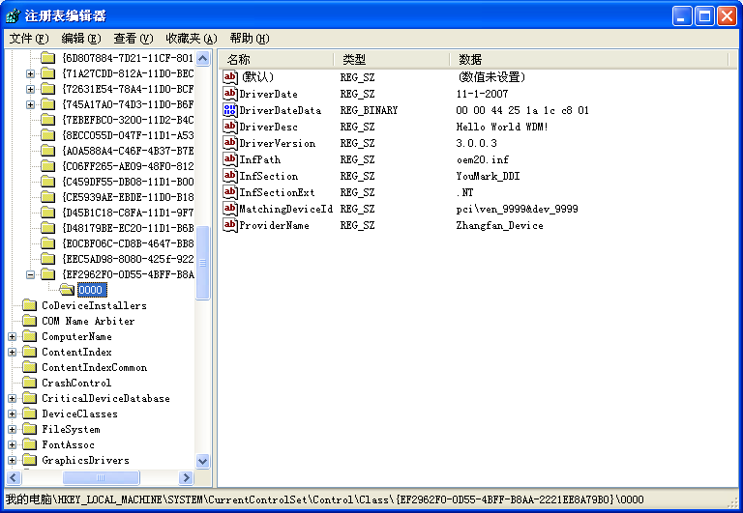
硬件子键

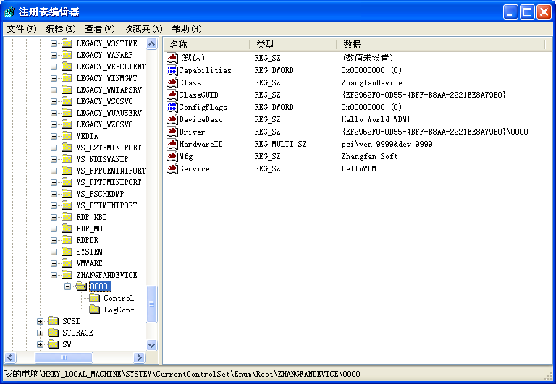
服务子键是为了兼容nt驱动
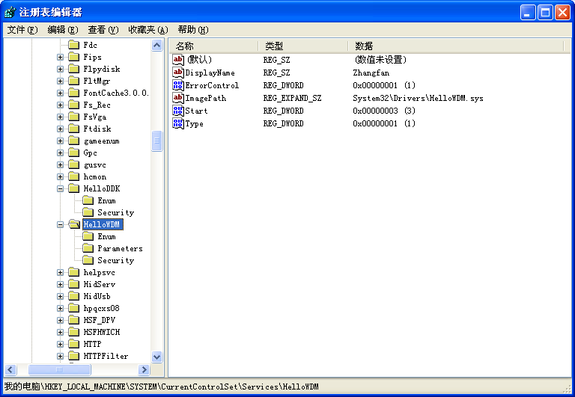

第四章,dmup驱动对象,设备对象信息
E:\ddkExam\chapter04
推荐软件devicetree

第五章,介绍一些数据结构
E:\ddkExam\chapter05
有
FileTest 文件读写
LinkList 链表
Lookaside 快速小内存管理
New 重载new
RegTest 注册表
RtlTest 系统rtl开头的一些函数
SEHTest 异常处理
StringTest 字符串

第七章, irp
E:\ddkExam\chapter07
有
DispatchTest 内含一个驱动和一个测试程序, 驱动可以打印出当前的irp请求类型
IOCTL_Test 内含一个驱动和一个测试程序, 测试IRP_MJ_DEVICE_CONTROL
MDL_Test 接读取设备方式(DO_DIRETCT_IO), MDL(内存描述符表)
Neither_Device_Test
ReadTest
SimulateFile

介绍一个irptrace工具
首先打开ｍｅｓｓａｇｅ－＞ｓｅｔｕｐ
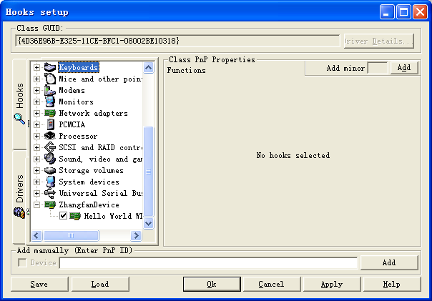
然后在Control Panel选择性地打开file logging / kernel tracing / kernel output tracing
这么就可以了

关于缓冲区方式(DO_BUFFERED_IO)读写操作, 系统会将用户模式的内存copy到内核模式下, 这样就不会有进程切换导致虚拟地址变化出问题. 此时,内核地址会保存在irp.AssociatedIrp.SystemBuffer, 字节大小保存在 IO_STACK_LOCATION.Parameters.Read/Write.Length

另一种, 直接读取设备方式(DO_DIRETCT_IO), 此时系统会将用户模式的地址锁定,将内核模式下将该内存做映射..

