1. Creating and Renaming Files/Directories
Create a directory named test_dir using mkdir.=>mkdir test_dir_one
Inside test_dir, create an empty file called example.txt.=>touch example.txt
Rename example.txt to renamed_example.txt using mv=> mv example.txt rename_example.txt

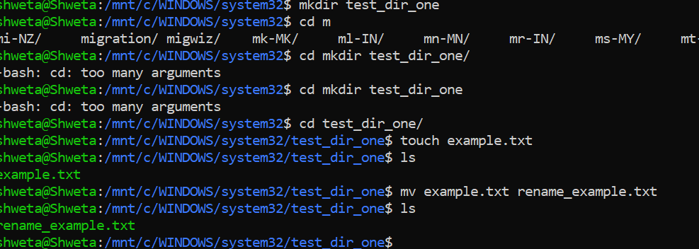

2. Viewing File Contents
Use cat to display the contents of /etc/passwd.
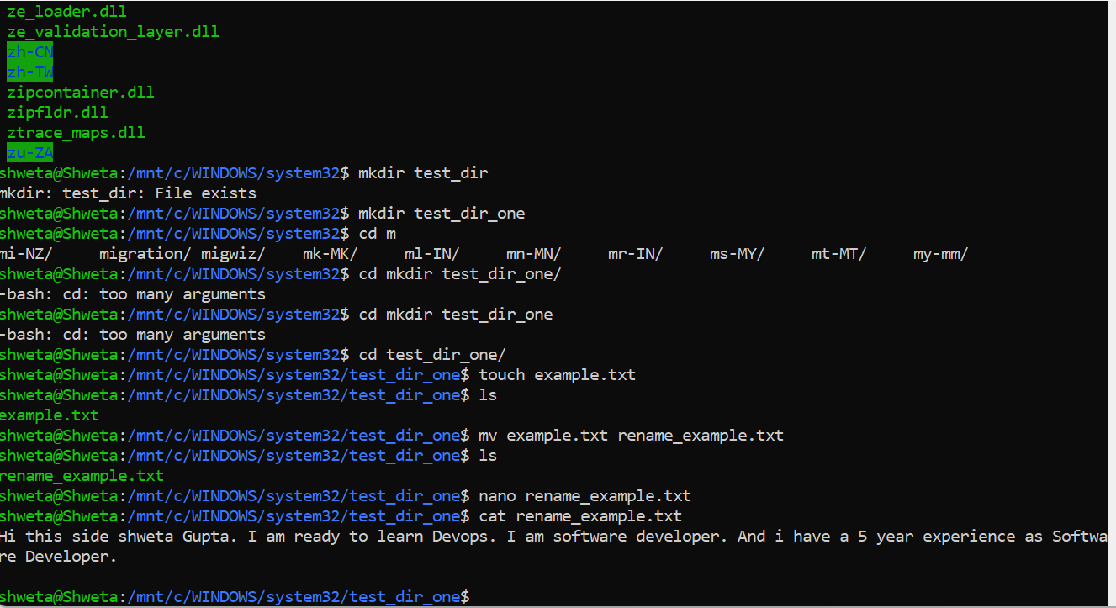
Display only the first 5 lines of /etc/passwd using head.
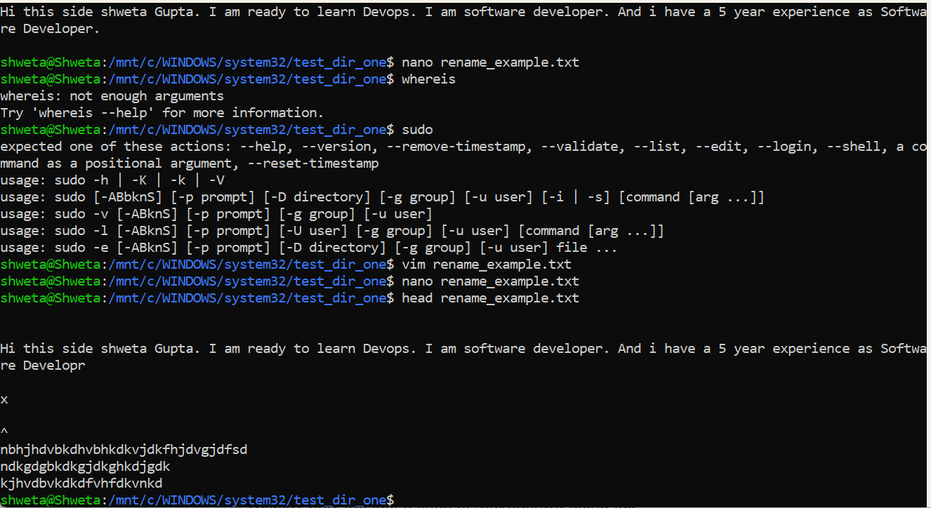
Display only the last 5 lines of /etc/passwd using tail.
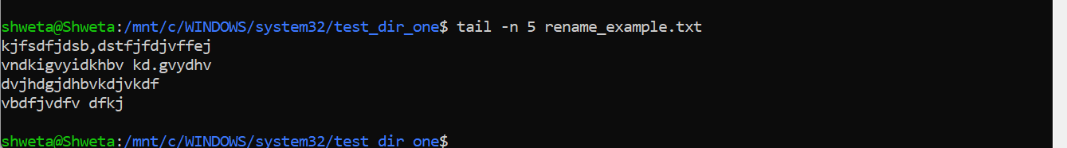

3.Searching for Patterns
Use grep to find all lines containing the word "root" in /etc/passwd.
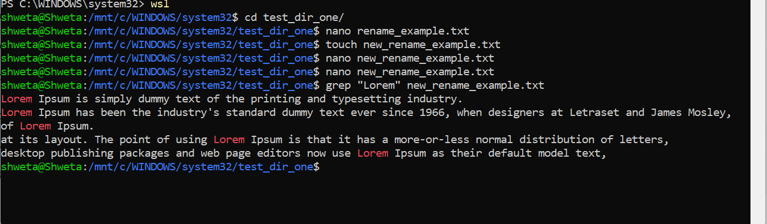

4. Zipping and Unzipping
Compress the test_dir directory into a file named test_dir.zip using zip.
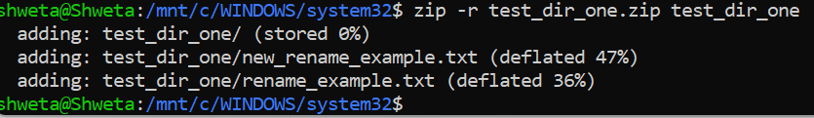
Unzip test_dir.zip into a new directory named unzipped_dir.
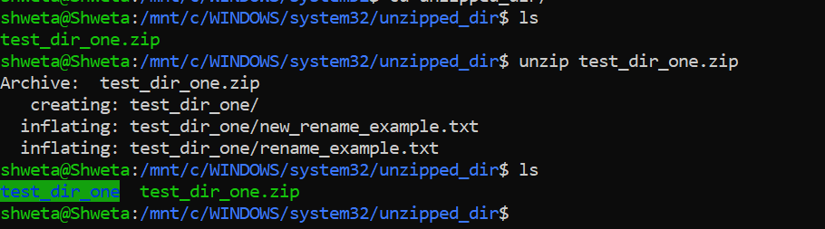

5. Downloading Files
Use wget to download a file from a URL (e.g., https://example.com/sample.txt).
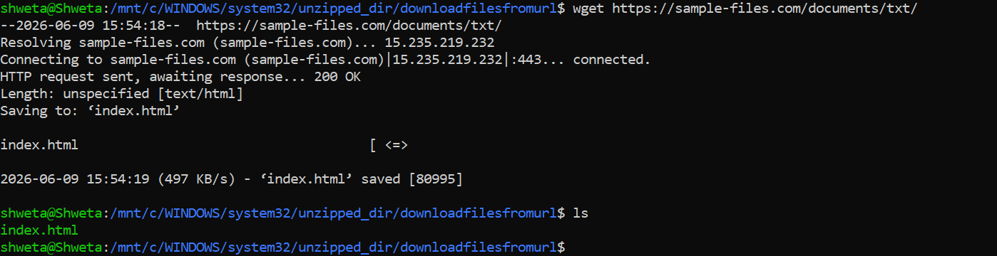

6. Changing Permissions
Create a file named secure.txt and change its permissions to read-only for everyone using chmod.
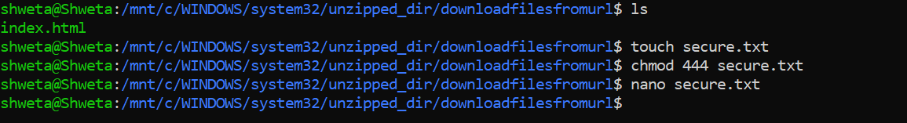
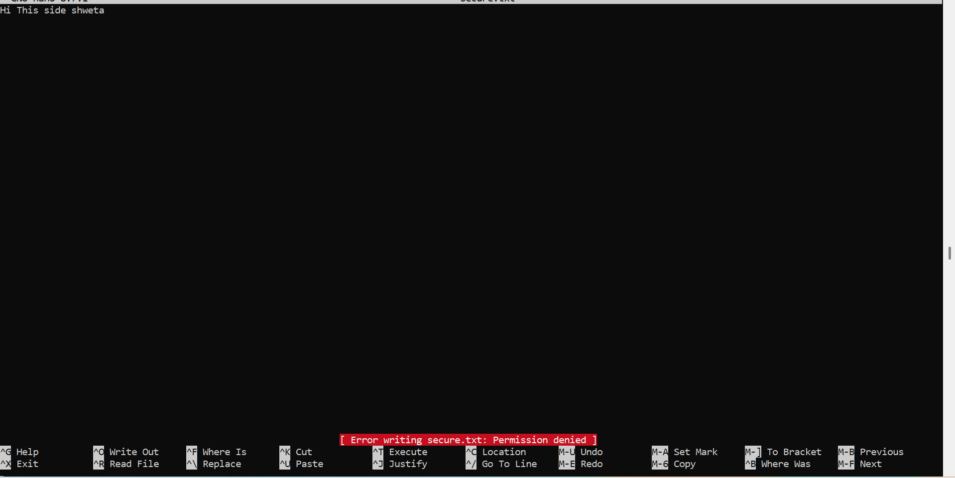

7. Working with Environment Variables
Use export to set a new environment variable called MY_VAR with the value "Hello, Linux!".

