Front-End UI/UX Mini Project  
  
Course: UI/UX Design Fundamentals

Project Title

**Local Business Homepage**

Submitted By~

**Team Members:**

* 1. Deepika Grace T T(2460357) [deepika.grace@btech.christuniersity.in](mailto:deepika.grace@btech.christuniersity.in)
  2. Eliza Miriam Paul(2460363) [eliza.miriam@btech.christuniversity.in](mailto:eliza.miriam@btech.christuniversity.in)
  3. Ridhi M Chabbria(2460433) ridhi.m@btech.christuniversity.in

**Instructor Name:** Ms Nagaveena **Date of Submission**:13/08/2025

**Institution:** Christ University ,Bangalore

**1. Abstract:**

This project involves the development of a responsive donut shop website using HTML and CSS. The website features a vertical navigation menu, animated donut display, and an attractive menu card layout showcasing various donut categories with prices. The key goal was to create an engaging, visually appealing interface for a local donut business that works across different devices. Core technologies used include HTML5 for structure, CSS3 for styling and animations, and Font Awesome for icons. The final outcome is a fully responsive website that effectively displays the donut menu with hover effects and maintains brand consistency throughout.

**2.Objectives:**

• Design an attractive interface for a donut shop using modern UI principles  
• Implement a responsive vertical navigation system  
• Create an eye-catching rotating donut animation  
• Develop a structured menu card with categorized donut items  
• Ensure proper layering of background and foreground elements  
• Maintain visual consistency across desktop and mobile devices

**3.Scope of the Project:**

• Front-end development only (HTML/CSS)  
• No backend functionality or JavaScript  
• Focused on menu display and visual presentation  
• Responsive design for desktop, tablet and mobile views  
• Uses pure CSS animations and transitions

**4.Tools and Technologies used:**

| **Tool/Technology** | **Purpose** |
| --- | --- |
| HTML5 | Website structure and content |
| CSS3 | Styling, layout and animations |
| Font Awesome | Navigation icons |
| Google Fonts (Bitcount Prop Double) | Typography |
| VS Code | Code editor |
| Chrome DevTools | Testing and debugging |
| Tool/Technology | Purpose |
| HTML5 | Website structure and content |
| CSS3 | Styling, layout and animations |
| Font Awesome | Navigation icons |
| Google Fonts (Bitcount Prop Double) | Typography |
| VS Code | Code editor |
| Chrome DevTools | Testing and debugging |

**5.HTML Structure Overview:**

• Semantic structure with <header>, <nav>, <main>, and <div> sections  
• Vertical navigation bar with icon links  
• Three main sections: header banner, donut display, and menu card  
• Organized menu using <ul> lists with price spans  
• Responsive image display for the rotating donut

**6.CSS Styling Overview:**

 External CSS file with organized sections  
• Key techniques used:

* Flexbox for layout management
* CSS animations for donut rotation
* z-index for element layering
* Media queries for responsiveness
* CSS filters for background effects
* Hover transitions for interactive element.
* Mobile-first approach with progressive enhancement

**7.Key Features:**

| **Feature** | **Description** |
| --- | --- |
| Vertical Navigation | Fixed sidebar with hover effects |
| Rotating Donut | Animated centerpiece with layered background |
| Menu Card | Categorized display with price listing |
| Responsive Design | Adapts to different screen sizes |
| Visual Effects | Gradients, shadows, and hover states |

**8.Challenges faced and Solution:**

| **Challenge** | **Solution** |
| --- | --- |
| Layering background behind rotating donut | Used z-index with absolute positioning |
| Maintaining proportions on resize | Implemented viewport-relative units (vw/vh) |
| Vertical nav scaling on mobile | Adjusted width and font sizes with media queries |
| Menu card readability | Added semi-transparent backgrounds to items |

**9.Outcome:**

**•** Created an attractive, functional donut shop website  
• Successfully implemented all visual elements using only HTML/CSS  
• Achieved responsive behavior across device sizes  
• Developed understanding of complex layering techniques  
• Established effective visual hierarchy and branding

**10.Future Enhancement:**

• Add JavaScript for order functionality  
• Implement a gallery section for donut varieties  
• Create an online ordering system  
• Add dark/light mode toggle  
• Integrate real-time inventory updates  
• Include customer reviews section

**11.Sample Code:**

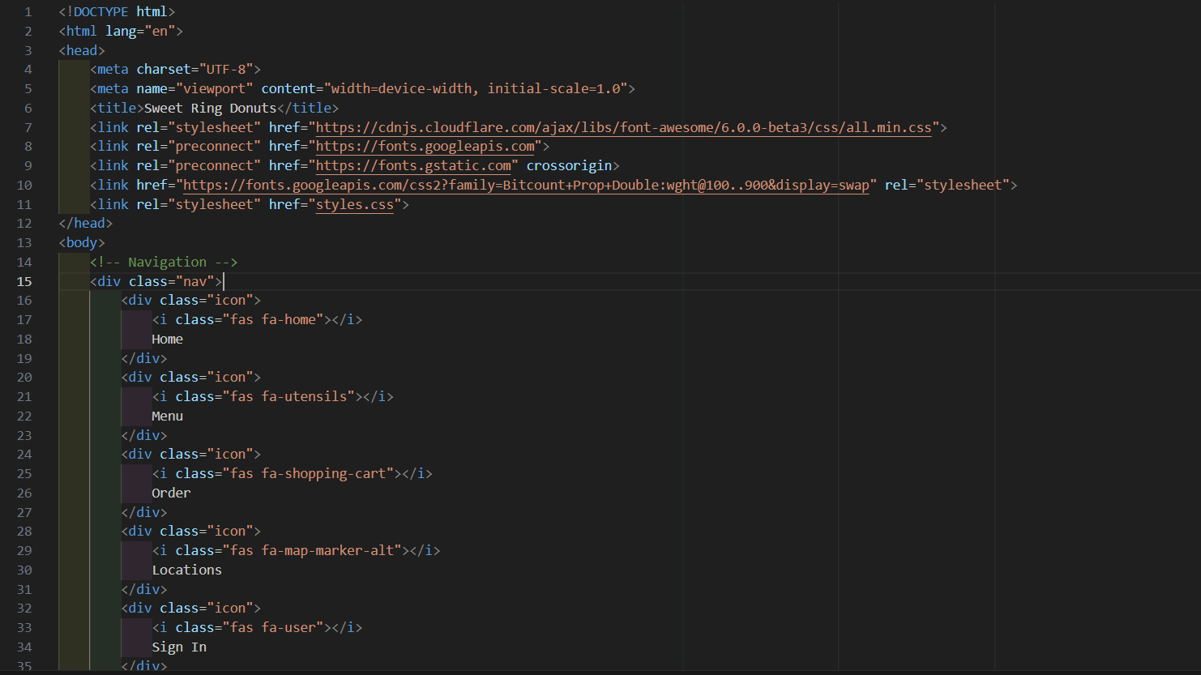

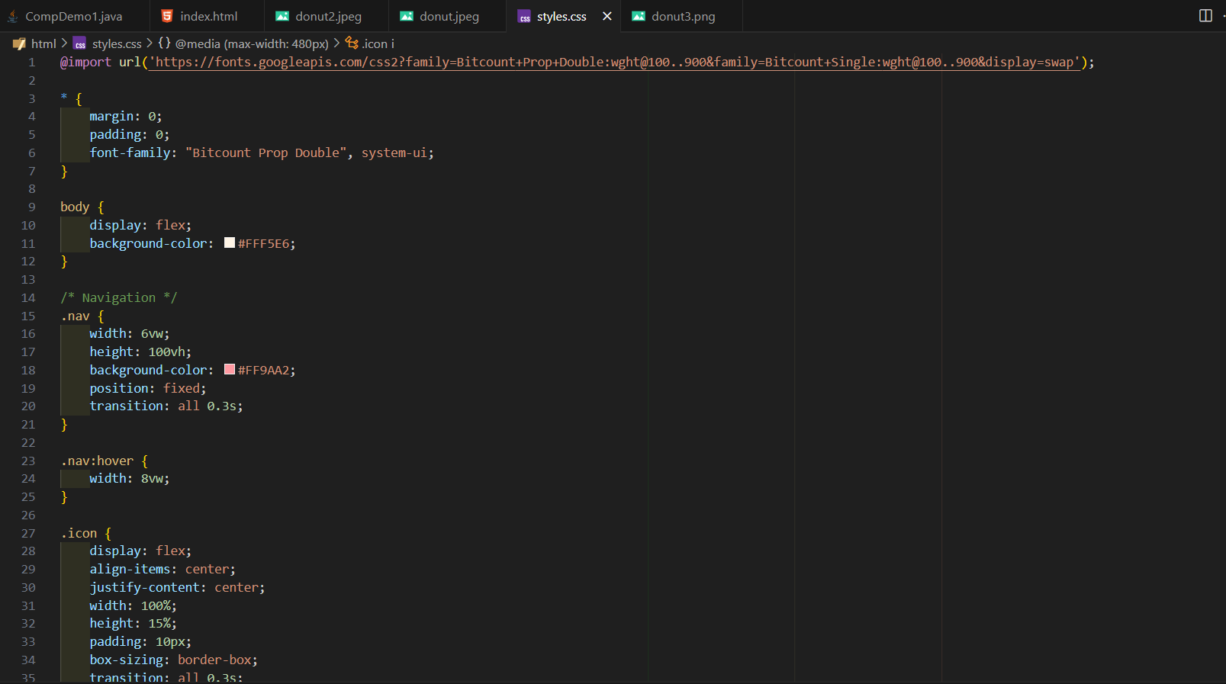

**12.Screenshots and final Output:**

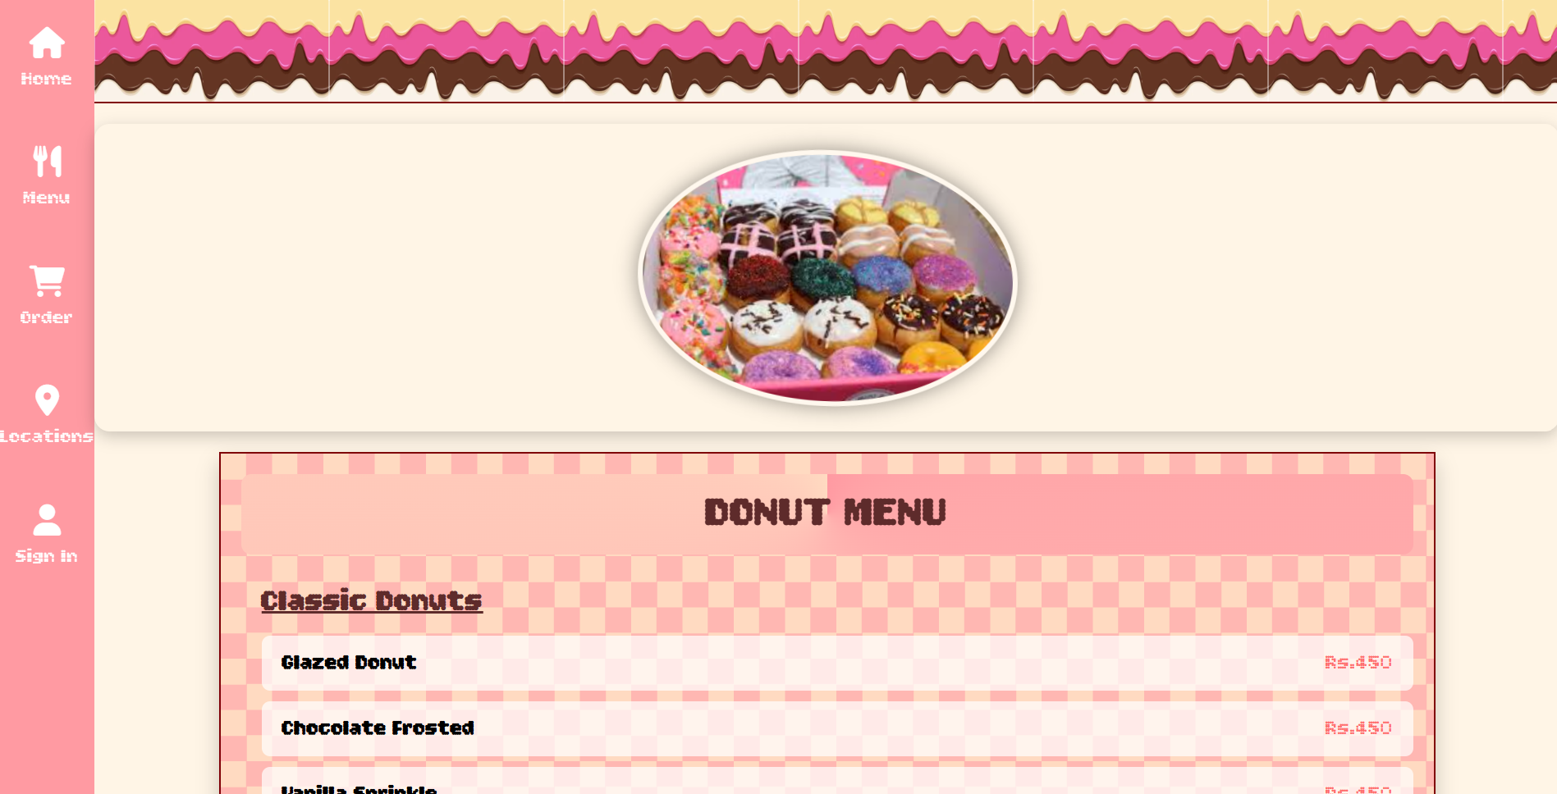

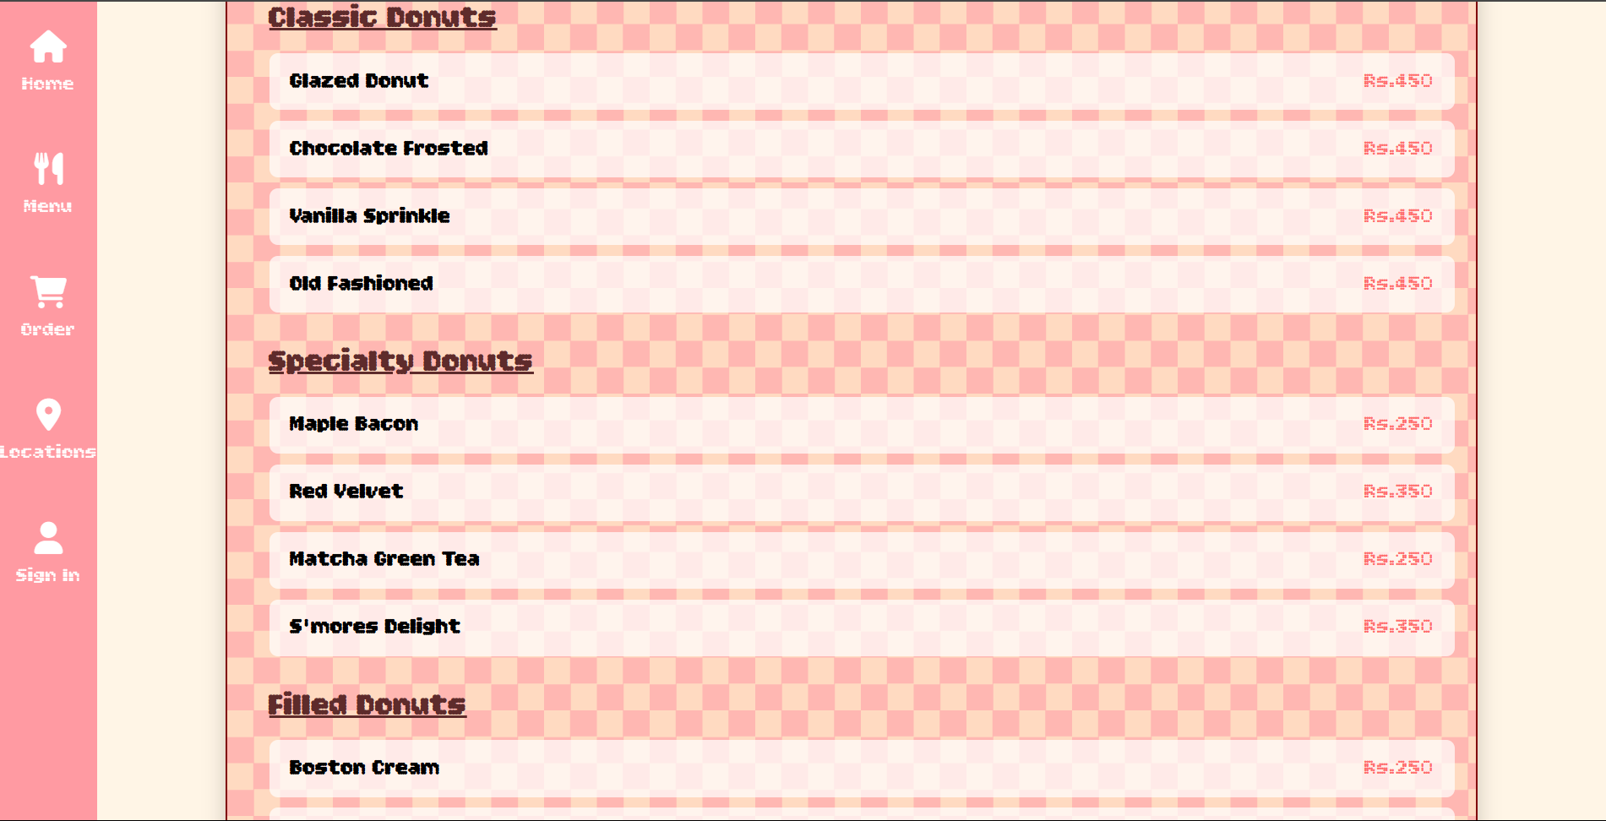

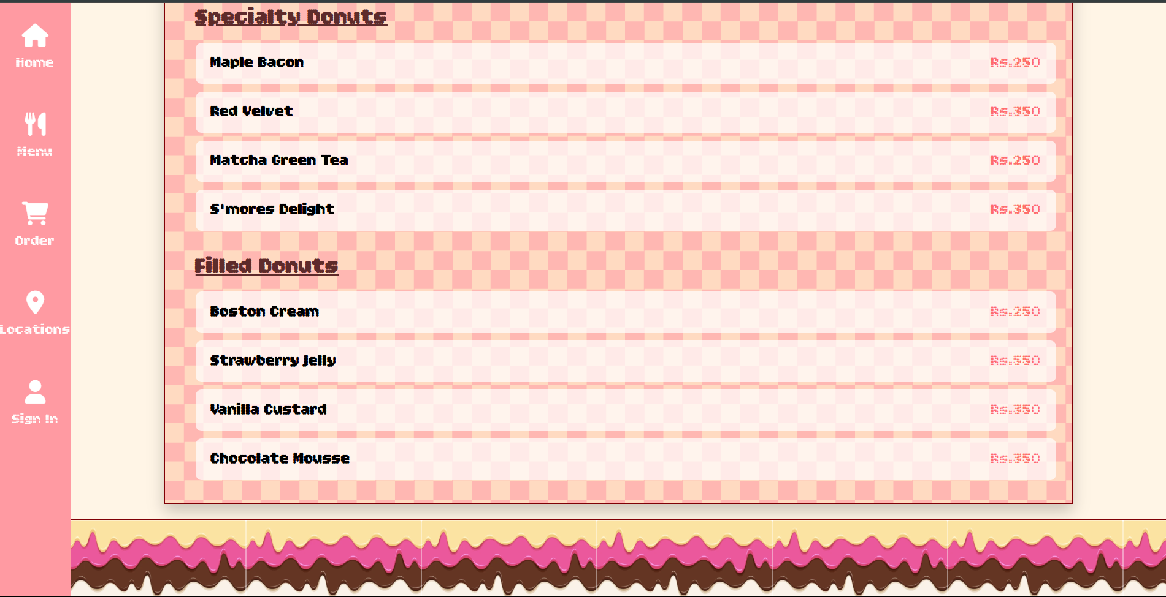

**13.Conclusion:**

This donut shop website project successfully demonstrates how HTML and CSS can be used to create an engaging, responsive business website. The implementation of visual elements like the rotating donut and categorized menu card provides an excellent user experience while showcasing the products effectively. Through this project, I gained valuable experience in responsive design principles, CSS animations, and creating visually cohesive interfaces. The website serves as an effective digital storefront that could be further enhanced with additional functionality.

**14.Reference:**

• L&T LMS: <https://learn.lntedutech.com/Landing/MyCourse>  
• MDN Web Docs  
• CSS-Tricks  
• W3Schools  
• Font Awesome documentation