The problem around 1350 is that rhythms such as Example 1 began to be written in more complex forms. These forms used greater specificity, what they called *subtilitas*, and thus the new era leading to the Ars Subtilior was born, where note shapes as shown Example 2 were used more often.



Example 1: Pre-1350 Note forms

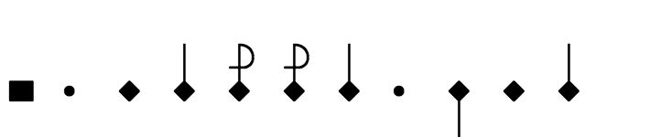

Example 2: Greater specificity in Italian music