Q1.

1)

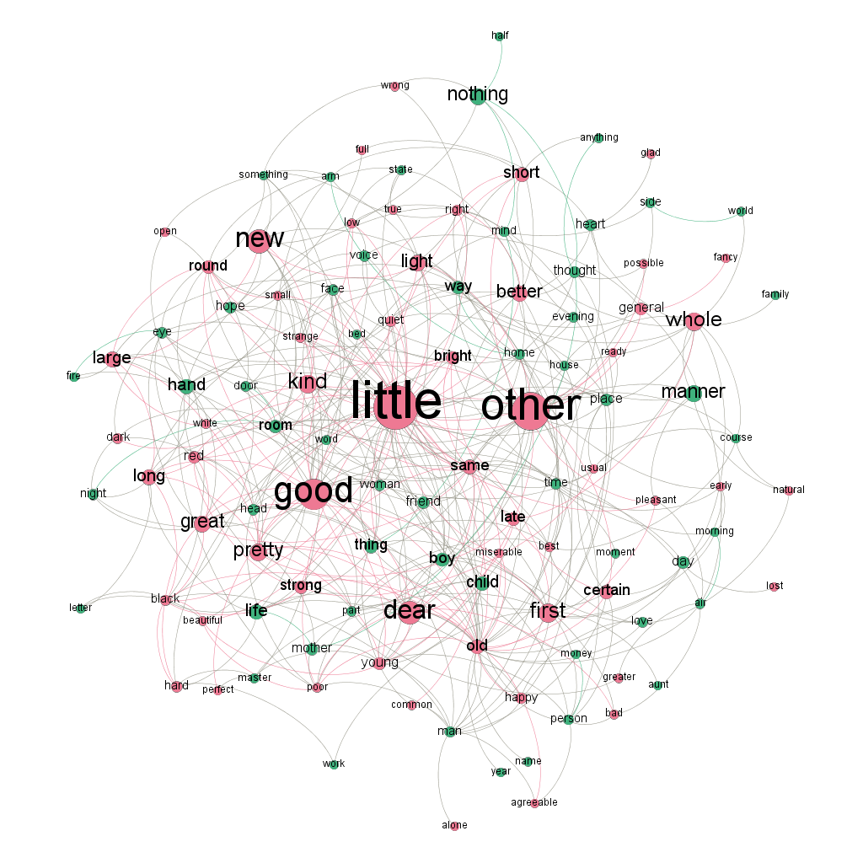

2)

(1) old, first, little, best, other, good, early, long, whole, light, same

(2) 8개

(3) man, person, thing, place, day

(4) little, other, good

3) 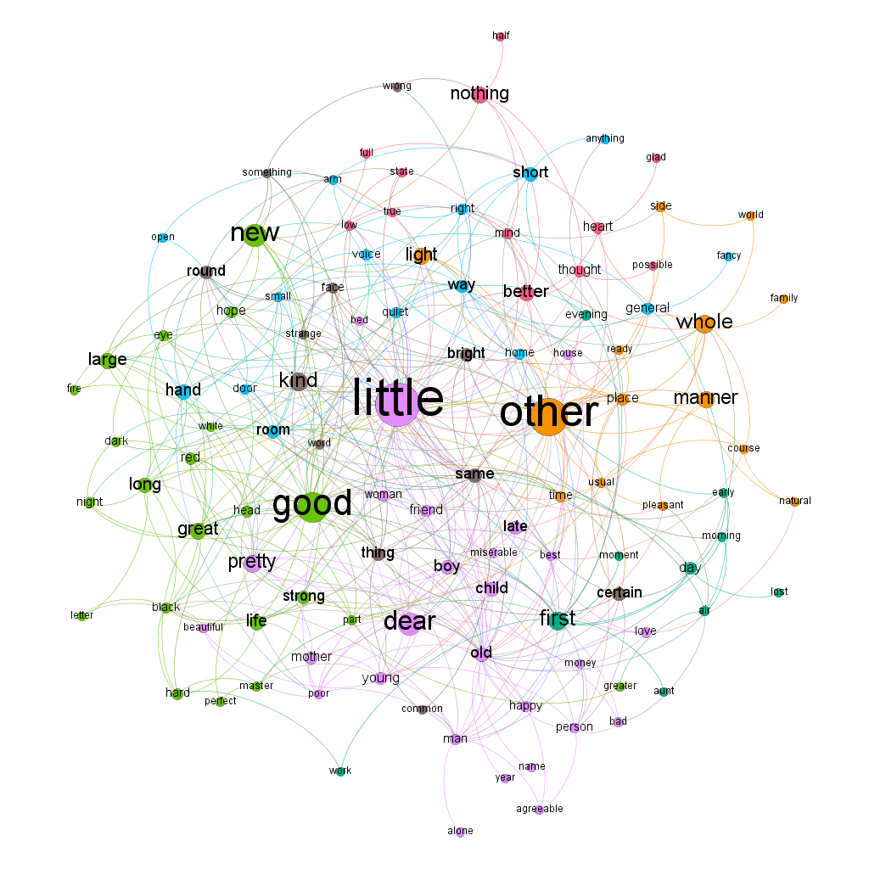

4)

(1) better, nothing, possible

(2) 4개