Q1.

1)

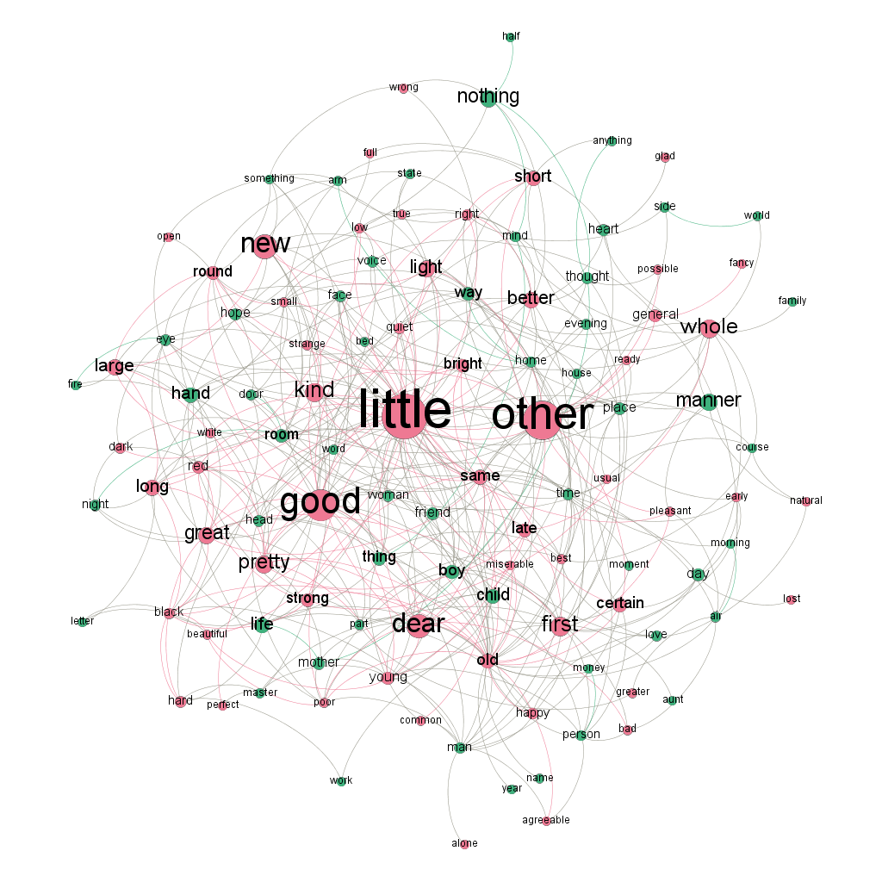

2)

(1) old, first, little, best, other, good, early, long, whole, light, same

(2) 8개

(3) man, person, thing, place, day

(4) little, other, good

3) 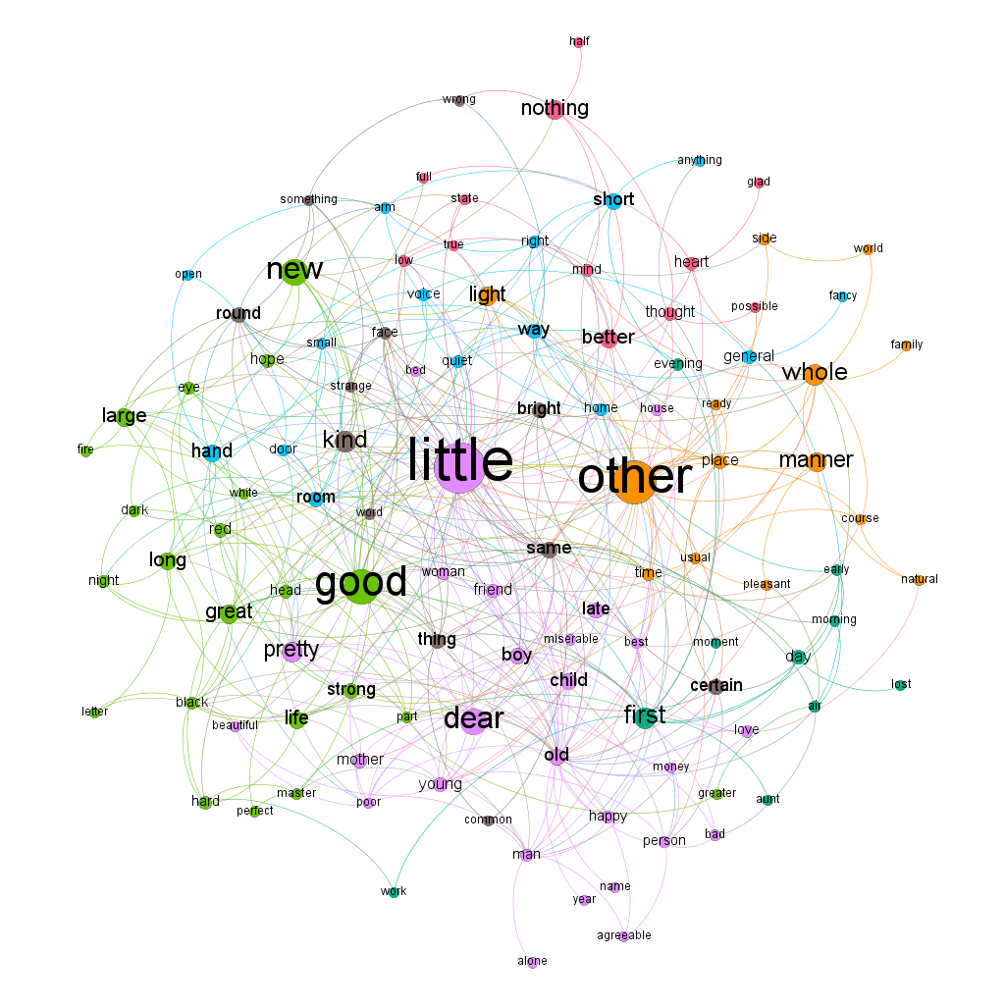

4)

(1) better, nothing, possible

(2) 4개

2.

1)

(1) Javascript, Java, Python

(2) 6개

(3) html – javascript

Machine learning – python

Haddop – scala

Linux – python

Git – linux

3.

1)

2)

(1) 7604 7603 798 7564 7424

(2) 비악성 7424

악성 7604

(3) 798

(4) 0.000216

4.

1)

2)

(1) 17

(2) 3254, 2008, 2170, 819, 2751

(3) 2589 2902 3011 2726 3775 3273 1782 3586

(4) 1053ss