2019710119 JeonHyeonSeong

Q1.

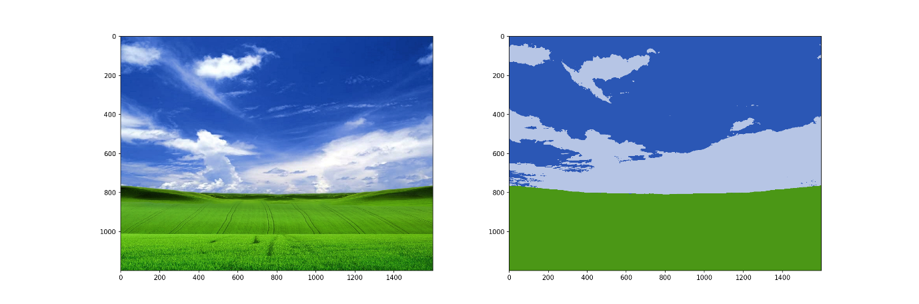

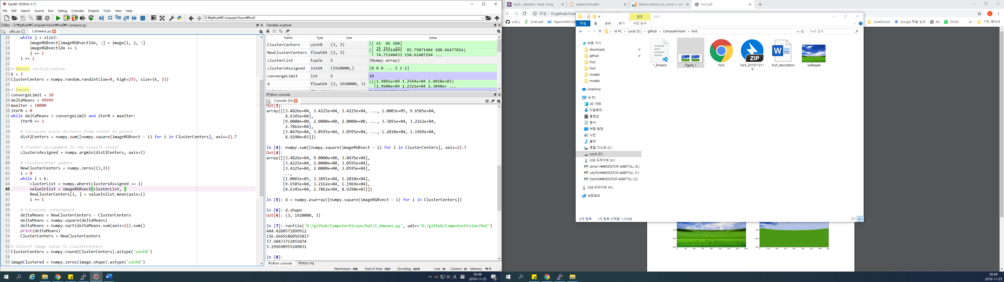

1. Distance SSE between all point and cluster center
2. Minimum distance assigned