Homework#3: Word Embedding
Name:___Chawit__U-Viengchai____________ Student ID:________5831011121_______

Q1: Use your own tokenizer (aka word segmentation model) to define word boundaries and split the given text file into words. Capture the screenshot of your code segment that loads the word segmentation model and uses the model to segment the text files.

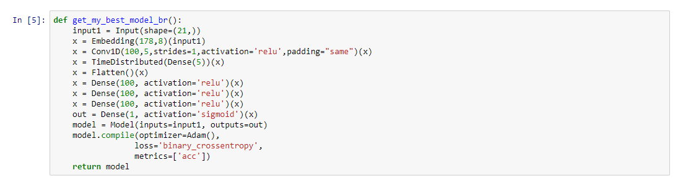

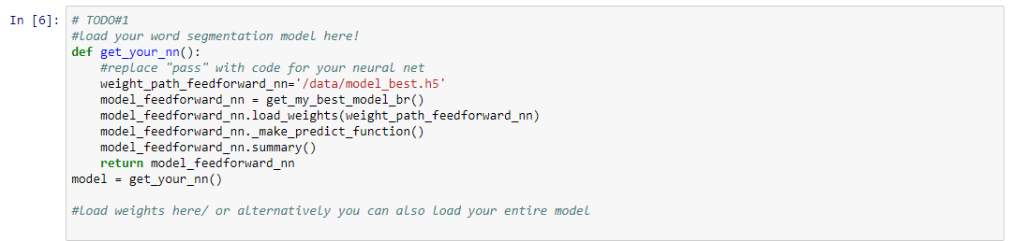

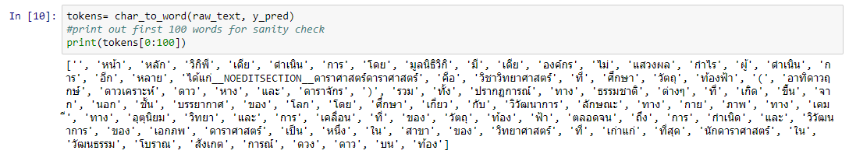

Q2: “UNK” is often used to represent an unknown word (a word which does not exist in your dictionary/training set). You can also represent a rare word with this token as well. How do you define a rare word in your program? Explain in your own words and capture the screenshot of your code segment that is a part of this process.

I define the rare word by using the threshold as well as I give the value of threshold to 4.

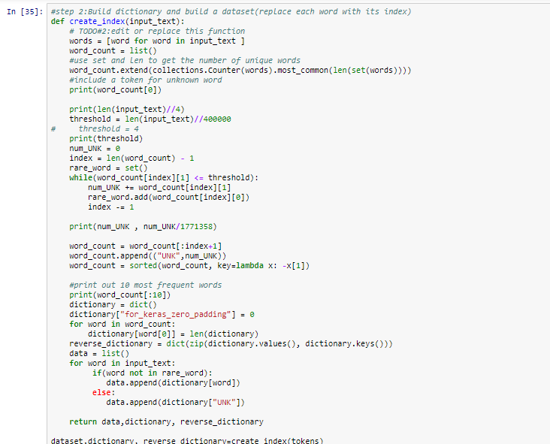

Q3: The negative samples are sampled from sampling table. Look through Keras source code to find out how they sample negative samples. Discuss the sampling technique taught in class and compare it to the Keras source code.

According to Keras tutorial (http://adventuresinmachinelearning.com/word2vec-keras-tutorial/), most of contents are similar with lesson in the class. However, there are something difference such as power(3/4)

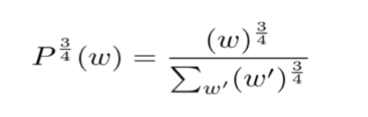

Q4: In your own words, discuss why Sigmoid is chosen as the activation function in the skip-gram model.

Sigmoid can use for the activation function in the skip-gram because the possible value of Sigmoid is between 0 and 1 as well as Sigmoid is non-linear function. For this model, the 1 label means that word is next to the input word. The 0 label means that word is not next to the input word.

Q5: Visualize the model using TSNE (scikit-kearn) and Tensorboard Projector include the image(s) of your visualization here and discuss what you observe. Include the link to your TensorBoard Projector here.

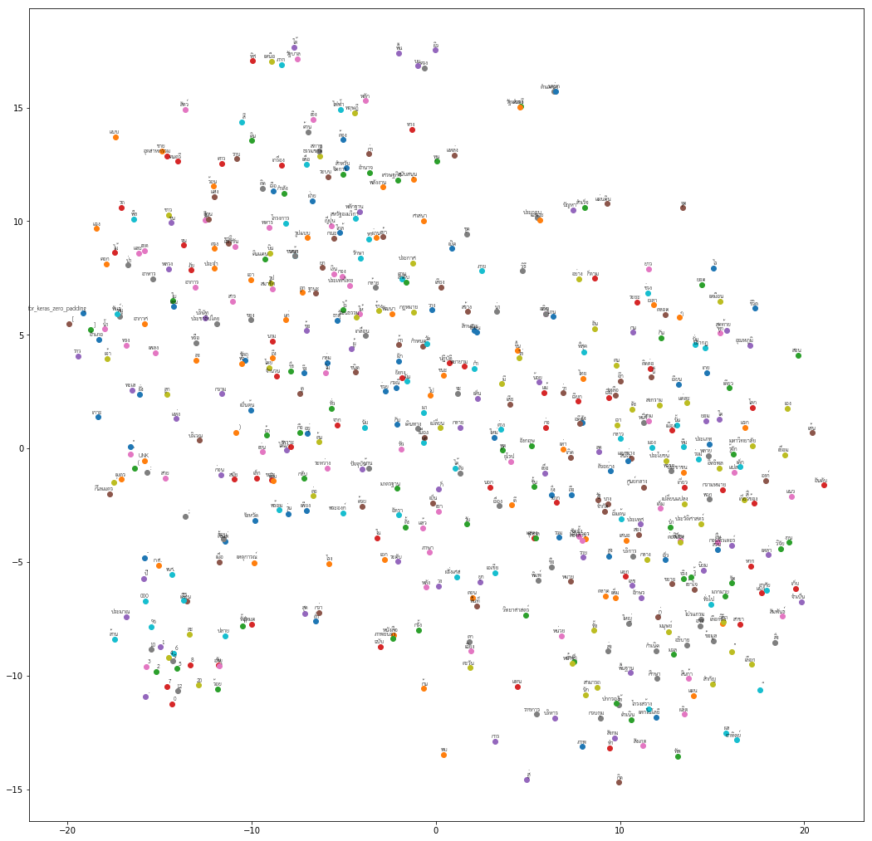
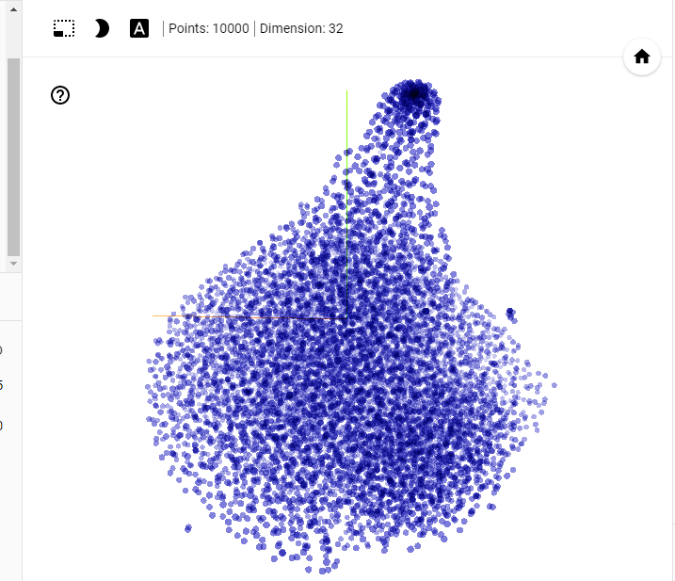
https://goo.gl/DnynC7

Q6: Use the word embeddings from the skip-gram model as pre-trained weights in a classification model. Compare the result the with the same classification model that does not use the pre-trained weights. (it's okay if the result is not what you expected, if that is the case tell us what do you expect to see.)

The model does use pre-trained weights

The model uses pre-trained weights

The model that uses pre-train weight has val_acc higher than the first one.

