데이터베이스 설계 레포트 4

분반: 1분반

학번: 2021136124

이름: 조병하

제출 날짜: 2023-3-30

**#1**

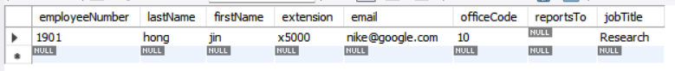

**#2**



**#3**

**<merit 테이블>**

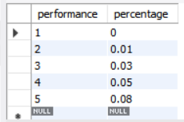

**<employees 테이블>**

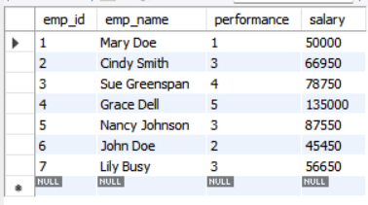

**#4**



**#5**

**<employees 테이블>**

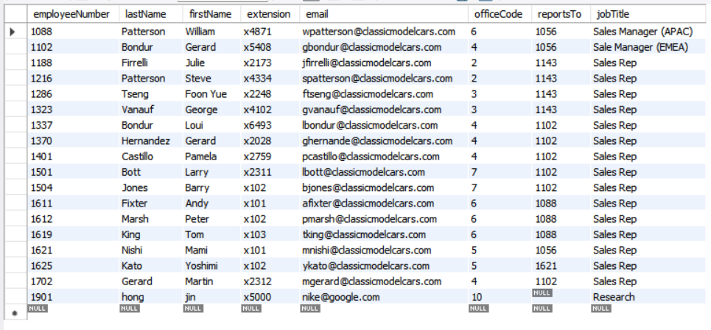

**<office 테이블>**

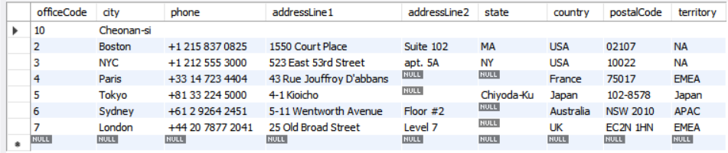

**#6**



**#7**

**<rooms테이블 삭제 전>**

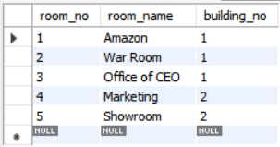

**<rooms테이블 삭제 후>**

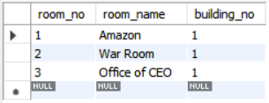

**<코드 전문>**

**USE `classicmodels`;**

**# 1**

**SET foreign_key_checks = 0;**

**INSERT INTO employees(employeeNumber, lastName, firstName, extension, email, officeCode, reportsTo, jobTitle) VALUES(1901, "hong", "jin", "x5000", "nike@google.com", 10, null, "Research"); #1**

**SET foreign_key_checks = 1;**

**SELECT * from `employees` where officeCode = 10;**

**# 2**

**INSERT INTO `offices` VALUES(10, "NYC", "", "", "", "", "", "", "");**

**UPDATE `offices` SET `city` = "Cheonan-si" where `officeCode` in (SELECT `officeCode` FROM `employees` where `jobTitle` = "Research");**

**SELECT * FROM `offices` where `officeCode` in (SELECT `officeCode` FROM `employees` WHERE `jobTitle` = "Research");**

**# 3**

**DROP DATABASE `empdb`;**

**CREATE DATABASE IF NOT EXISTS `empdb`;**

**USE `empdb`;**

**CREATE TABLE IF NOT EXISTS `merit` (**

**`performance` INT(11) NOT NULL,**

**`percentage` FLOAT NOT NULL,**

**PRIMARY KEY(`performance`)**

**);**

**CREATE TABLE IF NOT EXISTS `employees`(**

**`emp_id` INT(11) NOT NULL AUTO_INCREMENT,**

**`emp_name` VARCHAR(255) NOT NULL,**

**`performance` INT(11) DEFAULT NULL,**

**`salary` FLOAT DEFAULT NULL,**

**PRIMARY KEY(`emp_id`),**

**CONSTRAINT `fk_performance` FOREIGN KEY (`performance`) REFERENCES `merit`(`performance`)**

**);**

**INSERT INTO `merit` VALUES(1, 0);**

**INSERT INTO `merit` VALUES(2, 0.01);**

**INSERT INTO `merit` VALUES(3, 0.03);**

**INSERT INTO `merit` VALUES(4, 0.05);**

**INSERT INTO `merit` VALUES(5, 0.08);**

**SELECT * FROM `merit`;**

**INSERT INTO `employees` VALUES(1, "Mary Doe", 1, 50000);**

**INSERT INTO `employees` VALUES(2, "Cindy Smith", 3, 65000);**

**INSERT INTO `employees` VALUES(3, "Sue Greenspan", 4, 75000);**

**INSERT INTO `employees` VALUES(4, "Grace Dell", 5, 125000);**

**INSERT INTO `employees` VALUES(5, "Nancy Johnson", 3, 85000);**

**INSERT INTO `employees` VALUES(6, "John Doe", 2, 45000);**

**INSERT INTO `employees` VALUES(7, "Lily Busy", 3, 55000);**

**SELECT * FROM `employees`;**

**# 4**

**UPDATE `employees` JOIN `merit` SET `employees`.`salary` = `employees`.`salary` + `employees`.`salary` * `merit`.`percentage` WHERE `merit`.`performance` = `employees`.`performance`;**

**SELECT * FROM `employees`;**

**# 5**

**USE `classicmodels`;**

**SET foreign_key_checks = 0;**

**DELETE FROM `employees` WHERE `officeCode` = 1;**

**DELETE FROM `offices` WHERE `officeCode` = 1;**

**SET foreign_key_checks = 1;**

**SELECT * FROM `employees`;**

**SELECT * FROM `offices`;**

**# 6**

**USE `empdb`;**

**DELETE FROM `employees`;**

**SELECT * FROM `employees`;**

**# 7**

**CREATE TABLE buildings(**

**`building_no` INT(11) NOT NULL AUTO_INCREMENT,**

**`building_name` VARCHAR(255) NOT NULL,**

**`address` VARCHAR(355) NOT NULL,**

**PRIMARY KEY(`building_no`)**

**);**

**INSERT INTO buildings(building_name, address) VALUES("ACME Headquaters", "3950 North 1st Street CA 95134"), ("ACME Sales", "5000 North 1st Street CA 95134");**

**CREATE TABLE rooms(**

**room_no INT(11) NOT NULL AUTO_INCREMENT,**

**room_name VARCHAR(255) NOT NULL,**

**building_no INT(11) NOT NULL,**

**PRIMARY KEY (room_no),**

**KEY building_no(building_no),**

**CONSTRAINT rooms_ibfk_1 FOREIGN KEY(building_no) REFERENCES buildings (building_no) ON DELETE CASCADE**

**);**

**INSERT INTO rooms(room_name,building_no) VALUES("Amazon",1), ("War Room",1), ("Office of CEO",1), ("Marketing", 2), ("Showroom",2);**

**SELECT * FROM `rooms`;**

**DELETE FROM `buildings` WHERE `building_no` = 2;**

**SELECT * FROM `rooms`;**