Made in Taiwan :
We have two factories in Taiwan and one factory in Vietnam. Due to some specific types of helmet, we produce only shell in Vietnam. And ship to Taiwan to make the complete helmet. All the components and process are from Taiwan, also the materials in Vietnam are shipped from Taiwan. Therefore the quality is MADE IN TAIWAN.
台灣有2廠，越南有1廠。因應帽型的需求，部份帽型的帽殼在越南製作。但所有帽型開發到後製及配件來源，完全在台灣完成。越南所需物料也是由台灣海空運至越南。因此品質上完全是台灣製造。
Company:
Taiwan Ⅰ:
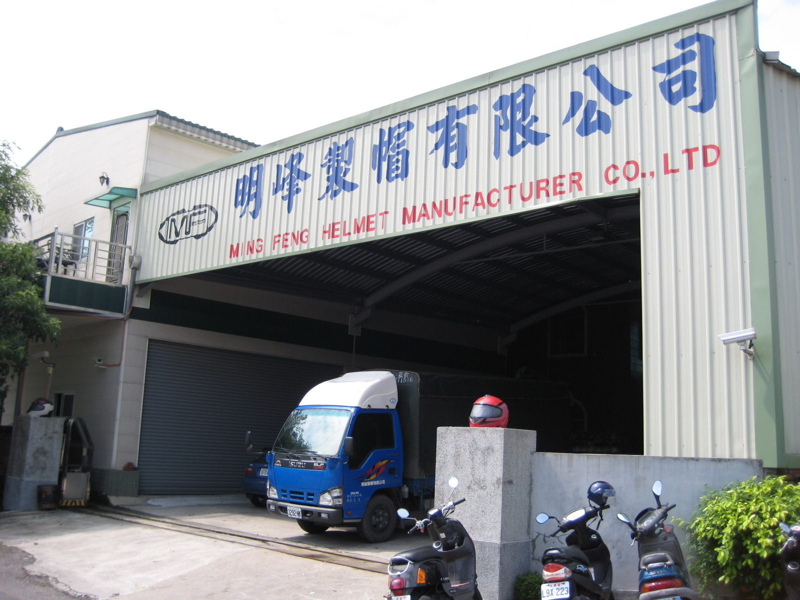

No.14,Fuh Chyang Rd., Kuan Tien Industrial Dist., Kuan Tien Hsiang, Tainan Hsien, Taiwan . R.O.C
TEL/+886-6-6982553
FAX/+886-6-6987133

