Main_cu

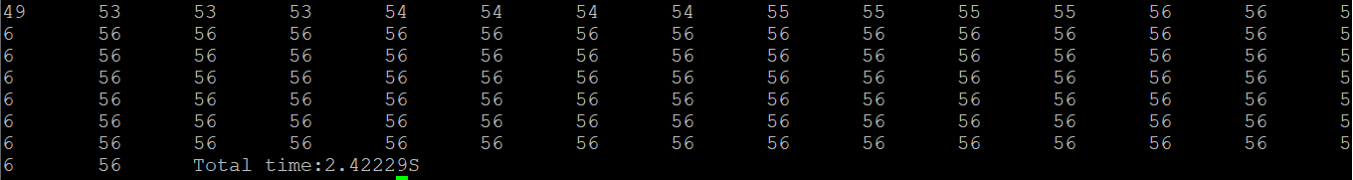

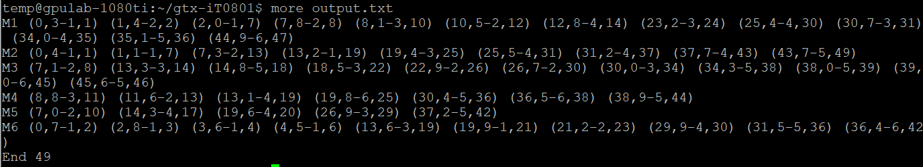

Main_cu_2

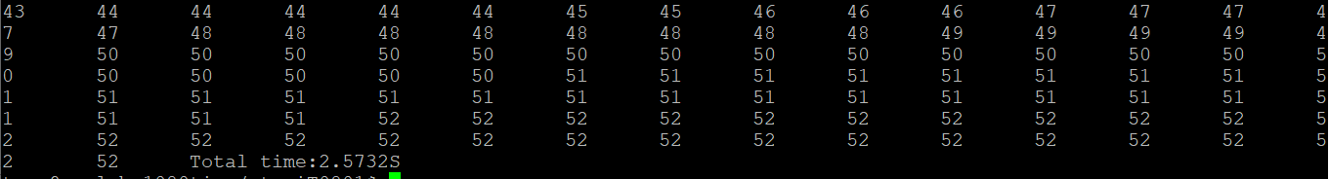

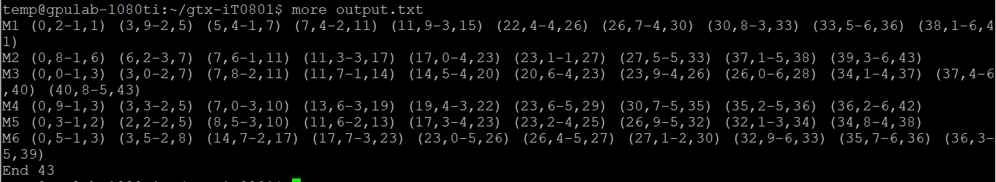

Main_cu_3

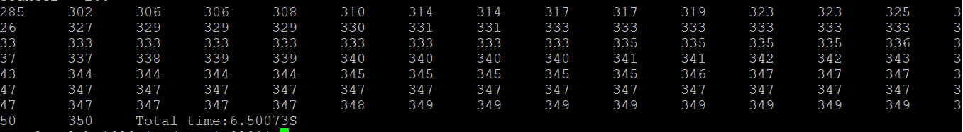

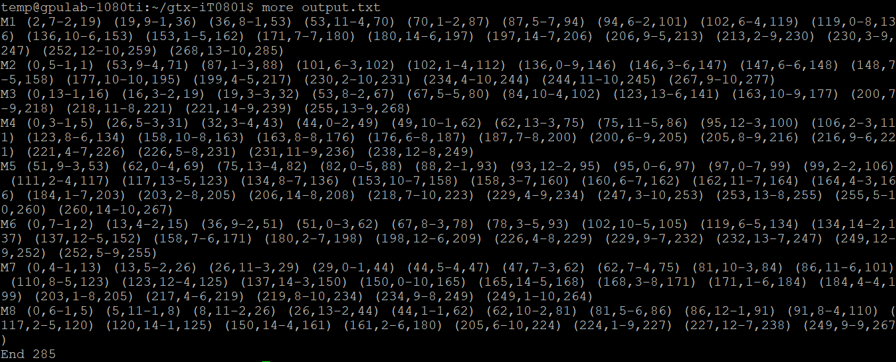

Main_cu_4

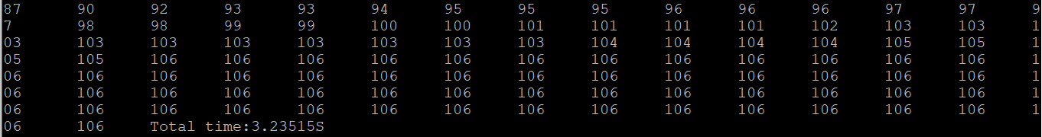

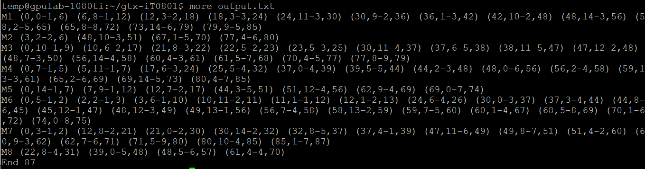

Main_cu_5

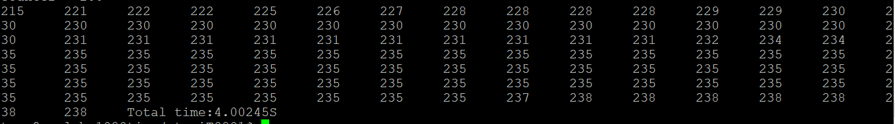

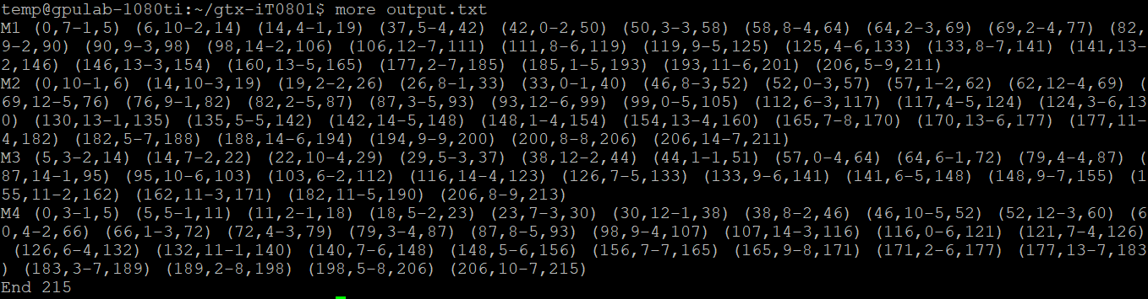

Python mk01

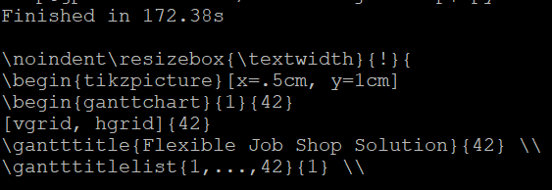

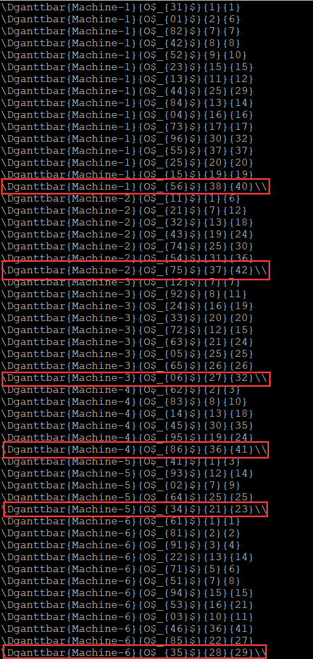

Python mk02

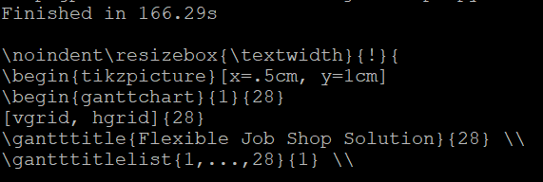

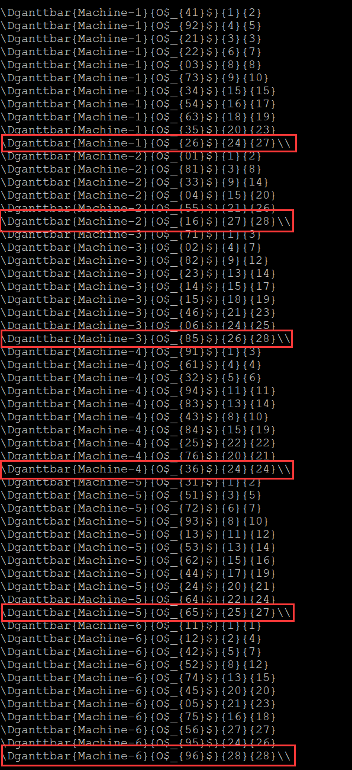

Python mk03

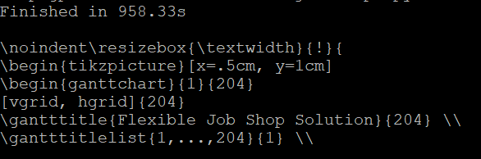







Pyhton mk04

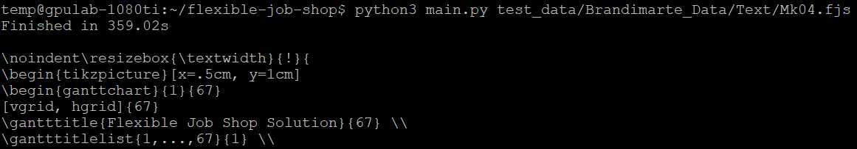



Python mk05

