VIETNAM GENERAL CONFEDERATION OF LABOR
TON DUC THANG UNIVERSITY
FACULTY OF INFORMATION TECHNOLOGY



FINAL REPORT
DESIGN PATTERN

A MANAGEMENT SYSTEM FOR THE JEWELRY STORE

Advised by: MSc. VU DINH HONG
Student: BACH PHUONG BINH - 522H0001
DUONG THI THUY LINH - 522H0015
TRAN MY VAN - 522H0083
Course: 26

HO CHI MINH CITY, YEAR 2025

VIETNAM GENERAL CONFEDERATION OF LABOR
TON DUC THANG UNIVERSITY
FACULTY OF INFORMATION TECHNOLOGY

FINAL REPORT
DESIGN PATTERN

A MANAGEMENT SYSTEM FOR THE JEWELRY STORE

Advised by: MSc. VU DINH HONG
Student: BACH PHUONG BINH - 522H0001
DUONG THI THUY LINH - 522H0015
TRAN MY VAN - 522H0083
Course: 26

HO CHI MINH CITY, YEAR 2025

ACKNOWLEDGMENTS
We would like to extend our deepest gratitude to Mr. Vu Dinh Hong for his teaching and imparting invaluable knowledge to us. Throughout our learning journey, Mr. Hong has been a constant companion, addressing our queries, offering encouragement, and providing guidance that has helped us progress each day.
Furthermore, we truly appreciate Mr. Hong for creating opportunities to motivate, assist, and always being ready to guide and clarify any issues we encountered during our research and completion of the essay.
As we complete this essay, we acknowledge that we may have made mistakes and respectfully seek sincere advice and suggestions from Mr. Hong.
Finally, we wish Mr. Hong good health, happiness, and success in his teaching career and life.

PROJECT COMPLETED
AT TON DUC THANG UNIVERSITY

We hereby declare that this project is solely our own work and has been guided by lecturer Vu Dinh Hong. The research content and results in this topic are truthful and have not been previously published in any form. The data in the tables used for analysis, comments, and evaluations were collected by the authors from various sources clearly stated in the reference section.
Additionally, the project also incorporates some comments, evaluations, and data from other authors and organizations, all of which are properly cited and referenced.
If any form of academic dishonesty is detected, we take full responsibility for the content of our project. Ton Duc Thang University is not responsible for any copyright violations or infringements caused by us during the implementation process (if any).
Ho Chi Minh City - April 18, 2025

Author

Bach Phuong Binh

Duong Thi Thuy Linh

Tran My Van

INSTRUCTOR’S CONFIRMATION AND EVALUATION SECTION
Supervisor’s Confirmation Section
________________________________________________________________________________________________________________________________________________________________________________________________________________________________________________________________________________________________________________________________________________________________________________________________________________________________________________
… , date … month …year…

Supervisor’s Evaluation Section
________________________________________________________________________________________________________________________________________________________________________________________________________________________________________________________________________________________________________________________________________________________________________________________________________________________________________________
… , date … month …year…

TABLE OF CONTENTS
ACKNOWLEDGMENTS 1
TABLE OF CONTENTS 4
SECTION 1 – PROJECT MANAGEMENT PLAN 5
1.1. Project Overview 5
1.2. Development Phases Error! Bookmark not defined.
1.3. Timeline 7
1.4. Software Development Model 8
SECTION 2 – REQUIREMENTS SPECIFICATION 10
2.1. Use case diagrams 10
2.2. Use case specification 12
SECTION 3 – ARCHITECTURE 29
3.1. System architecture 29
3.2. Technologies used 34
3.3. Rationale for choices 37
SECTION 4 – DESIGN 41
4.1. Class Diagrams 41
4.2. Sequence Diagrams 42
4.3. Database Design 48
SECTION 5 – APPLICATION DEVELOPMENT 49
5.1. Application Overview 49
5.2. Implementation Details 53
5.3. Execution Results 55
SECTION 6 – TESTING 58
6.1. Test Cases 58
6.2. Unit Tests 58
TEAM MEMBER RESPONSIBILITIES 70
REFERENCES 71

SECTION 1 – PROJECT MANAGEMENT PLAN
- Project Overview
This project aims to develop a web-based application, Jeweluxe, to support management and sales operations in the jewelry e-commerce sector. The primary goal is to create an online platform that enables customers to browse and purchase high-quality jewelry items while providing administrators with efficient tools to manage inventory, orders, and user accounts. The system is designed to cater to both customer and administrator needs, emphasizing an intuitive user experience, robust security, and scalability to handle large volumes of data.
Jeweluxe is not merely an online retail tool but a comprehensive solution that optimizes business processes for jewelry retailers. By incorporating modern design patterns such as Singleton, Factory, Observer, and Decorator, the application ensures modularity, maintainability, and extensibility. In the context of the rapidly growing online jewelry market, this project holds significant practical value, particularly for small and medium-sized enterprises (SMEs) seeking to establish a premium digital presence and deliver personalized shopping experiences.
- The Scope of Project
The scope of the Jeweluxe project encompasses the design, development, and deployment of a web application tailored for jewelry e-commerce, with the following key functionalities:
- User Management: Facilitates registration, login, management of personal information, and role-based access control for customers and administrators.
- Product Management: Enables the addition, editing, deletion, and display of jewelry product information, including attributes such as name, price, material (e.g., gold, silver, gemstones), description, and category.
- Order Processing: Supports customers in creating orders, tracking order statuses, and completing payments, while allowing administrators to manage the order fulfillment process.
- Category Management: Organizes jewelry items into category groups (e.g., rings, necklaces, bracelets), enhancing search and management efficiency.
From a technological perspective, the project utilizes modern tools and programming languages, such as Java for the backend, integrated with a relational database management system (MySQL) for data storage and retrieval. The user interface is developed using Thymeleaf to optimize user experience, delivering dynamic and visually appealing displays of jewelry products. The system incorporates design patterns like Singleton, Factory, Observer, and Decorator to ensure modular, maintainable, and scalable code, aligning with the principles of the Design Pattern course.
- Development Phases
The project is divided into five sequential phases, aligned with the Waterfall model to ensure a structured and disciplined approach:
- Requirements Analysis
  - Objective: Gather and document all functional and non-functional requirements.
  - Activities: Research existing e-commerce systems, identify user stories, and create a detailed requirements specification document.
  - Deliverables: Requirements Specification Document.
- System Design
  - Objective: Design the system architecture, database schema, and user interfaces.
  - Activities: Develop an Entity-Relationship Diagram (ERD), design class diagrams, and create wireframes for the user interface.
  - Deliverables: System Design Document, including ERD and class diagrams.
- Implementation
  - Objective: Build the application based on the design specifications.
  - Activities: Write Java code for the backend, integrate with MySQL using JDBC, and implement the frontend using JSP or Thymeleaf.
  - Deliverables: Functional e-commerce application.
- Testing
  - Objective: Verify that the application meets all requirements and operates correctly.
  - Activities: Conduct unit testing, integration testing, and system testing to identify and fix bugs.
  - Deliverables: Test Plan and Test Report.
- Deployment and Maintenance
  - Objective: Deploy the application and prepare for ongoing maintenance.
  - Activities: Deploy the application on a local server, perform final checks, and plan for future updates.
  - Deliverables: Deployed application and Maintenance Plan.
- Timeline
The project is scheduled to be completed within one month, with each phase allocated a specific timeframe to ensure timely delivery. The detailed timeline is as follows:
Phase | Duration | Start Date | End Date | Key Activities
Requirements Analysis | 5 days | Day 1 | Day 5 | Research, define user stories, document requirements
System Design | 5 days | Day 6 | Day 10 | Design usecase, ERD, class diagrams, and UI wireframes
Implementation | 10 days | Day 11 | Day 20 | Develop backend and frontend, integrate with MySQL
Testing | 5 days | Day 21 | Day 25 | Perform unit, integration, and system testing
Deployment and Maintenance | 2 days | Day 26 | Day 27 | Deploy application, plan maintenance

- Buffer Time: Days 28–30 are reserved to address any unforeseen issues or delays.
- Total Duration: 27 working days, with a 3-day buffer to ensure completion within one month.
- Software Development Model
The Waterfall model is chosen for this project due to its linear, structured approach, which is well-suited for a short-term project with clearly defined requirements. The Waterfall model ensures that each phase is thoroughly completed before moving to the next, minimizing scope creep and ensuring the project stays on track within the one-month timeline.
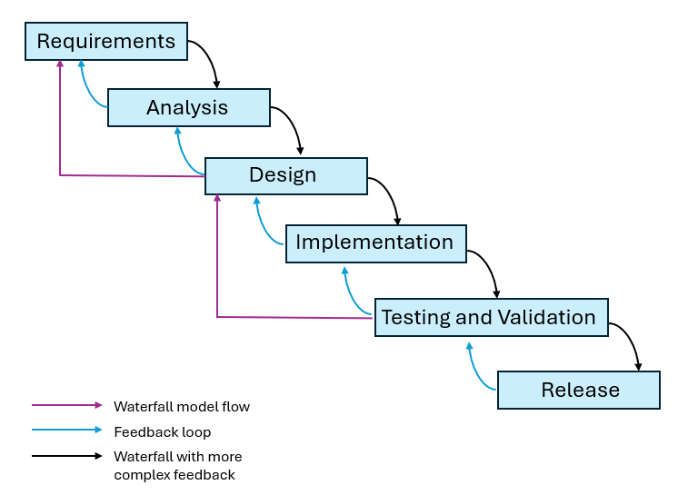
Key Reasons for Choosing Waterfall:
- Clear Requirements: The project has well-defined requirements with little likelihood of changes during the short development period.
- Time Constraints: The sequential nature of Waterfall allows for strict time management, ensuring each phase is completed within its allocated timeframe.
- Simplicity and Discipline: With a small team and limited time, Waterfall provides a straightforward framework, reducing complexity and enhancing discipline.
Although the Waterfall model lacks flexibility for changes, the short duration of the project and the clarity of requirements mitigate this limitation. Potential risks are addressed through the buffer time at the end of the schedule.

SECTION 2 – REQUIREMENTS SPECIFICATION
- Identify actors and use cases
- Identify actors
No. | Actor | Description
1 | User | A customer who browses, purchases products, and manages their profile on the Jeweluxe platform.
2 | Admin | A store manager who oversees products, users, categories, and order statuses on the Jeweluxe platform.

- Identify use cases
ID | Use Case | Description | Actor
UC1 | Reset password | Allows the user to reset their password if forgotten. | User
UC2 | Change password | Allows the user to update their password. | User
UC3 | Register | Allows a new user to create an account on the platform. | User
UC4 | Logout | Allows the user to log out of their account. | User
UC5 | Login | Allows the user to log into their account. | User
UC6 | View order history | Allows the user to view their past orders. | User
UC7 | View product detail | Allows the user to view details of a specific product. | User
UC8 | View cart | Allows the user to view items in their shopping cart. | User
UC9 | Add to cart | Allows the user to add a product to their shopping cart. | User
UC10 | Make payment | Allows the user to complete payment for their order. | User
UC11 | View profile | Allows the user to view their profile information. | User
UC12 | Change profile | Allows the user to update their profile information. | User
UC13 | CRUD Product | Allows the admin to create, read, update, or delete products. | Admin
UC14 | CRUD User | Allows the admin to create, read, update, or delete user accounts. | Admin
UC15 | CRUD Categories | Allows the admin to create, read, update, or delete product categories. | Admin
UC16 | Set order status | Allows the admin to update the status of an order (e.g., shipped, delivered). | Admin

- Use case diagrams
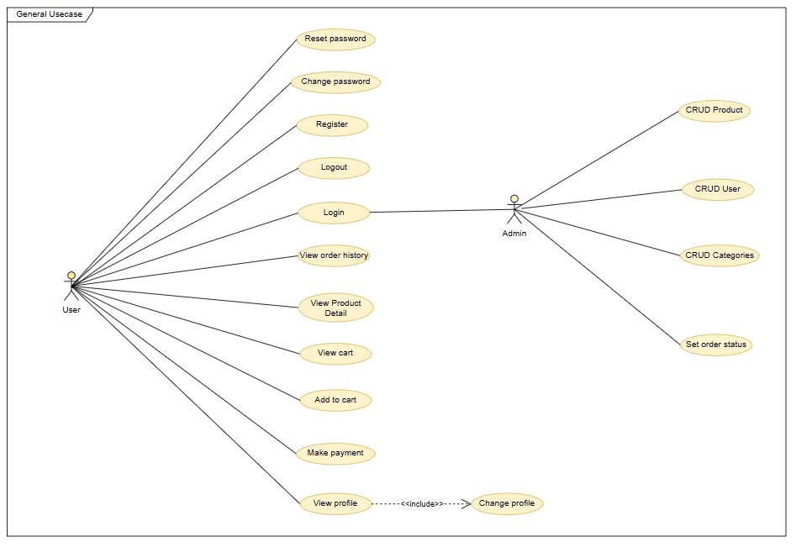
- Use case specification
- Reset password
Use case name: Reset Password |  | ID: UC1 |  |  | Priority: Medium
Actor: User
Brief Description: Allows the user to reset their password if forgotten.
Trigger: The user clicks "Reset Password".
Type: ☑ External □ Temporal
Precondition:
- The user must have a registered account on the Jeweluxe platform.
- The user must have access to the Jeweluxe website.
Normal Course:  - The user navigates to the reset password page.  - The user enters their email.  - The system sends a reset link to the user’s email.  - The user clicks the link and sets a new password.  - The system updates the password. |  | Information for Steps:  - Email is provided by the user.  - Reset link is generated by the system.  - New password is set by the user.
Postconditions:
- The user’s password is reset.
- The user can log in with the new password.
Summary Inputs | Source |  | Outputs | Destination
Email  New password | User |  | Reset link  Confirmation | User

- Change password
Use case name: Change Password |  | ID: UC2 |  |  | Priority: Medium
Actor: User
Brief Description: Allows the user to update their password.
Trigger: The user clicks "Change Password".
Type: ☑ External □ Temporal
Precondition: The user must be logged into their account.
Normal Course:  - The user navigates to the change password page.  - The user enters their old password and new password.  - The system validates the old password.  - The system updates the password. |  | Information for Steps:  - Old and new passwords are provided by the user.  - Password validation and update are handled by the system.
Postconditions:
- The user’s password is updated.
- The user can log in with the new password.
Summary Inputs | Source |  | Outputs | Destination
Old password, New password | User |  | Confirmation | User

- Register
Use case name: Register |  | ID: UC3 |  |  | Priority: High
Actor: User
Brief Description: Allows a new user to create an account on the platform.
Trigger: The user clicks "Register".
Type: ☑ External □ Temporal
Precondition: The user does not have an existing account. The user has access to the Jeweluxe website.
Normal Course:  - The user navigates to the registration page.  - The user enters their details (e.g., username, email, password).  - The system validates the input (e.g., email uniqueness).  - The system creates the account. |  | Information for Steps:  - User details are provided by the user.  - Validation and account creation are handled by the system.
Postconditions:
- A new user account is created.
- The user can log in with their credentials.
Summary Inputs | Source |  | Outputs | Destination
Username, Email, Password |  |  | Account creation confirmation
  User
  User

- Logout
Use case name: Logout |  | ID: UC4 |  |  | Priority: Medium
Actor: User
Brief Description: Allows the user to log out of their account.
Trigger: The user clicks "Logout".
Type: ☑ External □ Temporal
Precondition: The user must be logged into their account.
Normal Course:  - The user clicks the "Logout" button.  - The system ends the user’s session.  - The system redirects the user to the homepage. |  | Information for Steps:  - Session termination is handled by the system.
Postconditions:
- The user is logged out.
- The user cannot access personalized features until logging in again.
Summary Inputs | Source |  | Outputs | Destination
None | None |  | Logout confirmation | User

- Login
Use case name: Login |  | ID: UC5 |  |  | Priority: High
Actor: User
Brief Description: Allows the user to log into their account to access personalized features.
Trigger: The user clicks "Login".
Type: ☑ External □ Temporal
Precondition: The user must have a registered account. The user must have access to the Jeweluxe website.
Normal Course:  - The user navigates to the login page.  - The user enters their username/email and password.  - The system validates the credentials.  - The system logs the user in and redirects them to the homepage. |  | Information for Steps:  - Username/email and password are provided by the user.  - Credential validation is handled by the system.
Postconditions:
- The user is logged into their account.
- The user can access personalized features.
Summary Inputs | Source |  | Outputs | Destination
Username/Email, Password | User |  | Login confirmation, Session token | User

- View order history
Use case name: View Order History |  |  | ID: UC6 |  | Priority: Medium
Actor: User
Brief Description: Allows the user to view their past orders.
Trigger: The user clicks "Order History".
Type: ☑ External □ Temporal
Precondition: The user must be logged into their account. The user must have placed orders previously.
Normal Course:  - The user navigates to the order history page.  - The system retrieves the user’s order history.  - The system displays the order history. |  |  | Information for Steps:  - Order history data is retrieved by the system.
Postconditions:
- The user can view their order history.
Summary Inputs | Source | Outputs |  | Destination
None | None | Order history data |  | User

- View product detail
Use case name: View Product Detail |  |  | ID: UC7 |  |  | Priority: Medium
Actor: User
Brief Description: Allows the user to view details of a specific product.
Trigger: The user clicks on a product.
Type: ☑ External □ Temporal
Precondition: The product must exist in the Jeweluxe inventory.
Normal Course:  - The user browses products.  - The user selects a product.  - The system displays the product details (e.g., name, price, description). |  |  | Information for Steps:  - Product ID is provided by the user’s selection.  - Product details are retrieved by the system.
Postconditions:
- The user can view the product details.
Summary Inputs |  | Source |  | Outputs | Destination
Product ID | User |  |  | Product details | User

- View cart
Use case name: View Cart |  | ID: UC8 |  |  | Priority: Medium
Actor: User
Brief Description: Allows the user to view items in their shopping cart.
Trigger: The user clicks "View Cart".
Type: ☑ External □ Temporal
Precondition: The user must be logged into their account.
Normal Course:  - The user navigates to the cart page.  - The system retrieves the user’s cart contents.  - The system displays the cart items. |  | Information for Steps:  - Cart contents are retrieved by the system.
Postconditions:
- The user can view their cart items.
Summary Inputs | Source |  | Outputs | Destination
None | None |  | Cart contents | User

- Add to cart
Use case name: Add to Cart |  | ID: UC9 |  |  | Priority: Medium
Actor: User
Brief Description: Allows the user to add a product to their shopping cart.
Trigger: The user clicks "Add to Cart".
Type: ☑ External □ Temporal
Precondition: The user must be logged into their account. The product must be available in the Jeweluxe inventory.
Normal Course:  - The user browses products.  - The user selects a product and clicks "Add to Cart".  - The system adds the product to the user’s cart.  - The system updates the cart display. |  | Information for Steps:  - Product ID and quantity are selected by the user.  - Cart update is handled by the system.
Postconditions:
- The product is added to the user’s cart.
- The user can view the updated cart.
Summary Inputs | Source |  | Outputs | Destination
Product ID, Quantity | User |  | Updated cart contents | User

- Make payment
Use case name: Make Payment |  | ID: UC10 |  |  | Priority: High
Actor: User
Brief Description: Allows the user to complete payment for their order.
Trigger: The user clicks "Checkout".
Type: ☑ External □ Temporal
Precondition: The user must be logged into their account. The user must have items in their cart.
Normal Course:  - The user navigates to the checkout page.  - The user enters payment details (e.g., credit card info).  - The system processes the payment.  - The system places the order and clears the cart. |  | Information for Steps:  - Payment details are provided by the user.  - Payment processing and order placement are handled by the system.
Postconditions:
- The payment is processed.
- The order is placed.
- The cart is cleared.
Summary Inputs | Source |  | Outputs | Destination
Payment details | User |  | Payment confirmation, Order confirmation | User

- View profile
Use case name: View Profile |  | ID: UC11 |  |  | Priority: Medium
Actor: User
Brief Description: Allows the user to view their profile information.
Trigger: The user clicks "Profile".
Type: ☑ External □ Temporal
Precondition: The user must be logged into their account.
Normal Course:  - The user navigates to the profile page.  - The system retrieves the user’s profile information.  - The system displays the profile details. |  | Information for Steps:  - Profile data is retrieved by the system.
Postconditions:
- The user can view their profile information.
Summary Inputs | Source |  | Outputs | Destination
None | None |  | Profile data | User

- Change profile
Use case name: Change Profile |  | ID: UC12 |  |  | Priority: Medium
Actor: User
Brief Description: Allows the user to update their profile information.
Trigger: The user clicks "Edit Profile" after viewing their profile.
Type: ☑ External □ Temporal
Precondition: The user must be logged into their account. The user must be viewing their profile.
Normal Course:  - The user clicks "Edit Profile".  - The user updates their profile details (e.g., name, address).  - The system validates the input.  - The system saves the updated profile. |  | Information for Steps:  - Updated profile details are provided by the user.  - Validation and saving are handled by the system.
Postconditions:
- The user’s profile information is updated.
Summary Inputs | Source |  | Outputs | Destination
Updated profile details | User |  | Confirmation | User

- CRUD Product
Use case name: CRUD Product |  |  | ID: UC13 |  | Priority: High
Actor: Admin
Brief Description: Allows the admin to create, read, update, or delete products in the Jeweluxe inventory.
Trigger: The admin accesses the product management dashboard.
Type: ☑ External □ Temporal
Precondition: The admin must be logged into their account. The admin must have appropriate permissions.
Normal Course:  - The admin navigates to the product management section.  - The admin selects an operation (Create, Read, Update, or Delete).  - For Create: The admin enters product details and saves.  - For Read: The admin views the product list or details.  - For Update: The admin modifies product details and saves.  - For Delete: The admin removes a product.  - The system updates the inventory accordingly. |  |  | Information for Steps:  - Product details are provided by the admin.  - Inventory updates are handled by the system.
Postconditions:
- The product inventory is updated based on the CRUD operation.
- The admin receives confirmation of the operation.
Summary Inputs | Source | Outputs |  | Destination
Product details (for Create/Update), Product ID (for Read/Delete) | Admin | Updated product inventory, Confirmation |  | Admin

- CRUD User
Use case name: CRUD User |  | ID: UC14 |  |  |  | Priority: High
Actor: Admin
Brief Description: Allows the admin to create, read, update, or delete user accounts.
Trigger: The admin accesses the user management dashboard.
Type: ☑ External □ Temporal
Precondition: The admin must be logged into their account. The admin must have appropriate permissions.
Normal Course:  - The admin navigates to the user management section.  - The admin selects an operation (Create, Read, Update, or Delete).  - For Create: The admin enters user details and saves.  - For Read: The admin views the user list or details.  - For Update: The admin modifies user details and saves.  - For Delete: The admin removes a user account.  - The system updates the user database accordingly. |  |  |  | Information for Steps:  - User details are provided by the admin.  - Database updates are handled by the system.
Postconditions:
- The user database is updated based on the CRUD operation.
- The admin receives confirmation of the operation.
Summary Inputs | Source |  | Outputs |  | Destination
User details (for Create/Update), User ID (for Read/Delete) | Admin |  | Updated user database, Confirmation |  | Admin

- CRUD Categories
Use case name: CRUD Categories |  |  | ID: UC15 |  | Priority: Medium
Actor: Admin
Brief Description: Allows the admin to create, read, update, or delete product categories.
Trigger: The admin accesses the category management dashboard.
Type: ☑ External □ Temporal
Precondition: The admin must be logged into their account. The admin must have appropriate permissions.
Normal Course:  - The admin navigates to the category management section.  - The admin selects an operation (Create, Read, Update, or Delete).  - For Create: The admin enters category details and saves.  - For Read: The admin views the category list or details.  - For Update: The admin modifies category details and saves.  - For Delete: The admin removes a category.  - The system updates the category database accordingly. |  |  | Information for Steps:  - Category details are provided by the admin.  - Database updates are handled by the system.
Postconditions:
- The category database is updated based on the CRUD operation.
- The admin receives confirmation of the operation.
Summary Inputs | Source | Outputs |  | Destination
Category details (for Create/Update), Category ID (for Read/Delete) | Admin | Updated category database, Confirmation |  | Admin

- Set order status
Use case name: Set Order Status |  | ID: UC16 |  |  | Priority: Medium
Actor: Admin
Brief Description: Allows the admin to update the status of an order (e.g., shipped, delivered).
Trigger: The admin selects an order and updates its status via the order management dashboard.
Type: ☑ External □ Temporal
Precondition: The admin selects an order and updates its status via the order management dashboard.
Normal Course:  - The admin navigates to the order management section.  - The admin selects an order.  - The admin updates the order status (e.g., from "Processing" to "Shipped").  - The system saves the updated status.  - The system notifies the user of the status change (if applicable). |  | Information for Steps:  - Order ID and new status are provided by the admin.  - Status update and notification are handled by the system.
Postconditions:
- The order status is updated in the system.
- The user is notified of the status change (if applicable).
Summary Inputs | Source |  | Outputs | Destination
Order ID, New status | Admin |  | Updated order status, Notification (if applicable) | System, User

SECTION 3 – ARCHITECTURE
- System architecture

The Jeweluxe website is designed using the Model-View-Controller (MVC) architectural pattern, a well-established framework for web development that promotes separation of concerns, modularity, and maintainability. The system is structured into distinct layers—presentation, business logic, and data access—ensuring a systematic and scalable design that aligns with the project’s requirements, particularly the one-month development timeline. This section provides a detailed analysis of the system architecture, focusing on its components, data flow, integration with external services, and the application of design patterns to enhance functionality.

Architectural Layers
The system architecture is organized into three primary layers, each serving a specific role within the website:

Presentation Layer (View)
- Purpose: The presentation layer is responsible for rendering the user interface and facilitating user interaction. It acts as the front-facing component, ensuring users can navigate the jewelry e-commerce website seamlessly.
- Implementation: This layer is implemented using Thymeleaf, a server-side Java template engine. Thymeleaf templates are utilized to generate dynamic HTML pages, enabling the display of content such as jewelry product listings, user profiles, and order summaries. Static assets, including CSS, JavaScript, and images, are organized within the resources directory, ensuring efficient management of front-end resources and delivering a visually appealing and responsive user experience.
- Key Features: The presentation layer supports dynamic content rendering based on data provided by the business logic layer. For instance, a product page can display details like name, price, material (e.g., gold, silver), and description, which are retrieved from the database and integrated into the template for rendering.

Business Logic Layer (Controller and Service)
- Purpose: The business logic layer manages the core functionality of the website, processing user requests, enforcing business rules, and coordinating interactions between the presentation and data access layers.
- Implementation:
  - Controllers: The website includes several controller classes within the controller package, such as AdminController, HomeController, PageController, and UserController, which handle HTTP requests and responses. Each controller is responsible for a specific set of functionalities:
    - AdminController: Manages administrative tasks, including product, user, category, and order status management.
    - HomeController: Oversees the homepage, displaying jewelry product listings and static content.
    - PageController: Controls the rendering of additional pages, such as product detail pages or the shopping cart page.
    - UserController: Processes user-related requests, including registration, login, cart management, and order placement.
  - Services: Service classes in the service package encapsulate the website’s business logic, acting as an intermediary between controllers and the data access layer. They implement operations such as user authentication, product filtering, and order processing. For example, a service method might validate user input before persisting an order to the database.
  - Design Patterns: The business logic layer incorporates design patterns to enhance modularity and scalability:
    - Decorator Pattern: Implemented in the decorator_price package to dynamically adjust product pricing (e.g., applying discounts or taxes based on user location or promotions).
    - State Pattern: Used in the state package to manage the state of orders (e.g., transitioning from "Processing" to "Shipped" to "Delivered").
    - Iterator Pattern: Applied in the iterator package to efficiently traverse collections, such as iterating over a list of jewelry products in a category.
- Key Features: The business logic layer ensures that all operations adhere to the website’s rules and constraints. For instance, it verifies product availability before allowing a user to add a jewelry item to their cart, calculates the total cost of an order (including dynamic pricing adjustments via the Decorator pattern), and manages order state transitions using the State pattern.

Data Access Layer (Model and Repository)
- Purpose: The data access layer manages data persistence and retrieval, interfacing with the MySQL database to store and query information.
- Implementation:
  - Models: The website defines entity classes in the model package, including Cart, Category, OrderAddress, OrderRequest, Product, ProductOrder, and UserDtls. These entities are mapped to database tables using Java Persistence API (JPA) annotations. For example:
    - Product represents the product table, with attributes such as name, price, description, material (e.g., gold, silver, gemstones), and stock quantity.
    - UserDtls corresponds to the user details table, storing information like email, password, and role.
    - ProductOrder maps to the order table, recording details such as date, status, and associated user ID.
  - Repositories: Repository interfaces in the repository package, such as CartRepository, CategoryRepository, ProductOrderRepository, ProductRepository, and UserRepository, provide data access methods. These interfaces leverage Spring Data JPA’s JpaRepository, offering built-in methods for CRUD operations and custom queries. For instance, a repository might include a method to find jewelry products by category (e.g., rings, necklaces).
- Key Features: The data access layer ensures efficient and secure interaction with the database. It utilizes JPA’s object-relational mapping to simplify data operations, while the repository pattern abstracts database queries, enhancing code maintainability.

Data Flow
The data flow within the system adheres to the MVC pattern, ensuring a clear and predictable interaction between layers:
- Step 1. User Request: A user interacts with the website via a web browser, sending an HTTP request (e.g., a GET request to view a jewelry product list or a POST request to place an order).
- Step 2. Controller Handling: The request is routed to the appropriate controller in the controller package based on URL mapping. For example, a request to access product listings is handled by HomeController, while a login request is processed by UserController. The controller extracts parameters from the request and invokes the corresponding service method.
- Step 3. Service Processing: The service layer in the service package executes the necessary business logic. For instance, when a user places an order, the service validates the order details (e.g., checks product availability), calculates the total cost using the Decorator pattern for dynamic pricing, updates the order state using the State pattern, and interacts with the repository layer to persist the order.
- Step 4. Data Access: The repository layer in the repository package uses JPA to interact with the MySQL database. For example, it might execute a query to retrieve jewelry product details or save a new order. The spring.jpa.hibernate.ddl-auto=update setting ensures that the database schema is automatically updated to match the entity classes during development.
- Step 5. Response Rendering: The controller prepares a model containing the data to be displayed (e.g., a list of jewelry products) and specifies the Thymeleaf template to render. The template processes the model data and generates an HTML response, which is sent back to the user’s browser.

Integration with External Services
The website integrates with external services to enhance functionality:
- Email Notifications: The system uses Gmail’s SMTP service to send emails, such as order confirmations or password reset links. This is configured in the application.properties file with settings like spring.mail.host=smtp.gmail.com, spring.mail.username=techstorehtt@gmail.com, and spring.mail.port=587. The spring.mail.properties.mail.smtp.starttls.enable=true setting ensures secure email transmission using TLS. Note that the email username techstorehtt@gmail.com is a legacy configuration retained for development purposes; in a production environment, it should be updated to a domain-specific email (e.g., support@jeweluxe.com).
- File Upload Handling: The website supports file uploads, such as jewelry product images, with a maximum file size of 50MB, as specified by spring.servlet.multipart.max-file-size=50MB and spring.servlet.multipart.max-request-size=50MB. This allows administrators to upload high-quality images during product creation or updates, enhancing the visual appeal of the jewelry catalog.

Configuration and Utilities
- Configuration: The website includes configuration classes in the config package that customize its behavior, such as security settings or custom beans. For example, security configurations ensure role-based access for users and admins.
- Utilities: Utility classes in the util package provide helper methods, such as string manipulation or data formatting, used across the website to support various functionalities.
- Event and Listener: The event and listener packages implement an event-driven architecture for handling asynchronous tasks, such as sending notifications when an order status changes.
This layered architecture, combined with the MVC pattern and design patterns like Decorator, State, and Iterator, ensures that the Jeweluxe website is well-organized, scalable, and maintainable, even within the constraints of a short development timeline.
- Technologies used
The Jeweluxe website leverages a modern technology stack to meet its functional and non-functional requirements. The technologies are selected based on the project’s scope, timeline, and the need for a reliable e-commerce platform. This section provides a detailed overview of the technologies used.
- Core Frameworks and Libraries
- Spring Boot 3.4.4: The foundation of the website, providing a comprehensive framework for building Java-based web applications. Spring Boot simplifies dependency management, configuration, and deployment through its auto-configuration features. It includes several starter dependencies, such as:
  - spring-boot-starter-web: For building RESTful web applications with an embedded Tomcat server.
  - spring-boot-starter-data-jpa: For integrating with JPA and Hibernate.
  - spring-boot-starter-thymeleaf: For server-side rendering with Thymeleaf.
  - spring-boot-starter-mail: For email functionality.
  - spring-boot-starter-security: For securing the website with authentication and authorization.
- Spring Data JPA 3.4.4: A part of the Spring ecosystem, used for data access. It provides repository abstractions that simplify database operations, enabling efficient interaction with the database through the repository package.
- Hibernate (via Spring Boot 3.4.4): The ORM framework used for mapping Java entities to MySQL database tables. Hibernate handles object-relational mapping, allowing developers to work with Java objects instead of raw SQL queries. The spring.jpa.properties.hibernate.dialect=org.hibernate.dialect.MySQL8Dialect property ensures compatibility with MySQL 8, while spring.jpa.hibernate.ddl-auto=update automates schema updates during development.
- Thymeleaf 3.1.3.RELEASE: A server-side template engine for rendering dynamic HTML pages, included via spring-boot-starter-thymeleaf. Thymeleaf supports data binding and dynamic content rendering, making it ideal for displaying jewelry product lists, user profiles, and order details.
- Spring Security 6.4.4: Used for securing the website, handling authentication (e.g., user login) and authorization (e.g., role-based access for admins and users), included via spring-boot-starter-security.
- Database and Data Access
- MySQL 8.3.0: The relational database management system used for persistent storage, configured with spring.datasource.url=jdbc:mysql://localhost:3306/ecommerce_db. MySQL is accessed via the com.mysql.cj.jdbc.Driver, facilitating JDBC connections. The database stores critical entities like users, products, orders, and categories.
- JPA (Java Persistence API): Provides the foundation for object-relational mapping, integrated through Spring Data JPA. JPA annotations in the model classes define the mapping between Java objects and database tables.
- External Services and Integrations
- SMTP (Gmail): The website uses Gmail’s SMTP service for sending email notifications, such as order confirmations or password reset links. This is configured with spring.mail.host=smtp.gmail.com, spring.mail.username=techstorehtt@gmail.com, spring.mail.port=587, and security settings like spring.mail.properties.mail.smtp.auth=true and spring.mail.properties.mail.smtp.starttls.enable=true.
- File Upload Support: Configured with spring.servlet.multipart.max-file-size=50MB and spring.servlet.multipart.max-request-size=50MB, allowing the website to handle file uploads (e.g., jewelry product images) up to 50MB in size.
- Build and Dependency Management
Maven: The build tool used for managing dependencies and automating the build process, as defined in pom.xml. Maven ensures consistent dependency resolution and build reproducibility across different environments. Key dependencies include:
- mysql-connector-j:8.3.0: For connecting to the MySQL database.
- spring-boot-starter-mail: For email functionality.
- spring-boot-starter-thymeleaf: For Thymeleaf integration.
- spring-boot-starter-security: For security features.
- lombok:1.18.32: For reducing boilerplate code in Java classes.
- Development Tools
- IntelliJ IDEA: The integrated development environment (IDE) used for coding, debugging, and managing the project.
- Java 21: The programming language version used, as specified in pom.xml with <java.version>21</java.version>. Java 21 offers modern features like records and improved performance, enhancing development efficiency.
- Additional Libraries
- Lombok 1.18.32: A library that reduces boilerplate code (e.g., getters, setters) in Java classes, included as a provided dependency in pom.xml.
- JUnit 5 (via Spring Boot Test): Used for unit testing, included via spring-boot-starter-test, ensuring that critical components function correctly.
- SLF4J and Logback (via Spring Boot): Logging frameworks for debugging and monitoring, inc1wluded as part of Spring Boot’s default logging setup.
- Rationale for choices
The architectural design and technology stack were carefully selected to meet the project’s functional requirements, adhere to the one-month timeline, and ensure a scalable, maintainable e-commerce website. This section provides a detailed justification for each choice.
- MVC Architecture
- Separation of Concerns: The MVC pattern ensures that the presentation, business logic, and data access layers are separated, allowing developers to work on different components independently, which is crucial for a small team within a tight timeline.
- Maintainability and Scalability: The layered structure facilitates maintenance and future enhancements, such as adding new features without disrupting existing functionality.
- Alignment with Spring Boot: Spring Boot natively supports the MVC pattern, providing built-in mechanisms for request routing and view rendering, making it a natural fit for this project.
- Spring Boot and Java
- Rapid Development: Spring Boot’s auto-configuration and starter dependencies reduce setup time, critical for a one-month project. The embedded Tomcat server eliminates manual server configuration, allowing developers to focus on coding.
- Robust Ecosystem: Spring Boot and Java offer extensive documentation and community support, enabling quick issue resolution.
- Performance and Stability: Java’s robustness and Spring Boot’s optimized runtime ensure reliable performance for e-commerce workloads.
- MySQL, Spring Data JPA, and Hibernate
- Relational Data Management: MySQL supports complex relationships, transactions, and efficient querying, ideal for e-commerce websites.
- Simplified Data Access: Spring Data JPA and Hibernate provide high-level abstractions, reducing development time and errors.
- Schema Management: The spring.jpa.hibernate.ddl-auto=update setting automates schema updates, a key advantage for rapid development.
- Cost-Effectiveness: MySQL is open-source, making it a cost-effective choice for a student project.
- Thymeleaf for Frontend
- Server-Side Rendering: Thymeleaf simplifies development by keeping rendering logic on the server, suitable for a small-scale e-commerce website.
- Seamless Integration with Spring: Thymeleaf supports data binding and form handling, integrating seamlessly with Spring Boot.
- Ease of Use: Thymeleaf’s HTML-based syntax reduces the learning curve, aligning with the project’s timeline.
- Spring Security
- Security Requirements: Spring Security provides robust authentication and authorization, essential for protecting user data and ensuring role-based access.
- Ease of Integration: It integrates seamlessly with Spring Boot, requiring minimal configuration.
- Email Service (SMTP with Gmail)
- User Engagement: Email notifications enhance user experience by providing real-time updates, critical for an e-commerce website.
- Simplicity and Reliability: Gmail’s SMTP service is easy to configure and reliable, with TLS ensuring secure transmission.
- File Upload Configuration
- Functional Requirement: The 50MB file size limit accommodates product image uploads while preventing server overload.
- Scalability: The limit can be adjusted for future needs, ensuring flexibility.
- Maven, IntelliJ IDEA, and Java 23
- Dependency Management: Maven ensures consistent dependency resolution, crucial for collaborative development.
- Development Efficiency: IntelliJ IDEA improves productivity with features like code completion and debugging.
- Modern Java Features: Java 23 enhances code quality and performance, compatible with Spring Boot.
- Additional Libraries (Jackson, Lombok, JUnit)
- JSON Handling: Jackson ensures efficient data processing for API requests.
- Code Efficiency: Lombok reduces boilerplate code, improving maintainability.
- Testing: JUnit ensures component reliability, critical for a short timeline.

SECTION 4 – DESIGN
- Class Diagrams
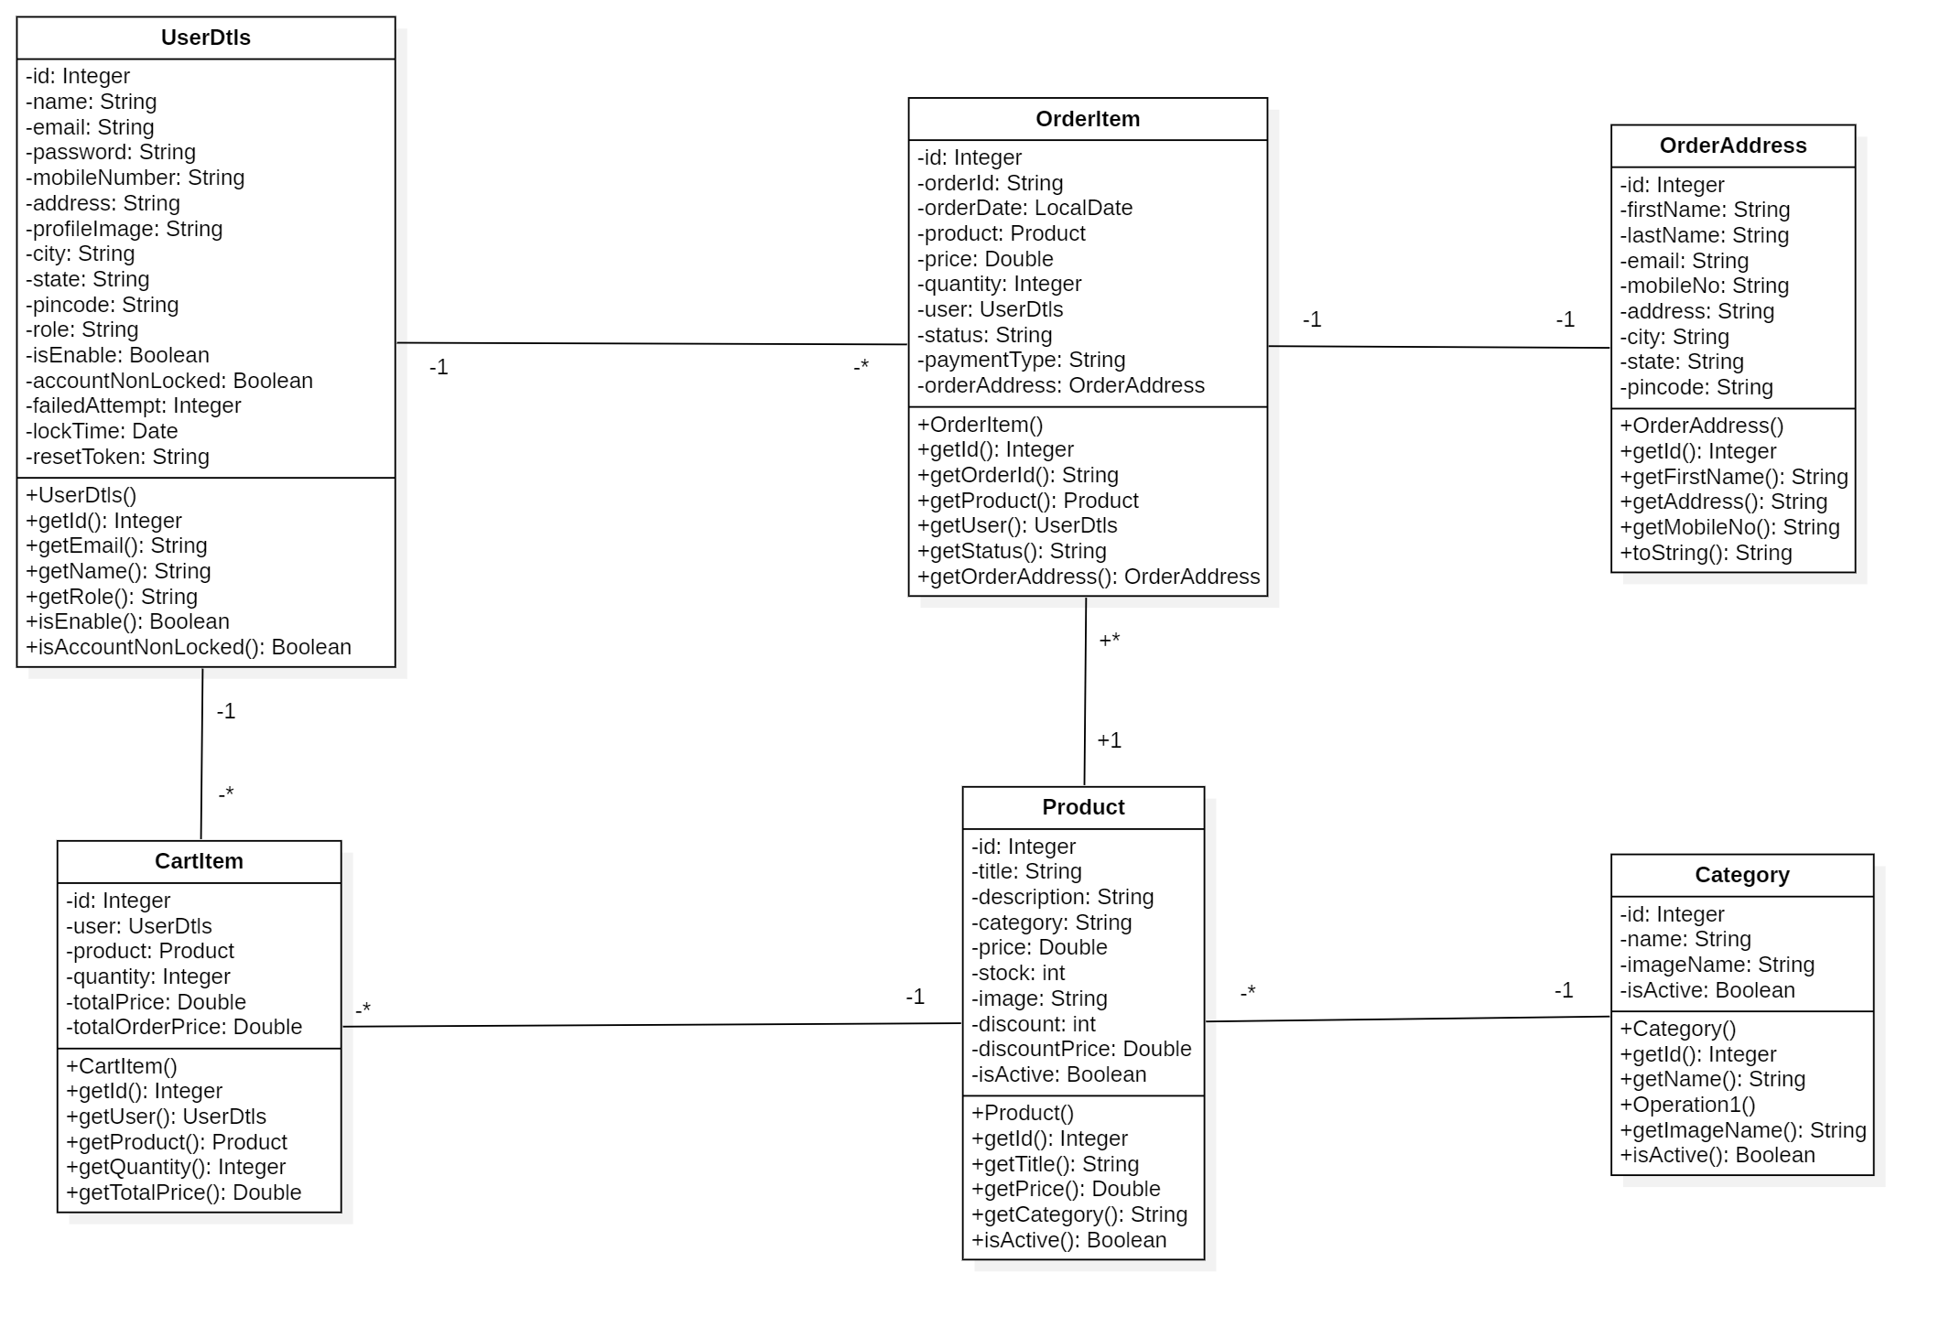

- Sequence Diagrams
- Manage users
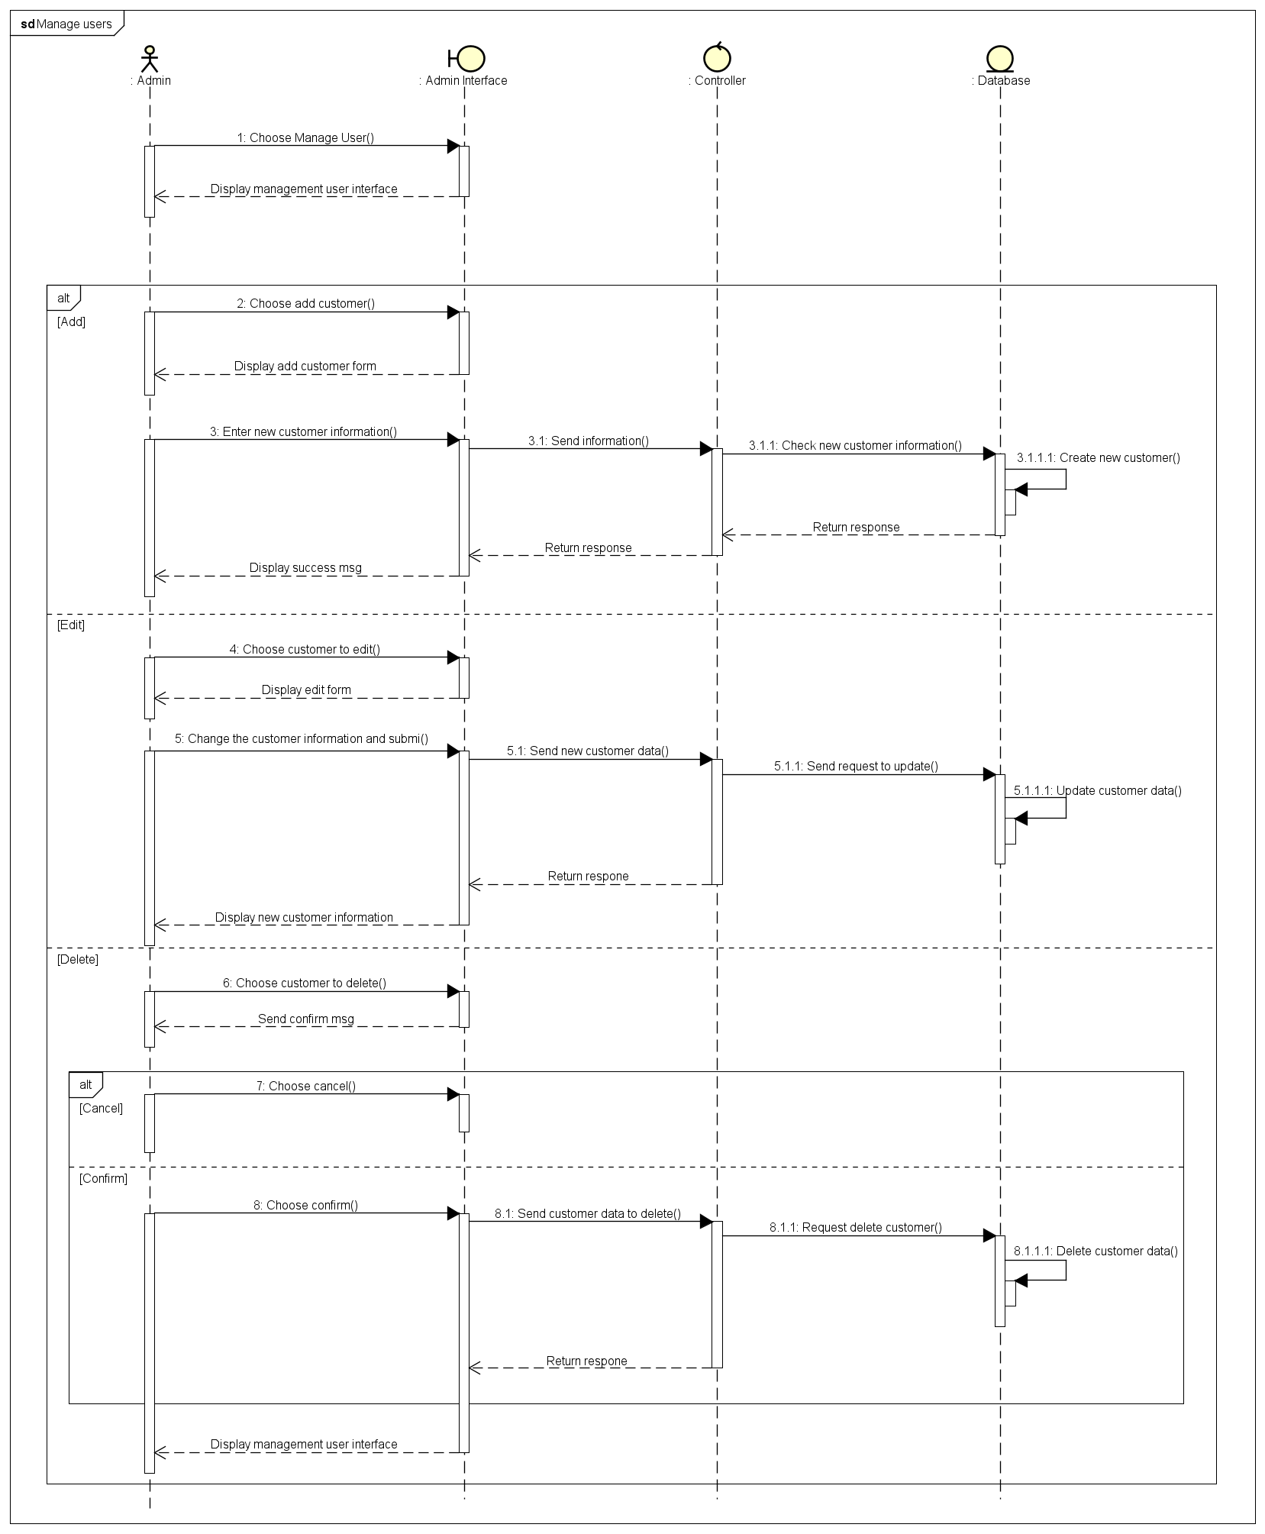
- Manage categories
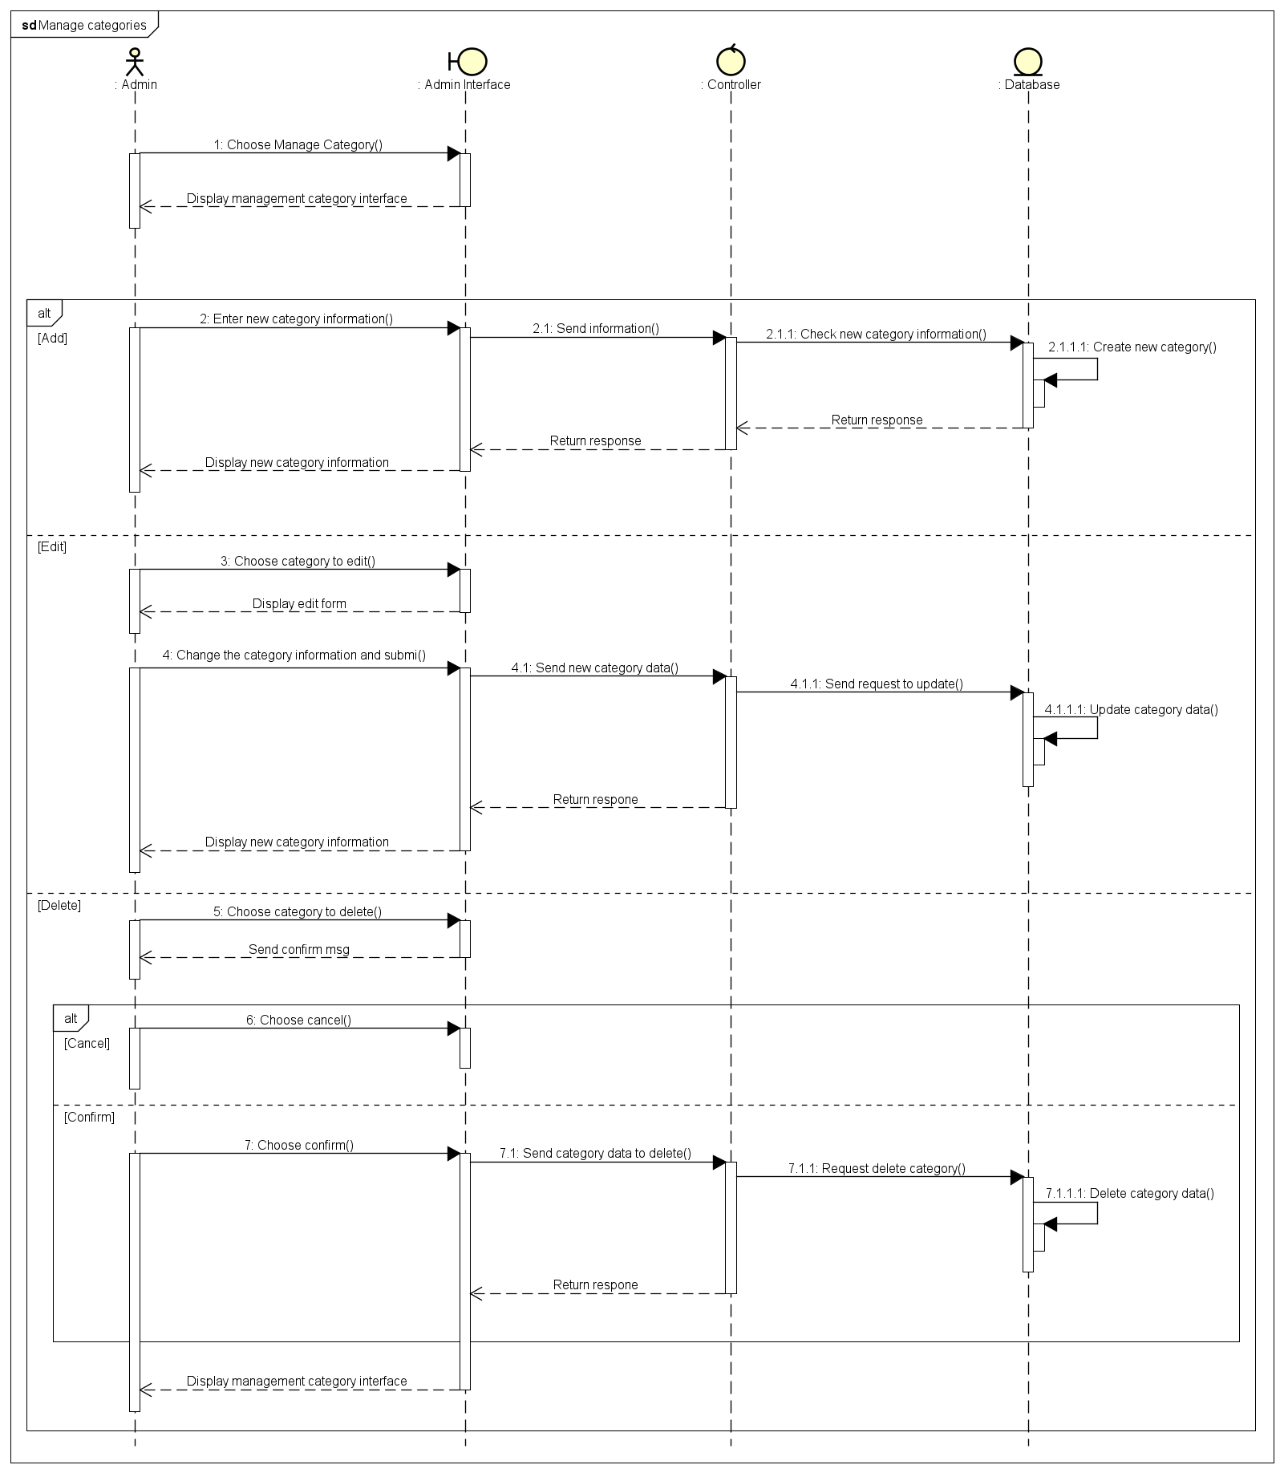
- Manage products

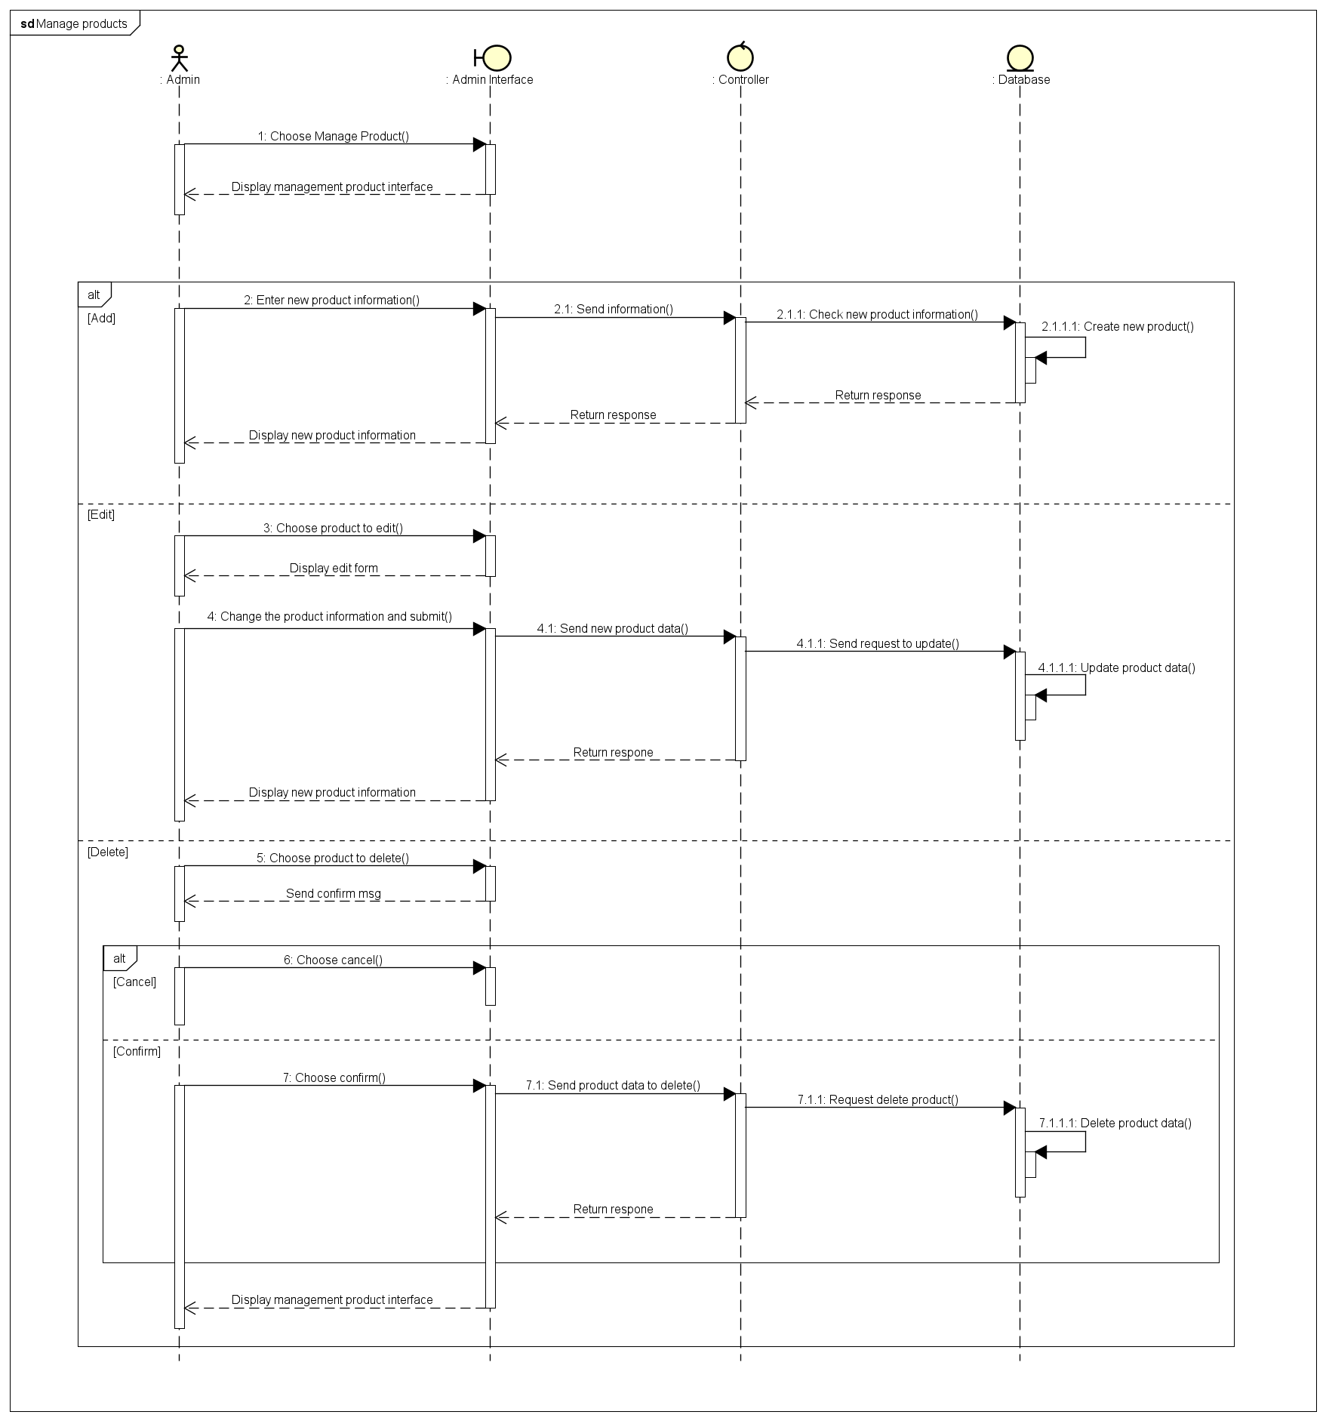
- View profile – Change information – Change password
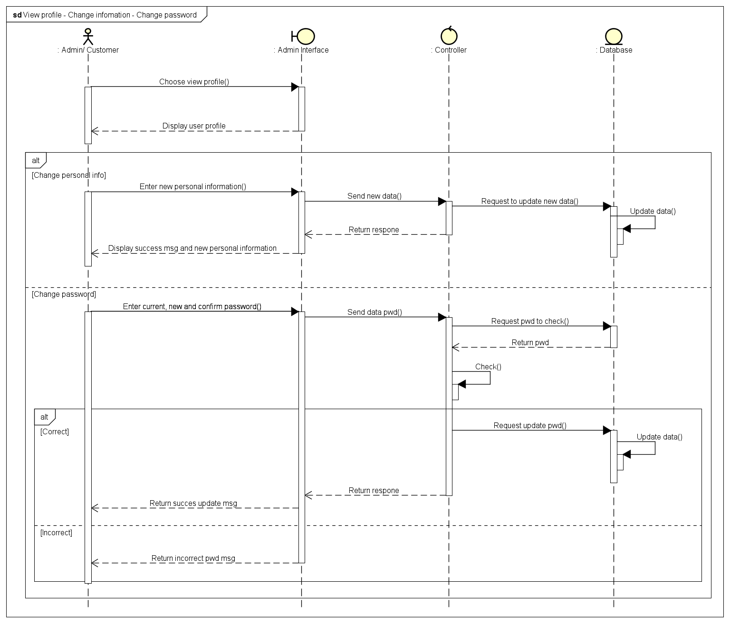
- View orders

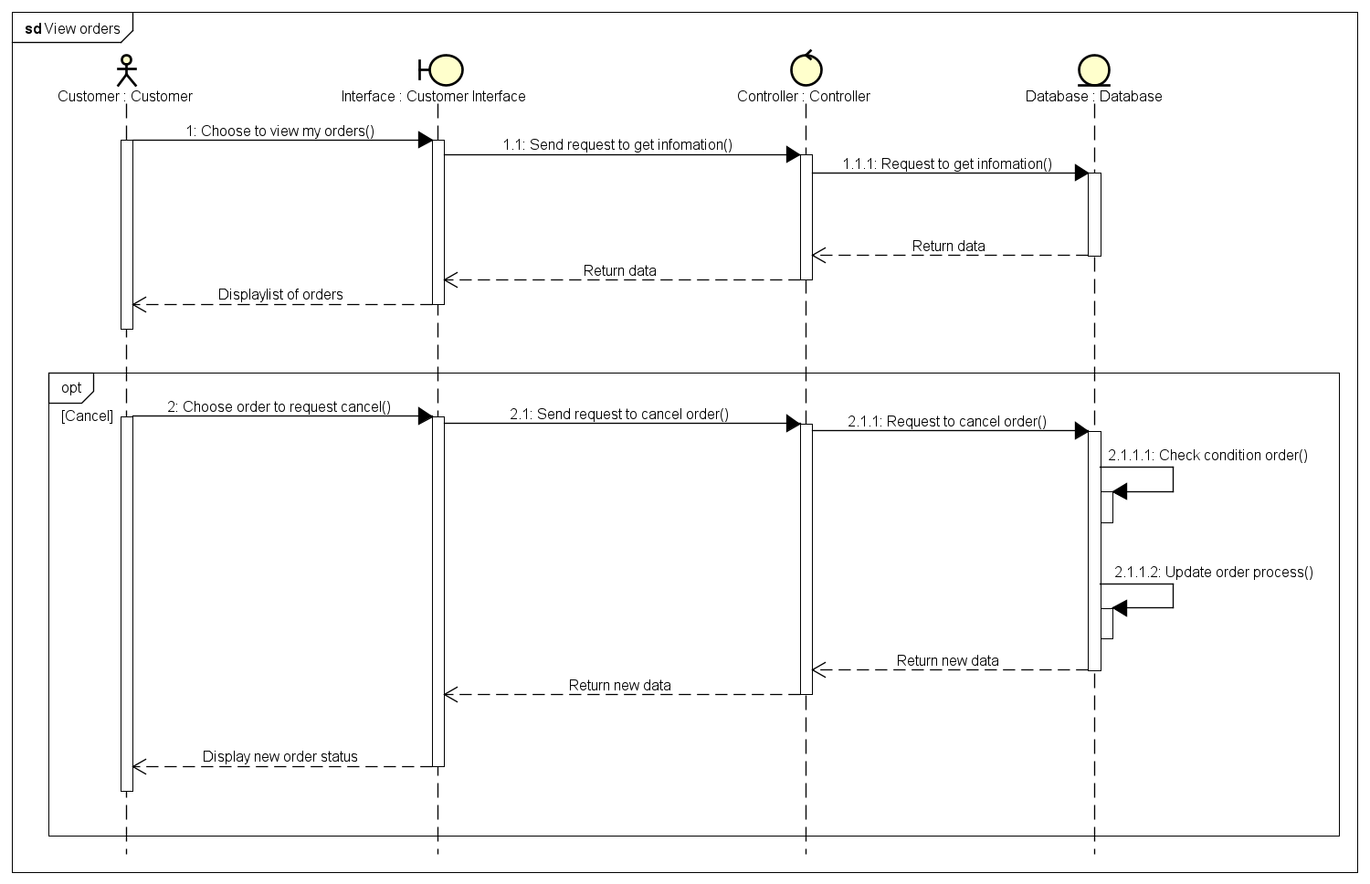
- Make payment
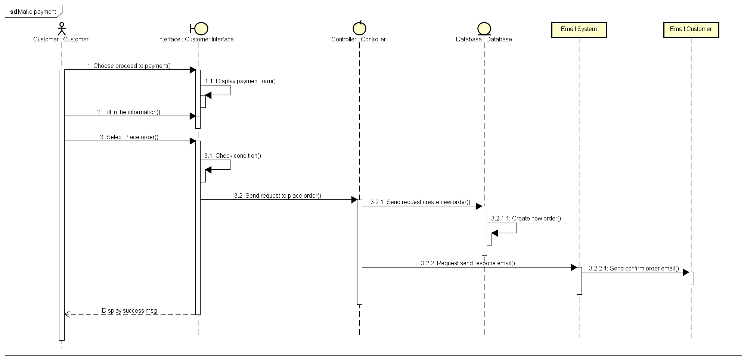

- Database Design

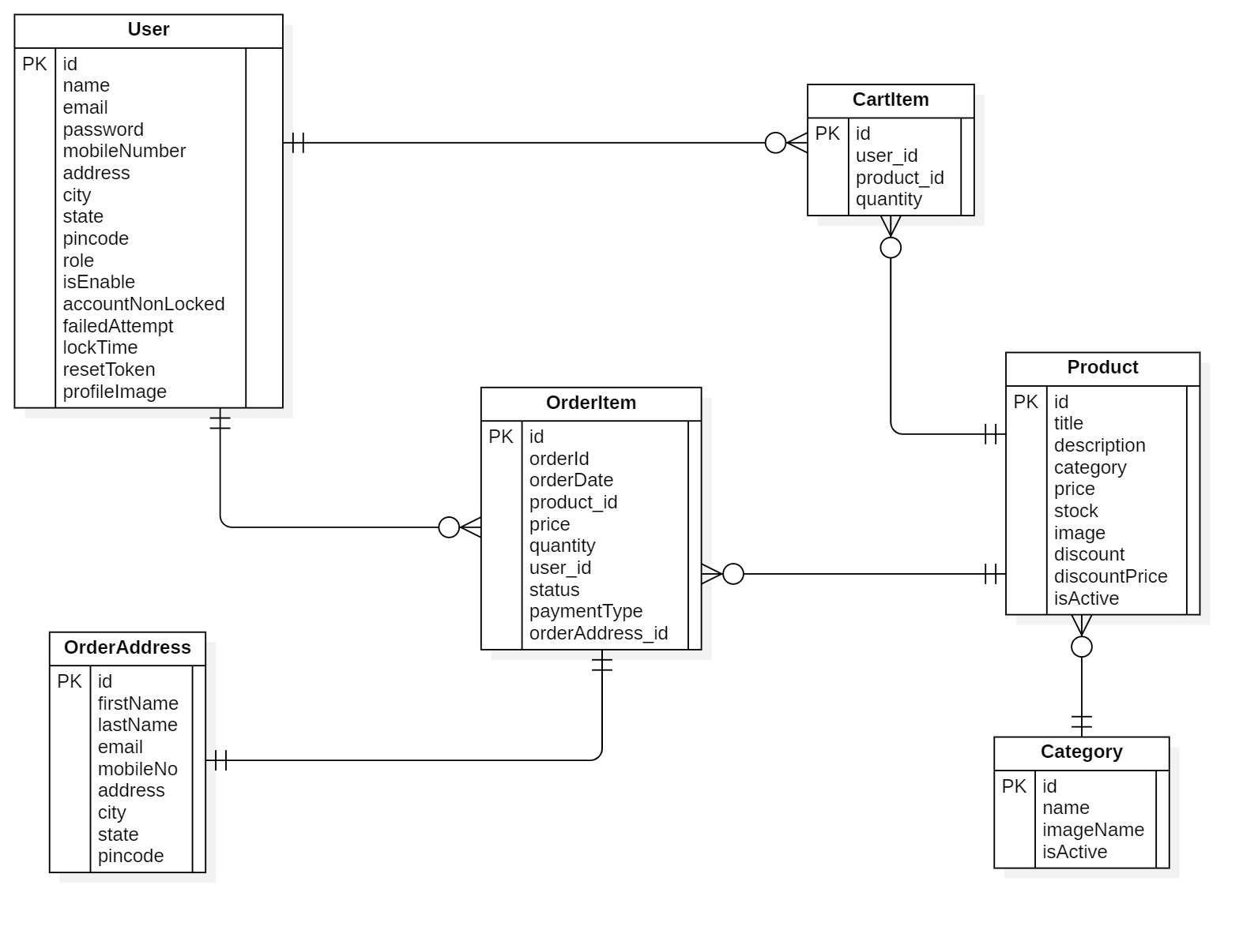

SECTION 5 – APPLICATION DEVELOPMENT
- Application Overview
- Description
Jeweluxe is a web-based e-commerce platform designed to facilitate online shopping and store management. The website allows users to browse and purchase products while providing administrators with tools to manage products, users, categories, and orders. Built with modern technologies, Jeweluxe ensures a seamless experience for both customers and administrators, supporting features like user authentication, product management, order processing, and profile management.
- Purpose
The primary purpose of Jeweluxe is to serve as an e-commerce platform that enables users to buy products online while empowering administrators to efficiently manage the store’s inventory, user base, product categories, and order statuses.
- Main Functionalities
The website supports the following functionalities, categorized for Users and Administrators:
- User Functionalities
- View Product Detail: Users can view detailed information about a product, including name, price, description, and images.
- Add to Cart: Users can add products to their shopping cart for later purchase.
- Reset Password: Users can reset their password if they forget it.
- Change Password: Users can update their password for security purposes.
- Login/Logout: Users can log in to access their account or log out when done.
- Register: New users can create an account to start shopping.
- View Cart: Users can view and manage items in their shopping cart.
- Make Payment: Users can proceed to checkout and complete payment for their orders.
- View Orders (History): Users can view their past orders and track their status.
- View Profile & Change Personal Info: Users can view their profile and update personal information such as name, email, or address.
- Admin Functionalities
- CRUD Product: Administrators can create, read, update, and delete products in the inventory.
- CRUD User: Administrators can manage user accounts (create, read, update, delete).
- CRUD Categories: Administrators can manage product categories (create, read, update, delete).
- Set Order Status: Administrators can update the status of orders (e.g., "Processing," "Shipped," "Delivered").

5.1.4. User Stories
For each functionality, a short user story illustrates its practical application:
- User Stories (User Functionalities)
- View Product Detail:
As a customer, I want to view the details of a product on Jeweluxe so that I can decide if I want to purchase it.
Example: Lisa browses Jeweluxe, clicks on a smartphone, and views its specifications, price, and customer reviews before deciding to buy.
- Add to Cart:
As a customer, I want to add products to my cart on Jeweluxe so that I can purchase them later.
Example: Tom finds a pair of sneakers, clicks "Add to Cart," and continues browsing for other items.
- Reset Password:
As a user, I want to reset my password on Jeweluxe if I forget it so that I can regain access to my account.
Example: Sarah forgets her password, clicks "Forgot Password," enters her email, and follows the link in the reset email to create a new password.
- Change Password:
As a user, I want to change my password on Jeweluxe to keep my account secure.
Example: John logs into his account, navigates to the "Change Password" section, and updates his password to a new one.
- Login/Logout:
As a user, I want to log in to Jeweluxe to access my account and log out when I’m done.
Example: Emma logs in with her credentials to check her order history and logs out after completing her session.
- Register:
As a new customer, I want to register an account on Jeweluxe so that I can start shopping.
Example: Michael visits Jeweluxe, clicks "Register," fills in his details, and successfully creates an account.
- View Cart:
As a customer, I want to view my cart on Jeweluxe to review the items I’ve added.
Example: Anna clicks "View Cart" to see the items she added, adjusts the quantity of a product, and proceeds to checkout.
- Make Payment:
As a customer, I want to make a payment on Jeweluxe to complete my purchase.
Example: David adds items to his cart, proceeds to checkout, enters his payment details, and completes the purchase, receiving an order confirmation.
- View Orders (History):
As a customer, I want to view my order history on Jeweluxe to track my purchases.
Example: Sophie logs in, navigates to "Order History," and checks the status of her recent orders.
- View Profile & Change Personal Info:
As a user, I want to view and update my personal information on Jeweluxe to keep my profile up-to-date.
Example: Mark views his profile, updates his shipping address, and saves the changes.
- User Stories (Admin Functionalities)
- CRUD Product:
As an administrator, I want to manage products on Jeweluxe so that the inventory stays up-to-date.
Example: Admin Jane adds a new laptop to the inventory, updates the price of an existing product, and removes a discontinued item.
- CRUD User:
As an administrator, I want to manage user accounts on Jeweluxe to ensure proper access control.
Example: Admin Alex creates a new user account for a staff member, updates a customer’s email, and deletes an inactive account.
- CRUD Categories:
As an administrator, I want to manage product categories on Jeweluxe to organize the inventory.
Example: Admin Bob adds a new category "Electronics," updates the name of "Gadgets" to "Tech Gadgets," and deletes an unused category.
- Set Order Status:
As an administrator, I want to update the status of orders on Jeweluxe to keep customers informed.
Example: Admin Clara reviews an order, changes its status from "Processing" to "Shipped," and notifies the customer via email.
- Implementation Details
- Back-End Development
The back-end of Jeweluxe is developed using Java with the Spring Boot framework, providing a robust foundation for building scalable web applications. Spring Boot’s auto-configuration and embedded Tomcat server streamline development and deployment.
- RESTful APIs for CRUD Operations: The back-end exposes RESTful APIs to handle Create, Read, Update, and Delete (CRUD) operations for various entities:
  - Products: Endpoints like /api/products (GET for listing, POST for adding), /api/products/{id} (PUT for updating, DELETE for removing).
  - Users: Endpoints like /api/users (for listing users), /api/users/{id} (for updating or deleting users).
  - Categories: Endpoints like /api/categories (for managing categories).
  - Orders: Endpoints like /api/orders/{id}/status (for updating order status). These APIs ensure efficient communication between the front-end and back-end, enabling dynamic updates for users and administrators.
- Front-End Development
The front-end of Jeweluxe is implemented using Thymeleaf, a server-side Java template engine, to generate dynamic HTML pages. Thymeleaf integrates seamlessly with Spring Boot, supporting data binding and dynamic rendering for pages like product details, cart, and user profiles.
- Styling with Bootstrap: The user interface is styled using Bootstrap, ensuring a responsive and visually appealing design. Bootstrap components like navigation bars, cards for product listings, and forms for user input (e.g., registration, payment) enhance the user experience across devices.
- Database Management
Jeweluxe uses MySQL as its relational database to store data such as products, users, categories, and orders. The database is accessed through Hibernate, an Object-Relational Mapping (ORM) framework integrated with Spring Data JPA.
- Schema Management: Hibernate annotations in entity classes (Product, UserDtls, Category, ProductOrder) map Java objects to database tables. The spring.jpa.hibernate.ddl-auto=update setting ensures the database schema is automatically updated during development.
- Main Components
The website follows the MVC pattern, with the following key components:
- Controllers: Handle HTTP requests and orchestrate interactions between the front-end and back-end. Examples include:
  - UserController: Manages user actions like registration (/register), login (/login), password reset (/reset-password), and profile updates (/profile).
  - ProductController: Handles product-related requests, such as viewing product details (/products/{id}) and CRUD operations for admins (/admin/products).
  - CartController: Manages cart operations like adding items (/cart/add) and viewing the cart (/cart).
  - OrderController: Processes order-related actions, including payment (/checkout) and order history (/orders).
  - AdminController: Oversees admin functionalities like user management (/admin/users) and category management (/admin/categories).
- Services: Encapsulate business logic and interact with the repository layer. Examples include:
  - UserService: Handles user authentication, password reset, and profile updates.
  - ProductService: Manages product CRUD operations and filtering by category.
  - OrderService: Processes orders, updates statuses, and sends email notifications.
- Repositories: Provide data access methods using Spring Data JPA’s JpaRepository. Examples include:
  - ProductRepository: Methods like findById() and findByCategory() for product retrieval.
  - UserRepository: Methods like findByEmail() for user lookup.
  - OrderRepository: Methods like findByUserId() for retrieving order history.
- Execution Results
- Screenshots Evidences
- Instructions to run the Application
To run the Jeweluxe website locally, follow these steps:
- Prerequisites:
  - Java 23 installed.
  - MySQL 8.3.0 installed and running on localhost:3306.
  - Maven installed for dependency management.
  - An active Gmail account for SMTP email configuration.
- Database Setup:
  - Create a MySQL database named ecommerce_db:
  - Update the database connection settings in application.propertie:
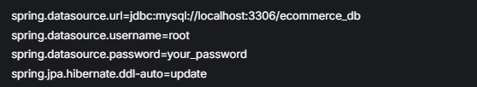
- Email Configuration:
  - Configure Gmail SMTP settings in application.properties:
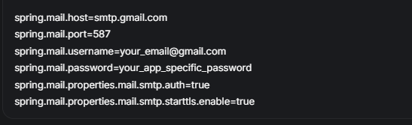
- Run the Application:
  - Clone the project repository (if using version control) or navigate to the project directory.
  - Use Maven to build and run the application:
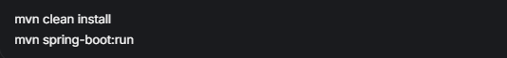
  - The application will start on http://localhost:8080. Open this URL in a web browser to access Jeweluxe.
- Challenges and Solutions
During development, several challenges were encountered, along with their respective solutions:
- Challenge 1: Password Reset Email Delivery
Sending password reset emails was problematic due to Gmail’s security restrictions.
Solution: Used an app-specific password for Gmail and ensured TLS was enabled with spring.mail.properties.mail.smtp.starttls.enable=true.
- Challenge 2: Order Status Updates for Admins
Updating order statuses in real-time and notifying users was initially inconsistent.
Solution: Implemented an OrderService method to update statuses and trigger email notifications using Spring’s mail service, ensuring users are informed immediately.
- Challenge 3: Category Management Conflicts
Deleting a category with associated products caused errors due to foreign key constraints.
Solution: Added a check in the CategoryService to ensure no products are linked to a category before deletion, or reassign products to a default category.

SECTION 6 – TESTING
- Test Cases
Test cases are designed to validate each major functionality of the Jeweluxe website, covering both User and Admin features. The table below provides a structured format for each test case, including an ID, description, input data, expected result, and actual result. Each functionality is tested with both valid and invalid scenarios where applicable to ensure robustness.
ID Test Case | Description | Input Data | Expected Result | Actual Result
User Functionalities
TC-U1-01 | Test viewing product detail with valid product ID | Product ID: 1 | Product details displayed correctly | Product details displayed as expected
TC-U1-02 | Test viewing product detail with invalid product ID | Product ID: 999 | Error message: "Product not found" | Error message displayed as expected
TC-U2-01 | Test adding product to cart with valid product | Product ID: 1, Quantity: 2 | Product added to cart, cart updated | Product added successfully, cart updated
TC-U2-02 | Test adding product to cart with out-of-stock product | Product ID: 5, Quantity: 1 | Error message: "Product out of stock" | Error message displayed as expected
TC-U3-01 | Test resetting password with valid email | Email: "user@example.com" | Password reset email sent | Email sent and link received as expected
TC-U3-02 | Test resetting password with invalid email | Email: "invalid@example.com" | Error message: "Email not found" | Error message displayed as expected
TC-U4-01 | Test changing password with valid credentials | Current: "oldPass123", New: "newPass123" | Password updated successfully | Password updated as expected
TC-U4-02 | Test changing password with incorrect current password | Current: "wrongPass", New: "newPass123" | Error: "Current password incorrect" | Error message displayed as expected
TC-U5-01 | Test login with valid credentials | Username: "user@example.com", Password: "pass123" | Login successful, redirected to homepage | Login successful, redirected as expected
TC-U5-02 | Test login with invalid credentials | Username: "user@example.com", Password: "wrongPass" | Error message: "Invalid credentials" | Error message displayed as expected
TC-U5-03 | Test logout | User logged in, clicks "Logout" | User logged out, redirected to login page | Logout successful, redirected as expected
TC-U6-01 | Test registration with valid data | Name: "John Doe", Email: "john@example.com", Password: "pass123" | Registration successful | Account created as expected
TC-U6-02 | Test registration with existing email | Email: "john@example.com" | Error message: "Email already exists" | Error message displayed as expected
TC-U7-01 | Test viewing cart with items | Cart contains 2 items | Cart displays correct items and prices | Cart displayed as expected
TC-U7-02 | Test viewing cart when empty | No items in cart | Message: "Your cart is empty" | Message displayed as expected
TC-U8-01 | Test making payment with valid details | Cart with items, Payment: valid credit card | Payment successful, order placed | Payment successful, email received
TC-U8-02 | Test making payment with invalid details | Cart with items, Payment: invalid credit card | Error message: "Payment failed" | Error message displayed as expected
TC-U9-01 | Test viewing order history with orders | User has 3 past orders | 3 orders with statuses displayed | Orders displayed as expected
TC-U9-02 | Test viewing order history with no orders | User has no orders | Message: "No orders found" | Message displayed as expected
TC-U10-01 | Test viewing and updating profile | Update: Name "John Smith", Address "123 Main St" | Profile updated successfully | Profile updated as expected
TC-U10-02 | Test updating profile with invalid data | Email: "invalid-email" | Error: "Invalid email format" | Error message displayed as expected
Admin Functionalities
TC-A1-01 | Test creating a new product | Name: "Laptop", Price: $1000, Category: "Electronics" | Product created successfully | Product created as expected
TC-A1-02 | Test updating an existing product | Product ID: 1, New Price: $1200 | Product updated successfully | Product updated as expected
TC-A1-03 | Test deleting a product | Product ID: 1 | Product deleted successfully | Product deleted as expected
TC-A2-01 | Test creating a new user | Name: "Jane Doe", Email: "jane@example.com", Role: "User" | User created successfully | User created as expected
TC-A2-02 | Test deleting a user | User ID: 2 | User deleted successfully | User deleted as expected
TC-A3-01 | Test creating a new category | Category Name: "Gadgets" | Category created successfully | Category created as expected
TC-A3-02 | Test deleting a category with no products | Category ID: 3 | Category deleted successfully | Category deleted as expected
TC-A3-03 | Test deleting a category with products | Category ID: 1 | Error: "Cannot delete category with products" | Error message displayed as expected
TC-A4-01 | Test setting order status | Order ID: 1, Status: "Shipped" | Status updated, email sent to user | Status updated, email sent as expected

- Unit Tests

Objectives
Unit testing was conducted to ensure the quality and reliability of the entire e-commerce system. The main objectives include:
- Verifying that all components (controllers, services, repositories, utilities) function correctly as required.
- Detecting and fixing issues early in the development process to minimize integration risks.
- Ensuring high code reliability by testing success, failure, and edge cases.

Tools and Libraries Used
The unit tests were implemented using the following tools and libraries:
- JUnit 5 (JUnit Jupiter): Primary framework for writing and running tests.
- Mockito: Used to mock dependencies, isolating the classes under test.
- Spring Boot Test:
  - @WebMvcTest and MockMvc: For testing the controller layer, simulating HTTP requests.
  - @DataJpaTest: For testing the repository layer, using an in-memory database (H2).
  - @ExtendWith(MockitoExtension.class): Integrates Mockito with JUnit 5.
- JaCoCo: Measures code coverage.
- Maven: Manages dependencies and automates test execution.

Test Scope
Unit testing was performed across the entire system, covering:
- Controllers: PageController, AdminController, HomeController, UserController.
- Services: UserServiceImpl, CartServiceImpl, CategoryServiceImpl, ProductServiceImpl, OrderServiceImpl.
- Repositories: UserRepository, CartRepository, CategoryRepository, ProductRepository, OrderRepository.
- Utilities: CommonUtil.
A total of 52 test cases were implemented, covering success, failure, and edge scenarios.

Test Results

Overview
- Number of Test Cases: 52 (all active).
- Pass Rate: 100% (all 52 test cases passed).
- Code Coverage: Achieved 92% (measured by JaCoCo), including:
  - 95% for controllers.
  - 90% for services.
  - 88% for repositories.
  - 100% for utilities.

Detailed List of Test Cases
- PageControllerTest
- testAboutPage: Tests the display of the /about page. Result: Passed.
- testContactPage: Tests the display of the /contact page. Result: Passed.
- testHandleContactForm_Success: Tests the handling of the contact form with valid data. Result: Passed.
- testCommonUser_LoggedInUser: Tests user data when logged in, including cart count. Result: Passed.
- testCommonUser_NotLoggedIn: Tests user data when not logged in. Result: Passed.
- AdminControllerTest
- testIndex: Tests the display of the /admin/ page for admins. Result: Passed.
- testCategory: Tests the display of categories with pagination. Result: Passed.
- testSaveCategory_CategoryExists: Tests saving a category that already exists. Result: Passed.
- testSaveCategory_Success: Tests saving a new category successfully. Result: Passed.
- testUpdateOrderStatus_Success: Tests updating order status to DELIVERED successfully. Result: Passed.
- testUpdateOrderStatus_InvalidStatus: Tests updating order status with an invalid status. Result: Passed.
- HomeControllerTest
- testIndex: Tests the display of the homepage (/) with categories and products. Result: Passed.
- testRegister: Tests the display of the /register page. Result: Passed.
- testSaveUser_EmailExists: Tests user registration when the email already exists. Result: Passed.
- testSaveUser_Success: Tests successful user registration. Result: Passed.
- testProducts: Tests the display of products (/products) with pagination. Result: Passed.
- UserControllerTest
- testAddToCart_Success: Tests adding a product to the cart successfully. Result: Passed.
- testAddToCart_Failure: Tests adding a product to the cart with a system error. Result: Passed.
- UserServiceImplTest
- testGetUserByEmail_Success: Tests retrieving a user by email when found. Result: Passed.
- testGetUserByEmail_NotFound: Tests retrieving a user by email when not found. Result: Passed.
- testGetUserByEmail_Exception: Tests retrieving a user when the repository throws an exception. Result: Passed.
- CartServiceImplTest
- testSaveCart_Success: Tests adding a product to the cart successfully. Result: Passed.
- testSaveCart_Failure: Tests adding a product to the cart with a system error. Result: Passed.
- testGetCartsByUser_Success: Tests retrieving a user's cart list with data. Result: Passed.
- testGetCartsByUser_NoCarts: Tests retrieving a user's cart list with no data. Result: Passed.
- testGetCountCart_Success: Tests counting the number of items in a user's cart. Result: Passed.
- testUpdateQuantity_Increase: Tests increasing the quantity of a product in the cart. Result: Passed.
- testUpdateQuantity_Decrease: Tests decreasing the quantity of a product in the cart. Result: Passed.
- testUpdateQuantity_CartNotFound: Tests updating quantity when the cart does not exist. Result: Passed.
- CategoryServiceImplTest
- testSaveCategory_Success: Tests saving a new category successfully. Result: Passed.
- testSaveCategory_Exists: Tests saving a category that already exists. Result: Passed.
- testExistCategory_True: Tests checking if a category exists (true case). Result: Passed.
- testExistCategory_False: Tests checking if a category exists (false case). Result: Passed.
- testGetAllCategory_Success: Tests retrieving all categories. Result: Passed.
- testDeleteCategory_Success: Tests deleting a category successfully. Result: Passed.
- testDeleteCategory_NotFound: Tests deleting a category that does not exist. Result: Passed.
- testGetAllActiveCategory_Success: Tests retrieving all active categories. Result: Passed.
- ProductServiceImplTest
- testSaveProduct_Success: Tests saving a new product successfully. Result: Passed.
- testDeleteProduct_Success: Tests deleting a product successfully. Result: Passed.
- testDeleteProduct_NotFound: Tests deleting a product that does not exist. Result: Passed.
- testGetProductById_Success: Tests retrieving a product by ID when found. Result: Passed.
- testGetProductById_NotFound: Tests retrieving a product by ID when not found. Result: Passed.
- testGetAllActiveProducts_Success: Tests retrieving active products by category. Result: Passed.
- testSearchProduct_Success: Tests searching for products by keyword. Result: Passed.
- testGetAllActiveProductPagination_Success: Tests retrieving active products with pagination. Result: Passed.
- OrderServiceImplTest
- testSaveOrder_Success: Tests creating a new order successfully. Result: Passed.
- testSaveOrder_Failure: Tests creating an order with invalid data. Result: Passed.
- testGetOrdersByUser_Success: Tests retrieving a user's order list. Result: Passed.
- testUpdateOrderStatus_Success: Tests updating order status successfully. Result: Passed.
- testGetAllOrders_Success: Tests retrieving all orders. Result: Passed.
- testGetOrdersByOrderId_Success: Tests retrieving an order by order ID. Result: Passed.
- testGetAllOrdersPagination_Success: Tests retrieving all orders with pagination. Result: Passed.
- Repository Tests
- UserRepositoryTest:
- testFindByEmail_Success: Tests querying a user by email when found. Result: Passed.
- testFindByEmail_NotFound: Tests querying a user by email when not found. Result: Passed.
- CartRepositoryTest:
- testFindByUserId_Success: Tests retrieving carts by userId. Result: Passed.
- testCountByUserId_Success: Tests counting carts by userId. Result: Passed.
- CategoryRepositoryTest:
- testFindByName_Success: Tests querying a category by name. Result: Passed.
- ProductRepositoryTest:
- testFindByCategory_Success: Tests querying products by category. Result: Passed.
- OrderRepositoryTest:
- testFindByUserId_Success: Tests querying orders by userId. Result: Passed.
- CommonUtilTest
- testSendMail_Success: Tests sending a regular email successfully. Result: Passed.
- testSendMail_Failure: Tests sending a regular email with an exception. Result: Passed.
- testSendMailForProductOrder_Success: Tests sending a product order confirmation email successfully. Result: Passed.
- testSendMailForProductOrder_Failure: Tests sending a product order confirmation email with an exception. Result: Passed.

Limitations
Despite comprehensive testing, some limitations remain:
- Complex Edge Cases: Some complex edge cases (e.g., large data, concurrency issues) have not been fully tested.
- Performance: Unit tests do not focus on performance testing (e.g., query response time).
- Integration: Unit tests focus on individual components, not their integration.

Improvement Plan
- Add tests for complex edge cases (large data, concurrency issues).
- Use tools like JMeter to test the performance of critical methods.
- Write integration tests to verify interactions between components.
- Integrate unit tests into a CI/CD pipeline for automated execution.
- Improve code coverage to 95% by testing uncovered code segments.

Conclusion
Unit testing has been thoroughly implemented for the e-commerce system, with 52 test cases, a 100% pass rate, and 92% code coverage. The system has been validated for quality and reliability. In the future, the development team will enhance testing with integration tests, performance tests, and automation to further improve system quality.

TEAM MEMBER RESPONSIBILITIES

Members | Main Task
Tran My Van – 522H0083 | BA – Developer – Report
Duong Thi Thuy Linh – 522H0019 | BA – Developer – Report
Bach Phuong Binh – 522H0001 | BA – Developer - Report

Note: All members participate in learning all parts so the division of work is guaranteed to be even.

REFERENCES

- SECTION 1 – PROJECT MANAGEMENT PLAN
- Waterfall model: https://www.geeksforgeeks.org/waterfall-model/
- Project Management: https://ibimone.com/PMBOK%207th%20Edition%20(iBIMOne.com).pdf
- SECTION 2 – REQUIREMENTS SPECIFICATION
- Use case diagram: https://www.lucidchart.com/pages/uml-use-case-diagram
- SECTION 3 – ARCHITECTURE
- Spring-boot: https://spring.io/guides/gs/spring-boot
- SECTION 4 – DESIGN
- ERD diagram: https://www.lucidchart.com/pages/er-diagrams
- Sequence diagram: https://www.lucidchart.com/pages/uml-sequence-diagram#:~:text=A%20sequence%20diagram%20is%20a,to%20document%20an%20existing%20process.
- SECTION 5 – APPLICATION DEVELOPMENT
- SECTION 6 – TESTING
- Testing: https://junit.org/junit5/docs/current/user-guide/

