# ~~Load Level Script~~

~~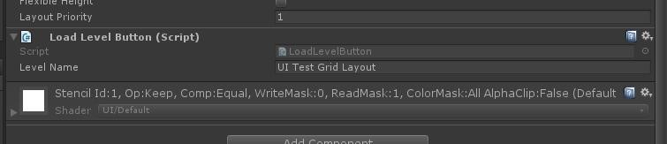~~

~~Every button in the UI has a script attached named~~ **~~LoadLevelButton~~**~~, this script is used to slowly fade the scene using the screen fader.~~

~~In the script there is a field in inspector where you can enter the name of the level (case sensitive) that you want to load when the button is clicked.~~

# ~~Load Level UI Normal Layout~~

~~The normal Ui Layout can be found in the scene~~ **~~UI Test~~**~~, this UI is using normal layout and you can freely move the buttons around to position it where you want.~~

# ~~Screen Fader~~

~~The load of levels is working throught another Object called~~ **~~Screen Fader~~**~~, you can find a prefab in the~~ **~~Screen Fader Folder.~~**

~~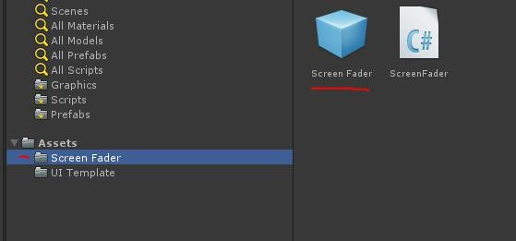~~

~~The screen fader is used to fade the screen to black before loading a new scene to create a smooth transition.~~

~~The screen fader must be in the scene to be able to load new levels from the UIs.~~

~~The screen fader can also be used in other scenes to create smooth transitions, to load a level you can call from any script:~~

~~ScreenFader.Instance.LoadLevel(“level Name”);~~

# Word Puzzle

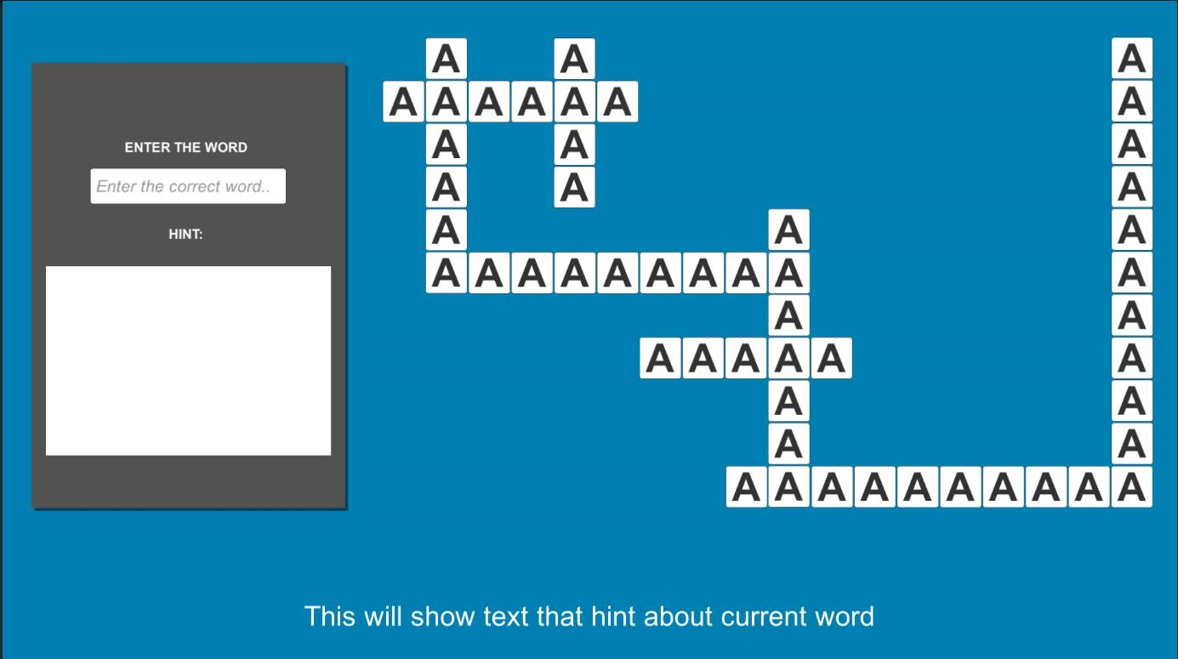

The word puzzle scene can be found in folder **Word Puzzle**.

## Gameplay

The game is a word guessing game.

The user have to guess the correct word by looking at the picture in the left panel and reading the sentence at the bottom.

## Adding new word puzzles

For adding a new puzzle the steps are this:  
  
- Create a new word database from unity create menu  
- The new database will be empty, you have to fill it in with questions, images and words  
- Add the new database to the Puzzle Manager (Word Puzzle script in the scene. is attached to the puzzle manager object)  
  
If you want to change the tiles in the scene, like the length of the words, or adding more words the steps are:  
  
- Duplicate the word puzzle scene (so that you are working on a new scene without destroying the one I've made)  
- Open the new scene   
- You will find all words tiles as child of the UI>Puzzle Panel in the hierarchy  
- To add a new word the easiest way is to simply duplicate any of the current word by selecting a word tile and pressing CTRL+D. (see attached screenshot "word tiles")

- Once the word tile is duplicated you have to position it in the scene where you want  
- Then you have add the new created word in the puzzle manager (see screenshot "word tiles list").

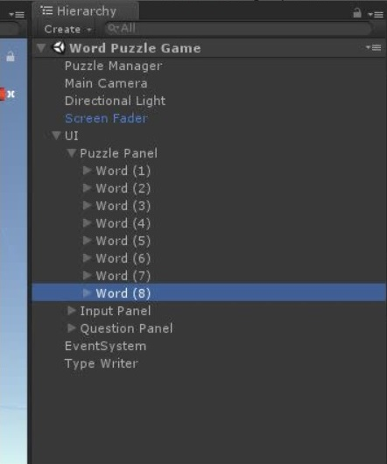

- To add new letters to a word simply duplicate any of the children (Tile (XX)) and position the tile accordingly.

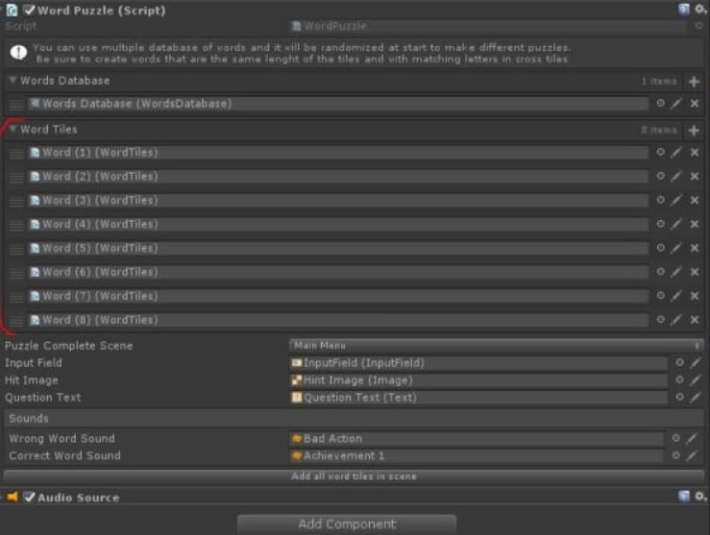

*New puzzles can be easily added by creating a new word database

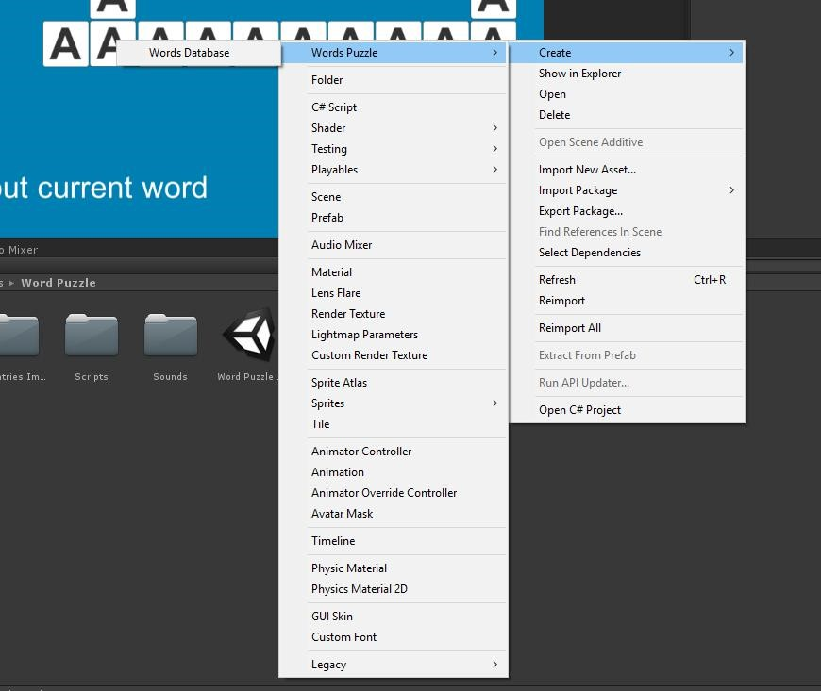

* Enter in the Unity create menu (right click in an empty space in the project browser)
* Select Word Puzzle > Word Database
* Select the newly create word database

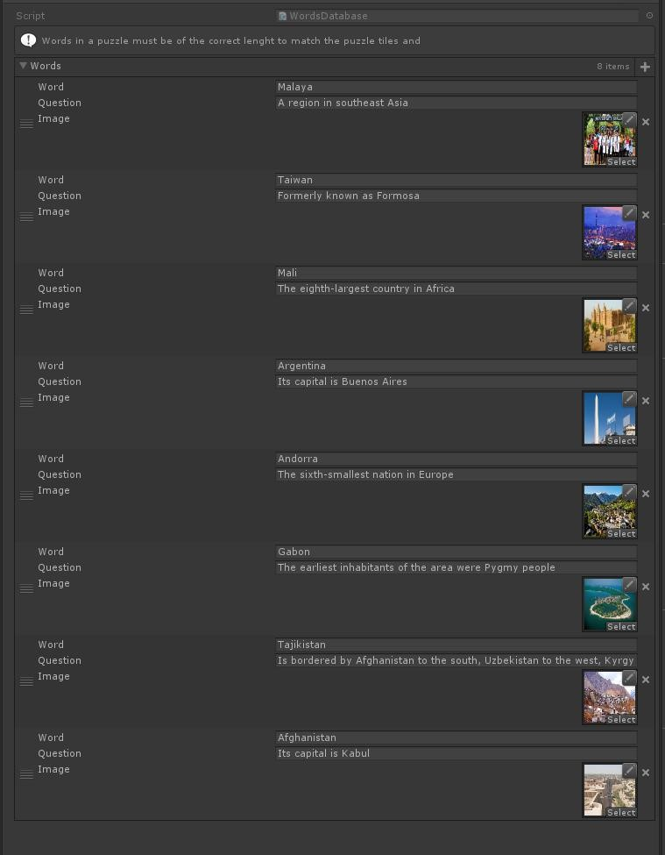

When selecting a wods database you will have a list where you can add a word a questiona and an image for each word in the new puzzle.

**It’s up to the designer to be sure that the words added match the cross tiles in the puzzle!**

Once the new database is completed it must be added to the word puzzle script attached to the **Puzzle Manager.**

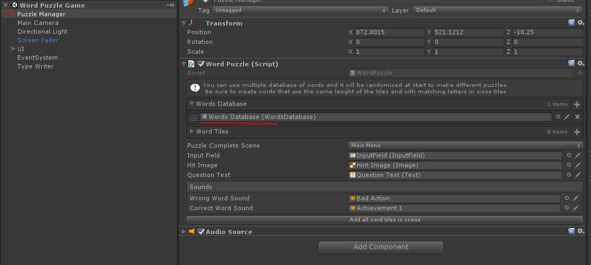

# Scripts Functionality

## ~~Load Level Button~~

~~This class is used to load a scene when clicking a UI button. The new scene is loaded using the screen fader.~~

## Screen Fader

This class is used to load a level using Unity API in the SceneManagement namespace.

It is used to create a smooth transition between scene by fading the screen to black before loading a new scene.

## Blink Image Color UI

This class is used to lerp a UI image component between 2 colors.

The speed and the colors can be set in inspector, in the word puzzle this class is used on Tile groups to blink the color from white to turquoise to show the user the current tile to answer.

## ~~Scene Utility~~

~~This class contains a simple method that return an array with all the scene currently added in the build settings.~~

~~It is used in combination with Odin plugin to draw the level selections in inspector.~~

## ~~Singleton~~

~~This is a base class which any other class can inherit from.~~

~~Inheriting from this class will make the child class a singleton.~~

## Type Writer Sound

This class is used to convert a string to sound to simulate an old type writer.

It is used in the Word puzzle to create the sound when the words are being typed in the tiles.

It contains an array of audio clips and all audio clips must be named in alphabet order.

## Print Letter Sound

This class is subscribed to an event from the Word Tile class and is used to produce the sound when a letter is added to a tile.

## Word Tiles

This class handles a group of tiles used to compose a word in the Word Puzzle.

It’s purpose is to toggle the blink when the tile is selected, it also responsible to type the letters when the correct word is entered by the user.

A Tile group are create by adding all the Text fields in the array in the inspector, it also have a button that can be used to add all current tiles that are child of this script.

## ~~Word Database~~

~~This is a class that inherit from scriptable object~~ [~~https://docs.unity3d.com/ScriptReference/ScriptableObject.html~~](https://docs.unity3d.com/ScriptReference/ScriptableObject.html)

~~This class is used to create a word database asset using the Unity create menu.~~

~~The database ca then be filled with all the required parameters to create a new puzzle.~~

~~The field are:~~

* ~~An image that is shown to the user in the left box~~
* ~~A question that is show to the user in the bottom of the screen~~
* ~~A word that is the word that the user will have to find using the question and image as hints~~

~~Once a database setup is completed it can be added to the~~ **~~Word Puzzle~~** ~~script in inspector to create a new puzzle.~~

## ~~Word Puzzle~~

~~This class act as a manager for the whole game.~~

~~In inspector can be found some parmeters that can be used to tweak the puzzle.~~

* ~~Word Databse field is a field where new database can be added.~~

~~At least one is required, if more then one databse is added the puzzle will be randomized at start.~~

* ~~Word tiles is a list of all the word tiles used for the puzzle.~~

~~Tiles can be added manually or by clicking the button at the bottom to add all tiles in the scene.~~

* ~~Puzzle Completed scene is the scene that will be loaded when the puzzle is complete~~

~~The other fields are reference to component used to show the question, the image and the input field to obtain data from the user.~~

~~Last 2 fields are sound clips that are played when a correct or wrong word is type in the input field.~~

## ~~Odin Inspector Plugin~~

~~This plugin is used to improve unity default inspector drawing, show error message in inspector by using simple property drawers.~~