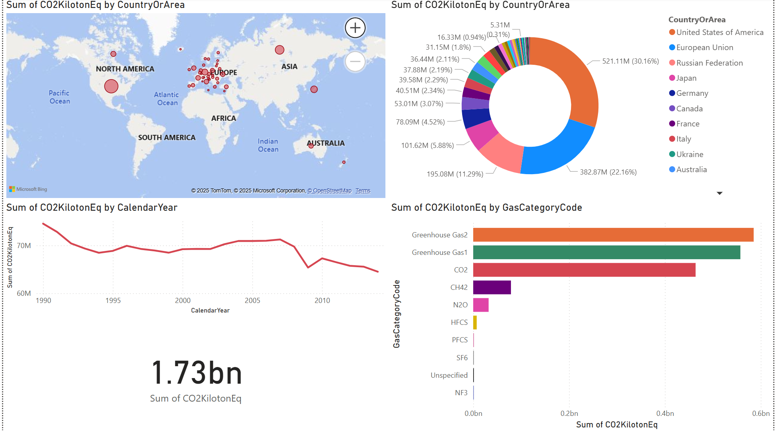
Viewers can see where emissions come from (map, donut chart), how they’ve changed over time (line chart), what gases contribute the most (bar chart), and the total impact (card).

