M O N I C A T U R N E R

P R O D U C T M A N A G E R

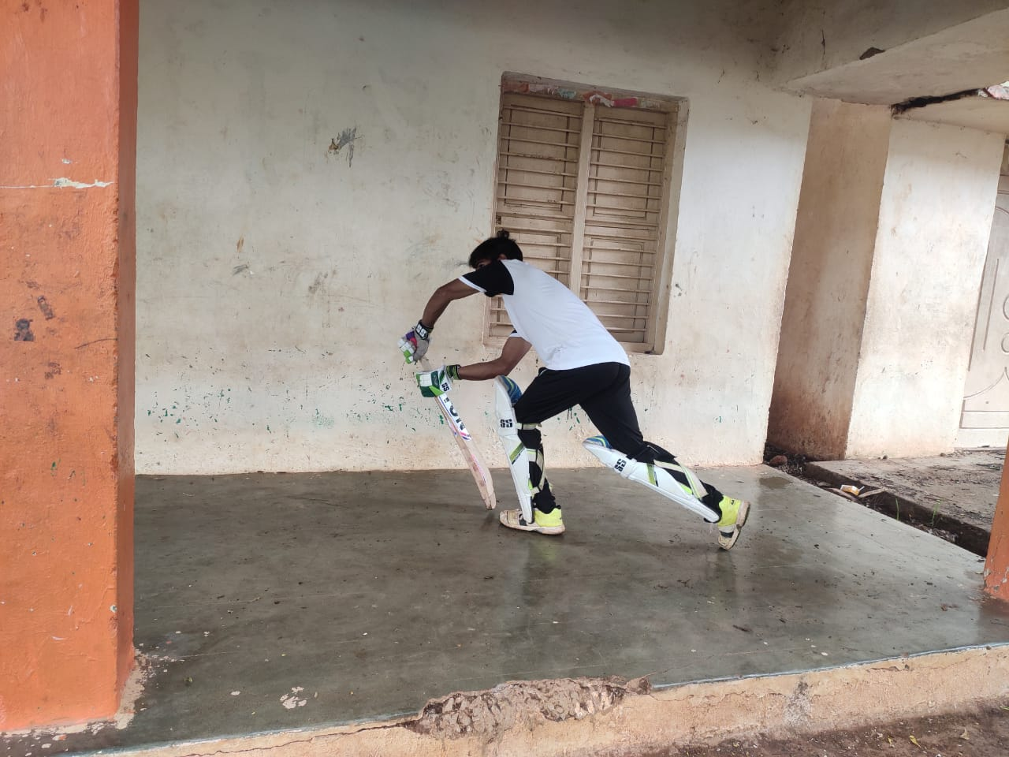

23-585-22,34

Shankar@gmail.com

City,state

|  |
| --- |
| E D U C A T I O N |

YOUR DEGREE NAME/MAJOR

EDUCATION

UNIVERSITY NAME

2012-2014

YOUR DEGREE NAME/MAJOR

EDUCATION

UNIVERSITY NAME

2012-2014

|  |
| --- |
| S K I L L S |

* RELEVANT SKILL
* RELEVANT SKILL
* RELEVANT SKILL
* RELEVANT SKILL
* RELEVANT SKILL
* RELEVANT SKILL
* RELEVANT SKILL
* RELEVANT SKILL
* RELEVANT SKILL
* RELEVANT SKILL
* RELEVANT SKILL

P R O F I L E

On the Insert tab, the galleries include items that are designed to coordinate with the overall look of your document. You can use these galleries to insert tables, headers, footers, lists, cover pages, and other document building blocks. When you create pictures, charts, or diagrams, they also coordinate with your current document look.

P R O F E S S I O N A L E X P E R I E N C E

WRITE YOUR JOB TITLE HERE

* On the Insert tab, the galleries include items that are
* designed to coordinate with the overall look of your
* document. You can use these galleries to insert tables,
* headers, footers, lists, cover pages, and other document
* building blocks. When you create pictures, charts, or
* diagrams, they also coordinate with your current
* document look.

P R O F E S S I O N A L E X P E R I E N C E

WRITE YOUR JOB TITLE HERE

* On the Insert tab, the galleries include items that are
* designed to coordinate with the overall look of your
* document. You can use these galleries to insert tables,
* headers, footers, lists, cover pages, and other document
* building blocks. When you create pictures, charts, or
* diagrams, they also coordinate with your current document look.

C O N T A C T