Reproducible Research: Peer Assessment 1

## Loading and preprocessing the data

strUrl <-"https://d396qusza40orc.cloudfront.net/repdata%2Fdata%2Factivity.zip"  
strFile <-"activity.zip"  
if (!file.exists(strFile))  
{  
 download.file(url = strUrl, destfile = "activity.zip", method = "curl", mode = "wb")   
}  
lstOfFiles <-unzip(zipfile = strFile)  
#  
df <-read.csv(file = lstOfFiles[1], colClasses = c("integer","character","integer"))  
#  
str(df)

## 'data.frame': 17568 obs. of 3 variables:  
## $ steps : int NA NA NA NA NA NA NA NA NA NA ...  
## $ date : chr "2012-10-01" "2012-10-01" "2012-10-01" "2012-10-01" ...  
## $ interval: int 0 5 10 15 20 25 30 35 40 45 ...

#  
df$interval.ori <-df$interval  
df$interval <-sprintf(fmt = "%04d", df$interval)  
#  
df$date.ori <-df$date  
df$date <-as.Date(df$date)  
#  
df$dayofweek <-weekdays(df$date)  
#  
df$daytype <-"weekday"  
df[substr(df$dayofweek,1,1) == "S", "daytype"] <-"weekend"  
df$daytype <-factor(df$daytype, levels = c("weekday","weekend"))  
#  
str(df)

## 'data.frame': 17568 obs. of 7 variables:  
## $ steps : int NA NA NA NA NA NA NA NA NA NA ...  
## $ date : Date, format: "2012-10-01" "2012-10-01" ...  
## $ interval : chr "0000" "0005" "0010" "0015" ...  
## $ interval.ori: int 0 5 10 15 20 25 30 35 40 45 ...  
## $ date.ori : chr "2012-10-01" "2012-10-01" "2012-10-01" "2012-10-01" ...  
## $ dayofweek : chr "Monday" "Monday" "Monday" "Monday" ...  
## $ daytype : Factor w/ 2 levels "weekday","weekend": 1 1 1 1 1 1 1 1 1 1 ...

## What is mean total number of steps taken per day?

# 1. Calculate the total number of steps taken per day  
TotalStepsPerDay <-tapply(X = df$steps, INDEX = df$date, FUN = sum, na.rm = TRUE)  
head(TotalStepsPerDay, n = 25)

## 2012-10-01 2012-10-02 2012-10-03 2012-10-04 2012-10-05 2012-10-06   
## 0 126 11352 12116 13294 15420   
## 2012-10-07 2012-10-08 2012-10-09 2012-10-10 2012-10-11 2012-10-12   
## 11015 0 12811 9900 10304 17382   
## 2012-10-13 2012-10-14 2012-10-15 2012-10-16 2012-10-17 2012-10-18   
## 12426 15098 10139 15084 13452 10056   
## 2012-10-19 2012-10-20 2012-10-21 2012-10-22 2012-10-23 2012-10-24   
## 11829 10395 8821 13460 8918 8355   
## 2012-10-25   
## 2492

# 2. Make a histogram of the total number of steps taken each day.  
hist(x = TotalStepsPerDay, breaks = 60)

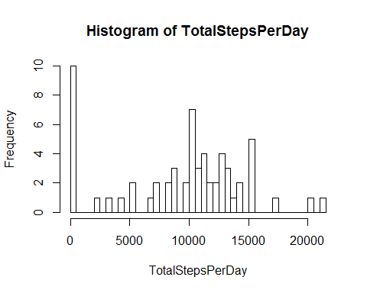

# 3. Calculae and report the mean and the median of the total number of steps taken per day.  
(meanTotalStepsPerDay <-mean(TotalStepsPerDay))

## [1] 9354.23

(medianTotalStepsPerDay <-median(TotalStepsPerDay))

## [1] 10395

## What is the average daily activity pattern?

AvgStepsPerInterval <-tapply(X = df$steps, INDEX = df$interval, FUN = mean, na.rm = TRUE)  
head(AvgStepsPerInterval, n = 25)

## 0000 0005 0010 0015 0020 0025 0030   
## 1.7169811 0.3396226 0.1320755 0.1509434 0.0754717 2.0943396 0.5283019   
## 0035 0040 0045 0050 0055 0100 0105   
## 0.8679245 0.0000000 1.4716981 0.3018868 0.1320755 0.3207547 0.6792453   
## 0110 0115 0120 0125 0130 0135 0140   
## 0.1509434 0.3396226 0.0000000 1.1132075 1.8301887 0.1698113 0.1698113   
## 0145 0150 0155 0200   
## 0.3773585 0.2641509 0.0000000 0.0000000

# 1. Make a time series plot (i.e. type = "l") of the 5-minute interval (x-axis) and the average number of steps taken, averaged across all days (y-axis)

plot(names(AvgStepsPerInterval), AvgStepsPerInterval,type = "l", xlab = "5 Minute Intervals")

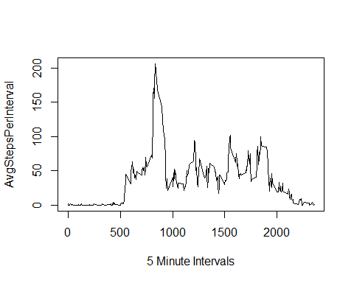

# 2. Which 5-minute interval, on average across all the days in the dataset, contains the maximum number of steps?  
(maxAvgStepsPerInterval <-AvgStepsPerInterval[AvgStepsPerInterval == max(AvgStepsPerInterval)])

## 0835   
## 206.1698

## Imputing missing values

# 1. Calculate and report the total number of missing values in the dataset (i.e. the total number of rows with NAs)  
sum(!complete.cases(df))

## [1] 2304

sum(is.na(df$steps))

## [1] 2304

# 2. Devise a strategy for filling in all of the missing values in the dataset.  
# create a matrix of avg steps per interval (row name) by day of week (column name)  
mxAvgStepsPerIntervalByDow <-tapply(X = df$steps, INDEX = list(df$interval,df$dayofweek), mean, na.rm = TRUE)  
# 3. Create a new dataset that is equal to the original dataset but with missing data filled in.  
df_narpl <-df  
# make copy of original steps variable  
df_narpl$steps.ori <-df_narpl$steps  
# loop through data frame "df_narpl" and replace NA steps with avg steps from replacement matix  
for (i in 1:nrow(df_narpl))  
{  
 isteps <-df_narpl[i,"steps"]  
 iinterval <-df_narpl[i,"interval"]  
 idayofweek <-df_narpl[i,"dayofweek"]  
 # if steps is missing, replace with avg from dfcmatrix  
 if(is.na(isteps))  
 {  
 df_narpl[i,"steps"] <-mxAvgStepsPerIntervalByDow[iinterval,idayofweek]  
 }  
}  
# 4. Make a histogram of the total number of steps taken each day and calculate the mean and median total number of steps taken per day.  
TotalStepsPerDay_narpl <-tapply(X = df_narpl$steps, INDEX = df_narpl$date, FUN = sum, na.rm = TRUE)

# histogram  
hist(x = TotalStepsPerDay_narpl, breaks = 60)

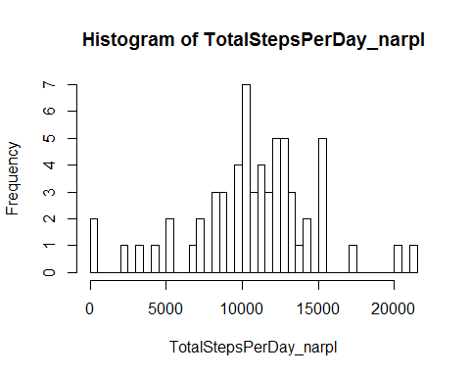

# mean and median  
meanTotalStepsPerDay_narpl <-mean(TotalStepsPerDay_narpl)  
medianTotalStepsPerDay_narpl <-median(TotalStepsPerDay_narpl)  
# compare with mean where incomplete records (NAs) were removed  
(meanDiff <-meanTotalStepsPerDay_narpl - meanTotalStepsPerDay)

## [1] 1466.98

# compare with median where incomplete records (NAs) were removed  
(medianDiff <-medianTotalStepsPerDay_narpl - medianTotalStepsPerDay)

## [1] 620

## Are there differences in activity patterns between weekdays and weekends?

df_narpl$dayofweek <-weekdays(df_narpl$date)  
# 1. Create a new factor variable in the dataset with two levels - "weekday" and "weekend" indicating whether a given date is a weekday or a weekend day.  
df_narpl$daytype <-"weekday"  
df_narpl[substr(df_narpl$dayofweek,1,1) == "S", "daytype"] <-"weekend"  
df_narpl$daytype <-factor(df_narpl$daytype)  
# 2. Make a panel plot containg a time serie plot (i.e. type = "l") of the 5-minute interval (x-axis) and the average number of steps taken, averaged across all weekdays or weekend days (y-axis)  
# create a matrix of average number of steps taken per interval per daytype (weekday & weekend)  
mxAvgStepsPerIntervalByDayType <-tapply(X = df_narpl$steps, INDEX = list(df_narpl$interval, df_narpl$daytype), FUN = mean, na.rm = TRUE)  
str(mxAvgStepsPerIntervalByDayType)

## num [1:288, 1:2] 2.3107 0.45 0.175 0.2 0.0889 ...  
## - attr(*, "dimnames")=List of 2  
## ..$ : chr [1:288] "0000" "0005" "0010" "0015" ...  
## ..$ : chr [1:2] "weekday" "weekend"

# reshape the matrix to a data frame with 3 columns : interval, day type and avg steps per interval  
require(reshape2)

## Loading required package: reshape2

df_mlt <-melt(data = mxAvgStepsPerIntervalByDayType, measure.vars = c("weekday","weekend"), id.vars = c("interval"))  
# update column/variable names  
names(df_mlt) <-c("timeInterval","dayType","avgSteps")  
str(df_mlt)

## 'data.frame': 576 obs. of 3 variables:  
## $ timeInterval: int 0 5 10 15 20 25 30 35 40 45 ...  
## $ dayType : Factor w/ 2 levels "weekday","weekend": 1 1 1 1 1 1 1 1 1 1 ...  
## $ avgSteps : num 2.3107 0.45 0.175 0.2 0.0889 ...

# create panel plots of avg steps by interal for each day type (weekday & weekend)

require("lattice")

## Loading required package: lattice

xyplot(avgSteps ~ timeInterval | dayType, data = df_mlt, type = "l", layout = c(1,2), xlab = "5 Minute Intervals", ylab = "Avg Steps Per 5 Minute Interval" )

