Charlene Butler
EEE304
Lab 1
Overview of Results:
In this lab, several analog and digital low-pass filters were designed, simulated, and analyzed to study their time and frequency domain behavior.
A first-order analog low-pass filter was implemented with a cutoff frequency of 2 kHz. Its step response showed a gradual rise with minimal overshoot, and the Bode plot exhibited a roll-off rate of −20 dB/decade, confirming its basic filtering behavior.
A second-order analog filter was then designed using the same cutoff frequency. Compared to the first-order filter, it demonstrated a sharper roll-off (−40 dB/decade) and a faster transient response with slightly more overshoot, indicating improved selectivity but reduced phase linearity.
A 5th-order Butterworth filter was also designed to achieve a maximally flat passband. The Butterworth design provided excellent attenuation of high-frequency components and a smooth, stable time response with minimal overshoot. Its magnitude response confirmed a much steeper slope (−100 dB/decade), validating the advantages of higher-order filters for precise frequency separation.
In the Simulink implementation, the low-pass filter effectively removed high-frequency components (e.g., 31 kHz) while allowing low-frequency signals (e.g., 300 Hz) to pass. A small DC offset was observed due to transient response, which can be corrected using a DC-blocking filter if necessary.
Finally, digital Butterworth filters were implemented at different sampling rates. At a high sampling rate (100 kHz), the discrete filter closely matched the analog behavior, showing accurate amplitude and phase response. However, when the sampling rate was reduced to 4 kHz, performance degraded — aliasing effects and phase distortion appeared near the cutoff frequency, illustrating the importance of selecting an adequate sampling rate relative to the filter’s bandwidth.
Overall, the results confirmed that increasing filter order improves frequency selectivity but may increase response time and computational complexity. Additionally, sampling rate directly affects digital filter accuracy, emphasizing the need to meet Nyquist criteria for effective signal reconstruction and filtering.

- H(s)=wc/s+wc
- 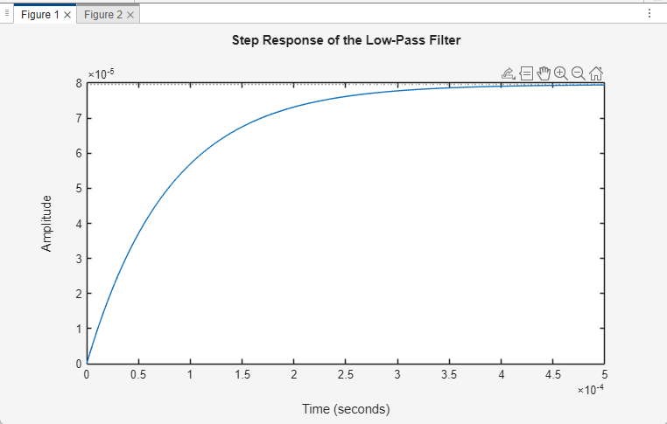
- 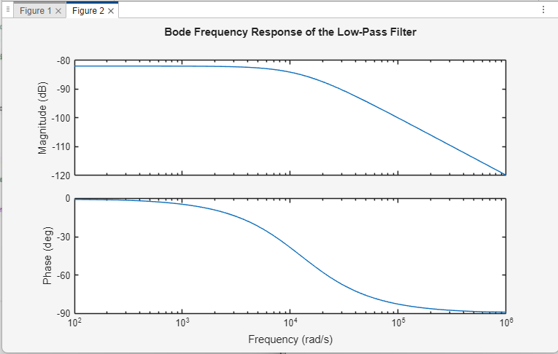
- % Define the cutoff frequency
wc = 2*pi*2000; % 2 kHz

% Transfer function H(s)
H = tf(wc, [1 wc]);

% Plot the step response
figure;
step(H);
title('Step Response of the Low-Pass Filter');

% Plot the Bode frequency response
figure;
bode(H);
title('Bode Frequency Response of the Low-Pass Filter');

- H2(s)=wc^2/(s^2+sqrt2wcs+wc^2)
- 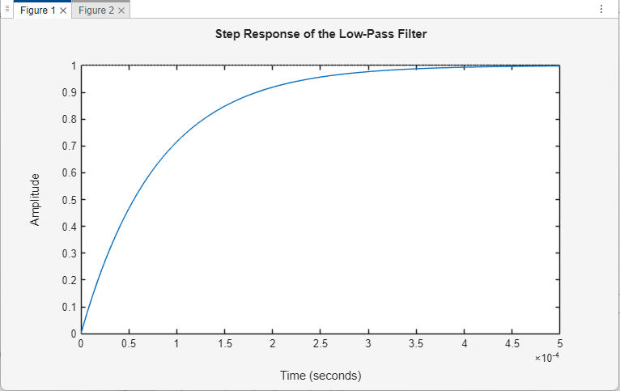
- 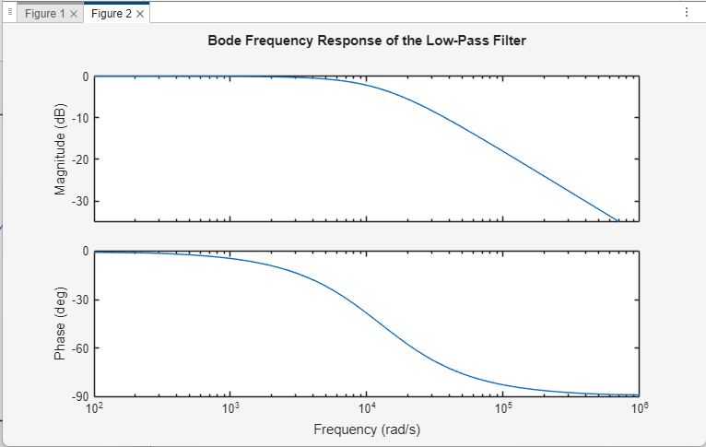
- % Define the cutoff frequency
wc = 2*pi*2000; % 2 kHz

% Transfer function H(s)
H1 = tf(wc, [1 wc]);

H2=tf(wc^2, [1 sqrt(2)*wc wc^2]);

figure;
step(H1, H2);
legend('1st Order', '2nd Order');
title('Step Response Comparison');

figure;
bode(H1, H2);
legend('1st Order', '2nd Order');
title('Bode Plot Comparison');

- [b, a]=butter(5, 2*pi*2000, ‘s’)
H_butter=tf(b, a)
- 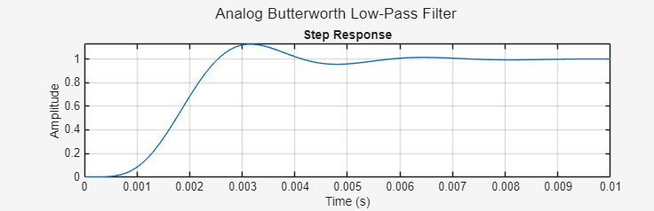
- 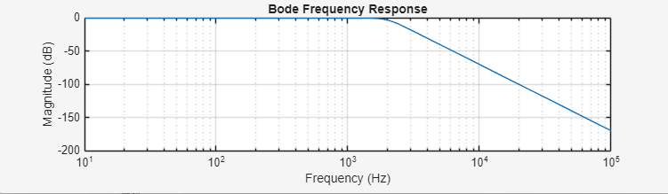
- While the Butterworth filter has a slower, more stable response with less overshoot and ringing, the second-order filter has a faster response with possibly more overshoot or ringing.
The Butterworth filter has a steeper roll-off ad better attenuation f high frequencies, and the second-order filter will have a less sharp cutoff which allows more high-frequency to get through.
- % Butterworth filter design
order = 5;
cutoff_freq = 2000;
[b, a]= butter(order, cutoff_freq, 's');

t = 0:0.0001:0.01;
step_response= step(tf(b, a), t);

w= logspace(1, 5, 1000);
H= freqs(b, a, w);

figure;

subplot(2, 1, 1);
plot(t, step_response);
title('Step Response');
xlabel('Time (s)');
ylabel('Amplitude');
grid on;

subplot(2, 1, 2);
semilogx(w, 20*log10(abs(H)));
title('Bode Frequency Response');
xlabel('Frequency (Hz)');
ylabel('Magnitude (dB)');
grid on;

sgtitle('Analog Butterworth Low-Pass Filter');

numerator = poly2str(b, 's');
denominator = poly2str(a, 's');
fprintf('Transfer Function: H(s) = %s / %s\n', numerator, denominator);

- 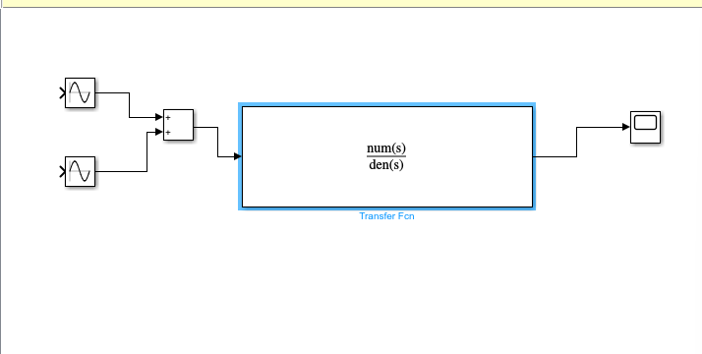
- 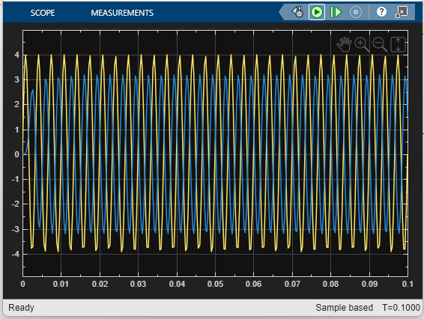
- The output of the Butterworth filter has a smaller amplitude, showing that only low-frequency components are passed.
The high-frequency component (≈31 kHz) is strongly attenuated, confirming the filter’s low-pass action.
The slight DC offset visible at the output is due to the transient response and can be ignored or removed using a DC-blocking stage.
- clc
close all
fc= 1e3;
fs= 100e3;

[b, a]= butter (5,fc/(fs/2));
t=0:1/fs:0.1;
x=2*sin(2*pi*300*t)+sin(2*pi*t*31.413e3);

y=filter(b,a,x);
figure()
plot(t,y,'b','linewidth',2);
hold on;
plot(t,x);
legend('Output','Input');
title('Using filter');

sys=tf(b,a,1/fs);
yl=lsim(sys,x,t);
figure();
plot(t,yl,'b','linewidth',2);
hold on;
plot(t,x);
legend('Output','Input');
title('Using Isim');
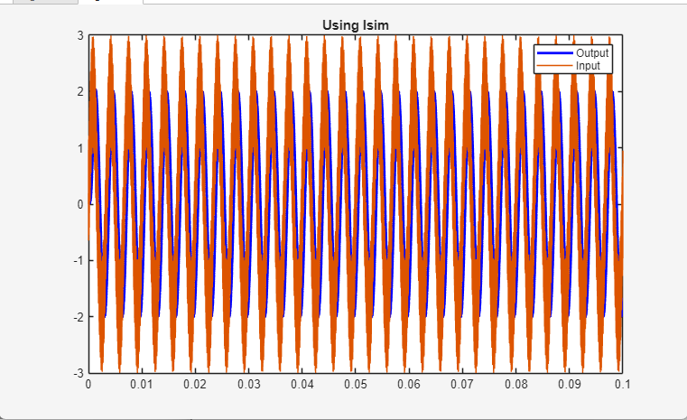
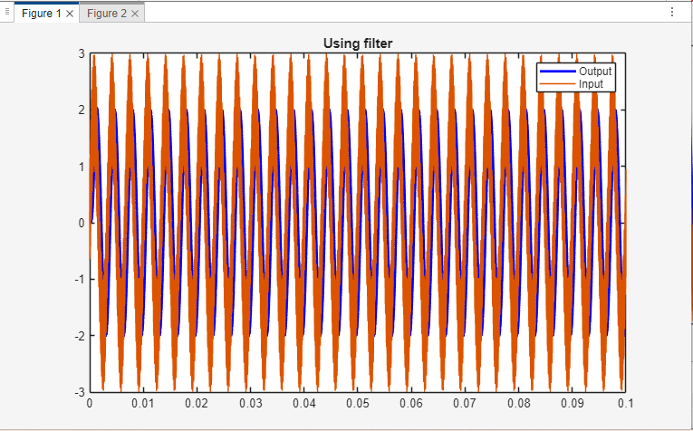

- clc
close all
fc= 1e3;
fs= 4e3;

[b, a]= butter (5,fc/(fs/2));
t=0:1/fs:0.01;
x=2*sin(2*pi*300*t)+sin(2*pi*t*31.413e3);

y=filter(b,a,x);
figure()

plot(t,y,'b','linewidth',2);
hold on;
plot(t,x);
legend('Output','Input');
title('Using filter');

sys=tf(b,a,1/fs);
yl=lsim(sys,x,t);
figure();
plot(t,yl,'b','linewidth',2);
hold on;
plot(t,x);
legend('Output','Input');
title('Using Isim');
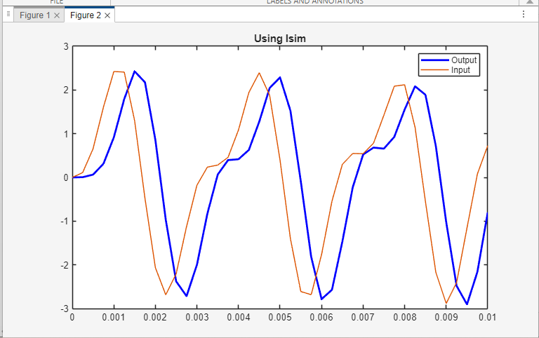
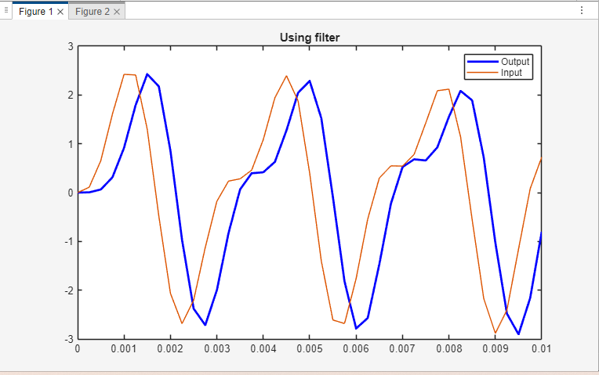
• At fs = 100 kHz: output matches the analog 5th-order filter closely; both frequency and step responses align.
The 31 kHz component is heavily attenuated.
• At fs = 4 kHz: digital filter performance degrades — limited resolution, more distortion.
The cutoff at 2 kHz is close to Nyquist, so aliasing and phase distortion increase.

