Assignment 1: Ray Tracing

Compiling Instructions:

In order to compile the uploaded source code for this assignment on your machine, you need to do the following:

1. Install CMAKE
2. Download the submission.
3. Create a directory called build in the assignment directory TOPDIR/Assignment1_vc16e, e.g. by typing in a terminal window: cd TOPDIR/ Assignment1_vc16e; mkdir build
4. Create the necessary makefiles for compilation and place them inside the build/ directory, using the CMAKE GUI (windows), or typing: cd build; cmake ../
5. Compile and run the compiled executable by typing: make; ./ Assignment1

Task1: Ray Tracing Spheres

**Implementation**:

1. Created multiple spheres with random positioning and radius. Set the color of the sphere to black.
2. Created light source with random positioning and set the intensity to 1.0 and color to white.
3. Created Matrices for R,G,B values
4. Taken -5, 5, 10 as the origin and looped over the 800x800 pixels
5. Since it is orthographic projection rays are created from the center of every pixel by computing the x-displacement and y-displacement required.
6. Then computed ray sphere intersection using the algorithm
7. For the intersected rays:
   1. Applied Lambertian shading algorithm and computed the pixel color values
   2. Applied alpha value to be 1
8. Computed RGB values are used to construct png image of the scene.

Result:

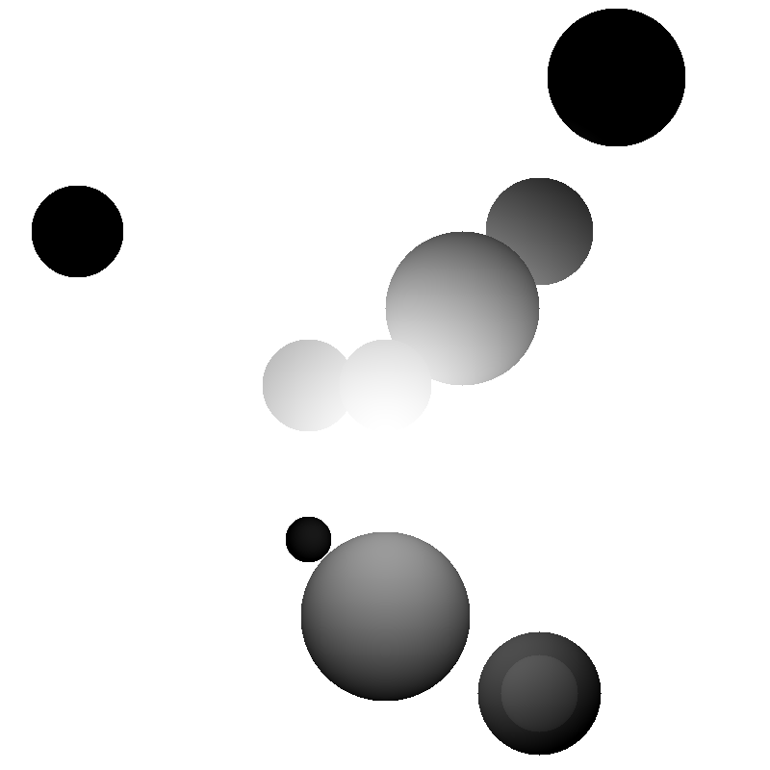

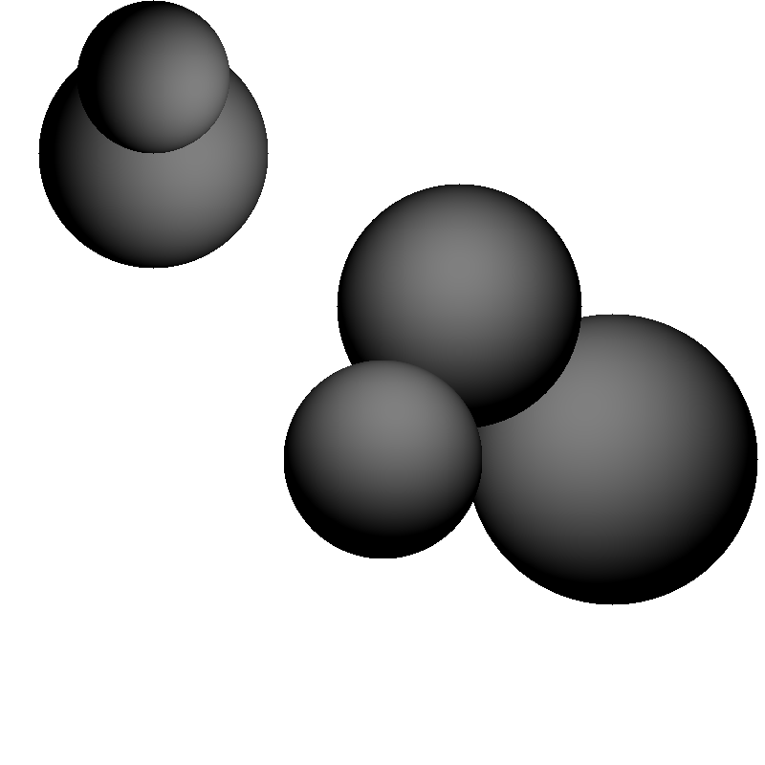

Task2: Shading

**Implementation**:

1. Created multiple spheres at definite positions and with specific radius. Set different colors and material properties to the spheres. Red sphere is purely diffuse and green sphere is purely specular.
2. Created light source at the definite position and set the intensity to 1.0 and color to white.
3. Created Matrices for R,G,B values
4. Taken -5, 5, 10 as the origin and looped over the 800x800 pixels
5. Since it is orthographic projection rays are created from the center of every pixel by computing the x-displacement and y-displacement required.
6. Then computed ray sphere intersection using the algorithm
7. For the intersected rays:
   1. Applied shading algorithm and computed the pixel color values
   2. Applied alpha value to be 1
8. Computed RGB values are used to construct png image of the scene.

Result: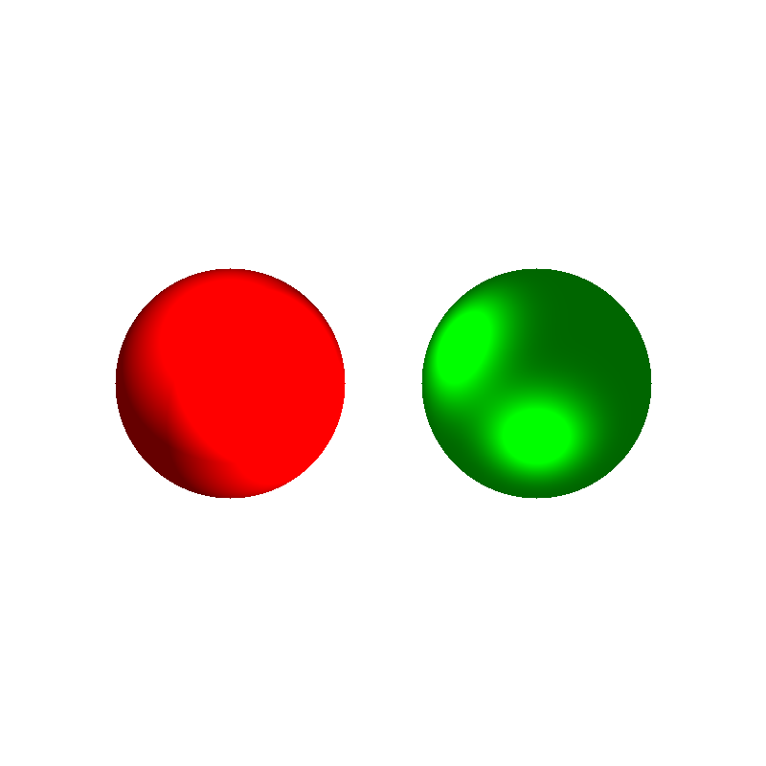

Task3: Perspective Projection

**Implementation**:

1. Created multiple spheres at definite positions and with specific radius. Set different colors and material properties to the spheres. Red sphere is purely diffuse and green sphere is purely specular.
2. Created light source at the definite position and set the intensity to 1.0 and color to white.
3. Created Matrices for R,G,B values
4. Taken -5, 5, 10 as the origin and looped over the 800x800 pixels
5. Since it is Perspective projection rays are created from the same origin and directed through every pixel by computing the x-displacement and y-displacement required.
6. Then computed ray sphere intersection using the algorithm
7. For the intersected rays:
   1. Applied shading algorithm and computed the pixel color values
   2. Applied alpha value to be 1

Computed RGB values are used to construct png image of the scene

Result: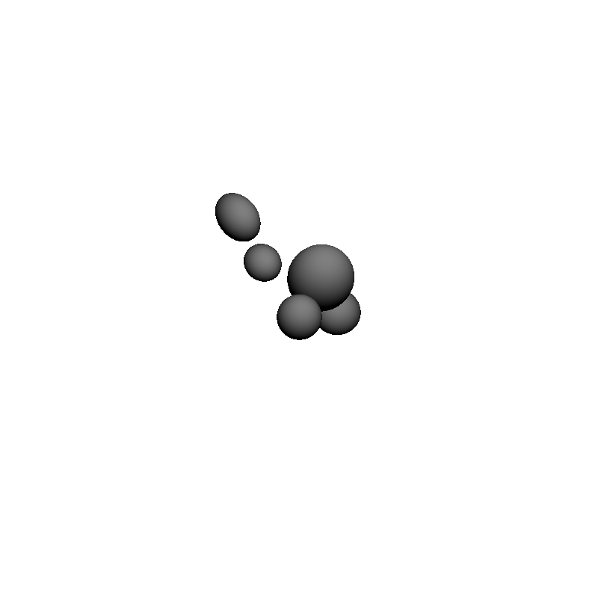

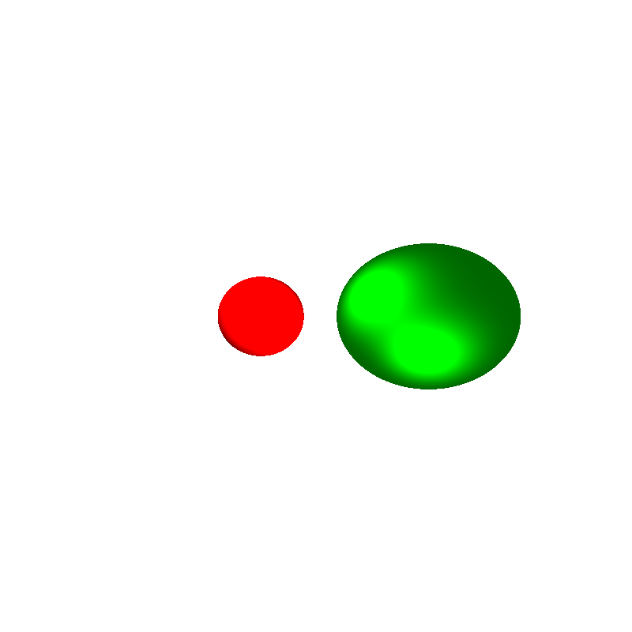

Task4: Ray Tracing Triangle Meshes

**Implementation**:

1. Loaded meshes from the given .off format files. And created multiple spheres at definite positions and with specific radius. Set different colors and material properties to the spheres. Red sphere is purely diffuse and green sphere is purely specular.
2. Created light source at the definite position and set the intensity to 1.0 and color to white.
3. Created Matrices for R,G,B values
4. Taken -5, 5, 10 as the origin and looped over the 800x800 pixels
5. Since it is Perspective projection rays are created from the same origin and directed through every pixel by computing the x-displacement and y-displacement required.
6. Then computed ray sphere intersection using the algorithm
7. Computed ray mesh intersection using the algorithm
8. For the intersected rays:
   1. Applied shading algorithm and computed the pixel color values
   2. Applied alpha value to be 1

Computed RGB values are used to construct png image of the scene

Result:

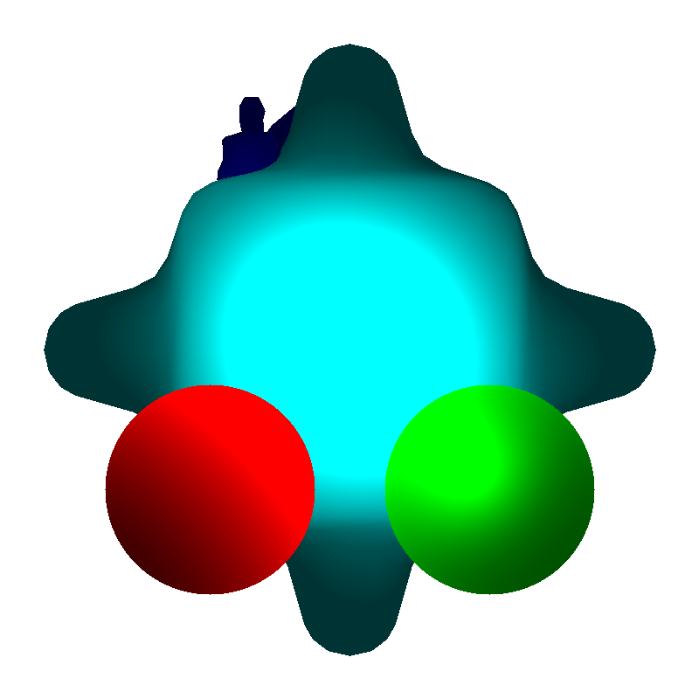

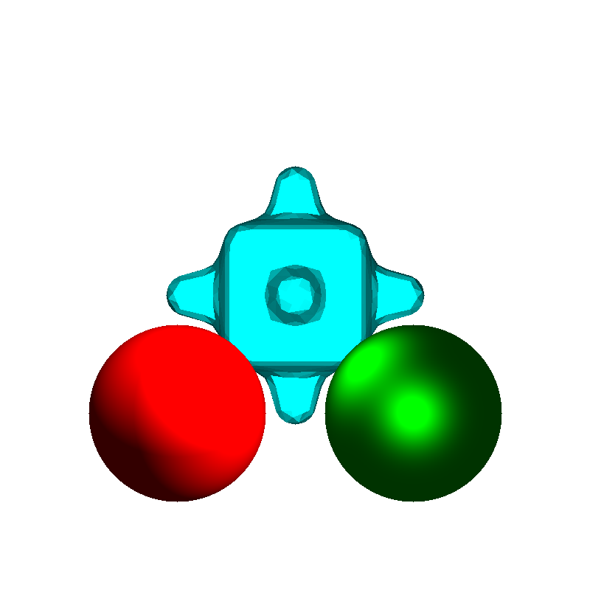

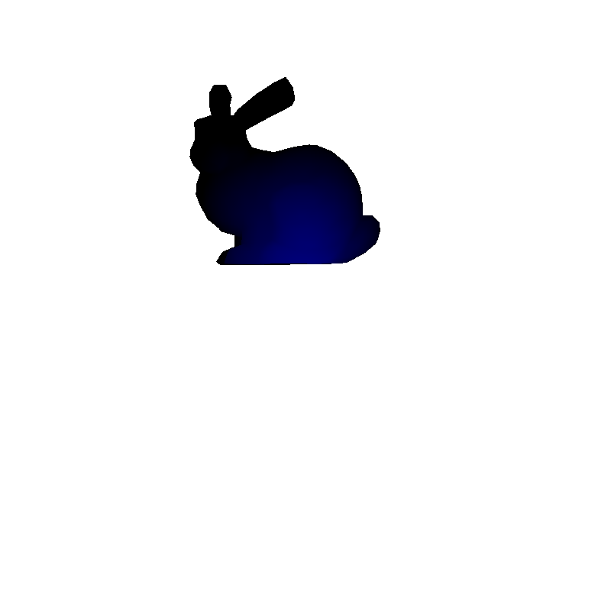

Task5: Shadows

Used shadows algorithm to compute shadows in addition to the above tasks

Result:

