ARTIFICIAL INTELLIGENCE INTERNSHIP PROGRAM
AI-BASED SPEECH-TO-TEXT TRANSCRIPTION SYSTEM
AN INTERNSHIP PROJECT REPORT
Submitted by
VELAN C
(Reg No:110725102266)
in partial fulfilment for the award of the degree
of
BACHELOR OF TECHNOLOGY
IN
Artificial Intelligence & Data Science

J.N.N Institute of Engineering
(An Autonomous Institute , Affiliated to Anna University, Chennai)
OCTOBER 2026 | ACADEMIC YEAR 2026–2027


VISION OF THE INSTITUTE:
Lead the transformation of engineering and management learning experience to educate the next generation of innovators and entrepreneurs who want to make the world a better place.
MISSION OF THE INSTITUTE:
IM1: To develop the required resources and infrastructure and to establish a conducive ambience for the teaching-learning process.
IM2: To nurture professional and ethical values in the students and to instils in them a spirit of innovation and entrepreneurship.
IM3: To encourage a desire for higher learning and research in the students and to equip them to face global challenges.
IM4: To provide opportunities for students to learn job-relevant skills to make them industry ready.
IM5: To interact with industries and other organization to facilitate transfer of knowledge and know-how.


VISION OF THE DEPARTMENT:
To impart quality-education, inculcate professionalism and enhance the problem-solving skills of the students in the domain of Artificial Intelligence & Data Science by applying recent technological tools and incorporating collaborative principles with a focus to make them industry ready.
MISSION OF THE DEPARTMENT:
• DM 1: To enhance the knowledge of the students with most recent advancements and refresh their insights in the field of Artificial Intelligence and Data Science.
• DM 2: To equip the students with strong fundamental concepts, analytical capability, programming and problem-solving skills.
• DM 3: To make the students industry ready and to enhance their employability through training, internships and real-time projects.
• DM 4: To guide the students to perform research on Artificial Intelligence and Data Science, with the aim to provide solutions to the problems of the industry.


PROGRAM OUTCOMES
S.NO | GRADUATE ATTRIBUTE | PROGRAM OUTCOMES
PO1 | Engineering knowledge | Apply the knowledge of mathematics, science, engineering fundamentals, and an engineering specialization to the solution of complex engineering problems.
PO2 | Problem analysis | Identify, formulate, review research literature, and analyze complex engineering problems reaching substantiated conclusions using first principles of mathematics, natural sciences, and engineering sciences.
PO3 | Design/Development of solutions | Design solutions for complex engineering problems and design system components or processes that meet the specified needs with appropriate consideration for the public health and safety, and the cultural, societal, and environmental considerations.
PO4 | Conduct investigations of complex problems | Use research-based knowledge and research methods including design of experiments, analysis and interpretation of data, and synthesis of the information to provide valid conclusions.
PO5 | Modern Tool usage | Create, select, and apply appropriate techniques, resources, and modern engineering and IT tools including prediction and modeling to complex engineering activities with an understanding of the limitations.
PO6 | The Engineer and society | Apply reasoning informed by the contextual knowledge to assess societal, health, safety, legal and cultural issues and the consequent responsibilities relevant to the professional engineering practice.
PO7 | Environment and sustainability | Understand the impact of the professional engineering solutions in societal and environmental contexts, and demonstrate the knowledge of, and need for sustainable development.
PO8 | Ethics | Apply ethical principles and commit to professional ethics and responsibilities and norms of the engineering practice.
PO9 | Individual and team work | Function effectively as an individual, and as a member or leader in diverse teams, and in multidisciplinary settings.
PO10 | Communication | Communicate effectively on complex engineering activities with the engineering community and with society at large, such as, being able to comprehend and write effective reports and design documentation, make effective presentations, and give and receive clear instructions.
PO11 | Project management and finance | Demonstrate knowledge and understanding of the engineering and management principles and apply these to one’s own work, as a member and leader in a team, to manage projects and in multidisciplinary environments.
PO12 | Life-long learning | Recognize the need for, and have the preparation and ability to engage in independent and life-long learning in the broadest context of technological change.

PROGRAM EDUCATIONAL OBJECTIVES (PEO)
S.No | PROGRAM EDUCATIONAL OBJECTIVES (PEO)
PEO1 | To provide graduates with the proficiency to utilize the fundamental knowledge of basic sciences, mathematics, Artificial Intelligence, data science and statistics to build systems that require management and analysis of large volume of data.
PEO2 | To enrich graduates with necessary technical skills to pursue pioneering research in the field of AI and Data Science and create disruptive and sustainable solutions for the welfare of ecosystems.
PEO3 | To enable graduates to think logically, pursue lifelong learning and collaborate with an ethical attitude in a multidisciplinary team.

PROGRAM SPECIFIC OBJECTIVES (PSOs)
S.No | PROGRAM SPECIFIC OBJECTIVES (PSOs)
PSO1 | Graduates should be able to evolve AI based efficient domain specific processes for effective decision making in several domains such as business and governance domains.
PSO2 | Graduates should be able to arrive at actionable Foresight, Insight, hindsight from data for solving business and engineering problems.
PSO3 | Graduates should be able to create, select and apply the theoretical knowledge of AI and Data Analytics along with practical industrial tools and techniques to manage and solve wicked societal problems.

BONAFIDE CERTIFICATE
Certified that this internship project report “ARTIFICIAL INTELLIGENCE INTERNSHIP PROGRAM – AI-BASED SPEECH-TO-TEXT TRANSCRIPTION SYSTEM” is the bonafide work of “VELAN C” (Reg No: 110725102266) who carried out the project work under my supervision.
Signature of the HOD with date  Dr. P. Nagarajan  Professor and Head,  Department of Artificial Intelligence & Data Science Engineering,  J.N.N Institute of Engineering, Chennai | Signature of the Supervisor with date  Ms. M. Gayathridevi  Project Supervisor,  Department of Artificial Intelligence & Data Science Engineering,  J.N.N Institute of Engineering, Chennai
Certified that the above student has attended the viva voce examination held on……………….
INTERNAL EXAMINER | EXTERNAL EXAMINER

ACKNOWLEDGEMENT
First and foremost, I express my sincere gratitude to our Beloved FOUNDER & CHAIRMAN Shri. S. JAYACHANDRAN B.Sc., B.L., and also heartfelt thanks to our VICE CHAIRMAN Mr. NAVEEN JAYACHANDRAN M.S., for providing necessary facilities for the completion of my internship.
I thank our PRINCIPAL Dr. G. MOHANBABU, Ph.D., for the encouragement provided with the congenial environment essential for me to complete the internship.
I take this opportunity to express my gratitude to our HEAD OF THE DEPARTMENT Dr. P. NAGARAJAN and all other faculty members in the Department of ARTIFICIAL INTELLIGENCE AND DATA SCIENCE for giving me continuous encouragement for completing my internship.
I extend my sincere thanks to Codec Technologies Pvt. Ltd. and its team for giving me the opportunity to complete the Artificial Intelligence Internship Program and for their guidance throughout the internship; and our internship supervisor, Ms. M. Gayathridevi, for the guidance, support and encouragement given to me while preparing this internship report.
Finally, I would like to thank my parents and friends for their constant support and encouragement.

ABSTRACT
Speech is the most natural way in which people communicate, but turning recorded speech into written text by hand is slow and tiring. Automatic speech-to-text technology reduces this effort and makes spoken content easier to store, search, edit and share. This report documents the work carried out during the one-month Artificial Intelligence Internship at Codec Technologies Pvt. Ltd., conducted from 02/08/2026 to 02/09/2026 under an AICTE & ICAC approved internship program, which focused on the development of an AI-Based Speech-to-Text Transcription System.
The system is a web application built with Python and the Streamlit framework. The user can upload an audio file in WAV, MP3, M4A or FLAC format, or record speech directly from the browser microphone, and can choose English or Tamil as the spoken language. The audio is loaded and validated with Pydub, converted to 16 kHz mono, optionally cleaned with volume normalisation and a high-pass filter, and divided into 25-second parts. Each part is passed through the SpeechRecognition library to the Google Web Speech API, and the recognised text is formatted into sentences and paragraphs. The result appears in an editable text area with word, character and paragraph counts; it can be copied, downloaded as a TXT or DOCX file, and is stored in a session-based history that can be exported as a CSV file.
The project integrates an existing Automatic Speech Recognition (ASR) service; no speech model was trained as part of this work. Its value lies in the complete application built around the service: input handling, audio validation and pre-processing, error handling, text formatting, transcription management and export. The internship strengthened skills in Python programming, Streamlit development, audio processing, ASR integration, debugging and technical documentation.

TABLE OF CONTENTS
CHAPTER NO | TITLE | PAGE NO.
1 | INTRODUCTION | 1
 | 1.1. OVERVIEW | 1
 | 1.2. INTERNSHIP DETAILS | 1
 | 1.3. OBJECTIVES | 2
 | 1.4. PROJECT OVERVIEW | 3
2 | LITERATURE REVIEW | 5
 | 2.1. ARTIFICIAL INTELLIGENCE | 5
 | 2.2. SPEECH RECOGNITION | 5
 | 2.3. AUTOMATIC SPEECH RECOGNITION (ASR) | 5
 | 2.4. SPEECH-TO-TEXT TECHNOLOGY | 5
 | 2.5. AUDIO PROCESSING | 6
 | 2.6. PYTHON PROGRAMMING LANGUAGE | 6
 | 2.7. STREAMLIT FRAMEWORK | 6
 | 2.8. SPEECH RECOGNITION ENGINE AND API | 6
 | 2.9. TEXT PROCESSING | 7
 | 2.10. TOOLS AND TECHNOLOGIES USED | 8
3 | METHODOLOGY | 9
 | 3.1. OVERALL APPROACH | 9
 | 3.2. SYSTEM WORKFLOW | 9
 | 3.3. AUDIO INPUT | 10
 | 3.4. AUDIO VALIDATION AND PROCESSING | 10
 | 3.5. SPEECH RECOGNITION | 10
 | 3.6. LANGUAGE PROCESSING | 11
 | 3.7. TRANSCRIPTION MANAGEMENT | 11
 | 3.8. EXPORT PROCESS | 11
 | 3.9. ERROR HANDLING | 11
 | 3.10. TESTING METHOD | 12
4 | IMPLEMENTATION | 13
 | 4.1. SYSTEM ARCHITECTURE | 13
 | 4.2. APPLICATION ARCHITECTURE | 15
 | 4.3. USER INTERFACE | 15
 | 4.4. AUDIO FILE UPLOAD MODULE | 16
 | 4.5. MICROPHONE RECORDING MODULE | 16
 | 4.6. SPEECH RECOGNITION MODULE | 16
 | 4.7. TRANSCRIPTION RESULT MODULE | 16
 | 4.8. IMPORTANT FUNCTIONS AND MODULES | 19
5 | RESULTS AND DISCUSSION | 20
 | 5.1. APPLICATION OUTPUT | 20
 | 5.2. DASHBOARD RESULT | 21
 | 5.3. AUDIO UPLOAD RESULT | 21
 | 5.4. MICROPHONE RECORDING RESULT | 21
 | 5.5. SPEECH TRANSCRIPTION RESULT | 22
 | 5.6. TESTING RESULTS | 23
 | 5.7 SKILLS GAINED | 24
 | 5.8 LIMITATIONS AND DISCUSSION | 25
 | INTERNSHIP CERTIFICATE | 26

CHAPTER 1

INTRODUCTION

1.1 Overview
Artificial Intelligence (AI) is the branch of computer science concerned with building systems that perform tasks which normally need human intelligence, such as understanding language, recognising patterns and making decisions. One of the most visible applications of AI is speech recognition, in which a computer listens to human speech and identifies the words that were spoken. When the recognised words are written out as text, the technology is called speech-to-text or transcription.
Speech-to-text is useful in many everyday situations. Lectures, meetings, interviews and voice notes can be turned into searchable and editable documents; people who find typing difficult can enter text by speaking; and spoken content in regional languages can be preserved in written form. Writing a transcript by hand is time-consuming, because the recording has to be played, paused and replayed repeatedly. An automated system reduces this effort, although its output still has to be checked and corrected by the user.
This report presents the AI-Based Speech-to-Text Transcription System, developed during the Artificial Intelligence Internship at Codec Technologies Pt. Ltd. from 02/08/2026 to 02/09/2026. The application is written in Python and uses the Streamlet framework to provide a browser-based interface. Python supplies the processing logic and the libraries for audio handling, speech recognition and document export, while Streamlet makes it possible to build a complete interactive interface, with file upload, microphone recording, buttons, tables and downloads, using Python alone.
It is important to state clearly what the project does and does not do. The system integrates an existing Automatic Speech Recognition (ASR) service, the Google Web Speech API, through the Speech Recognition library. No speech-recognition model was designed or trained from scratch during this work. The project focuses on application development: accepting audio, preparing it for recognition, calling the recognition service, handling errors, formatting the text, and giving the user tools to edit, store and export the result.

1.2 Internship Details
According to the offer letter issued on 02/08/2026, Codec Technologies is a global platform dedicated to empowering learners and connecting diverse talent to create meaningful career opportunities, and delivers IT and business consultancy services across more than 27 countries. The intern reported to the assigned project head(s). The internship certificate, signed by the Program Manager, Dr. Anurag Shrivastava, confirms that Velan C completed the 1 Month AICTE & ICAC approved internship program as an Artificial Intelligence Intern from 02/08/2026 to 02/09/2026. A copy of the certificate is included at the end of this report.
Table 1.1 Internship Details
Item | Details
Student Name | Velan C
Register Number | 110725102266
College | J.N.N Institute of Engineering
Department | B.Tech Artificial Intelligence & Data Science
Academic Year | Second Year
Organisation | Codec Technologies Pvt. Ltd.
Internship Domain | Artificial Intelligence
Designation | Artificial Intelligence Intern
Internship Program | 1 Month AICTE & ICAC Approved Internship
Mode | Hybrid (Pan India), as stated in the offer letter
Internship Period | 02/08/2026 – 02/09/2026
Duration | 1 Month
AICTE ID (as per certificate) | CORPORATE6759d549ce59e1733940553
Project Title | AI-Based Speech-to-Text Transcription System
Project Supervisor | Ms. M. Gayathridevi
Technologies Used | Python, Streamlit, Speech Recognition (Google Web Speech API), Pydub, FFmpeg, python-docx, pandas

1.3 Objectives
- To develop a practical speech-to-text application that converts human speech into written text.
- To accept speech through both audio file upload (WAV, MP3, M4A and FLAC) and microphone recording.
- To support transcription in English and Tamil, with a design in which further languages can be added easily.
- To validate and prepare audio before recognition so that unsuitable input is rejected with clear messages.
- To provide a simple and professional user interface with a dashboard, a workflow indicator and an audio information panel.
- To give the user an editable transcription with word, character and paragraph counts.
- To provide copy, TXT download, DOCX download, and a session-based transcription history that can be exported as CSV.
- To apply Python programming and AI-related concepts in a complete, working application.
- To understand how Automatic Speech Recognition works and how an existing ASR service can be integrated into a software application.

1.4 Project Overview
The AI-Based Speech-to-Text Transcription System is a Python and Streamlit web application. The user selects the spoken language, supplies audio by uploading a file or recording from the microphone, and presses a single button to start transcription. The application checks the audio, converts it to a format suitable for speech recognition, divides it into short parts, sends each part to the recognition service and joins the returned text into formatted paragraphs. The transcription is shown in an editable text box from which it can be copied or downloaded, and every completed transcription is added to a history table for the current session.
The high-level workflow of the system is shown below and is also displayed as a progress bar in the application interface.
Audio Input → Audio Processing → Speech Recognition → Text Processing → Transcription → Editing → Export
The main features of the implemented system are:
- Audio input and information: upload of WAV, MP3, M4A and FLAC files up to 100 MB, or recording from the browser microphone; file name, type, duration and size are displayed and the audio can be played back.
- Language selection: English (en-US) and Tamil (ta-IN).
- Pre-processing and transcription: conversion to 16 kHz mono with an optional noise-reduction step; recognition runs part by part with a progress bar, and unclear parts are counted and reported.
- Editable result: word, character and paragraph counts, copy button, TXT and DOCX download, and a clear button.
- Dashboard and history: summary cards, a session history table, a “Load into editor” option and CSV export of the history.
- Error handling: user-friendly messages for unsupported or unreadable files, oversized files, silent audio, missing FFmpeg, unclear speech and recognition-service problems.

CHAPTER 2

LITERATURE REVIEW
This chapter gives the background of the concepts, libraries and services used in the project. The explanations describe the technology in general terms; the way each item is used in this project is described in Chapters 3 and 4.

2.1 Artificial Intelligence
Artificial Intelligence is the field of computer science that aims to make machines perform tasks that normally require human intelligence. Machine learning is a major part of modern AI: instead of being given fixed rules, a model learns patterns from large amounts of example data. Many AI applications, such as image recognition, language translation and speech recognition, rely on models of this kind. Building an AI-based application does not always mean training a new model. In practice, developers often combine existing trained models or cloud services with their own software to solve a particular problem. This project follows the second approach.

2.2 Speech Recognition
Speech recognition is the ability of a computer to identify spoken words and convert them into a machine-readable form. Speech is a continuous signal with wide variation: people speak at different speeds, with different accents and pitch, and recordings contain background noise and echo. Words also run together without clear gaps, and different words can sound alike. These factors make speech recognition a difficult problem, and the quality of a recording strongly affects the quality of the result.

2.3 Automatic Speech Recognition (ASR)
Automatic Speech Recognition converts speech into text using AI. Traditional ASR uses feature extraction, acoustic models, pronunciation lexicons, language models, and a decoder. Modern systems often use deep learning and end-to-end models.
The AI-Based Speech-to-Text Transcription System does not train an ASR model. It integrates an existing ASR model or online service to convert speech into text.

2.4 Speech-to-Text Technology
Speech-to-text, also called transcription, builds on ASR to produce written text from audio. A practical speech-to-text application normally contains the following stages: capturing or receiving audio, checking that it is usable, converting it to a suitable format, passing it to a recognition engine, post-processing the recognised words, and presenting the result to the user in a form that can be reviewed, corrected and saved. The recognition engine is only one stage; the others determine how easy and reliable the application is to use. Because recognition errors cannot be avoided completely, an editable output is an important feature of a transcription tool.

2.5 Audio Processing
Audio processing prepares the recording for speech recognition.
- Sampling rate: Number of samples per second; 16 kHz is commonly used for speech.
- Channels: Speech recognition usually uses mono audio instead of stereo.
- Normalisation: Adjusts audio volume for clearer recognition.
- High-pass filter: Removes unwanted low-frequency noise.
- dBFS: Measures digital audio loudness and helps identify silence.
- Chunking: Splits long recordings into smaller parts for easier processing.

2.6 Python Programming Language
Python is a high-level, general-purpose language known for its readable syntax and its very large ecosystem of libraries. It is the most widely used language for AI and data-science work, and libraries exist for audio handling, speech recognition, document generation and web interfaces. The same language can therefore be used for the whole application, from reading an audio file to producing a Word document, which keeps the project simple to develop and maintain.

2.7 Streamlet Framework
Streamlet is an open-source Python framework for building interactive web applications without manually writing HTML, CSS, or JavaScript. It provides widgets such as file uploaders, buttons, tables, audio input, progress bars, and download buttons. Streamlit reruns the script when users interact with the app, while session state preserves important values. Custom CSS can also be used to improve the design.

2.8 Speech Recognition Engine and API
The Speech Recognition library is a Python package that connects applications to speech-recognition services. Its Recognizer processes audio, and recognize_google() sends the audio to the Google Web Speech API and returns text. It supports languages such as English (en-US) and Tamil (ta-IN).
The library uses exceptions for errors, such as unclear speech or connection problems. Since Google Web Speech API is an online service, an internet connection is required. It is convenient for learning and prototyping and works best with short audio clips.

2.9 Text Processing
The text returned by a recognition engine is usually a plain sequence of words. The engine used in this project does not predict punctuation, so the raw output has no full stops or capital letters. Text processing improves readability by removing extra spaces, starting sentences with capital letters, adding end punctuation and grouping sentences into paragraphs. Text processing of this kind is deliberately simple and rule-based; it does not change the recognised words, and it cannot correct recognition errors.

2.10 Tools and Technologies Used
Table 2.1 Tools and Technologies Used
Tool / Technology | Purpose
Python | Core programming language used for all application logic (Python 3.9 or later).
Streamlet | Web framework for the user interface: file upload, microphone recording, buttons, tables, progress bar and downloads.
Speech Recognition | Python library used to send audio to the recognition engine and receive text.
Google Web Speech API | Existing online ASR service that performs the actual speech-to-text conversion for English and Tamil.
Pydub | Loading audio files, measuring duration and loudness, converting to mono 16 kHz, filtering, normalising and splitting audio.
MPEG | External tool required by Pydub to decode MP3, M4A and FLAC files.
python-docx | Creating the downloadable Word (DOCX) transcription document.
pandas | Building the history table and the CSV export of the session history.
HTML and CSS (via Streamlet) | Custom styling of the header banner, workflow bar and dashboard cards; theme set in config.toml.
JavaScript (Clipboard API) | Small embedded script behind the “Copy transcription” button.
Git and GitHub | Version control and hosting of the project source code.

CHAPTER 3

METHODOLOGY

3.1 Overall Approach
The project was developed in the following stages:
Requirement Analysis → System Design → UI Development → Audio Processing → Speech Recognition → Transcription Management → Testing
- Requirement Analysis: Identified audio inputs, English/Tamil languages, editable text, TXT/DOCX export, history, and dashboard.
- System Design: Divided the application into UI, audio, recognition, export, and styling modules.
- UI Development: Created the Streamlit interface, sidebar, dashboard, and workflow.
- Audio Processing: Loaded, validated, cleaned, converted, and split audio using Pydub.
- Speech Recognition: Integrated the Speech Recognition library with Google Web Speech API.
- Transcription Management: Added editing, word counts, history, and export features.
- Testing: Tested valid/invalid inputs and handled errors with user-friendly messages.

3.2 System Workflow
The The complete workflow consists of the following steps:
- Select the language and noise-reduction option.
- Choose an audio file or microphone as the input.
- Validate the file and display its basic details.
- Convert the audio to 16 kHz mono, clean it if selected, and split it into 25-second chunks.
- Send each chunk to the speech recognition service and show progress.
- Combine the recognized text into sentences and paragraphs.
- Display the editable transcription, update counts and history.
- Allow the user to edit, copy, download TXT/DOCX, reload history, or ex

3.3 Audio Input
The system accepts audio from two sources. In the first, the user uploads a file through the file uploader. The supported formats are WAV, MP3, M4A and FLAC, and the maximum file size is 100 MB. In the second, the user records speech from the microphone using Streamlit’s browser-based audio recorder. Recording in the browser, rather than through a library that accesses the computer’s audio hardware directly, means that no additional microphone package has to be installed and the feature works on any computer whose browser has microphone permission. The recorded audio is handled in the same way as an uploaded WAV file.

3.4 Audio Validation and Processing
Validation and Audio Preparation are performed in several steps:
- The file format is checked and the 100 MB size limit is verified.
- The audio is decoded; FFmpeg is required for formats such as MP3, M4A, and FLAC.
- Files that are unreadable, shorter than 0.5 seconds, or completely silent are rejected.
- Valid audio is converted to 16 kHz, mono, 16-bit format.
- If selected, a 100 Hz high-pass filter and volume normalisation are applied to reduce low-frequency noise.
- The audio duration is displayed in minutes and seconds.
- Finally, the audio is divided into 25-second chunks for recognition and progress tracking.

3.5 Speech Recognition
Each audio part is processed in turn. A part whose loudness is below a silence threshold of −55 dBFS is skipped. Every other part is exported to an in-memory WAV file, read by the SpeechRecognition library and sent to the Google Web Speech API together with the language code. The service returns the recognised text for that part, which is stored in a list. If the service cannot understand a part, the part is counted as unclear and the process continues with the next part. If the service cannot be reached, processing stops and the user is informed. After the last part, the list of recognised texts is passed to the text-processing stage. If no part produced any text, the user is told that no clear speech was detected.

3.6 Language Processing
The user selects the spoken language from the sidebar. The system maps English to en-US and Tamil to ta-IN, then sends the selected code to the recognition service. The language should match the audio for accurate results. New languages can be added through the configuration file.
After recognition, the text is cleaned by removing extra spaces, capitalising sentences, adding full stops, and grouping every three parts into a paragraph. This improves readability without changing the recognised words.

3.7 Transcription Management
The formatted transcription is placed in an editable text area, so the user can correct recognition errors or change the text freely. The numbers of words, characters and paragraphs are recalculated from the current content of the text area whenever it changes. A copy button places the text on the clipboard, and a clear button empties the text area. Every completed transcription is also stored as a record in the history of the current browser session, containing the date and time, audio file name, language, word count and transcription text. An earlier record can be loaded back into the editor, and the whole history can be exported or cleared.

3.8 Export Process
The transcription currently shown in the editor can be exported in two formats. The TXT export saves the plain text in UTF-8 encoding, which allows Tamil text to be stored correctly. The DOCX export creates a Word document containing a title, a line with the audio source, the language and the date and time of creation, followed by the transcription paragraphs. The session history can be exported separately as a CSV file. The export buttons are disabled when there is no text.

3.9 Error Handling
The application is designed to explain problems in plain language instead of showing technical error messages. The cases handled are:
- Invalid files: an unsupported file type, a file larger than 100 MB, or a file that cannot be decoded.
- Missing FFmpeg: a request to load an MP3, M4A or FLAC file when FFmpeg is not installed.
- Empty audio: audio that is extremely short or silent.
- Speech not understood: parts that the service cannot recognise are skipped and counted, and the user is told how many were skipped; if nothing is recognised, a message suggests a closer microphone, less noise and a matching language.
- Microphone problems: the interface explains how to allow microphone access in the browser, and a message is shown if the installed Streamlit version does not support recording.
- Recognition service or network errors: a message asks the user to check the internet connection and try again.
- Unexpected errors: a general message is shown and the technical details are written to the application log.

3.10 Testing Method
The application is tested by functional (black-box) testing, in which each feature is exercised through the interface and the behaviour is compared with the behaviour expected from the design. The test cases cover valid input (supported file types, microphone recording, English and Tamil speech), invalid input (unsupported type, oversized, corrupted or silent audio), the editing and export functions, the history functions and the handling of errors such as missing internet connection. The test cases and the behaviour expected from the implementation are listed in Section 5.10. No test results are stated in this chapter.

CHAPTER 4

IMPLEMENTATION
This chapter describes the implementation of the system as found in the project source code, which is maintained in the GitHub repository cvelan62-sys/Speech-to-Text-Transcription-System. The application is written in Python and is started with the command streamlit run app.py.

4.1 System Architecture
The system follows a layered, pipeline-style architecture. The user interacts with the Streamlit interface, which passes the audio through validation, processing and recognition stages. The recognised text is formatted and presented in an editable result area, from which it can be exported or saved to the session history. Speech recognition itself is carried out by an external service, the Google Web Speech API, which is contacted through the SpeechRecognition library.
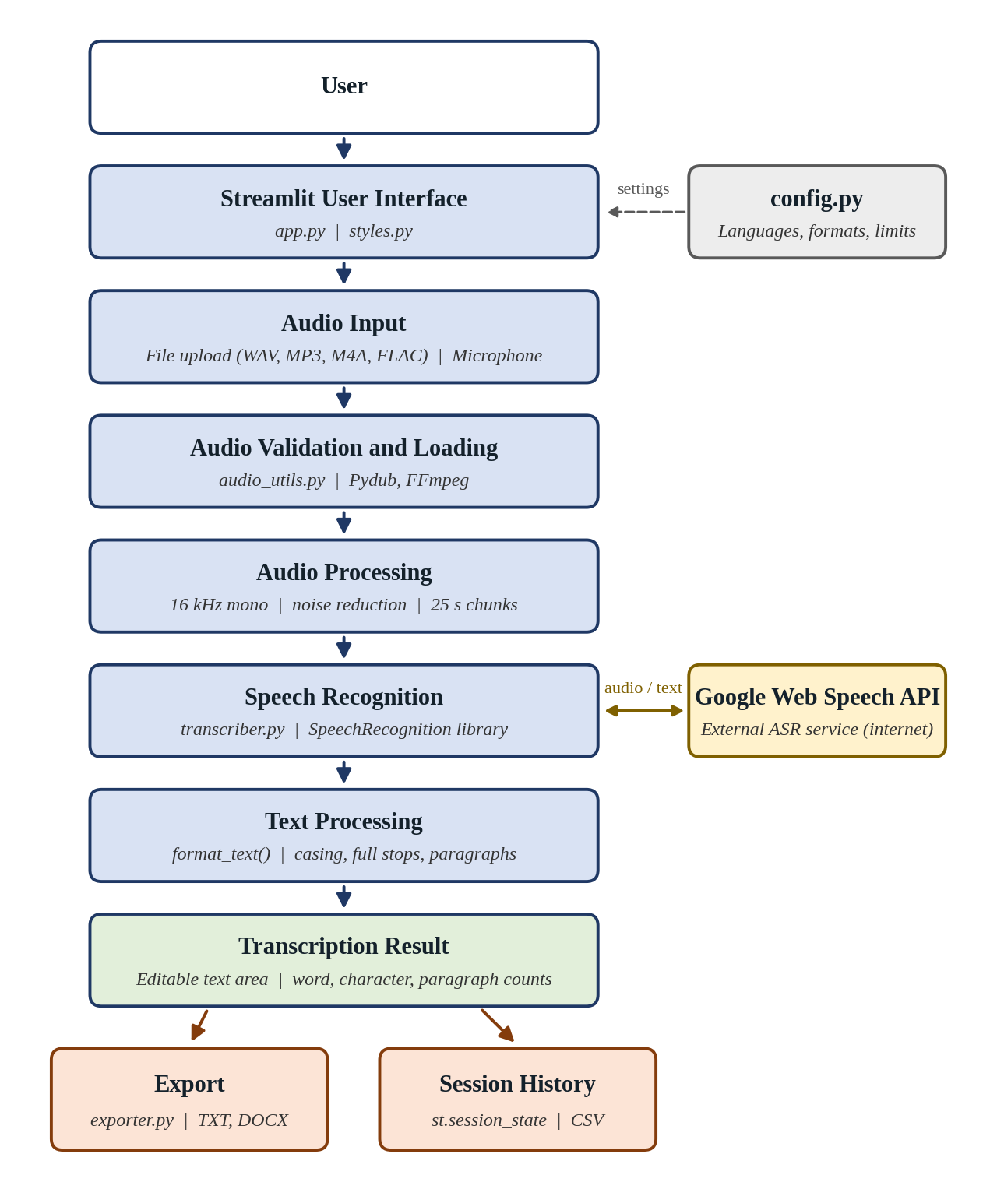
Figure 4.1: System Architecture of the AI-Based Speech-to-Text Transcription System
Figure 4.1 shows the main stages of the pipeline and the Python file that implements each stage. The configuration file supplies the languages, supported formats and limits to the other modules.

4.2 Application Architecture
The project is organised into small modules, each with one responsibility. This separation keeps the interface code free of audio and recognition details and makes each part easier to test and modify.
Speech-to-Text-Transcription-System/
|-- app.py # Streamlet UI, session state, dashboard, history
|-- audio_utils.py # audio loading, validation, pre-processing, chunking
|-- transcriber.py # speech recognition and text formatting
|-- exporter.py # TXT and DOCX export
|-- styles.py # custom CSS, dashboard cards, workflow bar
|-- config.py # languages, formats and limits
|-- config.toml # Streamlet theme and server settings
|-- requirements.txt # Python dependencies
`-- README.md # setup instructions and design notes
Table 4.1 Project Files and Their Purpose
File | Purpose
app.py | Main Streamlet application: page layout, sidebar settings, audio input, transcription button, result editor, export buttons, session history and dashboard.
audio_utils.py | Loading audio with Pydub, checking MPEG availability, rejecting empty audio, converting to mono 16 kHz, noise clean-up and splitting into chunks.
transcriber.py | Recognising each chunk with Speech Recognition and the Google Web Speech API, counting unclear chunks, and formatting the final text.
exporter.py | Creating the TXT (bytes) and DOCX (python-docx) files for download.
styles.py | CSS for the header banner, workflow bar, dashboard cards, buttons and text area; functions that build the cards and workflow bar.
config.py | Central configuration: application title, language table, supported formats, maximum file size, chunk length, sample rate and silence threshold.
config.toml | Streamlit theme colours and font, upload size limit of 100 MB, and disabling of usage statistics.
requirements.txt | Dependencies: streamlet, Speech Recognition, pydub, python-docx, pandas, and audioop-lts for Python 3.13 and later.

The key settings in config.py are summarised below. Keeping them in one place allows a language or limit to be changed without touching the logic.
LANGUAGES = {"English": "en-US", "Tamil": "ta-IN"}
SUPPORTED_FORMATS = ["wav", "mp3", "m4a", "flac"]
MAX_FILE_MB = 100
CHUNK_SECONDS = 25 # short clips suit the free recognition API
SAMPLE_RATE = 16000 # 16 kHz mono is standard for speech recognition
SILENCE_DBFS = -55 # chunks quieter than this are treated as silence

4.3 User Interface
The interface is built using Streamlit with a wide layout and custom CSS. The main components are:
- Sidebar: Language selection, noise reduction, FFmpeg status, and internet/engine information.
- Header: Application title and description.
- Workflow bar: Shows seven stages from audio input to export.
- Dashboard cards: Displays transcription count, word count, audio duration, and language.
- Four sections: Audio Input, Transcribe, Transcription, and Session History.
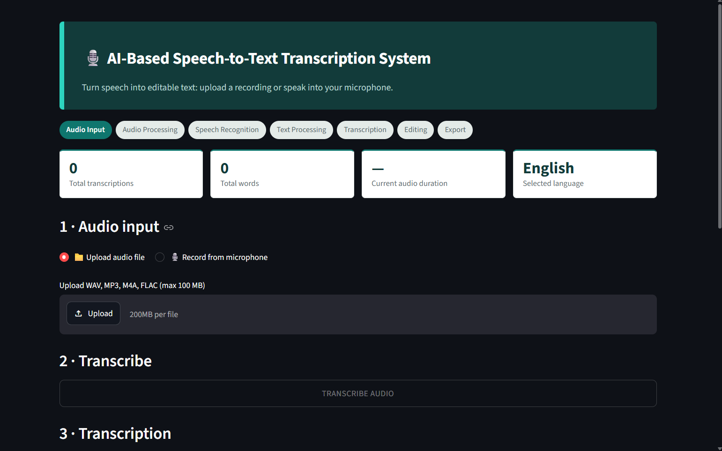
Figure 4.2: Main Dashboard of the Speech-to-Text Application
Figure 4.2 shows the header banner, workflow bar, dashboard cards and sidebar settings when the application is first opened.

4.4 Audio File Upload Module
When the upload option is selected, the application displays a file uploader that accepts a single file. The uploader itself does not restrict file types, so the application checks the extension and size in its own code and shows an error message if the file is unsuitable.
ext = f.name.rsplit(".", 1)[-1].lower() if "." in f.name else ""
if ext not in SUPPORTED_FORMATS:
st.error("Unsupported format ... Please upload one of: WAV, MP3, M4A, FLAC.")
elif f.size > MAX_FILE_MB * 1024 * 1024:
st.error("File is larger than 100 MB. Please upload a smaller file.")
else:
data, name = vegetable(), f.name
A valid file is decoded by the function cached load(), which calls load audio() in audio_utils.py. The decorator st.cache_resource (limited to three entries) keeps decoded audio in memory, so that the file is not decoded again each time Streamlet re-runs the script. After decoding, the application plays the audio with St. Audio() and displays four metrics: file name (shortened if long), file type, duration in minutes and seconds, and size in megabytes.

4.5 Microphone Recording Module
When Microphone is selected, the application uses Streamlit’s st.audio_input() to record speech directly from the browser. The system checks whether this feature is available and asks for microphone permission if needed.
The recording is saved with a time-based filename, such as recording_HHMMSS.wav, and follows the same processing path as an uploaded WAV file. PyAudio was avoided because it can be difficult to install on Windows, while browser-based recording requires no extra installation.

4.6 Speech Recognition Module
Speech recognition is performed in two steps: audio preparation in audio_utils.py and speech recognition in transcriber.py.
The prepare() function checks that the audio is at least 0.5 seconds long and not silent. It converts the audio to mono, 16 kHz, and 16-bit format. If noise reduction is enabled, a 100 Hz high-pass filter and normalisation are applied. The split() function then divides the audio into 25-second chunks.
seg = seg.set_channels(1).set_frame_rate(SAMPLE_RATE).set_sample_width(2)
if reduce_noise:
seg = normalize(high_pass_filter(seg, 100))
The transcribe_segments() function creates a Recognizer and processes each chunk. Chunks below −55 dBFS are skipped. Other chunks are converted to an in-memory WAV file and passed to recognize_google() using the selected language.
with sr.AudioFile(buf) as src:
audio = recognizer.record(src)
parts.append(recognizer.recognize_google(audio, language=language_code))
If speech cannot be understood, the chunk is counted as unclear. If the recognition service cannot be reached, a TranscriptionError is raised. The progress callback updates the interface with “Recognising speech… part i of n”.
The actual speech recognition is performed by the Google Speech Recognition service through recognize_google(). The project does not contain any model-training code.

4.7 Transcription Result Module
After recognition, format_text() processes the list of recognised parts. It collapses repeated spaces, capitalises the first letter, adds a full stop if the part does not already end with ., ! or ?, and joins every three parts into a paragraph separated by a blank line. The returned text is stored in the session-state variable editor, which is linked to the text area by its key, so the text appears in the editor and can be changed by the user.
Below the text area, three metrics show the number of words, characters and paragraphs. They are calculated from the current content, so they change as the user edits the text. If some chunks were not understood, a warning states how many parts were skipped.
WEBSITE LINK: https://github.com/cvelan62-sys/Speech-to-Text-Transcription-System

Table 4.2Error Handling in the Implementation
Situation | Where handled | Message / behaviour
Unsupported file type | app.py | Error stating the unsupported extension and listing the allowed formats.
File larger than 100 MB | app.py | Error asking for a smaller file.
MP3/M4A/FLAC without FFmpeg | audio_utils.load_audio() | Message that FFmpeg is required, with the option of uploading a WAV file.
Corrupted or unreadable file | audio_utils.load_audio() | Message that the file could not be read or uses an unsupported encoding.
Empty or silent audio | audio_utils.prepare() | Message asking for audio that contains speech.
Silent chunks | transcriber.py | Skipped without calling the service.
Speech not understood | transcriber.py | Chunk counted as unclear; a warning reports the number skipped.
No speech recognised at all | app.py | Error suggesting a closer microphone, less noise and a matching language.
Service or network failure | transcriber.py | Message to check the internet connection and retry.
Other recognition failure | transcriber.py | Message to try a different file or language.
Recording not supported | app.py | Message to upgrade Streamlit.
Unexpected error | app.py | General message; details logged.

4.8 Important Functions and Modules
Table 4.3 Important Functions
Function | File | Purpose
ffmpeg_available() | audio_utils.py | Checks whether FFmpeg is installed on the system.
load_audio() | audio_utils.py | Decodes uploaded or recorded bytes into an audio segment, with friendly errors.
prepare() | audio_utils.py | Rejects empty audio, converts to mono 16 kHz, applies optional noise clean-up.
split() | audio_utils.py | Divides the audio into 25-second chunks.
transcribe_segments() | transcriber.py | Recognises the chunks through the Google Web Speech API and counts unclear chunks.
format_text() | transcriber.py | Capitalises, adds full stops and groups text into paragraphs.
to_txt(), to_docx() | exporter.py | Create TXT and DOCX downloads.
cards(), pipeline() | styles.py | Build the HTML for dashboard cards and the workflow bar.
cached_load() | app.py | Caches decoded audio between Streamlit re-runs.
copy_button() | app.py | Embeds the clipboard copy button.
load_record(), clear_text() | app.py | Callbacks to reload a history record and to clear the editor.
fmt_time() | app.py | Formats seconds as mm:ss.

CHAPTER 5

RESULTS AND DISCUSSION
This chapter describes the output of the AI-Based Speech-to-Text Transcription System. The behaviour described is that defined by the project source code and the project documentation. The figures that illustrate the running application are marked as screenshot positions, to be filled with actual screenshots of the application taken by the student. No accuracy percentage, dataset or performance measurement is reported, because none was produced during the project.

5.1 Application Output
The final output of the project is a working Streamlit web application, started with streamlit run app.py, that carries the user from audio input to an editable and exportable transcription on a single page. The page contains a header banner, a workflow bar, four dashboard cards, the four numbered sections for input, transcription, result and history, and a sidebar for the settings. The application accepts WAV, MP3, M4A and FLAC files and microphone recordings, supports English and Tamil, and produces output as editable text, TXT and DOCX files, and a CSV history.
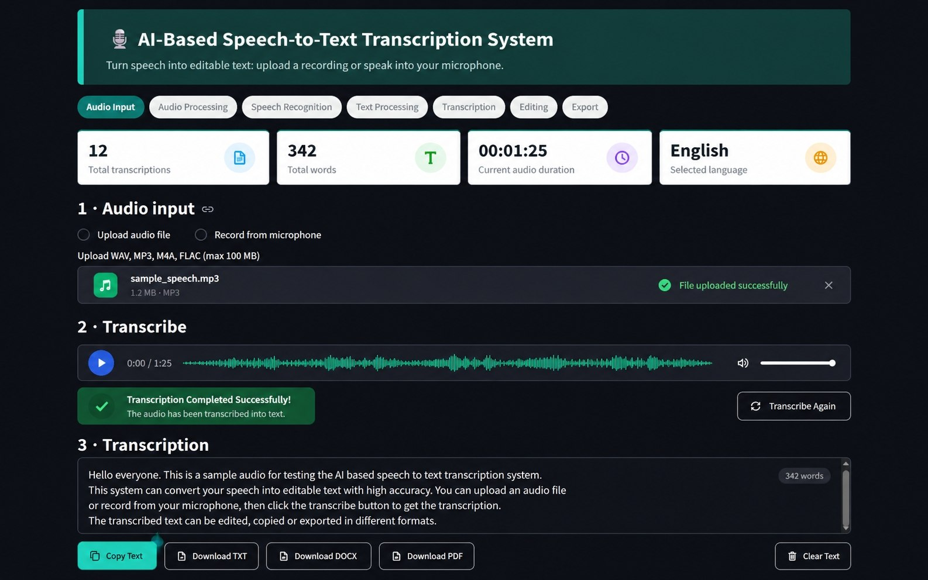
Figure 5.1: Successful Transcription Output
Figure 5.1 shows the complete application page after a successful transcription, with the text in the editor and the counts and dashboard updated.

5.2 Dashboard Result
The dashboard consists of four cards that are refreshed each time the page is drawn: the total number of transcriptions and the total number of words in the session history, the duration of the audio that is currently loaded (shown as a dash when no audio is loaded) and the selected language. The workflow bar above the cards reflects the state of the work: it shows Audio Input as the current step before audio is supplied, Audio Processing once audio is loaded, and Editing, with the earlier steps marked as complete, once a transcription is available. The dashboard therefore gives the user an immediate summary of the session and of the current stage.

5.3 Audio Upload Result
When a supported audio file is uploaded, the application decodes it and displays an audio player and four information boxes showing the file name, type, duration (mm:ss) and size (MB). The TRANSCRIBE AUDIO button, which is disabled while no valid audio is loaded, becomes available. If the file has an unsupported extension, exceeds 100 MB, needs FFmpeg that is not installed, or cannot be decoded, a clear error message is displayed in place of the information boxes.
WEBSITE LINK: https://github.com/cvelan62-sys/Speech-to-Text-Transcription-System

5.4 Microphone Recording Result
In the microphone mode, the browser asks for permission to use the microphone and the user records speech with the start and stop controls. The recording is treated as a WAV file named with the time of recording, its information is displayed in the same way as for an uploaded file, and it can be transcribed with the same button. Because recording takes place in the browser, the feature does not depend on a microphone library installed on the computer.
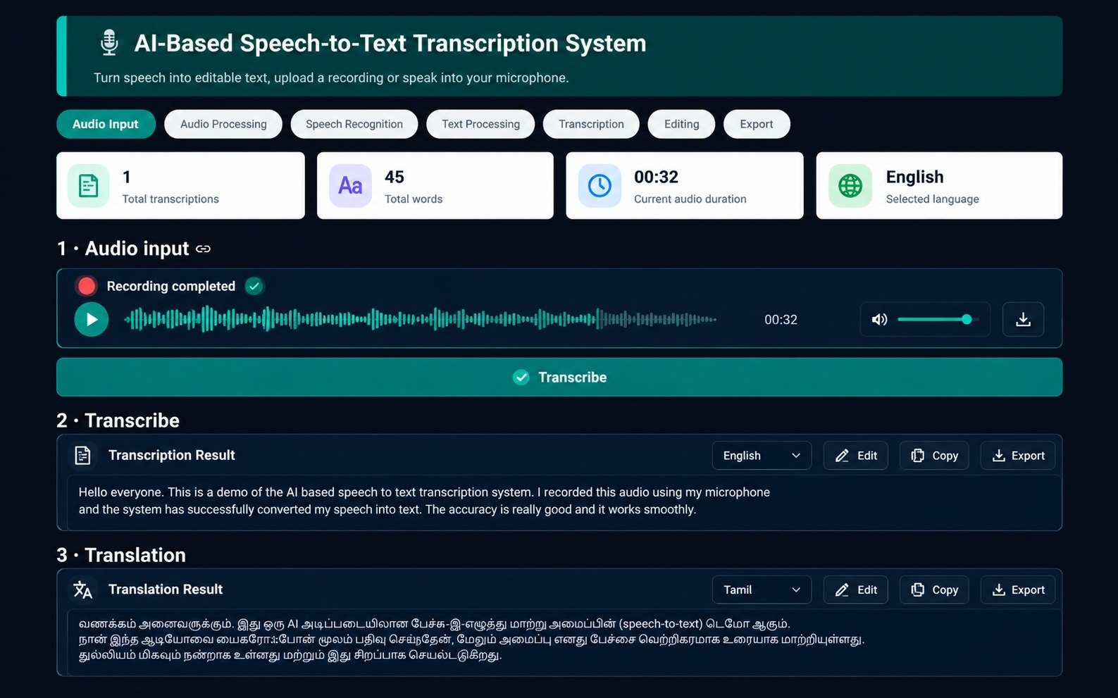
Figure 5.4: Microphone Recording Result
Figure 5.4 shows a completed recording with its information panel.

5.5 Speech Transcription Result
When transcription is started, a status box shows the stages “Processing audio…” and “Recognising speech… part i of n” with a progress bar, and ends with “Transcription complete”. The recognised text is shown in the editor as sentences that begin with capital letters and end with full stops, grouped in paragraphs of up to three recognised parts. The text reflects what the recognition service returned; it may contain recognition errors, and the engine does not predict punctuation other than the full stops added by the text-processing step.
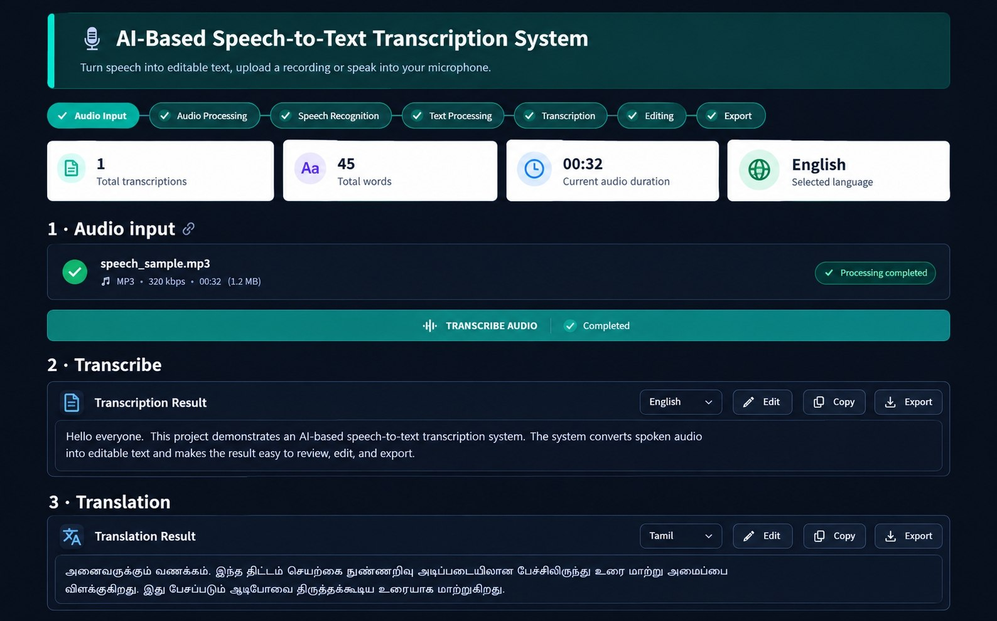

5.6 Testing Results
Table 5.1 lists the functional test cases for the application. The column “Expected Result” gives the behaviour defined by the implementation, and the column “Module” shows where that behaviour is implemented. The column “Observed Result” is to be completed with Pass or Fail by the student while running each test on the final application, so that only results actually observed are recorded.
Table 5.1 Functional Test Cases
No. | Test Case | Expected Result (as implemented) | Module | Observed Result
1 | Upload a valid WAV file | File accepted; name, type, duration and size shown; audio player appears; TRANSCRIBE AUDIO button enabled. | app.py, audio_utils
2 | Upload MP3, M4A or FLAC with FFmpeg installed | File decoded and information shown as for WAV. | audio_utils
3 | Upload MP3 without FFmpeg | Message that the format needs FFmpeg; WAV suggested. | audio_utils
4 | Upload an unsupported file type | Error naming the unsupported extension and listing allowed formats. | app.py
5 | Upload a file larger than 100 MB | Error asking for a smaller file. | app.py, config.toml
6 | Upload a corrupted audio file | Message that the file could not be read. | audio_utils
7 | Transcribe silent or very short audio | Message that the audio is empty or silent. | audio_utils
8 | Record speech from the microphone | Recording named recording_HHMMSS.wav; information shown; transcription enabled. | app.py
9 | Transcribe English speech with English selected | Formatted text appears in the editor; record added to history; dashboard updated. | transcriber, app.py
10 | Transcribe Tamil speech with Tamil selected | Tamil text appears in the editor; record added to history. | transcriber, config
11 | Audio containing unclear parts | Warning stating how many parts were skipped. | transcriber, app.py
12 | Audio with no recognisable speech | Error stating that no clear speech was detected. | app.py
13 | Transcribe without internet connection | Message to check the connection and try again. | transcriber
14 | Edit the transcription text | Word, character and paragraph counts update. | app.py
15 | Press Copy transcription | Text copied; button briefly shows “Copied!”. | app.py
16 | Press Download TXT / Download DOCX | transcription.txt / transcription.docx downloaded with the current text. | exporter
17 | Press Clear transcription | Editor emptied; export buttons disabled. | app.py
18 | Open a history record and press Load into editor | Record text, source and language loaded into the editor. | app.py
19 | Press History (CSV) and Clear history | CSV downloaded; history list emptied. | app.py

5.7 Skills Gained
- Python development: structuring a project into modules, defining functions and custom exceptions, using session data and working with bytes, files and in-memory buffers.
- Streamlit development: building an interactive interface with widgets, session state, caching, progress indicators, download buttons and custom CSS.
- Audio processing: understanding sampling rate, channels, loudness, filtering, normalisation and chunking, and using Pydub and FFmpeg.
- Speech recognition integration: using the SpeechRecognition library with the Google Web Speech API and handling its responses and exceptions.
- AI and ASR concepts: understanding how ASR works and the difference between training a model and integrating an existing recognition service.
- UI/UX design: designing a clear workflow, readable dashboard and helpful messages for users.
- Error handling and debugging: anticipating failure cases such as invalid files, silent audio, missing tools and network problems, and presenting them clearly.
- Software architecture and version control: separating interface, audio, recognition, export, styling and configuration, and keeping the code in a GitHub repository.
- Testing and documentation: preparing functional test cases and documenting the system and its limitations in this report.

5.8 Limitations and Discussion
The project successfully provides a complete workflow from speech input to editable and exportable text. Key design choices include using 25-second audio chunks, skipping silent parts, handling unclear speech without stopping, and using browser-based recording instead of PyAudio.
Limitations
- Recognition accuracy depends on audio quality, noise, accent, and speaking style.
- Internet connection is required, and audio is sent to an external service.
- Punctuation is limited to basic capitalization and full stops.
- Fixed 25-second chunks may split words at boundaries.
- Noise reduction uses only basic normalization and a high-pass filter.
- Transcription history is lost when the browser session ends.
- MP3, M4A, and FLAC require FFmpeg.
- Only English and Tamil are supported; speaker identification and timestamps are not available.

INTERNSHIP CERTIFICATE
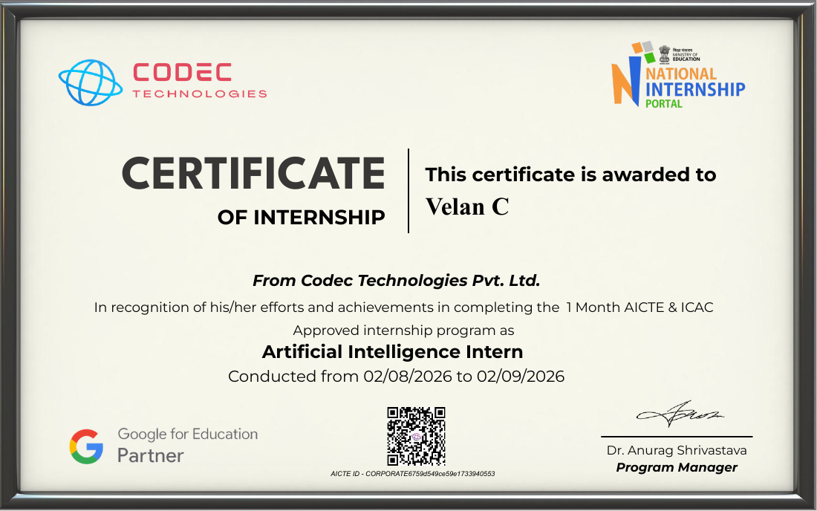
Figure 5.9: Internship Certificate issued by Codec Technologies Pvt. Ltd. to Velan C (Artificial Intelligence Intern, 02/08/2026 to 02/09/2026)

