T1: Creation of Music Critic Exercise

A1-Part-1: Tutorial: Test the Billy Jean Track(2pts)  
My first test showed microphone not working well. The problem was Firefox.  
It works OK with MS Edge browser.

Done 1 recording

Ready to roll more recordings.

The Sound Settings used were as follows:

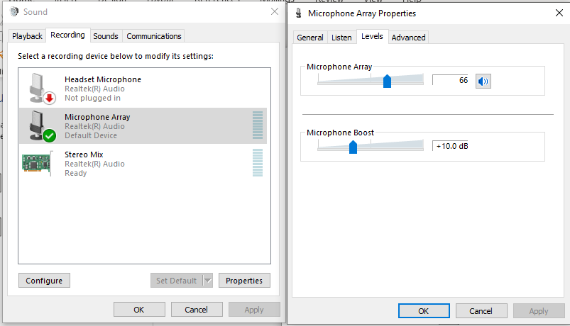

The file can be located here:

bass-critic\bassimmusic-experiments\bass_for_beginners\student_recording\BillieJeanRecording1.wav

Audacity was used to boost the amplitude 20dB. Although there is some audible background noise, the resulting signal is a good candidate for performance assessment in Music Critic.

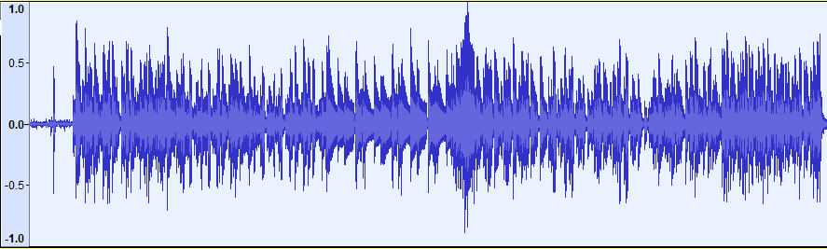

# A1-Part-2: Create Separate Repository(1pt)

The Repository shall be titled “Bass Critic” and is private with access only granted to supervisors.

The main README was added with a summary describing how the repository will be organised into an Experimental section and a Deployment section. (These are not subfolders with 1:1 mapping as such, but concepts of development. As the hierarchy of the repository evolves these sections, should be clearly identified in folder groups)

https://github.com/cvf-bcn-gituser/bass-critic

The Experimental section shall contain the necessary Notebooks that make measurements on offset and on duration, the implementation of which shall be done in “T2: Offset, Onset and Duration Experiments”

The Deployment section shall be organised in folders that separate the Data from the Functionality.

The Data section shall contain the recordings, score, text files , etc that shall be used in the Landing Pages for the Students

<https://github.com/cvf-bcn-gituser/bass-critic/tree/main/bassimmusic-experiments/bass_for_beginners/data/exercises/trinity/bass>

The Data section shall contain the Lillipond and JSON for the selected audio to allow the assessment to take place.

# A1-Part-3: Define Purpose and Objectives of Exercise(2pts)

## Exercise Objective Requirements

Data shall be gathered from real student performances that will give a good distribution of good, fair and bad performances. The aim is to have three outputs in each quality category.

The “ground truth” (GT) is the Trinity Stem of the separate Bass. The GT should give a fully green output on Music Critic on all the pitch and rhythm markings.

So together with 9 performances and 1 GT, the idea is to have 10 example stems in total for each song.

The Performances shall be assessed using the criteria of the TCL Rock and Pop template, with numbers and comments given in the sections of Fluency/Security, Technical Control and also Communication and Style.

A normal song is graded as follows:

Fluency & Security: 8

Technical Control: 8

Communication and Style : 9

A TF song is given the following weights

Fluency & Security: 8

Technical Control: 12

Communication and Style : 9

The Performance assessment shall be done by a qualified teacher. If necessary, some check on the final assessment shall be done with other volunteer expert resources available within the MTG.

The Performance Assessment details shall be customised according to each song in a later section called “Performance Assessment Requirements”.

# A1-Part-4: Define Music Songs for Addition to MC(2pts)

The first batch of songs consists of six extracts that together sum to 500 seconds of recorded backing tracks. All songs with the last (Walking on the Moon) have been chosen based on Technical Focus marked songs between grade 0 and grade 3.

|  |  |  |  |
| --- | --- | --- | --- |
|  |  |  | **Seconds** |
| Grade 0 | 1 | Yellow | 93 |
| Grade 1 | 2 | Billie Jean | 55 |
| Grade 1 | 3 | Just Looking | 86 |
| Grade 2 | 4 | Brown Eyed Girl | 64 |
| Grade 3 | 5 | Roadrunner | 82 |
| Grade 3 | 6 | Walking on the Moon | 120 |
|  |  |  | 500 |

The short listing of the songs has been made on the basis of covering as many aspects as the Trinity guidelines cover in the explanations of the Technical Focus songs.

The second batch of songs consists of six extracts that together sum to 523 seconds of recorded backing tracks. All songs with the last (Walking on the Moon) have been chosen based on Technical Focus marked songs between grade 0 and grade 4.

|  |  |  |  |
| --- | --- | --- | --- |
|  |  |  | **Seconds** |
| Grade 0 | 1 | Standby Me | 44 |
| Grade 0 | 2 | Shelter | 59 |
| Grade 1 | 3 | Labelled with Love | 60 |
| Grade 2 | 4 | Something to Talk about | 60 |
| Grade 2 | 5 | Sweet Disposition | 63 |
| Grade 3 | 6 | Seasons | 60 |
| Grade 3 | 7 | Misery Business | 60 |
| Grade 4 | 8 | Sledgehammer | 117 |
|  |  |  | 523 |

# A1-Part-5: Design Landing Page (2pts)

## Landing Page Requirements

A real student performance requires a landing page that describes the song that is about to be recorded and explains the parameters of the song (BPM, pitch, etc). The best landing page illustration is that the student shall see the score so that they can prepare a little bit before recording.

The Landing Page shall also contain a link to the Demo version of the song so that the student can listen to the song to get familiar before recording.

The Landing Page shall be located by means of link to each demo song shall appear as follows

https://musiccritic.upf.edu/training/demo/<number>

e.g., for Billie Jean

<https://musiccritic.upf.edu/training/demo/203>

Here is how the Upper Section shall look:

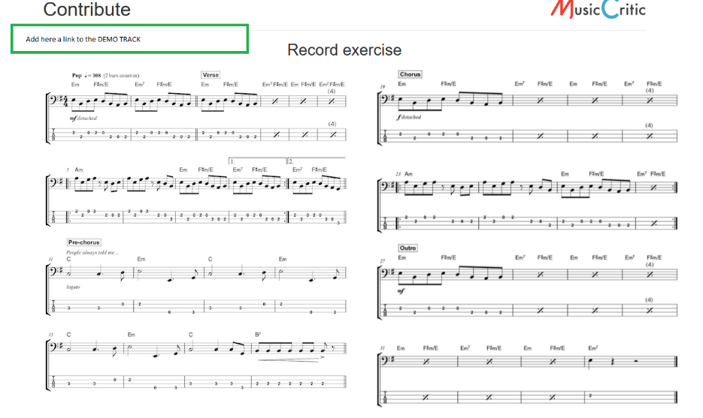

Here is how the lower section shall look:

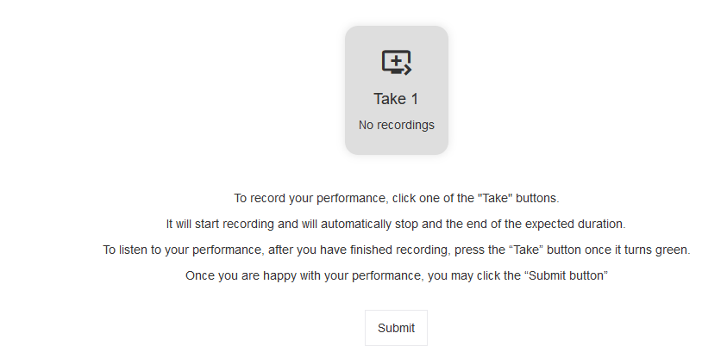

The displayed test above shall be taken from the file “Guidelines.txt”

<https://github.com/cvf-bcn-gituser/bass-critic/blob/main/bassimmusic-experiments/bass_for_beginners/data/exercises/trinity/bass/Guidelines.txt>

The Landing Page availability is crucial to begin Student recordings. As a goal the timestamp:  
 21 April 11am, shall be marked as having it “UP” for Batch 1.

# A1-Part-6: Define Teacher Requirements Schedule and Researcher Follow up Actions(3pts)

## Performance Assessment Requirements

There will be a customized Google Form that will concentrate the assessment on the areas of Rhythm and timing precision for each individual song.

The quality aspects of the recording to be considered shall take into account the following aspects, starting with the ones that have highest priority and then in descending order of priority.

* Note Lengths
* Rhythm and Rhythmic Accuracy
* Syncopation
* Accented syncopation
* Phrasing
* Repeated notes
* Dynamics
* Articulation
* Coordination
* Swing
* Slides
* Rests
* Semi quaver push
* Palm Muting

The above aspects are displayed in an accompanying working document called **“PerformanceAssessmentMatrix.xls**” that related each quality aspect to song.

Also, an attempt shall be made to “objectify” as much as possible these descriptions into numbers that can be defined in low level audio parameters.  
e.g. If the Articulation indicates a note is “staccato” or , this will map to shorter duration. Syncopation characteristics will influence the “lateness” or “early-ness” of a particular onset.

All of these subjective to objective mappings shall be elaborated in the file **“PerformanceAssessmentMatrix.xls**” while the student recordings are taking place.

The mapping must be completed in time in order to publish the final version of the Google Form that shall be used by the Teacher for doing the Human Assessment and filling out the Rubik for each song and for each Student performance.

The Teacher-Researcher meeting shall take place on Wed. 21st April 11am.

For this, meeting, a completed google form for 1 song shall be ready.

In this meeting the time estimates shall be agreed for working through batch 1 and batch 2 of the songs.

The target date for completing the Batch 1 assessments shall be between 27 and 28 April.

This will mean that all student performances need to be completed over the weekend 24-25 April.

In parallel with these activities the Masters Student shall do all the annotations (JSON/Lilly Pond file) editing for all of the Batch 1 songs.

In parallel with these activities the Masters Student shall start training a model based “Fake Data”.

The Models used for training shall be based on the ones used previously for the Guitar.

When the Teacher has completed the human assessment then the Masters Student has all JSON and LILLY files ready, then the Training can begin

The Main Project Objective is to have begun this training on Real Performance Data and be able to show Frederick Font a sample and progress on this on 29 April 11am.

The best case scenario would be to have this Batch 1 completed and plans for Batch 2 underway (or a decision on whether it is needed or not).

Questions and Answer Section

**What if there are not enough student recordings?**

The teacher and researcher can fill the gap.

**What if….. ?**

Then……

**What if….. ?**

Then……

**What if….. ?**

Then……

**What if….. ?**

Then……

**What if….. ?**

Then……