T2: Offset, Onset and Duration Experiments

# Overview

The objective of this Work Package 2 (or track 2) is to check-in a baseline ( jargon for “First Software Revision”) of set of notebooks that form part of the experiments in evaluating suitable algorithms that will accurately capture onset and offset locations for bass guitar and derived from this the duration. Since we are dealing with jupyter notebooks a shared google drive shall be used for tests. When stable software versions are available, these shall be checked into github as notebooks and “.py” files.

First Github Check-ins: Date: 6 May 2021

Initial experiments with comparing onset/offset algorithms with ground truth

These are 4 notebooks that are based around the same RMS based offset algorithms and “off the shelf” onset algorithms from essential.

Directory of e:\THESIS_CODE\bass-critic\transcription-experiments

Notebook: calculatedurationsabesser.py

Core Function: calculate_offset()

Description: Measure offset using RMS measurements on each frame.

Test Data: 002.wav;004.wav;010.wav;012.wav

Notebook: calculateonsetsabesser.py

Description: Onset measurements using essential onsets_hfc/ onsets_complex

Test Data: 002.wav; 004.wav; 010.wav; 012.wav.

Notebook: calculatestudentdurationsbrown.py

Description: Measure offset using RMS measurements on each frame.

Test Data: Grade 1 Trinity Song : Brown Eyed Girl (Van Morrison )

Stem and student performances

Notebook: calculatestudentdurationsyellow.py

Description: Measure offset using RMS measurements on each frame.

Test Data: Grade 0 Trinity Song : Yellow (cold play )

Stem and student performances performances

Abessers Test Data:

This is related to Abessers paper [1] paper and uses annotated the annotated dataset” IDMT-SMT-BASS-SINGLE-TRACK”

The tracks 2,4,10 and 12 from this DS (dataset)are the most closely aligned with the complexity of the basic Trinity Grades. The DS contains score (PDF), annotated onsets/offset(in XML) and audio (in .WAV).

List of Notebooks in Google drive (not yet in github):

* OffsetTradeStudy.ipynb
* OnsetTradeStudy.ipynb
* OnsetOffsetAlgorithms.ipynb

# Requirements for Onset/Offset experiments in WP2 and WP3.

This section describes the main objective and breaks it down to individual requirements.

In both onset and offset algorithms, a set of evaluation results will require numerically measuring accuracy. This will form the basis or criteria for choosing proper onset/offset algorithm. Initially this is achieved by numerically calculating differences between the ground truth onsets  
/ offsets and the measured values.

Micro-onset measures the extent in which the onset time for properly detected notes deviates from ground truth onset.

For histogram plots, plotly shall be used in conjunction with pandas

It is measured for each note and the accumulated deviations shall lead to presenting distribution histogram and basic statistics (mean and std. deviation) for each song and for the dataset.

Offset measurement only applies to micro measurements, no macro measurements apply.

(because it makes no sense to talk about offsets of falsely detected notes).

The offset time (or duration) shall deviate (or not) from a ground truth offset time (or duration).

The absolute deviation shall be measure in seconds

The relative deviation shall be measured in % of ground truth note duration.

The measured deviation for each event shall lead to presenting distribution histogram and basic statistics (mean and std. deviation) for each song and for the dataset.

An estimate shall be made on how student's performance deviates from reference one on macro level (onsets).

An estimate shall be made on how student's performance deviates from reference one on micro -onset level.

An estimate shall be made on how student's performance deviates from reference one on micro -offset level.

These estimates shall be correlated with the grades given by teachers.

A macro measurement shall show if all the notes are played.

A macro measurement shall show if any imposter notes are played

(e.g., Frederic's performance of Billie Jean should not be super accurate on "macro" level).

The micro-rhythm deviations shall have greater weigh in affecting overall student grade.

# T2-Part-1: Trade Study of Onset measurements for Bass in Notebook (2pts)

The term “Trade Study” is a way to describe the comparison of different algorithms.

**In progress:**

For measuring onsets, the following candidate approaches are under study.

1. HFC/ Complex Essentia
2. Current Music Critic (Essentia / Madmom combination)

So far, the green lines of the “Abesser” annotated ground truth have been shown to have a good correlation with (1). In (2) considerations are given for chords which may not apply to bass.

The first approach(1) has provided some promising outcomes. The plots below show the 002.wav signal with the measured onset in red and the annotated offsets in green. (The X-axis is time given in samples)

Measured Onsets Positions

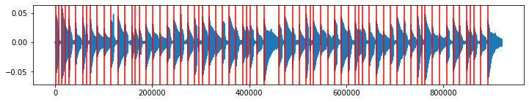

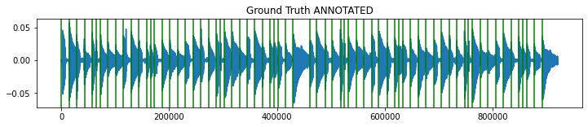

The second approach (2), using the currently implemented pysimmusic algorithms shall be evaluated in subsequent revisions of this work package. This approach will have to be customised to take account of the following:

* The onsets do not have to detect chords
* The onsets shall have to take into account the attack qualities of finger and plectrum styles of playing.
* The onset detection will have to be optimised for the lower register of the bass notes and their different timbre qualities to guitar strings.

At the moments there are no plots available for the second approach, these shall be shown in subsequent revisions. Generally, onset measurement is a wel- known problem and there are several alternative ways of implementing this and there are referenced in the SOTA references. One candidate method would to test the onset_SOP() function developed by Ramon Romeu.

# T2-Part-2: Trade Study of Offset and duration measurement algorithms (2pts)

In contrast to onsets, measurement, Offsets are not well studies and research into relevant techniques are at the core of the masters thesis. Without offset there is not duration measurements.

From the total 17 number of tracks of Abesser DS, 4 have been short listed for first set of algorithm evaluations. These 4 tracks are “finger style” tracks and they fall approximately within the Grade Scope of the project.

The first offset algorithm is based on a simple RMS frame by frame measurement approach and is contained in the notebook “Calculatedurationsabesser.ipynb” . The plots below show a narrow section of the 002.wav signal with the measured onset in yellow and the annotated offsets in green. (The X-axis is time given in seconds)

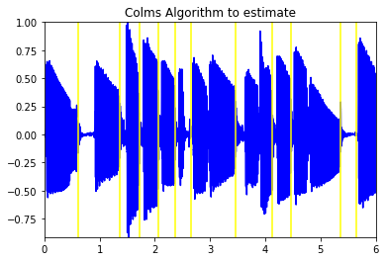

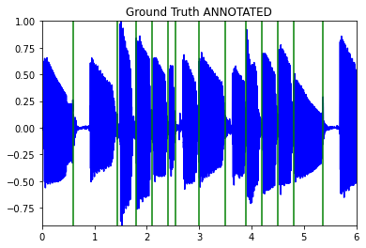

There are some “false hits” (e.g., the last yellow line) and some ambiguity in the region 2.4 to 2.7 seconds, a “missed note” at 3.9 seconds but generally , the alignment is very good. Some measurements were made calculating the differences in the closely aligned green and yellow lines, and it shows that we still have some way to go before we can get a good tolerance for deviation from the ground truth. There should be a high concentration around the centre with 90% of the notes falling withing 50 ms. Anything outside of this would not be acceptable for music education standards.

There is another notebook, that is work in progress called “OffsetTradeStudy.ipynb” that will extend first notebook experiments (“Calculatedurationsabesser.ipynb”) to use the Trinity Dataset songs

The second offset algorithm is based on Ramon Romeus “Tone experiments” with the saxophone. It segments the song using the onsets (superflux method from madmom library). Between the note onset, and the next note onset, there is where the note is. An energy activation function filters out "interonset notes" that are mostly silent. This notebook shall be studied in the next section  
 T2-Part 3.

# T2-Part-3 -Alternative methods to extract onset and offset information

(Please note: The first offset algorithm was developed without any knowledge of Ramons code)

Ramons algorithms is also based on measuring energy. The function he used was modified to produce the function myOnsetEnergyChecker()in the notebook OnsetOffsetAlgorithms.ipynb.

**This function returns start and stop indices that indicated the onset and offset points.**

These indices were obtained from the audio file 002.wav. The offset deviation histogram appears as follows:

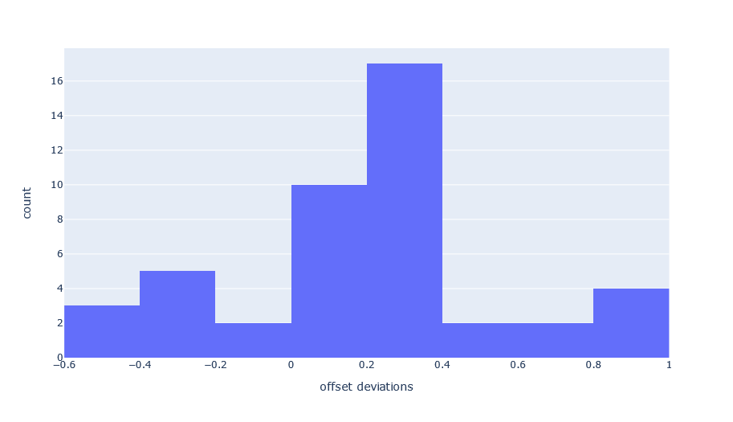

These deviations are too wide for music education standards. Perhaps a customised approach needs to be adopted depending on inter-onset intervals. E.g. for Billy Jean you have “jerky notes” where offset detection is theoretically easier. On the other hand a legato section, where one offset runs into the onset of the subsequent note is more complicated to determine using energy measurements.

Ideally a music sections style discrimination would allow us to choose legato or staccato sensitive approaches to offset measurements.

# T2-Part-4: Conduct first Teacher analysis of Recordings (4pts)

All results need to be imported into Notebooks and used as a comparison for the different observed deviations from the Stem recordings.

Statistically deviations from onset cause more impact on teacher results. Also, abrupt endings where it is no allowed (e.g. Walking on the Moon by the Police) could also be very noticeable

For each recording there may be a need to postprocess the data,( i.e. collect all the statistics manually of (a) Excess Notes (b) Missing Notes) to compliment the teachers observations.

**Checklist:**

Construction of fake data for pre-analysis

* Some artificial deviations were generated from ideal onsets and offsets to help find tune the function: def get_devs(measured, a_gt,thresh)

Completed Grading for 50 songs

* Done, but some post processing needed on statistics and also some recalibration with respect to the Trinity stem with a second teacher. Please note, original teacher no longer available.

Teachers recording pending.

* The teacher did not send his samples. These wont be received.

Export to CSV / JSON

* Pandas analysis of results is the end goal of pre-processing the teacher data. This shall be moved to Work Package 4.

Analysis of Comments. e.g. Mapping of articulation descriptions into note separation measurements.

* Mapping of syncopation descriptions to onset deviations windows
* Definition of note with Tenuto duration
* Definition of duration of notes tied/legato
* Definition of note duration that are staccato
* Definition of note duration that have underline(Roadrunner)

**All this shall be moved to Work Package 4.**

Definition of Lilly Pond and JSON File for 5 Trinity Songs(Standard Technical Procedure-Predictable time)

* TO DO

**Open “Availability” Issues:**

1. “IDMT-SMT-BASS-VAR-DUR” is not available on Frauenhofer website. Pending a follow up on this. This is a dataset that focuses on different durations for single notes.
2. No direct link to matlab code from Absessers papers. Some tool box code “pymus” on github for F0 tracker to compare with methods used in MusicCritic. No code samples to implement math formula provided in [1]

**Open “Academic” Issues:**

1. Find "technological" correlate of music education notion of "note separation" or "articulation".
2. How to deal with Imposter Notes, Missing Notes?

-> work in progress in OnsetOffsetAlgorithms.ipynb

1. How do we manage what should be “onset dependent-offset measurement”  
   -> work in progress in OnsetOffsetAlgorithms.ipynb

**Ideas considered but not yet tried:**

* Segmentation exercise(ASP Lab 6)
* Helper functions MIR assignment 1
* Related Essentia Algorithms (for Fo detection, Music Transcription)

PitchContourSegmentation.

PitchMelodia

PredominantPitchMelodia

**Abandoned Ideas:**

* Some research was carried out related to Music Transcription notebook examples.

Behzads note book (useful helper functions, but algorithm fails for Billie Jean)

# References

1. J Abeßer, G Schuller. Instrument-centered music transcription of solo bass guitar recordings IEEE/ACM Transactions on Audio, Speech, and Language Processing 25 (9), 1741. DOI: 10.1109/TASLP.2017.2702384 (2017)