1. What is the title of the visualization? Who created it? Where is the visualization from? What data does it use?

2. What is the purpose of visualization?

3. How is the visualization composed? What charts are used?

4. Does the visualization have a clear message? Who is the intended audience?

5. Is the visualization effective? Why/why not?

6. How would you change the visualization to strengthen the message?

[Visualizing Europe’s heat wave with melting popsicles](https://www.washingtonpost.com/world/interactive/2022/europe-heat-wave-melting/)

By Ruby Mellen and Kasha Patel for the Washington Post

Data Source: Observational by the journalists involved

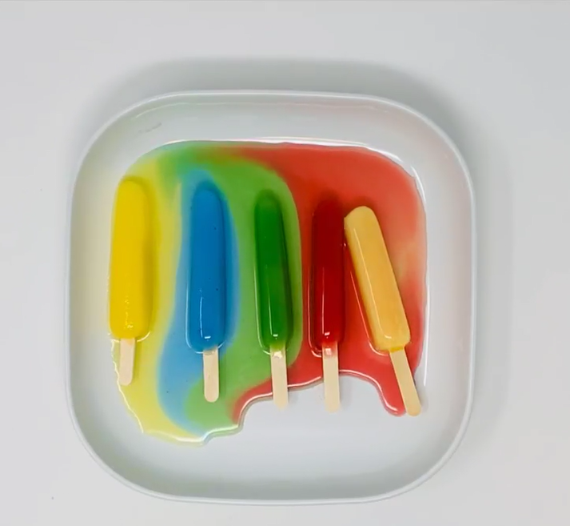

Purpose: The popsicles are meant to convey the impact of rising temperatures. The authors are addressing heat’s invisibility by providing something tangible as an example of climate change’s dangerous potential. Popsicles were chosen because of their association with cooling down in hot weather and their striking color palette.

Composition: There is a heat map at the beginning of the article showing air temperatures in Europe over the course of a midsummer heatwave in 2022. Otherwise, as you scroll through the writing provided, the melting popsicles serve as a background animation. The visualizations are in a supporting role relative to the facts of how various countries are fighting heat for their population.

Message and Audience: They use the visualization to underscore the potential dangers of extreme heat. The heatmap provides a quantitative/geographic view of the current environment of extreme heat in Europe. The popsicles provide a qualitative visual aid to underscore that, while heat may not have the same obvious impacts as other results of climate change, it should still raise concerns for people’s health. It is very eye-catching, and seems intended to pull in an audience that responds to nostalgia, color, and human-centered framings of largescale problems.

Efficacy: Unfortunately, this is an interesting idea poorly executed. The popsicle visuals add very little to the article. As you scroll, they are covered by the writing. They also provide no information of any kind. It would have been much more interesting to provide a timer to understand the speed at which they melt. Or, perhaps, as a baseline animation style/decoration for a more informative visualization. The map is not particularly helpful in communicating the purpose of the article either. Placed at the top, you must scroll past it to get to the content, and then because of the combined animations and text it is difficult to scroll back up to it for use as a reference. The whole thing adds up to feel more gimmicky than informative.

Changes: I would use the popsicles melting at the top of the article with timers for each country’s popsicle and the environmental conditions they are under. This would set up a simple foundation for the readers. As the details on each country’s response scrolls through, I would include a visualization for each. Taking the melting motifs and colors from the initial image, I would have them “drip” down one by one as we reach their country. The drips would form bar graphs to show that country’s responses to climate change as outlined by the article. By the end, all of the bars would be filled and the user could see a side-by-side comparison of the investments each country is making to fight climate change.

[Nuclear Weapons Proliferation](https://ourworldindata.org/nuclear-weapons)

By Bastian Herre for Our World in Data

Data Source: Bleek (2017) and Nuclear Threat Initiative (2022)

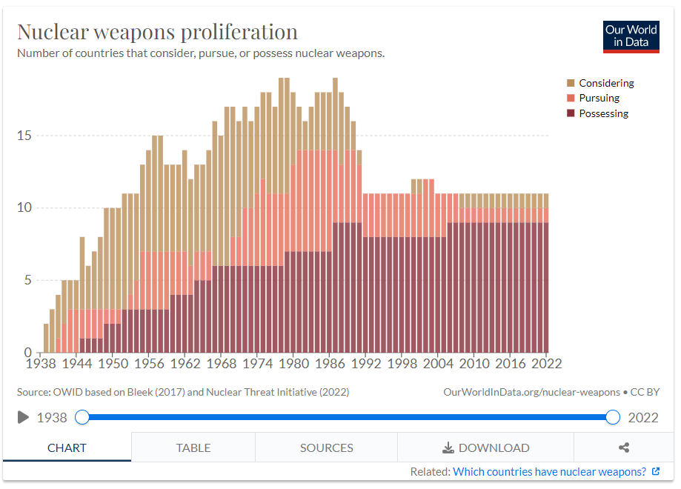

Purpose: This bar chart is meant to convey long term trends in nuclear proliferation. It is meant for exploration through mouseover interactivity for annual detail drilldowns and a simple animation showing the dynamic change over the last 84 years.

Composition: The stacked bar graph is the only chart used in this visualization. Though, the animation emulates the drawing process of a line graph to pull in the time elements line charts excel at.

Message and Audience: This simple visualization powerfully delivers several messages. In its static form, the impact of the 1991 START treaty is easily apparent. In its animated form, the meteoric rise of nuclear armament is quite striking. Both of them show how little progress has been made towards disarmament, and how far we have to go to achieve that goal. This chart does little to invite the viewer in. The interactive elements are minimal, there is little effort to catch the eye, and the key/legend information does little to enhance or assist in the viewer’s experience. The result feels targeted towards an audience that already has a foundational interest and understanding of the problem space.

Efficacy: This visualization is largely effective. The unfortunate color coding drew me to it. The “pursuing” and “considering” colors are nearly impossible for me to distinguish. It is also odd that they allow the bars to run off the top of the chart, making it difficult to eyeball the numbers without using the mouseover tool. It is quite simple, but the information it seeks to portray doesn’t require much more. The animation adds a lot of punch to the storytelling, helping to reveal trends over time.

Changes: The colors need to be higher contrast and supplemented with non-color bordering/variation to assist colorblind viewers. It would be interesting to include historical events as flags in years of interest as part of the mouseover drilldowns and animation sequence. Adding definitions for the vague terms “pursuing” and “considering” would give those portions of the chart much more meaning. The chart should run to 20 on the y-axis instead of 15 to more easily identify the high numbers which top out at 19. I would also add a secondary drilldown element where clicking on a bar adds country names by category to a larger tooltip box, this would help show which countries are making nuclear decisions in that year.

[Who’s in Your Wallet?](https://pudding.cool/2022/04/banknotes/)

By Alejandro Arevalo, Eric Hausken, Jeff MacInnis for Pudding

Data Source: Polling of global currency issuers by writers.

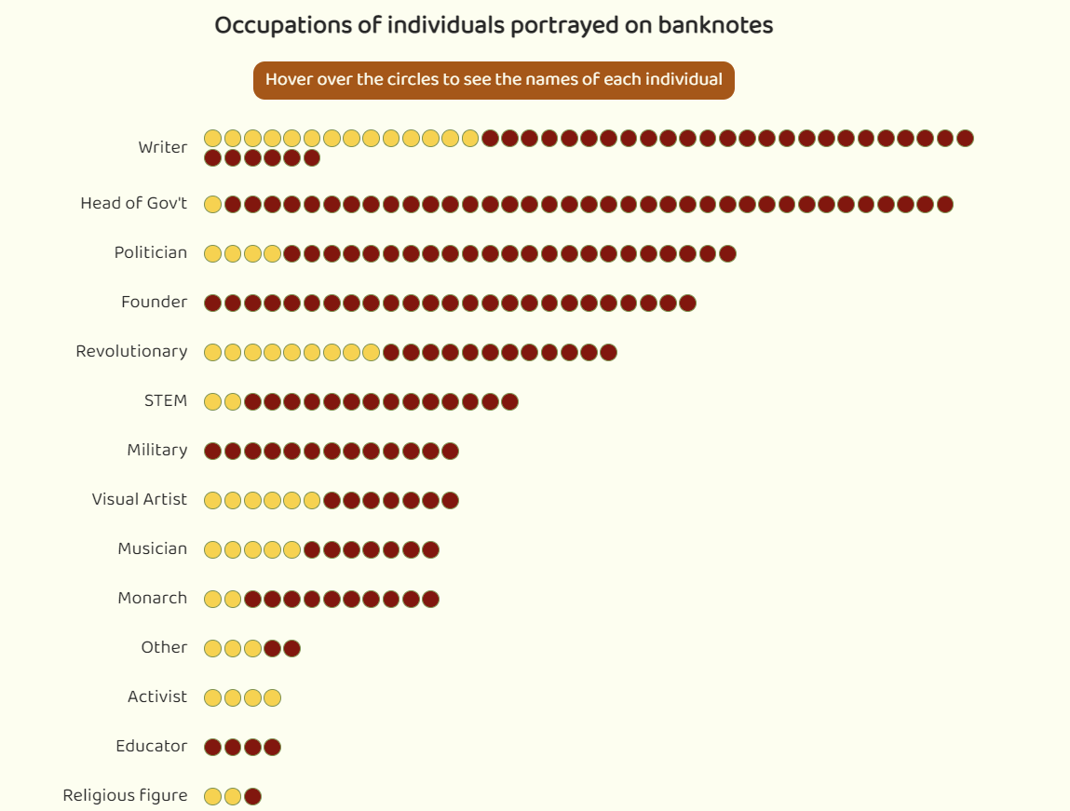

Purpose: This article provides information and author insights into various distributions of people featured on banknotes. Using a variety of chart types and accompanying writing, the creators explore characteristics like gender, profession, accomplishment, and relativity to date of death. They are providing an overview of who gets on banknotes, where, and why. Their tone and focus imply a desire to see banknote honors evolve with the times.

Composition: The creators use many kinds of charts in this long-form article. Segmented bar charts give profession and “Notable Firsts” breakdowns by country, where each segment represents an individual and can be hovered over to see who it is. A segmented histogram shows the distribution of gender by value of banknote and uses the same hover technique as the bar charts. A proportion bar shows the aggregated split between men and women on the notes. A slideshow shows banknotes representing individuals who received this honor for being “first” at something in their life. Finally, a gantt chart shows how long each individual was dead prior to being featured on their note. For those who were still alive when featured it shows the time between their honoring and their death.

Message and Audience: The message has a few layers. The first is to inform people of some basic statistical facts about who is featured on banknotes. The second asks readers to consider who ought to be on banknotes. The third is to take a stance on that question and make arguments for greater diversification of who – and, in some cases, perhaps: what – is featured on banknotes. They are targeting a broad audience. Multinational, left-leaning, people who are politically and culturally engaged. Within that group, I would imagine this article appeals most to history and data nerds. People who would be most intrigued by the combination of people and statistics.

Efficacy: This visualization is very effective. Each one is intuitive, interactive, and informative. The hovers unlock a wealth of information for the historically curious without bogging down the base visualizations for those most interested in comparing the distributions. The segmentations make area comparison charts easier to use by providing counting as an alternative to “eyeballing.” The gantt chart is far too cluttered to be legible in full, however, the creators address this elegantly by isolating regions with zoom-ins and accompanying text as you scroll. The slideshow is redundant with its accompanying segmented bar chart, but it’s interesting to see some of the actual bills.

Changes: I would replace the slideshow of bills with a focused world map. The underlying data is a small sample (38 nations) and showing the geographic distribution is important for people to understand where these numbers are coming from. The map could then have a hover over for each country that played a slideshow of their bills. The value/gender histogram would be more powerful and easier to compare if it was an overlay. Boxing up the dots into histogram bars and overlaying the genders would retain the individual mouseover capability (with small functionality changes) while providing for easier comparison.