Register to borrow book

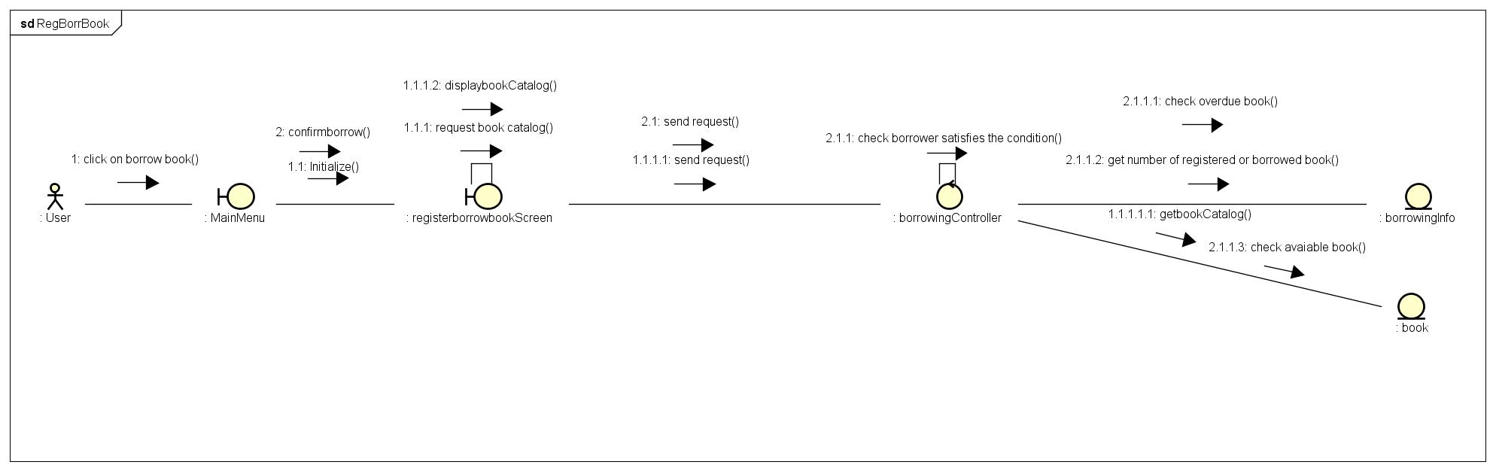

View borrowed books’s list

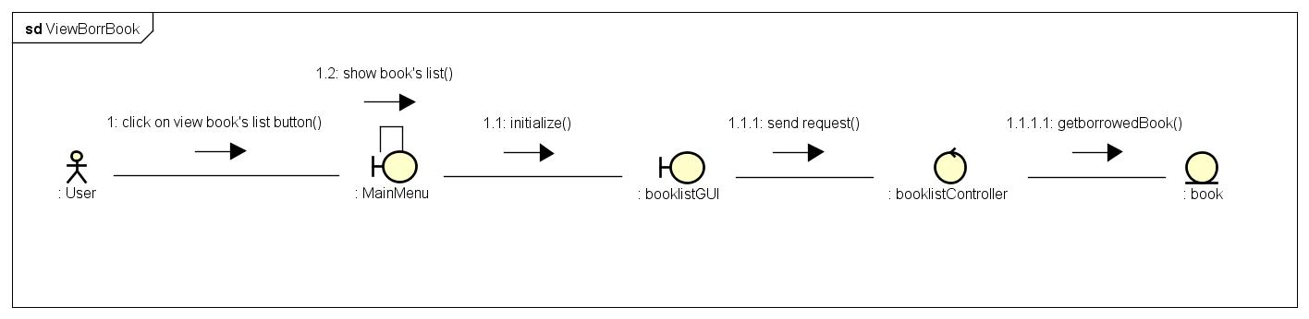

Cancel borrow book

