Register to borrow book

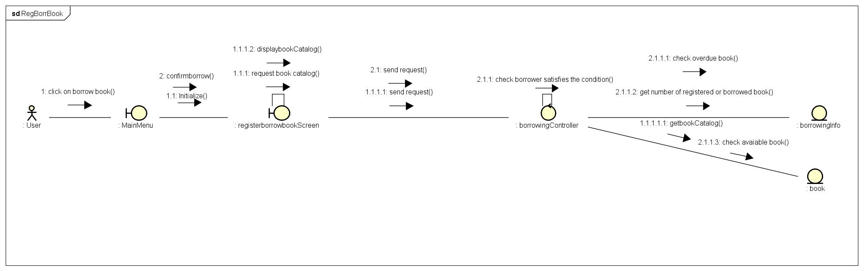

View borrowed books’s list

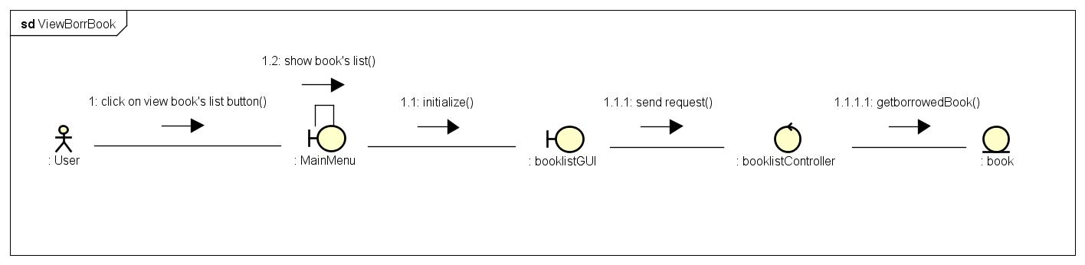

Cancel borrow book

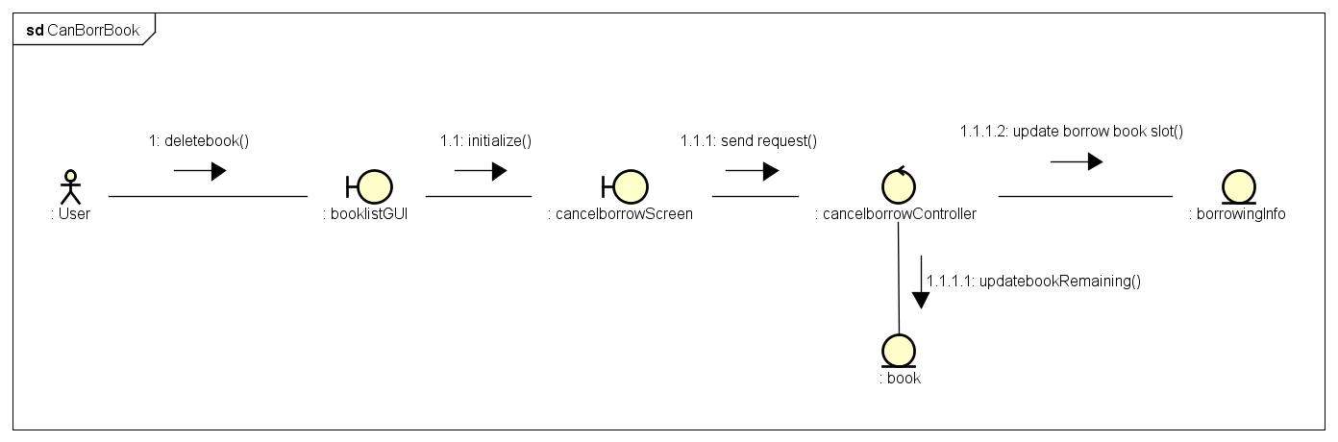

Return Book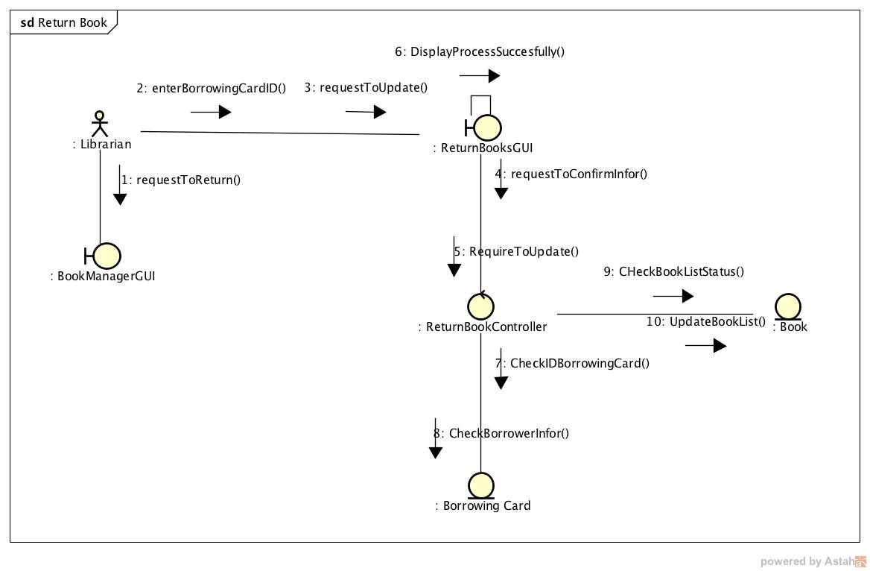

Search Return Book Infor

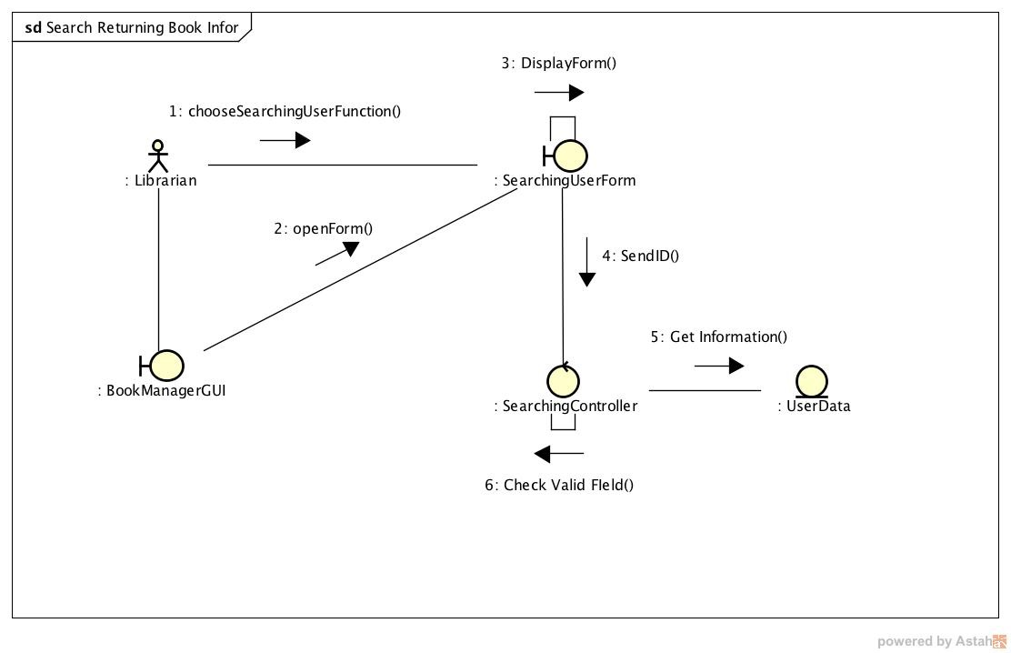

Add Book