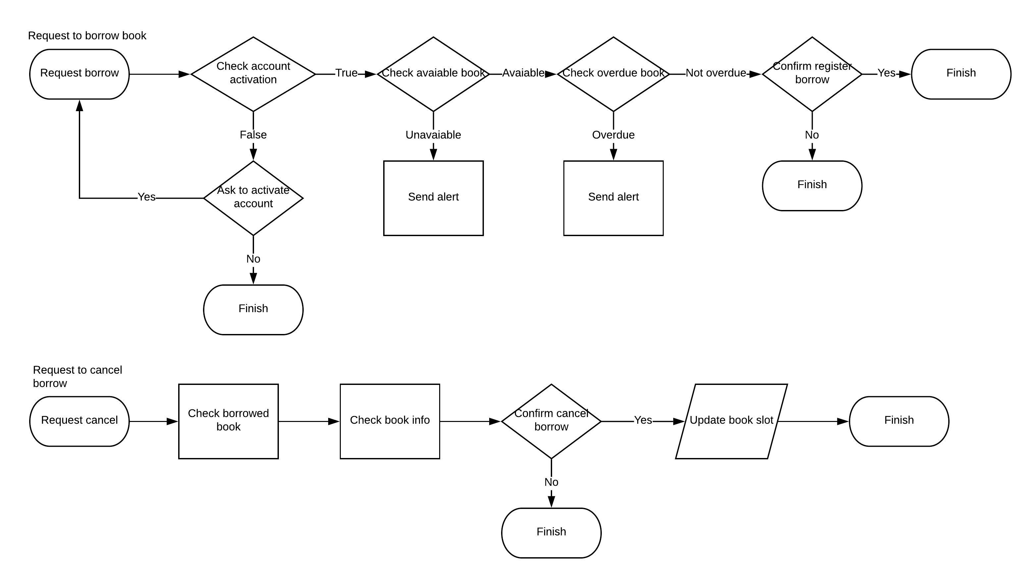

Hình 1 Lưu đồ thuật toán cho phương thức phức tạp

* **Javadoc**

|  |
| --- |
| **package** User.boundary;  /**  * **@author** Cai Việt Hoàng  * This class show code about Screen of register to borrow book  */  **public** **class** registerborrowScreen  {  /**  * This funtion make user choose that want to borrow book  * **@param** userSelect is boolean  * **@return** true if user choose "yes" or false if user choose "no"  */  **public** **boolean** confirmBorrow(**boolean** userSelect)  {  **return** userSelect;  }  /**  * This funtion show the information about borrow book  *  * **@throws** timeout if connect to database is currupt  */  **public** **void** displayborrowInfo()  {    }  } |
| **package** User.boundary;  /**  * **@author** Cai Việt Hoàng  * This class show code about Screen of register to borrow book  */  **public** **class** viewborrowScreen  {  /**  * This funtion show the list of the book  */  **public** **void** showbookList()  {    }  } |
| **package** User.boundary;  /**  * **@author** Cai Việt Hoàng  * This class show code about Screen of register to borrow book  */  **public** **class** cancelborrowScreen  {    } |
| **package** entity;  /**  * This class show some information about book in database  * **@author** Cai Việt Hoàng  */  **public** **class** Book  {  /**  * This class check book avaiable  * **@param** bookAvai is boolean process checking  * **@return** bookCount  */  **public** **boolean** checkbookAvaiable(**boolean** bookAvai)  {  **return** bookAvai;  }    /**  * This funtion  * **@param** bookName is String show the full book name  * **@param** bookID is int show the identify of this book  * **@param** copyID is int show the identify of this copy book  * **@param** author is String show the author's book  * **@throws** timeout if connect to database is currupt  * **@return** 0  */  **public** **void** getbookInfo(String bookName, **int** bookID, **int** copyID, String author)  {    }  } |
| **package** entity;  **public** **class** borrowingInfo  {  /**  * This funtion get borrowing information  * **@param** username is String show full username  * **@param** bookCount is int that show an amount of borrowing books  * **@param** bookPay is double that show an amount of money who user borrowing book  */  **public** **void** getborrowingInfo(String username, **int** bookCount, **double** bookPay)  {    }  /**  * This funtion help program update book slot when user register to borrow or cancel borrow book  * **@param** bookSlot is int that an amount of book left in stock  */  **public** **int** updatebookSlot(**int** bookSlot)  {  **return** bookSlot;  }  /**  * This funtion check overdue book  * **@param** overdueBook is boolean that display "yes" or "no" overdue  * **@return** true if overdue or false if not overdue  */  **public** **boolean** checkoverdueBook(**boolean** overdueBook)  {  **return** overdueBook;  }  } |
| **package** entity;  /**  * This class include information about borrowing card in database  * **@author** Cai Việt Hoàng  *  */  **public** **class** cardInfo  {  /**  * This funtion is many information about card  * **@param** cardName is String that display username  * **@param** cardID is int that display card identify  * **@param** cardExpired is int that display card expired date  */  **public** **void** getcardInfo(String cardName, **int** cardID, **int** cardExpired)  {    }  /**  * This funtion is many information about card  * **@param** cardExpired is int that display card expired date  * **@return** cardExpired  */  **public** **int** getexpiredDate(**int** cardExpired)  {  **return** cardExpired;  }  } |