Redfin Data Initial Exploratory Data Analysis (EDA)

Conrad Ibanez

February 2, 2019

####a. Exploratory Graphs and Tables

## 'data.frame': 48960 obs. of 55 variables:  
## $ ï..Worksheet.Filter : chr "Value" "Value" "Value" "Value" ...  
## $ Measure.Display : logi NA NA NA NA NA NA ...  
## $ Number.of.Records : int 1 1 1 1 1 1 1 1 1 1 ...  
## $ Avg.Sale.To.List : num 0.97 0.98 0.953 0.976 0.925 ...  
## $ Avg.Sale.To.List.Mom : chr "-1.0%" "-0.7%" "-1.6%" "-0.2%" ...  
## $ Avg.Sale.To.List.Yoy : chr "0.8%" "0.3%" "-1.0%" "0.0%" ...  
## $ City : chr "" "" "" "" ...  
## $ Homes.Sold : int 177 99 22 278 9 206 24 213 228 9 ...  
## $ Homes.Sold.Mom : chr "18.8%" "-8.3%" "0.0%" "23.0%" ...  
## $ Homes.Sold.Yoy : chr "10.6%" "8.8%" "-31.3%" "3.0%" ...  
## $ Inventory : int 225 98 77 431 28 226 23 194 358 11 ...  
## $ Inventory.Mom : chr "-3.8%" "5.4%" "-3.8%" "2.4%" ...  
## $ Inventory.Yoy : chr "12.5%" "32.4%" "-14.4%" "25.7%" ...  
## $ Median.Dom : num 60 43 194.5 81 79.5 ...  
## $ Median.Dom.Mom : num -5 0 56.5 9 -43.5 9.5 11 -22 0.5 -29 ...  
## $ Median.Dom.Yoy : num 0.5 -13 99.5 -17.5 20.5 0 -9.5 -11.5 -4.5 26 ...  
## $ Median.List.Ppsf : num 117.5 173.8 106.5 105.6 72.1 ...  
## $ Median.List.Ppsf.Mom : num -0.007874 -0.000374 0.164356 -0.014055 -0.061131 ...  
## $ Median.List.Ppsf.Yoy : num 0.1095 0.0415 0.1559 0.0382 -0.1022 ...  
## $ Median.List.Price : num 289900 350000 222200 279900 130500 ...  
## $ Median.List.Price.Mom : num 0 0 0.0844 -0.0509 -0.1414 ...  
## $ Median.List.Price.Yoy : num -0.0304 0.0495 0.0581 -0.0345 -0.1944 ...  
## $ Median.Ppsf : num 96.7 170.1 74.4 105.7 50.8 ...  
## $ Median.Ppsf.Mom : num -0.042005 0.010634 -0.043392 0.000276 -0.234962 ...  
## $ Median.Ppsf.Yoy : num -0.0421 0.0294 -0.0784 0.0784 -0.2742 ...  
## $ Median.Sale.Price : chr "$197K" "$289K" "$167K" "$280K" ...  
## $ Median.Sale.Price.Mom : chr "-6.0%" "5.1%" "13.8%" "5.1%" ...  
## $ Median.Sale.Price.Yoy : chr "-24.8%" "-2.0%" "2.6%" "9.4%" ...  
## $ months_of_supply : num NA NA NA NA NA NA NA NA NA NA ...  
## $ months_of_supply_mom : num NA NA NA NA NA NA NA NA NA NA ...  
## $ months_of_supply_yoy : num NA NA NA NA NA NA NA NA NA NA ...  
## $ New.Listings : int 173 83 31 355 20 145 20 268 229 10 ...  
## $ New.Listings.Mom : chr "-19.9%" "-2.4%" "-3.1%" "9.2%" ...  
## $ New.Listings.Yoy : chr "9.5%" "13.7%" "0.0%" "22.4%" ...  
## $ off_market_in_two_weeks : num 0.1792 0.3253 0.0323 0.1577 0.1 ...  
## $ off_market_in_two_weeks_mom: num 0.02641 -0.08646 0.00101 0.01621 0.05 ...  
## $ off_market_in_two_weeks_yoy: num -0.0297 0.065 0.0323 0.0336 0.0286 ...  
## $ pending_sales : int 188 79 31 332 15 113 28 306 232 7 ...  
## $ pending_sales_mom : num -0.134 -0.16 0.24 0.122 0.25 ...  
## $ pending_sales_yoy : num 0.3239 -0.0366 0.2917 0.0153 6.5 ...  
## $ Period.Begin : chr "5/1/2014" "7/1/2016" "12/1/2014" "3/1/2016" ...  
## $ Period.Duration : int 90 90 90 90 90 90 90 90 90 90 ...  
## $ Period.End : chr "7/31/2014" "9/30/2016" "2/28/2015" "5/31/2016" ...  
## $ Price.Drops : num NA NA NA NA NA NA NA NA NA NA ...  
## $ Price.Drops.Mom : num NA NA NA NA NA NA NA NA NA NA ...  
## $ Price.Drops.Yoy : num NA NA NA NA NA NA NA NA NA NA ...  
## $ Property.Type : chr "All Residential" "All Residential" "All Residential" "All Residential" ...  
## $ Region : chr "Zip Code: 30350" "Zip Code: 30329" "Zip Code: 30183" "Zip Code: 30115" ...  
## $ Region.Type : chr "zip code" "zip code" "zip code" "zip code" ...  
## $ Sold.Above.List : num 0.096 0.131 0.136 0.165 0.111 ...  
## $ Sold.Above.List.Mom : num -0.0449 -0.0724 -0.0455 -0.0115 0 ...  
## $ Sold.Above.List.Yoy : num -0.079 -0.0445 0.0114 0.0432 0.1111 ...  
## $ State : chr "Georgia" "Georgia" "Georgia" "Georgia" ...  
## $ State.Code : chr "GA" "GA" "GA" "GA" ...  
## $ Table.Id : int 12652 12632 12533 12476 12570 12389 12550 12509 12622 12535 ...

## [1] 48960

## [1] 55

## [1] 112.9739

## [1] NA

## [1] NA

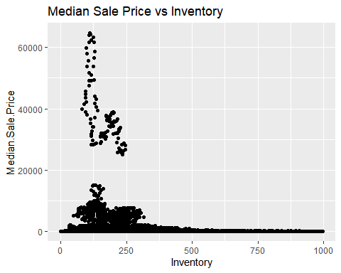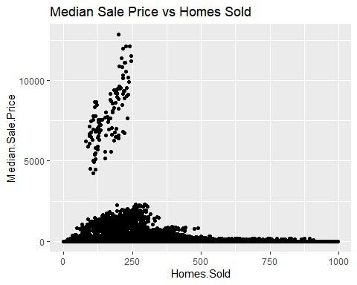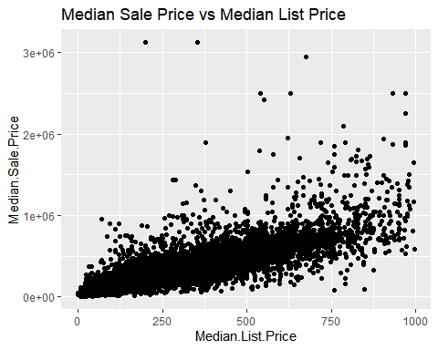

## [1] "data.frame"

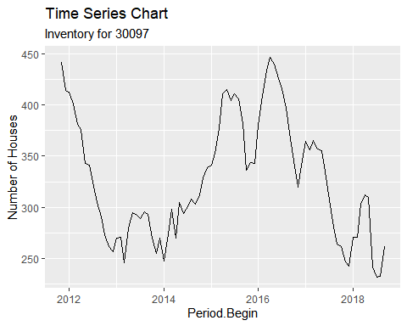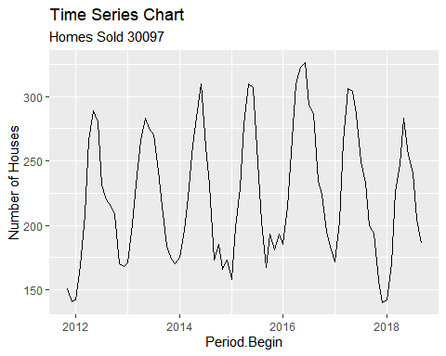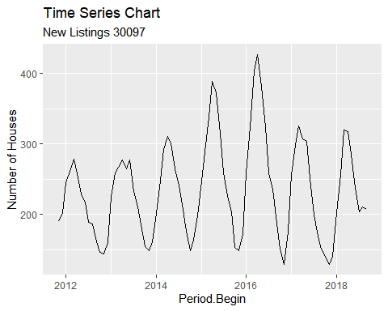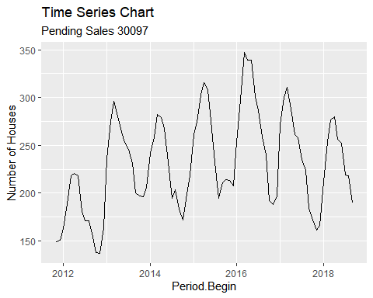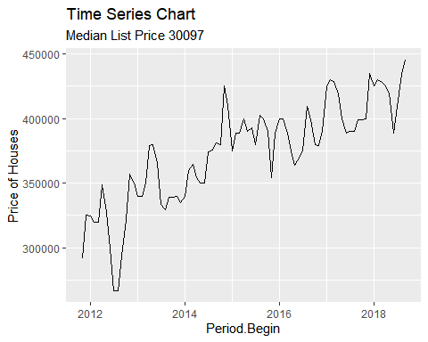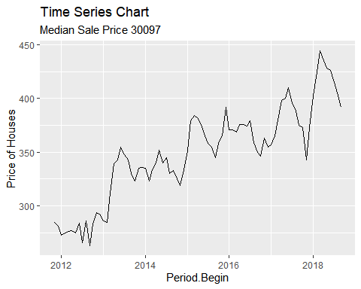

## References

Field, A. et. al. Discovering Statistics Using R. 2012