Air and Land Travel Safety



Have you ever dreamed of going on an island vacation getaway? Perhaps you’ve already checked that off your bucket list and want to go on a trip to Europe instead or visit the ancient pyramids or the Great Wall of China. If so, you will probably book a flight to your destination. My name is Conrad and I’m a data scientist for Southwest Airlines. I know there haven’t been great news lately for the airline industry due to recent accidents, but I’m here to provide you some data to show that air travel is still one of the best and safest modes of transportation available today.

**On the Move**

As human beings, we have the natural tendency to move. We want to go to places, visit friends, go shopping, try new restaurants, and explore the world. The graph below shows the common reasons for our travels. We make hundreds of trips a year for many purposes which include social/recreational events, errands, shopping, and work at the top of the list.

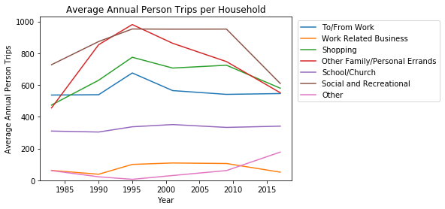

We spend trillions of dollars a year on our transportation needs. The line graph below shows that most of our expenses are for user-operated transportation which includes the vehicles that we own and drive. Airlines is a distant second. This is understandable as the preferred mode of transportation is an automobile based on a survey conducted in 2017 and shown on the pie chart.

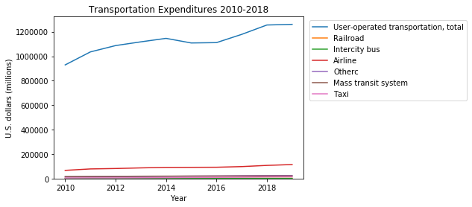 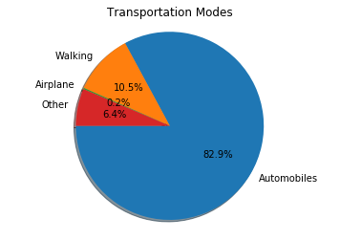

**Airline Fatalities**

Unfortunately, accidents do occur which can lead to loss of life for any mode of transportation. The airline industry prides itself on the safety of all our customers and employees. Whenever airline crashes happen, it is front-page news and rightfully so since it usually impacts many lives. In comparison, car crashes happen more frequently but only a handful of people are involved. Thus, car accidents are primarily reported in local communities.

Below is a chart showing the fatalities that have occurred for some of the largest and well-known airlines in the U.S. from 2000 to 2014. U.S. airline fatalities are in the hundreds, but there are a few airlines that have not had any fatalities during the period. I am proud to say that Southwest Airlines is one of them, and we’re working hard everyday to keep it that way.

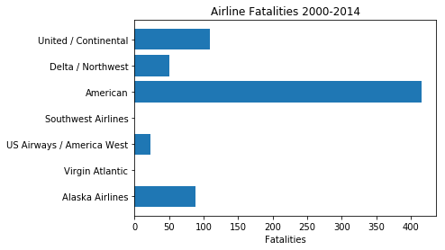

Below is another graph showing the fatalities for U.S. Airlines during the same period of time but broken down by years. You can see that the fatalities are less than 80 a year for the U.S. airline industry as a whole, and there appears to be a trend downwards. All of the major airlines work with the Federal Aviation Agency (FAA) and even collaborate amongst each other to ensure that all safety protocols as well as aircraft maintenance are strictly followed.

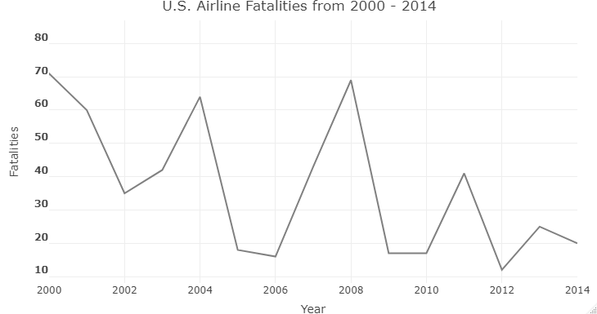

**U.S. Vehicle Fatalities**

If we compare the airline’s numbers to U.S. vehicles during the same time, we see that the number of fatalities involved with vehicles is so much more. Sadly, we’re seeing more than 30 thousand deaths a year in the U.S. from car accidents. This can explain why many of us know someone, perhaps even a close family member or friend, who has died from a car crash. It is likely that few of us can say the same for airline crashes, yet we do not hesitate or think twice about driving or getting in a car to get to our destination.

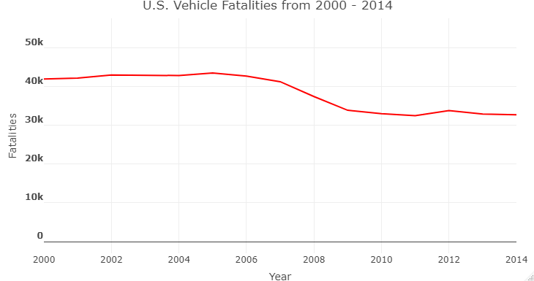

**Conclusion**

Each of us has a thirst to move about. People are constantly going from place to place. For many of us, it means getting inside a car to get from point A to point B. However, there are places where using a car may not be the best option or may not even be an option. Air travel is fast, safe, and reliable for getting you to your destination.

So go ahead. What are you waiting for? Book the flight to your next great adventure! You won’t regret it and you’ll have memories to last a lifetime. Your well-being is our top priority, and we at Southwest will continue to do our best to keep you and your travel companions safe.

Data Sources:

https://catalog.data.gov/dataset/accidents-and-accident-rates-by-ntsb-classification-1995-through-2014-for-u-s-air-carriers

https://catalog.data.gov/dataset/accidents-fatalities-and-rates-1995-through-2014-for-u-s-air-carriers-operating-under-14-c-2e5ec

https://cdan.nhtsa.gov/tsftables/tsfar.htm#

https://www.bts.gov/content/average-annual-pmt-vmt-person-trips-and-trip-length-trip-purpose

https://www.bts.gov/content/personal-consumption-expenditures-transportation-subcategory

https://nhts.ornl.gov/