Laboratory III: Using Pins for Servomotor Control
Anna Shimunova, Allan Itzkowitz

CS345 Hardware Laboratory, Queens College, Spring 2004

• Introduction
In this lab we were asked to generate signals and send them to the FPGA’s I/O pin, in order to drive a connected servomotor. We used the pushbuttons to make the motor rotate right, left, or stop. The program pins.hcc generate pulses of specified frequency and pulse widths, which is verifiable through simulation on waveform analyzer and using an oscilloscope, and later by connecting a servomotor to the RC200E.

• Method
Achieving control over the motor consisted of three parts. First, working through the Waveform analyzer example, which helps to test the code’s simulation and introduces the bus_out() interface. Second, code a program that generates pulses and test it with oscilloscope. The last part consists of putting the first two parts together and using one endless loop to time the millisecond intervals and another endless loop to generate the pulses. The two loops are synchronized with each other using a Handel-C channel. The last program controls the motor according to the specifications and passed testing with the waveform analyzer, oscilloscope, and servomotor.

• Results
The program is generating a pulse every 20 msec. If one pushbutton is pressed on RC200E, the pulse is 1.0 msec long and the motor rotates right, if the other button is pressed, the pulse is 2.0 msec long and the motor rotates left. If neither button/both buttons are pressed, the pulse is to be 1.5 msec long and the motor will do nothing.

Ωαϖεφορμ Αναλψζερ ρεσυλτσ:
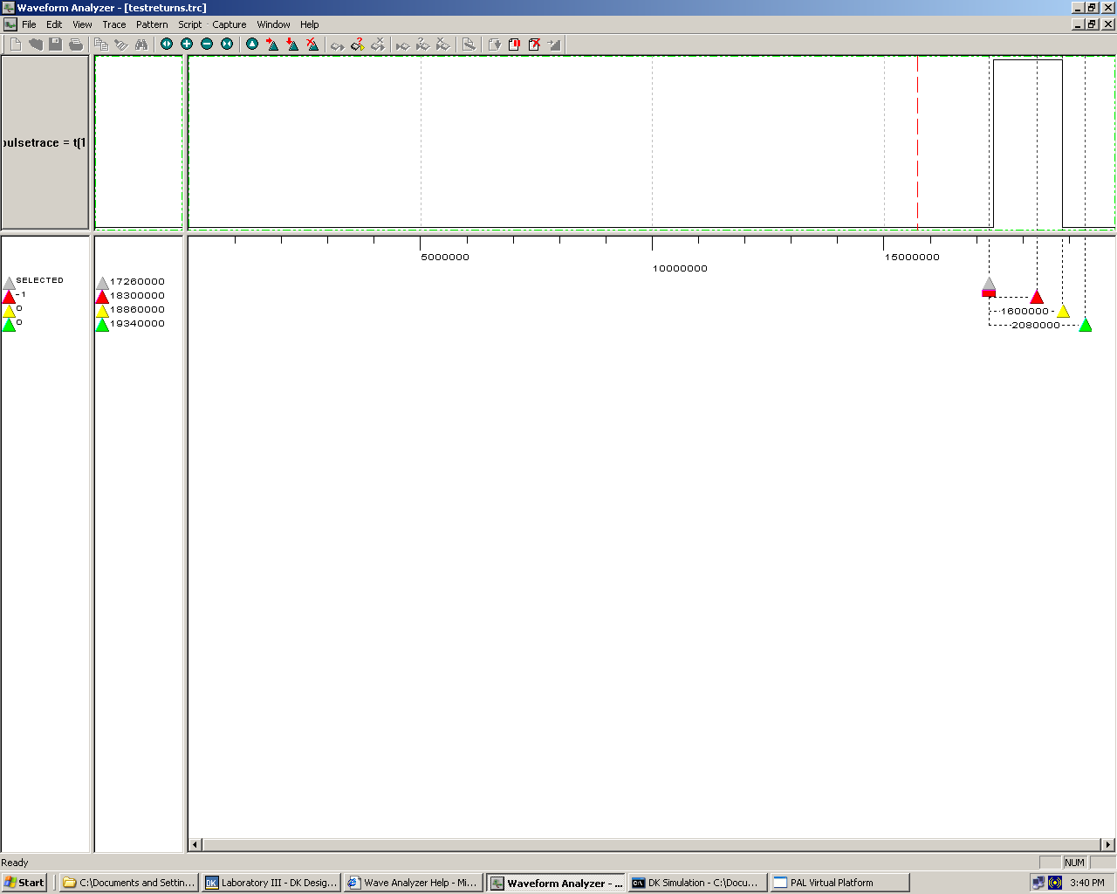

• Discussion
The program behaves exactly as it supposed, the code passed testing through all the devices. Therefore the assignment is completed successfully.

• Appendices

I - view_waveforms.hcc

//DKDync.dll is getting the clock cycle to be synchronous between // the code and the Waveform Analyzer.
//DKConnect.dll is getting the value of
//The period = 400

set clock = external "P1"
with
{
extlib = "DKSync.dll", extinst = "50", extfunc = "DKSyncGetSet"
};

unsigned 3 x = 0;

interface bus_out() ob1(unsigned 3 out = x)
with
{
extlib = "DKConnect.dll", extinst = "t(3)", extfunc = "DKConnectGetSet"
};

void main(void)
{
while(1) x++;
}

II - macrosec_delay.hcc

#define PAL_TARGET_CLOCK_RATE 50000000
#include <pal_master.hch>
#include "stdlib.hch"
#ifdef USE_SIM
#define Switch_0 8
#define Switch_1 9
#else
#define Switch_0 0
#define Switch_1 1
#endif
unsigned 1 pulse;

interface bus_out () OutBus(unsigned 1 OutPort = pulse) with
{
data =
{
"P1"
}
};

static macro proc microsec_delay (microsec);

void main(void)
{
}

/*
* Sleep for "n" milliseconds
*/
static macro proc microsec_delay (microsec)
{
macro expr Cycles = (PAL_ACTUAL_CLOCK_RATE * microsec) / 1000000;
unsigned (log2ceil (Cycles)) Count;

Count = 0;
do
{
Count++;
}
while (Count != Cycles - 1);
}

III – pins.hcc

/****************************************************************
* *
* Project : Laboratory III - FPGA’s I/O pins *
* Date : 03 MAR 2004 *
* File : pipeline.hcc *
* Author : Anna & Allan *
* Description: motor control *
****************************************************************/

#ifdef USE_SIM
#define PAL_ACTUAL_CLOCK_RATE 1000000
set clock = external "P1"
with
{
extlib = "DKSync.dll",
extinst = "1000", // Period of 1MHz simulated clock
extfunc = "DKSyncGetSet"
};

#define Switch_0 8
#define Switch_1 9
#else
#define PAL_TARGET_CLOCK_RATE 50000000
#define Switch_0 0
#define Switch_1 1
#endif
#include <pal_master.hch>
#include "stdlib.hch"
unsigned 1 pulse = 0;
unsigned 1 pulselength1;
unsigned 1 pulselength2;
chan <unsigned 1> pulsechan;
unsigned 1 pulsesignal = 1;

interface bus_out () OutBus(unsigned 1 OutPort = pulse) with
{
#if (defined USE_RC200 || USE_RC200E)
data = { "M2" }
#else
extlib = "DKConnect.dll",
extinst = "t(1)",
extfunc = "DKConnectGetSet"
#endif

};

static macro proc microsec_delay (microsec);

void main(void)
{
par
{
while(1)
{
microsec_delay (20000);
pulsechan! pulsesignal;
}
while(1)
{
pulsechan? pulsesignal;
pulse = 1;

if (pulselength1 && pulselength2)
{
microsec_delay (1500);
}
else if (!pulselength1 && !pulselength2)
{
microsec_delay (1500);
}
else if (pulselength1)
{
microsec_delay (1000);
}
else //if (pulselength2)
{
microsec_delay (2000);
}

pulse = 0;
}
}
}

void main(void)
{
while (1) {
PalSwitchRead(PalSwitchCT(Switch_0), &pulselength1);
PalSwitchRead(PalSwitchCT(Switch_1), &pulselength2);
}
}
/*
* Sleep for "n" milliseconds
*/
static macro proc microsec_delay (microsec)
{
macro expr Cycles = (PAL_ACTUAL_CLOCK_RATE * microsec) / 1000000;
unsigned (log2ceil (Cycles)) Count;

Count = 0;
do
{
Count++;
}
while (Count != Cycles - 1);
}

