Laboratory V

LCD Framebuffer

Contents
Contents 1
Introduction 2
Method 2
Results 3
lcd_keyboard 3
parameters 4
unbuffered 5
lcd_framebuffer 5
Discussion 5
Appendix A – lcd_keyboard.hcc 7
Appendix B – parameters.hcc 12
Appendix C – unbuffered.hcc 15
Appendix D – lcd_framebuffer.hcc 17

Laboratory V

LCD Framebuffer
Anna Shimunova and Allan Itzkowitz
CS-345, Spring 2004

Introduction
For laboratory V, we created four projects to examine ways of displaying video images first in simulation and than on RC200E. The first project taught us how to control which pixel is to be drawn where. We were asked to display the ASCII value of any character, input into the keyboard, and display the value on the video monitor. This display would update every time a new character was input. Essentially, we were asked to create an image “on the fly”. In the second project we were asked to get the values of certain parameters. We needed to find the total and visible number of lines and columns and the widths of various values. Using these values we were able to do the third project which required us to draw a pattern onto the RC200 monitor using the HBlank for synchronization. This eventually led us to the culminating project in this laboratory. We learned how to use RAM to make a framebuffer. We then used the framebuffer to write a pattern onto the monitor that would continuously update; the pinnacle of our lab experience, if you will.

Method
The creation of the above masterpiece is based on the following strategies. We set up the configuration in the usual way.
- For the first project (which we called lcd_keyboard instead of sevensegments) we initially set up names for each of the seven segments (we named them after the seven dwarves of course. What else would we use?) and ordered them (happy was first, dopey was second, ect.). We set up, in a rom, a representation for each number by specifying which segments are needed for each one. We then read in a character from the keyboard. This comes in as 8 bits and by splitting it into two 4 bit numbers we can use those to tell us what number (in hex of course) should go in the left and right displays. Then we use these numbers as indexes to look up, in the rom, which segments need to be displayed. Once we know this, we use a giant if statement (of doom) that uses combinational logic to draw each segment. We set the dimensions of each segment for the if statement to check against the current position of the curser.
- The second part of this laboratory required us to get certain parameters. We needed to find the widths of variables, number of rows and columns, and number of bits needed to represent some of them. To find most of these parameters, there were ready made macros in the API. The only time that there weren’t ready made macros was when we needed to find the width needed for a variable that ranges over all X or Y coordinates on a scan line. For this we needed to use the log2ceil function on the total number of visible pixels.
- The third part required us to draw columns on the screen that alternated between two colors of our choosing. We also needed to display a white pixel at the beginning of each scan line. To draw the alternating colors, we tested one bit, the third one, of the variable used to hold the current position of the cursor. As it alternated, so did our colors. To draw the white pixel at the beginning of each scan line, we made use of the HBlank, or horizontal blanking period. We had it draw white while it was in the blanking period and by doing this we ended up with one white pixel drawn after the blanking period ended.
- Finally we were asked to draw a similar pattern to the one in the previous part. However, there were two important differences. One was that the white border had to extend around the entire display. The second difference was that here, we first had to write our pattern into RAM and then read it back out of RAM before drawing it on the screen. In order to have our pattern display correctly there was a specific sequence in which we had to read, write and draw each pixel. This sequence can be seen as a pipeline as illustrated below.
t(-3) | Set address for pixel 0
t(-2) | Set address for pixel 1 | Read pixel 0
t(-1) | Set address for pixel 2 | Read pixel 1 | Write pixel 0
t(0) | Set address for pixel 3 | Read pixel 2 | Write pixel 1 | Pixel 0 displays
t(1) | Set address for pixel 4 | Read pixel 3 | Write pixel 2 | Pixel 1 displays

Results

lcd_keyboard
The seven segment display worked equally correct in simulation & RC200E it let us type in a character on a keyboard connected to a PS/2 port and then displays the ASCII value for it in black on red background.

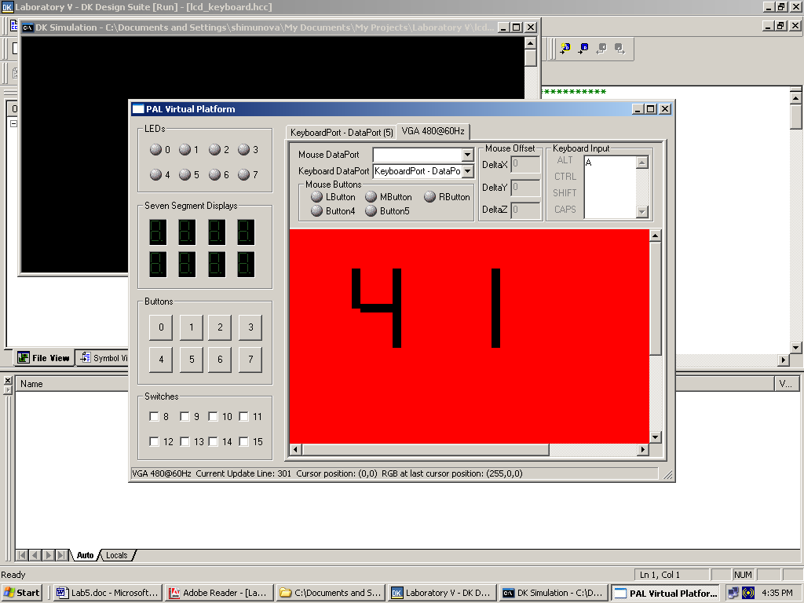

parameters
Using macros from the API allowed completing the second assignment, where we would get total number of visible pixels for x and y coordinates in real time and compile time, as well as number of pixels per scan line and total number of scan lines. After which we could use that information to find the widths to hold these values.

Parameters | Simulation | RC200E
# of visible pixels/scan @ CT | 640 | 640
# of visible scan lines @ CT | 480 | 480
# of visible pixels/scan @ RT | 640 | 640
# of visible scan lines @ RT | 480 | 480
total # of pixels/scan line | 800 | 800
total # of scan lines | 525 | 525
width needed for a variable to hold X coordinate of a visible pixel | 10 | 10
width needed for a variable to hold Y coordinate of a visible pixel | 9 | 9
width needed for a variable that ranges over all X coordinates on a scan line | 12 | 12
width needed for a variable that ranges over all Y coordinates on a scan line | 12 | 12
width needed for a variable that holds a RAM memory address | 19 | 20
width needed for a variable that holds a word of RAM data | 32 | 36

unbuffered
This project uses HBlank and draws a white pixel in the first column of each scan line, and draw vertical bars of alternating colors across the remainder of each line. It produces same picture in simulation as well as on RC200E drawing one white border and then alternating green and yellow stripes.

lcd_framebuffer
The final part of the project looks a lot like project3, but employs more complex strategy for generating proper picture. It still has the alternating bars only this time all four sides have one pixel wide border. This is done by reading from the memory and writing to the screen using pipeline to wait three cycles between setting the pixel’s address and displaying it.
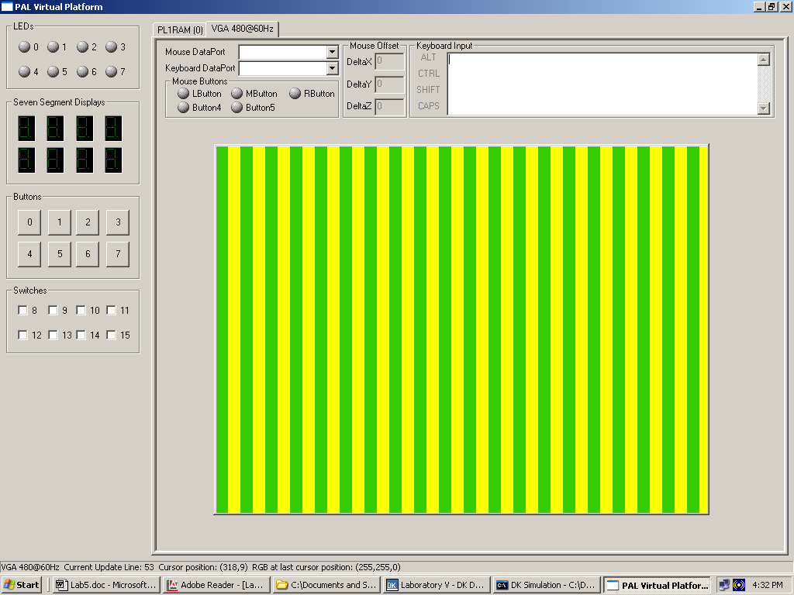

Discussion
So far this was the most interesting assignment because it incorporated everything we learned before with plus it lets us see the out put in color. Figuring out the pixels to be drawn for the seven segments took a while since because of the complicated while loop. This was also a good practice for using the API in order to find the appropriate PAL macros. Another interesting aspect of this laboratory is the parameters project; where data results differed between simulation and FPGA. The differences are displayed in the table included in the results part of the laboratory write up.

Appendix A – lcd_keyboard.hcc
// lcd_keyboard.hcc

/****************************************************************
* *
* Project : Laboratory V - lcd_keyboard *
* Date : 08 MAR 2004 *
* File : lcd_console.hcc *
* Author : Anna & Allan *
* Description: PAL Keyboard *
****************************************************************/

#define PAL_TARGET_CLOCK_RATE 25175000

#include "pal_master.hch"
#include "pal_console.hch"
#include "pal_keyboard.hch"
#include "stdlib.hch"

rom unsigned 7 aTable[16] =
{ 0b1110111, 0b0100100, 0b1011101, 0b1101101,
0b0101110, 0b1101011, 0b1111011, 0b0100101,
0b1111111, 0b0101111, 0b0111111, 0b1111010,
0b1010011, 0b1111100, 0b1011011, 0b0011011
};
/* Happy
*******************
* *
*Dopey *
* *
* *
* *Sneezy
* Doc *
*******************
* *
* *
*Bashful *
* *
* *
* *
* Grumpy *Sleepy
******************* */

unsigned Char = 0x88;
unsigned lbits = 0;
unsigned rbits = 0;
unsigned 7 l_num;
unsigned 7 r_num;

// Variables that will be either true or false to show
// if each segment is on or off.
unsigned 1 l_happy;
unsigned 1 l_dopey;
unsigned 1 l_sneezy;
unsigned 1 l_doc;
unsigned 1 l_bashful;
unsigned 1 l_sleepy;
unsigned 1 l_grumpy;

unsigned 1 r_happy;
unsigned 1 r_dopey;
unsigned 1 r_sneezy;
unsigned 1 r_doc;
unsigned 1 r_bashful;
unsigned 1 r_sleepy;
unsigned 1 r_grumpy;

// Variables that set the boundaries for each segment
// while they are being drawn.

unsigned l_happy_left = 90;
unsigned l_doc_left = 90;
unsigned l_grumpy_left = 90;
unsigned l_dopey_left = 79;
unsigned l_sneezy_left = 131;
unsigned l_bashful_left = 79;
unsigned l_sleepy_left = 131;

unsigned l_happy_right = 130;
unsigned l_doc_right = 130;
unsigned l_grumpy_right = 130;
unsigned l_dopey_right = 89;
unsigned l_sneezy_right = 141;
unsigned l_bashful_right = 89;
unsigned l_sleepy_right = 141;

unsigned l_happy_top = 50;
unsigned l_doc_top = 95;
unsigned l_grumpy_top = 140;
unsigned l_dopey_top = 50;
unsigned l_sneezy_top = 50;
unsigned l_bashful_top = 101;
unsigned l_sleepy_top = 101;

unsigned l_happy_bottom = 60;
unsigned l_doc_bottom = 105;
unsigned l_grumpy_bottom = 150;
unsigned l_dopey_bottom = 100;
unsigned l_sneezy_bottom = 100;
unsigned l_bashful_bottom = 150;
unsigned l_sleepy_bottom = 150;

unsigned r_happy_left = 216;
unsigned r_doc_left = 216;
unsigned r_grumpy_left = 216;
unsigned r_dopey_left = 205;
unsigned r_sneezy_left = 257;
unsigned r_bashful_left = 205;
unsigned r_sleepy_left = 257;

unsigned r_happy_right = 256;
unsigned r_doc_right = 256;
unsigned r_grumpy_right = 256;
unsigned r_dopey_right = 215;
unsigned r_sneezy_right = 267;
unsigned r_bashful_right = 215;
unsigned r_sleepy_right = 267;

unsigned r_happy_top = 50;
unsigned r_doc_top = 95;
unsigned r_grumpy_top = 140;
unsigned r_dopey_top = 50;
unsigned r_sneezy_top = 50;
unsigned r_bashful_top = 101;
unsigned r_sleepy_top = 101;

unsigned r_happy_bottom = 60;
unsigned r_doc_bottom = 105;
unsigned r_grumpy_bottom = 150;
unsigned r_dopey_bottom= 100;
unsigned r_sneezy_bottom = 100;
unsigned r_bashful_bottom = 150;
unsigned r_sleepy_bottom = 150;

static macro expr handle_lcd = PalVideoOutOptimalCT(PAL_ACTUAL_CLOCK_RATE);

// Color scheme
static macro expr red = 0xFF0000;
static macro expr black = 0x000000;

static macro expr gotX = PalVideoOutGetX(handle_lcd);
static macro expr gotY = PalVideoOutGetY(handle_lcd);
macro proc KeyboardRun();
macro proc VideoRun();

PalKeyboard *KeyboardPtr;

// Takes the incoming bits and maps them to the
// appropriate segments of the 7 segment display.

static macro proc bits_to_number(l_num, r_num)
{
par
{
l_happy = l_num[0];
r_happy = r_num[0];
l_dopey = l_num[1];
r_dopey = r_num[1];
l_sneezy = l_num[2];
r_sneezy = r_num[2];
l_doc = l_num[3];
r_doc = r_num[3];
l_bashful = l_num[4];
r_bashful = r_num[4];
l_sleepy = l_num[5];
r_sleepy = r_num[5];
l_grumpy = l_num[6];
r_grumpy = r_num[6];
}
}
/*
* Main program. Just your every day run
* of the mill main program.
*/

void main (void)
{
par
{
PalVideoOutRun (handle_lcd, ClockRate);
PalKeyboardRun (&KeyboardPtr, PalPS2PortCT (1), ClockRate);
seq
{
par
{
PalVideoOutEnable (handle_lcd);
PalKeyboardEnable (KeyboardPtr);
}
par
{
KeyboardRun();
VideoRun();
}
}
}
}
//
macro proc KeyboardRun()
{
/*
* Read characters from the keyboard and
* splits the bits into what will be in
* the left and right segments.
*/
while (1)
{
PalKeyboardReadASCII (KeyboardPtr, &Char);
lbits = Char[7:4];
rbits = Char[3:0];
l_num = aTable[lbits];
r_num = aTable[rbits];
bits_to_number(l_num, r_num);
}

}

macro proc VideoRun()
{
/*
* Paints the segments to the LCD using the
* giant if statement of doom to check the position
* of the curser and decide whether it should draw there.
*/
while (1)
{
if (
(l_happy && (gotX >= l_happy_left && gotX <= l_happy_right)
&& (gotY >= l_happy_top && gotY <= l_happy_bottom)) ||
(r_happy && (gotX >= r_happy_left && gotX <= r_happy_right)
&& (gotY >= r_happy_top && gotY <= r_happy_bottom)) ||

(l_dopey && (gotX >= l_dopey_left && gotX <= l_dopey_right)
&& (gotY >= l_dopey_top && gotY <= l_dopey_bottom)) ||
(r_dopey && (gotX >= r_dopey_left && gotX <= r_dopey_right)
&& (gotY >= r_dopey_top && gotY <= r_dopey_bottom)) ||

(l_sneezy && (gotX >= l_sneezy_left && gotX <= l_sneezy_right)
&& (gotY >= l_sneezy_top && gotY <= l_sneezy_bottom)) ||
(r_sneezy && (gotX >= r_sneezy_left && gotX <= r_sneezy_right)
&& (gotY >= r_sneezy_top && gotY <= r_sneezy_bottom)) ||

(l_doc && (gotX >= l_doc_left && gotX <= l_doc_right)
&& (gotY >= l_doc_top && gotY <= l_doc_bottom)) ||
(r_doc && (gotX >= r_doc_left && gotX <= r_doc_right)
&& (gotY >= r_doc_top && gotY <= r_doc_bottom)) ||

(l_bashful && (gotX >= l_bashful_left && gotX <= l_bashful_right)
&& (gotY >= l_bashful_top && gotY <= l_bashful_bottom)) ||
(r_bashful && (gotX >= r_bashful_left && gotX <= r_bashful_right)
&& (gotY >= r_bashful_top && gotY <= r_bashful_bottom)) ||

(l_sleepy && (gotX >= l_sleepy_left && gotX <= l_sleepy_right)
&& (gotY >= l_sleepy_top && gotY <= l_sleepy_bottom)) ||
(r_sleepy && (gotX >= r_sleepy_left && gotX <= r_sleepy_right)
&& (gotY >= r_sleepy_top && gotY <= r_sleepy_bottom)) ||

(l_grumpy && (gotX >= l_grumpy_left && gotX <= l_grumpy_right)
&& (gotY >= l_grumpy_top && gotY <= l_grumpy_bottom)) ||
(r_grumpy && (gotX >= r_grumpy_left && gotX <= r_grumpy_right)
&& (gotY >= r_grumpy_top && gotY <= r_grumpy_bottom))
)
PalVideoOutWrite(handle_lcd,black);
else
PalVideoOutWrite(handle_lcd,red);
}
}

Appendix B – parameters.hcc
// parameters.hcc

/****************************************************************
* *
* Project : Laboratory V - parameters *
* Date : 08 MAR 2004 *
* File : parameters.hcc *
* Author : Anna & Allan *
* *
****************************************************************/

#define PAL_TARGET_CLOCK_RATE 25175000

#include "pal_master.hch"
#include "pal_console.hch"
#include "stdlib.hch"

/*
* Forward declarations to set variables for all of the
* parameters we were asked to display and the labels for
* these parameters.
*/

PalConsole *ConsolePtr;
macro expr ClockRate = PAL_ACTUAL_CLOCK_RATE;

macro expr handle = PalVideoOutOptimalCT(PAL_ACTUAL_CLOCK_RATE);

static unsigned 32 visible_Xct = PalVideoOutGetVisibleXCT (handle, ClockRate);
static unsigned 32 visible_Yct = PalVideoOutGetVisibleYCT (handle);
static unsigned 32 visible_Xrt = 0@PalVideoOutGetVisibleX (handle, ClockRate);
static unsigned 32 visible_Yrt = 0@PalVideoOutGetVisibleY (handle);
static unsigned 32 total_X = 0@PalVideoOutGetTotalX (handle, ClockRate);
static unsigned 32 total_Y = 0@PalVideoOutGetTotalY (handle);
static unsigned 8 visible_x_msg[12] = "Visible X:\t";
static unsigned 8 visible_y_msg[12] = "Visible Y:\t";
static unsigned 8 total_x_msg[10] = "Total X:\t";
static unsigned 8 total_y_msg[10] = "Total Y:\t";
static unsigned 8 visible_xct_msg[15] = "Visible CT X:\t";
static unsigned 8 visible_yct_msg[15] = "Visible CT Y:\t";
static unsigned 32 max_width_x = PalVideoOutGetXWidth(handle);
static unsigned 32 max_width_y = PalVideoOutGetYWidth(handle);
static unsigned 32 RAM_width_addr = PalPL1RAMGetAddressWidth(handle);
static unsigned 32 RAM_width_word = PalPL1RAMGetDataWidth(handle);
static unsigned 8 max_x_width[14] = "Max X width:\t";
static unsigned 8 max_y_width[14] = "Max Y width:\t";
static unsigned 8 RAM_addr_width[20] = "RAM address width:\t";
static unsigned 8 RAM_word_width[17] = "RAM data width:\t";
static unsigned 8 visible_pixelX_width[18] = "Visible X width:\t";
static unsigned 8 visible_pixelY_width[18] = "Visible Y width:\t";
static unsigned 32 visible_width_pixelX = (log2ceil(PalVideoOutGetVisibleXCT (handle, ClockRate)));
static unsigned 32 visible_width_pixelY = (log2ceil(PalVideoOutGetVisibleYCT (handle)));

macro proc Display();

/*
* Main program. There is no strange thing here.
*/

void main (void)
{
par
{
PalConsoleRun (&ConsolePtr, PAL_CONSOLE_FONT_NORMAL,
PalVideoOutOptimalCT (ClockRate), ClockRate);
seq
{
par
{
PalConsoleEnable (ConsolePtr);
}
par
{
Display();
}
}
}

}

// Writes all of the labels and parameters to the console.
macro proc Display()
{
PalConsolePutString (ConsolePtr, visible_xct_msg);
PalConsolePutUInt (ConsolePtr, visible_Xct);
PalConsolePutChar (ConsolePtr, '\n');
PalConsolePutString (ConsolePtr, visible_yct_msg);
PalConsolePutUInt (ConsolePtr, visible_Yct);
PalConsolePutChar (ConsolePtr, '\n');
PalConsolePutString (ConsolePtr, visible_x_msg);
PalConsolePutUInt (ConsolePtr, visible_Xrt);
PalConsolePutChar (ConsolePtr, '\n');
PalConsolePutString (ConsolePtr, visible_y_msg);
PalConsolePutUInt (ConsolePtr, visible_Yrt);
PalConsolePutChar (ConsolePtr, '\n');
PalConsolePutString (ConsolePtr, total_x_msg);
PalConsolePutUInt (ConsolePtr, total_X);
PalConsolePutChar (ConsolePtr, '\n');
PalConsolePutString (ConsolePtr, total_y_msg);
PalConsolePutUInt (ConsolePtr, total_Y);
PalConsolePutChar (ConsolePtr, '\n');
PalConsolePutString (ConsolePtr, max_x_width);
PalConsolePutUInt (ConsolePtr, max_width_x);
PalConsolePutChar (ConsolePtr, '\n');
PalConsolePutString (ConsolePtr, max_y_width);
PalConsolePutUInt (ConsolePtr, max_width_y);
PalConsolePutChar (ConsolePtr, '\n');
PalConsolePutString (ConsolePtr, RAM_addr_width);
PalConsolePutUInt (ConsolePtr, RAM_width_addr);
PalConsolePutChar (ConsolePtr, '\n');
PalConsolePutString (ConsolePtr, RAM_word_width);
PalConsolePutUInt (ConsolePtr, RAM_width_word);
PalConsolePutChar (ConsolePtr, '\n');
PalConsolePutString (ConsolePtr, visible_pixelX_width);
PalConsolePutUInt (ConsolePtr, visible_width_pixelX);
PalConsolePutChar (ConsolePtr, '\n');
PalConsolePutString (ConsolePtr, visible_pixelY_width);
PalConsolePutUInt (ConsolePtr, visible_width_pixelY);
}

Appendix C – unbuffered.hcc
// unbuffered.hcc

/****************************************************************
* *
* Project : Laboratory V - Unbuffered *
* Date : 08 MAR 2004 *
* File : unbuffered.hcc *
* Author : Anna & Allan *
* *
****************************************************************/

#define PAL_TARGET_CLOCK_RATE 25175000

#include "pal_master.hch"
#include "stdlib.hch"

/*
* Forward declarations
*/
macro expr ClockRate = PAL_ACTUAL_CLOCK_RATE;

macro expr handle = PalVideoOutOptimalCT(PAL_ACTUAL_CLOCK_RATE);

static macro expr gotX = PalVideoOutGetX(handle);

macro proc VideoRun();

//Color scheme. Do you think it clashes?

static macro expr yellow = 0xFFFF33;
static macro expr green = 0x33FF00;
static macro expr white = 0xFFFFFF;

/*
* Main program. That pretty much says it all.
*/

void main (void)
{
par
{
PalVideoOutRun(handle, ClockRate);
seq
{
par
{
PalVideoOutEnable(handle);
}
par
{
VideoRun();
}
}
}
}
// Paints our display to the LCD

macro proc VideoRun()
{
/*
* Paints to LCD using HBlank to synchronize the
* where the white line starts.
*/
while (1)
{
if (PalVideoOutGetHBlank(handle))
PalVideoOutWrite(handle,white);
else {
if (gotX[3])
PalVideoOutWrite(handle,green);
else
PalVideoOutWrite(handle,yellow);
}

}
}

Appendix D – lcd_framebuffer.hcc
// lcd_framebuffer.hcc

/****************************************************************
* *
* Project : Laboratory V - lcd_framebuffer *
* Date : 08 MAR 2004 *
* File : lcd_framebuffer.hcc *
* Author : Anna & Allan *
* *
****************************************************************/

#define PAL_TARGET_CLOCK_RATE 25175000

#include "pal_master.hch"
#include "stdlib.hch"

macro expr handlePL1 = PalPL1RAMCT (0);
static macro expr AddrWidth= PalPL1RAMGetMaxAddressWidthCT ();

// Declares variables for our addresses, x/y coordinates, and
// data values.

static unsigned (PalPL1RAMGetMaxAddressWidthCT ()) write_address;
static unsigned (PalPL1RAMGetMaxAddressWidthCT ()) read_address;
static unsigned (PalVideoOutGetXWidth(handlePL1)) x_cord;
static unsigned (PalVideoOutGetYWidth(handlePL1)) y_cord;
static unsigned (PalPL1RAMGetMaxDataWidthCT ()) color;
static unsigned (PalPL1RAMGetMaxDataWidthCT ()) data;

/*
* Forward declarations
*/

macro expr ClockRate = PAL_ACTUAL_CLOCK_RATE;
macro expr handle = PalVideoOutOptimalCT(PAL_ACTUAL_CLOCK_RATE);

static macro expr gotX = PalVideoOutGetX(handle);
static macro expr gotY = PalVideoOutGetY(handle);
static macro expr maxX = PalVideoOutGetTotalXCT(handle, ClockRate);
static macro expr maxY = PalVideoOutGetTotalYCT(handle);
static macro expr visible_Xct = PalVideoOutGetVisibleXCT (handle, ClockRate);
static macro expr visible_Yct = PalVideoOutGetVisibleYCT (handle);

macro proc VideoWrite();
macro proc VideoRead();

// Color scheme.

static macro expr yellow = 0xffff00;
static macro expr green = 0x33cc00;
static macro expr white = 0xFFFFFF;

static macro expr curAddr = (y_cord<-(PalPL1RAMGetMaxAddressWidthCT()
-log2ceil(visible_Xct))) @ (x_cord<-(log2ceil(visible_Xct)));

/*
* Main program……………period.
*/

void main (void)
{
par
{
PalVideoOutRun(handle, ClockRate);
PalPL1RAMRun (handlePL1, ClockRate);
seq
{
par
{
PalPL1RAMEnable (handlePL1);
PalVideoOutEnable(handle);
}
VideoWrite();
VideoRead();
}
}
}
// Writes our pattern to RAM.

macro proc VideoWrite()
{
for (x_cord = 0; x_cord < visible_Xct; x_cord++)
{
for (y_cord = 0; y_cord < visible_Yct; y_cord++)
{
if (x_cord == 0 || x_cord == (visible_Xct - 1) || y_cord == 0 || y_cord == (visible_Yct-1))
color = white;
else {
if (x_cord[4])
color = yellow;
else
color = green;
}
write_address = (y_cord<-(PalPL1RAMGetMaxAddressWidthCT()-log2ceil(visible_Xct)))
@ (x_cord<-(log2ceil(visible_Xct)));

PalPL1RAMSetWriteAddress (handlePL1, write_address);
PalPL1RAMWrite (handlePL1, color);
}
}
}

// Reads our pattern from RAM and draws a white border around
// alternating color bars

macro proc VideoRead()
{
x_cord = 0;
y_cord = 0;

while (gotY < maxY - 1) {
delay;
}
while (gotX < maxX - 2) {
delay;
}

par
{
PalPL1RAMSetReadAddress (handlePL1, curAddr);
x_cord ++;
}
par {
PalPL1RAMSetReadAddress (handlePL1, curAddr);
PalPL1RAMRead(handlePL1, &data);
x_cord ++;
}
par {
PalPL1RAMSetReadAddress (handlePL1, curAddr);
PalPL1RAMRead (handlePL1, &data);
PalVideoOutWrite(handle, data<-24);
x_cord ++;
}
while (1) {
par {
PalPL1RAMSetReadAddress (handlePL1, curAddr);
PalPL1RAMRead (handlePL1, &data);
PalVideoOutWrite(handle, data<-24);
x_cord = (x_cord < maxX - 1) ? x_cord + 1 : 0;
if(x_cord == 0)
y_cord = (y_cord < maxY - 1) ? y_cord + 1 : 0;
}
}
}

