LCD Framebuffer

Xingting Sun
CSCI 345: Hardware Laboratory, Queens College, Spring 2004

Introduction

This lab is to familiarize us of different ways of creating video images. In the first project, two seven-segment-like images is created by drawing designated pixel values on every pixel, according to the current pixel position along the scan lines. The second project displays various PAL parameters that will affect the next two projects. The third project create an image pattern without using a Framebuffer, instead, it performs the synchronization with the HBlank parameter in PAL Video Out. The fourth project creates a pattern using PL1 RAM to implement a classic Framebuffer design.

Method

- sevenseg.hcc
This project displays two seven-segment-like images on the LCD. The hexadecimal value to be displayed depending on the user’s input from a PS/2 keyboard, just like one of our previous project, “SevenSeg”, with difference being the seven-segment is displayed on the LCD screen. Thus, the program has to first determine whether the current pixel belongs to the segments to illuminate or the background, and then, in the same clock cycle, writes the segment color or background color respectively to it.
There’s a ROM lookup table “decoder”,

rom unsigned 7 decoder[16] = { 0b1111110, 0b0110000, 0b1101101,0b1111001,
0b0110011, 0b1011011, 0b1011111,0b1110000,
0b1111111, 0b1111011, 0b1110111,0b0011111,
0b1001110, 0b0111101, 0b1001111,0b1000111 }.

Each element in “decoder” is a seven-bit value that tells which segments to illuminate for each value that a segment can display (i.e. 0 (0x0) to 15 (0xF) ). There are two infinite loops in this project. One is to read characters and to use their hex values to assign values to two seven-bit variables (Leftmost and Rightmost 4 bits) that tell which segments to illuminate. The other loop continuously determines the ‘x’ and ‘y’ coordinates being refreshed on the LCD, by calling macros PalVideoOutGetX (handle) and PalVideoOutGetY (handle) respectively, and decides whether to display segment color or background color. Even though I use a big if-statement in the project to decide what color to draw, together with the PalVideoOutWrite statement, it only takes one clock cycle to complete. This is one of the important factors for the project to work. (For more detail, see Discussion:1)

- parameters.hcc
This project simply displays some of the important PAL macro parameters for Video Out and RAM. By calling the corresponding macro expression or procedure in PAL, parameters are correctly display on the console.

(3) unbuffered.hcc
This project is to draw a test pattern by synchronizing with HBlank. The test pattern has a white pixel in the first column of each scan line, and vertical bars of alternating colors across the remainder of each line. That is, white pixels are to be written to invisible portions of the refresh cycle and, whenever the HBlank goes from 1 to 0, alternating vertical bars are drawn until HBlack goes from 0 to 1. (Discussion: 3)

(4) framebuffer.hcc
This project is to draw another pattern with four 1-pixel wide white border and two alternating color bars inside. We are to use a framebuffer to store those pixel values to an address depending on the values of x and y. The reader will determine what address to read from, read the value from that address, then finally, write to the screen. The address I use to store each pixel values is determine by concatenating the x value and y value. The x value consists of “VisibleXwid” bits and the y consists of “VisibleYwid” bits.
For the reader, I need to take care of the pipelining of the time it takes for a pixel value to be read and to be actually written on the screen. I accomplished that by adding the time period (3, in this case) to the current x value for the address in RAM and by carefully taking care of the cases at the left border and the upper left corner.

Discussion

- In the early development of the first project, “sevenseg.hcc”, I have tried to use a macro procedure to display segments, since they all take the same shape and differ only on positions and alignment on the LCD. However, because of the delays between function calls, I cannot make the project to work, no matter how hard I have tried to make them execute in the same clock cycle.
- As an extension to the first project, “sevenseg.hcc”, I have made the seven-segment image look more like a real seven-segment display, i.e. with two sharp projecting ends. This is accomplished by taking the projecting angle as 90º. Thus, on the two ends, whether to draw the segment color on a specific position depends on the ratio of the “dx” and “dy” (dx: difference of the current x value from the leftmost point of the segment; dy: difference of the current y value from the top point of the segment.)
- In the third project, “unbuffered.hcc”, I have no choice but to write during the invisible portions of the refresh cycles, because the PalVideoOutGetHBlank only tells me whether the CURRENT pixel being scanned is blank or not, but the PalVideoOutWrite is to set the pixel value to be written at the NEXT clock cycle. Therefore, it will be too late for me to write a white pixel at the time I know HBlank goes from 1 to 0, and that white pixel is always displayed one pixel later.

Results

As described above, the projects work as the lab manual requires and run correctly on both the simulator and the RC200E. The followings are some screen shots after running from the simulator.
1) Video (input: letter “h”)

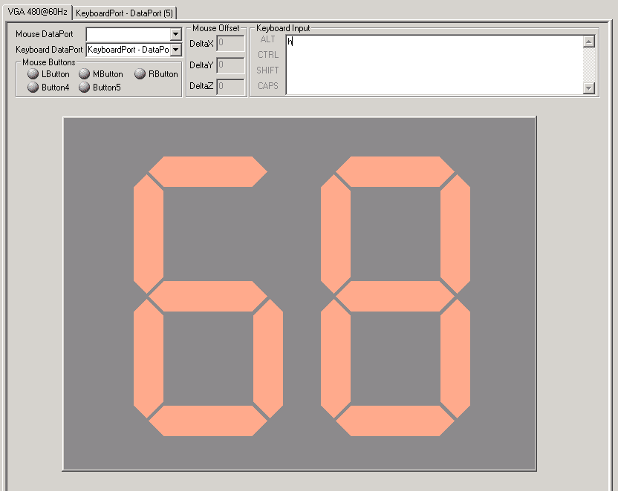

2) Parameters:
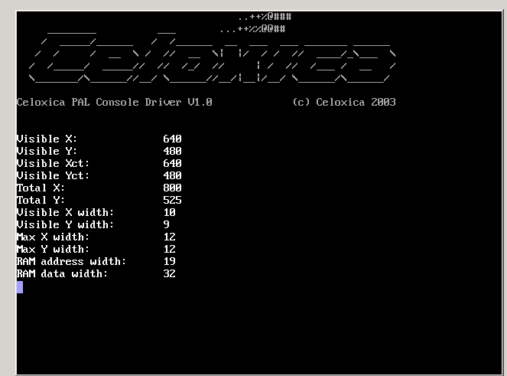

3) Unbuffered
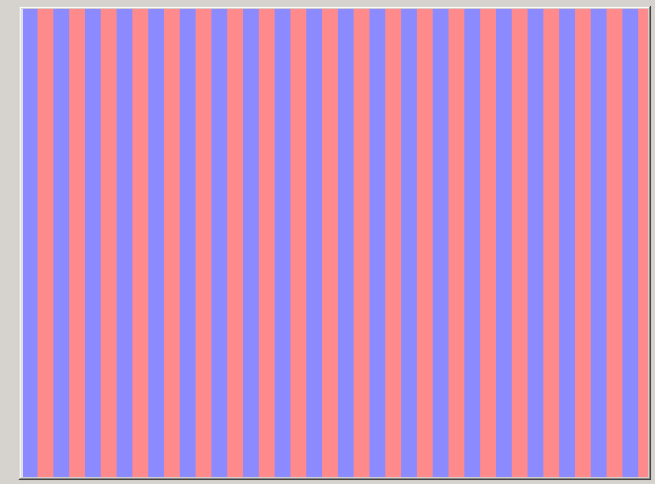

4). Framebuffer – Upper Left Corner
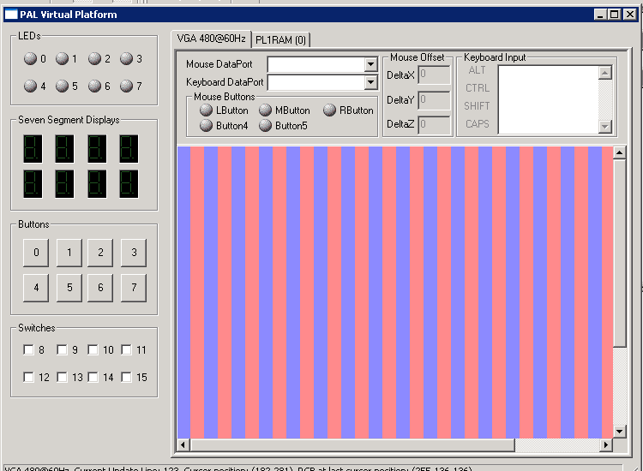

5) Framebuffer – Lower Right Corner
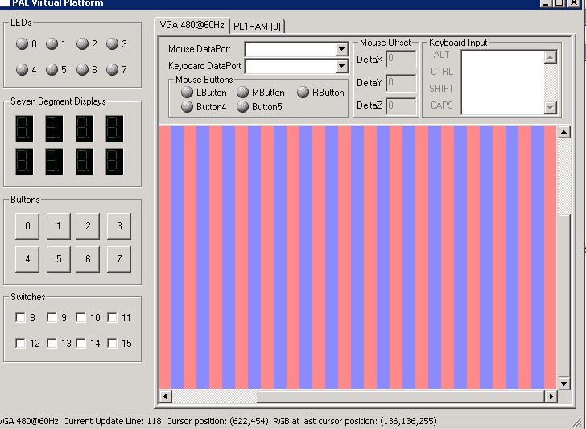

Appendices

//1. video.hcc
// Xingting Sun @ QC

#define PAL_TARGET_CLOCK_RATE 25175000
#include "stdlib.hch"
#include "pal_master.hch"
#include "pal_keyboard.hch"

#define ClockRate PAL_ACTUAL_CLOCK_RATE
macro expr VideoOut = PalVideoOutOptimalCT (ClockRate);
#define VisibleX PalVideoOutGetVisibleX (VideoOut, ClockRate)
#define VisibleY PalVideoOutGetVisibleY (VideoOut)
#define SegSeam 4

#define SegLength VisibleX/4 //length of each seg line, a quarter of the VisibleX
#define SegThick SegLength/4 //number of pixels for the thickness of each seg line
#define SegGap SegLength/3
#define startX (VisibleX/2-SegGap/2-SegLength-SegThick/2)
#define startY (VisibleY/2-SegLength-SegThick/2-2*SegSeam )

#define startXR (VisibleX/2+SegGap/2+SegThick/2) //X pos for right seg

//to save some key strokes

#define x PalVideoOutGetX(VideoOut)
#define y PalVideoOutGetY(VideoOut)
#define dy (y-startY)
#define dx (x-startX)

#define R_dx (x-startXR)

#define Color 0xFFAA88 //orange
#define Bg 0x888888 //gray

static macro proc RunOutput (VideoOut);

//Global variables:
rom unsigned 7 decoder[16] = { 0b1111110, 0b0110000, 0b1101101,0b1111001,
0b0110011, 0b1011011, 0b1011111,0b1110000,
0b1111111, 0b1111011, 0b1110111,0b0011111,
0b1001110, 0b0111101, 0b1001111,0b1000111 };

unsigned 7 leftsegs;
unsigned 7 rightsegs;
/*
static macro proc WriteSegLine (VideoOut, segType, startPosX, startPosY)
{
switch (segType)
{
case 0: //horizontal line
while (y<startPosY) {
delay;
}
while (y<= (startPosY +SegThick) )
{

if ( y <= (startPosY+SegThick/2) && x >= (startPosX-dy) && x <= (startPosX+SegLength+dy) )

PalVideoOutWrite (VideoOut, Color);

else if (y>=SegThick/2+startPosY && x>=startPosX-(SegThick-dy)
&& x< (startPosX+SegLength+SegThick-dy) )
PalVideoOutWrite (VideoOut, Color);

else
delay;
}
break;

case 1: //vertical line
while (x<startPosX || y<startPosY){
delay;
}
while ( ( x>= (startPosX+ SegThick )) && x <= (startPosY + SegLength) )
{
PalVideoOutWrite (VideoOut, Color);
}
break;
default: break;
}
}

static macro proc WriteSegs (VideoOut, val, startPosX, startPosY)
{
par
{
if (val !=1 || val !=4 || val !=11 || val !=13) //seg # 1
WriteSegLine (VideoOut, 0, startPosX, startPosY);

if (val !=5 || val !=6 || val !=11 || val !=12 || val !=14 || val !=15) //seg # 2
WriteSegLine (VideoOut, 1, startPosX, startPosY);

if (val !=2 || val !=12 ||val !=14 || val !=15 ) //seg #3
WriteSegLine (VideoOut, 1, startPosX, startPosY);
}
}
*/

void main ()
{

PalKeyboard *KeyboardPtr;
unsigned 8 kin; //keyboard input

PalVersionRequire (1, 0);
PalVideoOutRequire (1);
PalPS2PortRequire (2);

//PalKeyboardReadASCII (KeyboardPtr, &kin);
par
{
PalKeyboardRun (&KeyboardPtr, PalPS2PortCT (1), ClockRate);
PalVideoOutRun (VideoOut, ClockRate);
seq
{
par
{
PalKeyboardEnable (KeyboardPtr);
PalVideoOutEnable (VideoOut);
}
par
{
RunOutput(VideoOut);
while (1)
{
PalKeyboardReadASCII (KeyboardPtr, &kin);
leftsegs = decoder[kin[7:4]];
rightsegs = decoder[kin[3:0]];

}
}

}
}

}

#define L_rightmost startX+SegLength
#define L_horibtm1 startY+SegThick
#define bottom1 startY+SegThick/2+SegSeam+SegLength
#define bottom2 bottom1+2*SegSeam+SegLength

#define R_rightmost startXR+SegLength

static macro proc RunOutput (VideoOut)
{
while (1)
{
if (!leftsegs && !rightsegs)
PalVideoOutWrite (VideoOut, Bg);
else if( (leftsegs[6] && (dx >=abs(SegThick/2-dy)) && (dx<SegLength-abs(SegThick/2-dy)) && y>= startY && y<=L_horibtm1) //a
|| (leftsegs[5] && x >L_rightmost-SegThick/2 && x<=L_rightmost+SegThick/2 && y>startY && dy>= SegThick/2+SegSeam+abs(SegLength-dx+3) && y<=(bottom1-abs(SegLength-dx+3))) //b
|| (leftsegs[4] && x >L_rightmost-SegThick/2 && x<=L_rightmost+SegThick/2 && y>= bottom1+2*SegSeam+abs(SegLength-dx+3) && y<=bottom2-abs(SegLength-dx+3)) //c
|| (leftsegs[3] && (dx >=abs(bottom2+SegSeam-y)) && (dx<SegLength-abs(bottom2+SegSeam-y)) && y>= bottom2+SegSeam-SegThick/2 && y<=bottom2+SegSeam+SegThick/2) //d
|| (leftsegs[2] && x >=startX-SegThick/2 && x<startX+SegThick/2 && y>= bottom1+2*SegSeam+abs(startX-x-3) && y<=bottom2-abs(startX-x-3)) //e
|| (leftsegs[1] && x >=startX-SegThick/2 && x<startX+SegThick/2 && y>=startY+SegThick/2+SegSeam && y>= startY+SegThick/2+SegSeam+abs(startX-x-3) && y<=bottom1-abs(startX-x-3)) //f
|| (leftsegs[0] && (dx >=abs(bottom1+SegSeam-y)) && (dx<SegLength-abs(bottom1+SegSeam-y)) && y>= bottom1+SegSeam-SegThick/2 && y<=bottom1+SegSeam+SegThick/2) //g

|| (rightsegs[6] && (R_dx >=abs(SegThick/2-dy)) && (R_dx<SegLength-abs(SegThick/2-dy)) && y>= startY && y<=L_horibtm1) //a
|| (rightsegs[5] && x >R_rightmost-SegThick/2 && x<=R_rightmost+SegThick/2 && y>startY && dy>= SegThick/2+SegSeam+abs(SegLength-R_dx+3) && y<=(bottom1-abs(SegLength-R_dx+3))) //b
|| (rightsegs[4] && x >R_rightmost-SegThick/2 && x<=R_rightmost+SegThick/2 && y>= bottom1+2*SegSeam+abs(SegLength-R_dx+3) && y<=bottom2-abs(SegLength-R_dx+3)) //c
|| (rightsegs[3] && (R_dx >=abs(bottom2+SegSeam-y)) && (R_dx<SegLength-abs(bottom2+SegSeam-y)) && y>= bottom2+SegSeam-SegThick/2 && y<=bottom2+SegSeam+SegThick/2) //d
|| (rightsegs[2] && x >=startXR-SegThick/2 && x<startXR+SegThick/2 && y>= bottom1+2*SegSeam+abs(startXR-x-3) && y<=bottom2-abs(startXR-x-3)) //e
|| (rightsegs[1] && x >=startXR-SegThick/2 && x<startXR+SegThick/2 && y>=startY+SegThick/2+SegSeam && y>= startY+SegThick/2+SegSeam+abs(startXR-x-3) && y<=bottom1-abs(startXR-x-3)) //f
|| (rightsegs[0] && (R_dx >=abs(bottom1+SegSeam-y)) && (R_dx<SegLength-abs(bottom1+SegSeam-y)) && y>= bottom1+SegSeam-SegThick/2 && y<=bottom1+SegSeam+SegThick/2) //g
)

PalVideoOutWrite (VideoOut, Color);

else
PalVideoOutWrite (VideoOut, Bg);
}
}

//2. parameters.hcc

//Xingting Sun @ QC

#define PAL_TARGET_CLOCK_RATE 25175000
#include "stdlib.hch"
#include "pal_master.hch"
#include "pal_console.hch"

#define ClockRate PAL_ACTUAL_CLOCK_RATE
macro expr VideoOut = PalVideoOutOptimalCT (ClockRate);

#define VisibleXCT PalVideoOutGetVisibleXCT (VideoOut, ClockRate)
#define VisibleYCT PalVideoOutGetVisibleYCT (VideoOut)
#define VisibleX PalVideoOutGetVisibleX (VideoOut, ClockRate)
#define VisibleY PalVideoOutGetVisibleY (VideoOut)
#define TotalX PalVideoOutGetTotalX (VideoOut, ClockRate) //total pixels per scanline
#define TotalY PalVideoOutGetTotalY (VideoOut) //total num of scanlines
#define VisibleXwid log2ceil(VisibleXCT )
#define VisibleYwid log2ceil(VisibleYCT )
#define MaxXwid PalVideoOutGetXWidth (VideoOut)
#define MaxYwid PalVideoOutGetYWidth (VideoOut)
#define RamAddrwid PalPL1RAMGetMaxAddressWidthCT ()
#define RamDatawid PalPL1RAMGetMaxDataWidthCT ()

#define MSG_NUM 12 //number of messages to print out
#define MSG_WID 19 //number of characters per message

static unsigned rom char msg[228] = "Visible X: \t" "Visible Y: \t" "Visible Xct: \t" "Visible Yct: \t"
"Total X: \t" "Total Y: \t"
"Visible X width: \t" "Visible Y width: \t" "Max X width: \t"
"Max Y width: \t" "RAM address width:\t" "RAM data width: \t";

void main()
{
unsigned (log2ceil(MSG_NUM)) i;
unsigned (log2ceil(MSG_WID)) j;

PalConsole *ConsolePtr;
PalVersionRequire (1, 0);
PalVideoOutRequire (4);

par {
PalConsoleRun (&ConsolePtr, PAL_CONSOLE_FONT_NORMAL,
PalVideoOutOptimalCT (ClockRate), ClockRate);
seq {
PalConsoleEnable (ConsolePtr);

for (i=0; i<=MSG_NUM-1; i++)
{

for (j=0; j<=MSG_WID-1; j++)
{
PalConsolePutChar (ConsolePtr, msg[j+i*MSG_WID]);
}
switch (i) {
case 0: PalConsolePutUInt (ConsolePtr, VisibleXCT);
break;
case 1: PalConsolePutUInt (ConsolePtr, VisibleYCT);
break;
case 2: PalConsolePutUInt (ConsolePtr, adju(VisibleX,32));
break;
case 3: PalConsolePutUInt (ConsolePtr, adju(VisibleY,32));
break;
case 4: PalConsolePutUInt (ConsolePtr, adju(TotalX,32));
break;
case 5: PalConsolePutUInt (ConsolePtr, adju(TotalY,32));
break;
case 6: PalConsolePutUInt (ConsolePtr, VisibleXwid);
break;
case 7: PalConsolePutUInt (ConsolePtr, VisibleYwid);
break;
case 8: PalConsolePutUInt (ConsolePtr, MaxXwid);
break;
case 9: PalConsolePutUInt (ConsolePtr, MaxYwid);
break;
case 10: PalConsolePutUInt (ConsolePtr, RamAddrwid);
break;
case 11: PalConsolePutUInt (ConsolePtr, RamDatawid);

}

PalConsolePutChar (ConsolePtr, '\n');
}
}
}
}

//3. unbuffered.hcc
// Xingting Sun @ QC

#define PAL_TARGET_CLOCK_RATE 25175000

#include "stdlib.hch"
#include "pal_master.hch"

#define ClockRate PAL_ACTUAL_CLOCK_RATE
#define VideoOut PalVideoOutOptimalCT (ClockRate)
#define isBlank PalVideoOutGetHBlank (VideoOut)
#define x PalVideoOutGetX(VideoOut)
#define y PalVideoOutGetY(VideoOut)
#define alt 4

#define white 0xFFFFFF
#define blue 0x8888FF
#define red 0xFF8888

void main ()
{
unsigned 1 oldBlank;

unsigned 1 begXbit; //holds value of the bit value at the beginning of a scanline

PalVersionRequire (1, 0);
PalVideoOutRequire (1);
par
{
PalVideoOutRun (VideoOut, ClockRate);
seq {
PalVideoOutEnable (VideoOut);
while (1) { //infinite thread to draw the alternating pattern
if (oldBlank==1 && isBlank ==0){ //At the beginning of a scanline
//PalVideoOutWrite (VideoOut, white);
par {
oldBlank =0;
begXbit = x[alt]; //remember the 4th bit value for the beginning
PalVideoOutWrite (VideoOut, blue);
}
} else if (oldBlank ==0 && isBlank ==0 && x[alt]==begXbit)
PalVideoOutWrite (VideoOut, blue);
else if (oldBlank ==0 && isBlank ==0 && x[alt]!=begXbit)
PalVideoOutWrite (VideoOut, red);
else if (oldBlank==0 && isBlank ==1)
oldBlank =1;
else PalVideoOutWrite (VideoOut, white);

}
}
}
}

//4. framebuffered.hcc
// Xingting Sun @ QC

#define PAL_TARGET_CLOCK_RATE 25175000
#include "stdlib.hch"
#include "pal_master.hch"

macro expr ClockRate= PAL_ACTUAL_CLOCK_RATE;
macro expr VideoOut = PalVideoOutOptimalCT (ClockRate);
#define PL1RAM PalPL1RAMCT (0)

#define VisibleXCT PalVideoOutGetVisibleXCT (VideoOut, ClockRate)
#define VisibleYCT PalVideoOutGetVisibleYCT (VideoOut)
#define VisibleX PalVideoOutGetVisibleX (VideoOut, ClockRate)
#define VisibleY PalVideoOutGetVisibleY (VideoOut)
#define TotalX PalVideoOutGetTotalX (VideoOut, ClockRate) //total pixels per scanline
#define TotalY PalVideoOutGetTotalY (VideoOut) //total num of scanlines
#define VisibleXwid log2ceil(VisibleXCT )
#define VisibleYwid log2ceil(VisibleYCT )
macro expr RamAddrwid = PalPL1RAMGetMaxAddressWidthCT ();
macro expr RamDatawid = PalPL1RAMGetMaxDataWidthCT ();

#define white 0xFFFFFF
#define blue 0x8888FF
#define red 0xFF8888
#define alt 4

#define x (PalVideoOutGetX(VideoOut))
#define y (PalVideoOutGetY(VideoOut))
#define xpart (adju (i, RamAddrwid) \\ (RamAddrwid-VisibleXwid))
#define ypart (adju (i, RamAddrwid) <- VisibleYwid)

void main ()
{
unsigned RamAddrwid addr;
unsigned RamDatawid Data;
unsigned 1 a;
unsigned 2 b;
unsigned i;

PalVersionRequire (1, 0);
PalVideoOutRequire (1);
PalPL1RAMRequire (1);

par {
PalPL1RAMRun (PL1RAM, ClockRate);
PalVideoOutRun (VideoOut, ClockRate);
Data =0xFFFFFF;
seq {
par {
PalPL1RAMEnable (PL1RAM);
PalVideoOutEnable (VideoOut);
}

//writer
do{
PalPL1RAMSetWriteAddress (PL1RAM, i);
if (xpart ==0 || ypart ==0 || xpart==adju(VisibleX-1,width(xpart)) || ypart==adju(VisibleY-1,width(ypart)))
PalPL1RAMWrite (PL1RAM, white);
else {
if (xpart[alt])
PalPL1RAMWrite (PL1RAM, red);
else
PalPL1RAMWrite (PL1RAM, blue);

}
i++;
}while (i != ~0);

//reader
PalPL1RAMSetReadAddress (PL1RAM, 0);
while (1)
{
par {
if (b <2)
b ++;
else
PalVideoOutWrite (VideoOut, Data <- 24);

if (a<1)
a++;
else
PalPL1RAMRead (PL1RAM, &Data);

if(y==TotalY-1)
PalPL1RAMSetReadAddress (PL1RAM, (adju(x+3, RamAddrwid)) << VisibleYwid);
else if (x==TotalX-2 || x==TotalX-1)
PalPL1RAMSetReadAddress (PL1RAM, (adju(x-TotalX+2, RamAddrwid-VisibleYwid)) @ (adju(y+1,VisibleYwid)));
else
PalPL1RAMSetReadAddress (PL1RAM, (adju(x+2, RamAddrwid-VisibleYwid)) @ (adju(y,VisibleYwid)));

}
}
}

}
}

