Supplementary material: Simulation to optimize the laboratory diagnosis of bacteremia
Table of Contents
Observation form example (Figure S1) 2
Simulation input parameters (Table S1) 3
Blood culture process maps (Figure S2–Figure S5) 4
Supplementary plots (Figure S6–Figure S8) 8

Observation form example (Figure S1)
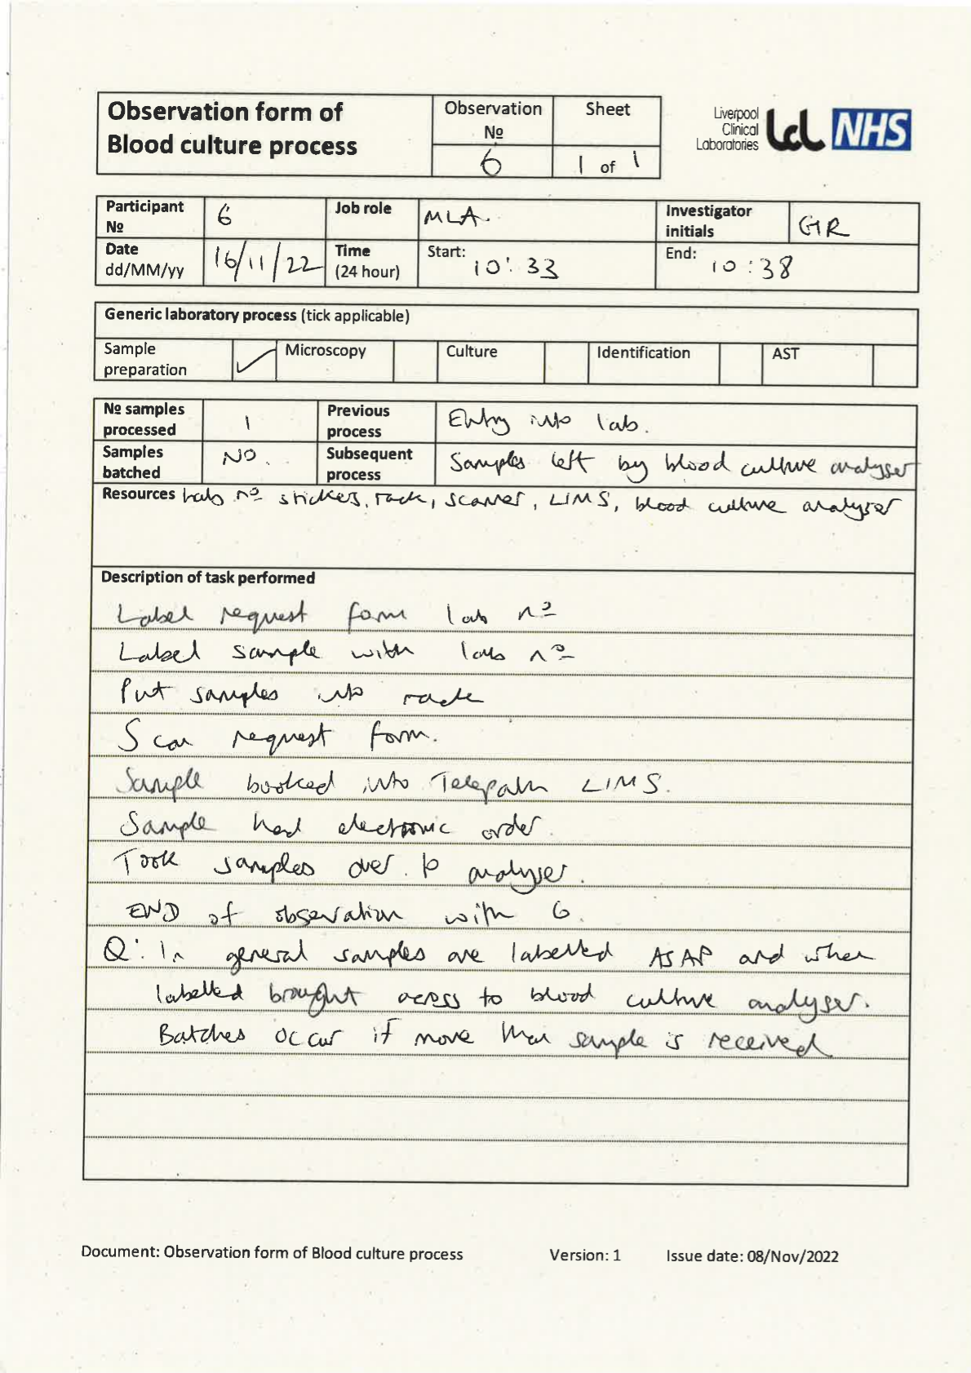
Figure S1 – Example observation form for blood culture processes. LIMS=laboratory information management system, MLA=medical laboratory assistant (technician)

Simulation input parameters (Table S1)
Table S1: Simulation input parameters not listed in main text.
Parameter name | Distribution/Value | Parameter values
Specimen generation rate | Exponential | 0.0638
Shift working on | Boolean | True
Shift patterns (reception technician only) |  | 08:00–20:00: On duty  20:00–08:00: Off duty
Time to positivity | Weibull | alpha = 1417; beta = 1.383
Maximum incubation time | Constant | 5 days
Positivity rate | Proportion | 11.1%
Transport time | Gamma | alpha = 0.99; beta = 333.3
AST incubation time* | Constant | 18 hours
n specimens per simulation | Constant | 500
*AST=antimicrobial susceptibility testing

Blood culture process maps (Figure S2–Figure S5)
Note: Associate practitioners (AP) were classed as technicians within the simulator.
Figure S2 – Process model of blood cultures from laboratory receipt to processing positive bottle.
Figure S3 – Process model of blood cultures for direct identification from positive bottle using Sepsityper.

Figure S4– Process model of blood cultures for 24-hour culture read.

Figure S5 – Process model of blood cultures for 48 hour and post 48-hour culture reads.

Supplementary plots (Figure S6–Figure S8)
Figure S6 – Correlation matrix for retrospectively collected data. Diagonal blocks show data histograms and the chosen probability distributions. Lower blocks show data points. Upper blocks show Pearson correlation coefficient (r).

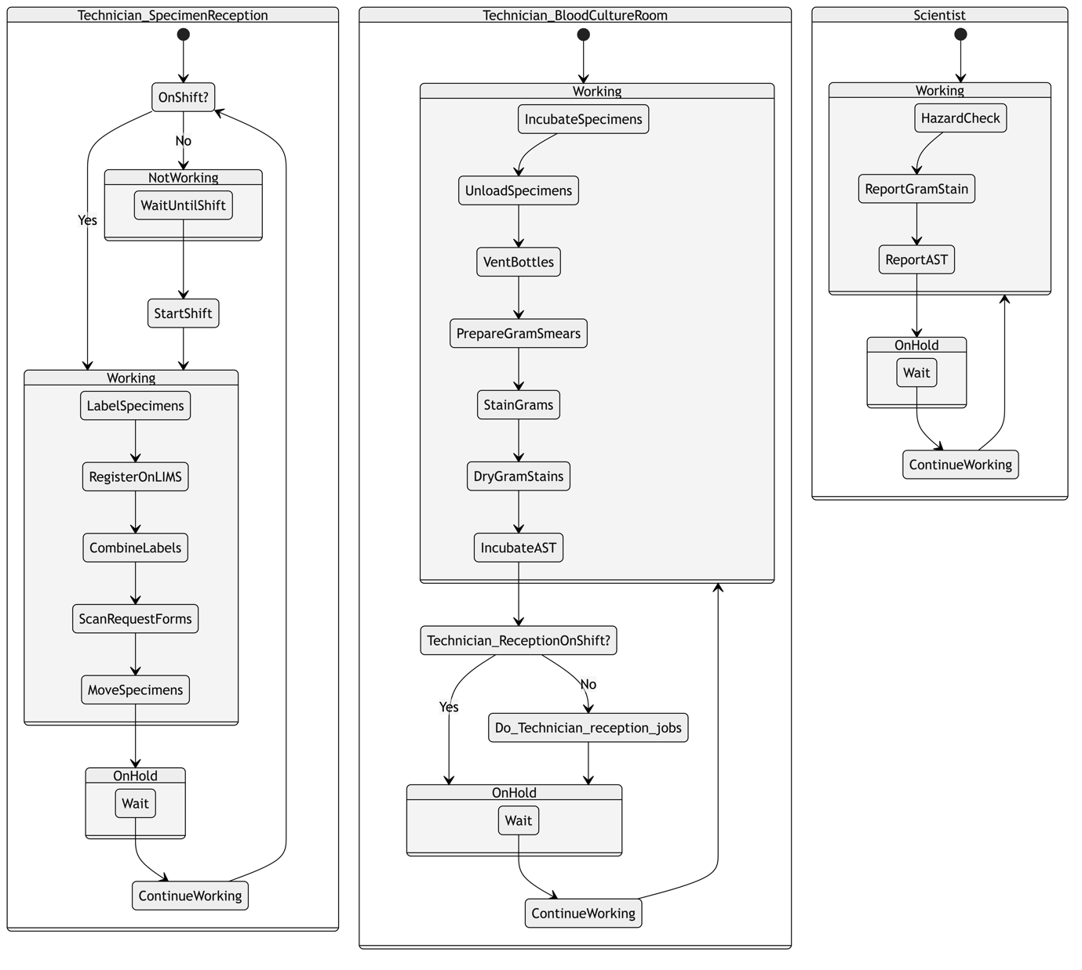
Figure S7 – Behavior of staff within the simulated laboratory. Technicians generally perform processing steps, while scientists generally perform interpretative steps. LIMS = laboratory information management system, AST = antimicrobial susceptibility testing.
Figure S8 – Results of specimens generated from a single simulation run, with distribution of key event node times plotted against those observed in real specimens. 'OnHold' wait time was fixed at 23 minutes for all staff members.

