**Sudoku Desktop Application**

**User Manual**

**Table of Contents**

**1.0**  **Introduction** 1

1.1 System Overview 1

1.2 Organization of the Manual 1

**2.0**  **System Summary** 3

2.1 System Requirements 3

2.2 User Access Levels 3

2.3 Contingencies 3

**3.0**  **Getting Started** 4

3.1 Downloading 4

3.2 Installing 4

3.3 Starting the Application 4

**4.0**  **Using the System** 6

4.1 The Menu System 6

**4.1.1** **Starting a New Game** 7

**4.1.2** **Loading a Saved Game** 9

**4.1.3** **Viewing Your Statistics** 10

**4.1.4** **Creating Your Own Puzzles** 12

**4.1.5** **Changing the Game Settings** 12

**4.1.6** **Quitting the Game** 13

4.2 Playing the Game 14

**4.2.1** **Rules of Sudoku** 14

**4.2.2** **The Interface** 15

# **1.0 Introduction**

Welcome. This user guide will cover how to use and get the most out of your Sudoku desktop application. In this section, you’ll learn what the Sudoku desktop application is, what it does, and how to use this user guide to get the most out of your application.

The Sudoku application was developed by a team of computer science students at the University of Oregon for a core course. The application contains features that were required based on one customer’s preferences.

## **1.1 System Overview**

This Sudoku desktop application was designed to give Sudoku enthusiasts a nifty application they could play on their computers or laptops on-the-go. The application offers thousands of Sudoku puzzles in varying difficulties, giving the user higher replayability. The application allows users to start a puzzle, save it and resume it later after exiting the program. A timer is installed, giving the user the ability to time themselves, and also saves the user’s best times for each difficulty. Other in-game features include a list of legal moves given for the selected tile, highlighting numbers, and getting hints and the solution. All of these features and functionalities are covered more in-depth in section 4.

One unique feature this application also offers is for the user to create their own Sudoku puzzles. They can be inspired by anything, either from imagination, a puzzle found in the newspaper, etc. Users can create new puzzles, play them, solve them, and delete them. Players can export these puzzles and send them to friends with the application to challenge them, or they can import puzzles from other users as well. This feature is covered more in-depth in section 5.

## **1.2 Organization of the Manual**

This manual is divided into seven sections total. This first section was to provide an overview of what the Sudoku desktop application was about and what it offered. In the second section, you will learn about the system requirements needed to run the software, the access levels, and user contingencies. The third section will show you how to download, install, and run the program.

The fourth section introduces you to the bulk of the program. There, you will learn how to navigate the home menu, how to start a new puzzle, resume a saved puzzle, view your statistics, or best times, change the settings, and how to exit the application. You will also learn how to play Sudoku and how to play it on the program’s interface. You will also learn how to highlight, insert, and delete numbers as well as get hints and solutions.

In the fifth section, you will learn how to create your own Sudoku puzzles. You will learn how to create a new puzzle, edit a puzzle, play and solve puzzles, and also how to import and export puzzles. You will also learn about the file system and where the application saves all of your data.

The sixth section includes a troubleshooting guide, which you can refer to if something in the program goes wrong. There, you will find many different problem scenarios that offer a diagnosis and suggested solution for each problem. Hopefully, you will never need to refer to this section. The seventh and final section contains the credits, and download links to resources mentioned in the guide.

# **2.0 System Summary**

In this section, you will learn what system requirements you will need to run the software, and how to meet them if you do not. You will also learn who can use the application, and who has access to your data. Finally, you will learn about some of the contingencies that can occur, and what the program’s response will be to them.

## **2.1 System Requirements**

To run the application, your computer must have Java 8 or a later version installed. If you have an older version of java, you can click [here](https://java.com/en/download/) to download the most recent version. Once you’ve downloaded the java update package, open the folder and select the executable download file to start the download. Follow the prompted instructions given on the screen to finish downloading and installing your Java update.

If the above link doesn’t work, go to www.oracle.com. From there, hover over the ‘Downloads’ tab, then select ‘Java for Your Computer’. You will be taken to the download page where you can download the most recent version of Java. Select the package that matches with your operating system. Then follow the instructions in the above paragraph to install the update.

## **2.2 User Access Levels**

After installing the program, anyone who has access to your desktop can use the program and manipulate your data. To prevent this, it is recommended that you change your user account settings to require administrative access to run the program or to access your desktop. Refer to your computer’s manual on how to do this.

## **2.3 Contingencies**

Unfortunately, there are cases where unexpected events can occur that cause our computer to crash or do unexpected things. Your data is not saved until you exit the application, so any unsaved data that you have before the crash happens will be lost. This only includes your saved game, best times, and any edits made on one of your puzzles after your last save.

If you delete the saved data on your computer while the program is running, it could cause certain buttons to become unresponsive or could crash the program. To prevent this, do not open and manipulate your program’s save files while the program is running.

# **3.0 Getting Started**

This section covers where and how to download the application, how to install and set up the program on your computer, and how to launch the program. By the end of this section, you should have the program functioning on your computer and will be ready to start learning how to use the program.

## **3.1 Downloading**

Chances are, if you’re reading this guide, you’ve already downloaded and installed the application. If so, feel free to skip to section 3.2. If not, you can download the program [here](https://github.com/cvikupitz/Sudoku/releases). On this page, simply click the ‘Sudoku.zip’ link to download the program. Go to your computer’s downloads folder to find the downloaded zipped archive folder.

## **3.2 Installing**

Simply unzip the folder you downloaded, then click and drag the program to whichever directory you want. It is recommended that you place the program onto your desktop, like most other programs. However, the program should work from any directory you decide to place it in.

## **3.3 Starting the Application**

To start the application, simply double-click the program to launch it. If your computer meets the system requirements specified earlier, the program should launch successfully, and you should see the window shown in figure 3.1. If the application did not successfully start, refer back to the system requirements (Section 2.1) or the troubleshooting section (Section 6).

*The rest of this page is intentionally left blank.*

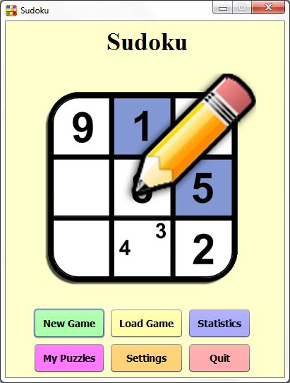

**Figure 3.1** –*This window will appear if the program launched successfully. If this window appears for you on start-up, then you have successfully installed the program and are ready to start learning how to use it.*

# **4.0 Using the System**

Now that you have the program running successfully, it’s time to start learning the basics. By the end of this section, you’ll know how to start a new game, play a simple game of Sudoku, load a saved game, view your best times, change your game settings, and quit the application.

## **4.1 The Menu System**

In this section, you’ll learn about the menu system and how to navigate through it. This includes starting a new game, loading a saved game, viewing your best times, accessing your saved custom puzzles, changing your settings, and quitting the program. See figure 4.1 below for a quick guide on how this section is organized.

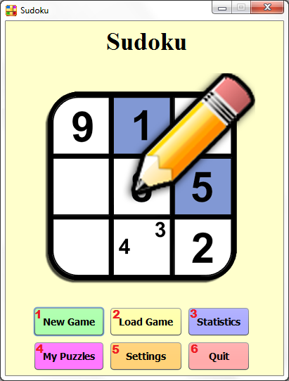

**Figure 4.1** – *The home menu of the program with a key next to each option, explained below.*

1.) *New Game* – Clicking this button will start a new game of Sudoku (section 4.1.1).

2.) *Load Game* – Clicking this button will load the previous game you started (section 4.1.2).

3.) *Statistics* – Clicking this button will display your best times, organized by puzzle difficulty (section 4.1.3).

4.) *My Puzzles* – Clicking this button takes you to your custom puzzle menu, where you can create and play user-created Sudoku puzzles. Briefly covered in section 4.1.4, but covered fully in section 5.

5.) *Settings* – Clicking this button takes you to the settings menu, where you can change the program settings (section 4.1.5).

6.) *Quit* – Clicking this button will exit the program (section 4.1.6).

### **4.1.1 Starting a New Game**

To start a new game, click the ‘New Game’ button from the home menu. You will be taken to another window where you can choose the puzzle difficulty, as shown in figure 4.2. There are five difficulties to choose from, including ‘Novice’, ‘Easy’, ‘Medium’, ‘Hard’, and ‘Expert’. A novice game will give you a puzzle with 45 tiles already filled, an easy game giving you a puzzle with 40 tiles filled, medium with 35 tiles, hard with 30 tiles, and expert with 25 tiles. You can also click the ‘Back’ button to return the home menu.

Once you’ve clicked a difficulty, a new game will start and you should see a window similar to the one shown in figure 4.3. Note that once you start a new game, your saved puzzle will be overwritten with the new puzzle and the data from the previous will be lost. If you do not want this to happen, go back to the home menu before starting a new game and click ‘Load Game’ to resume the saved game.

*The rest of this page is intentionally left blank.*

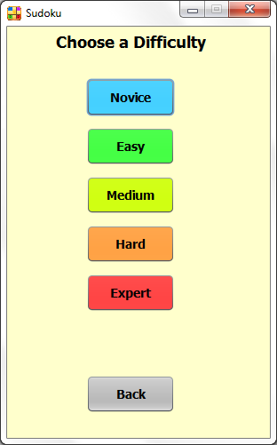

**Figure 4.2** – *This window appears when you click ‘New Game’. Click on the button with the specified puzzle difficulty of your desire to start a new puzzle with that difficulty, or the back button to go back to the home menu.*

*The rest of this page is intentionally left blank.*

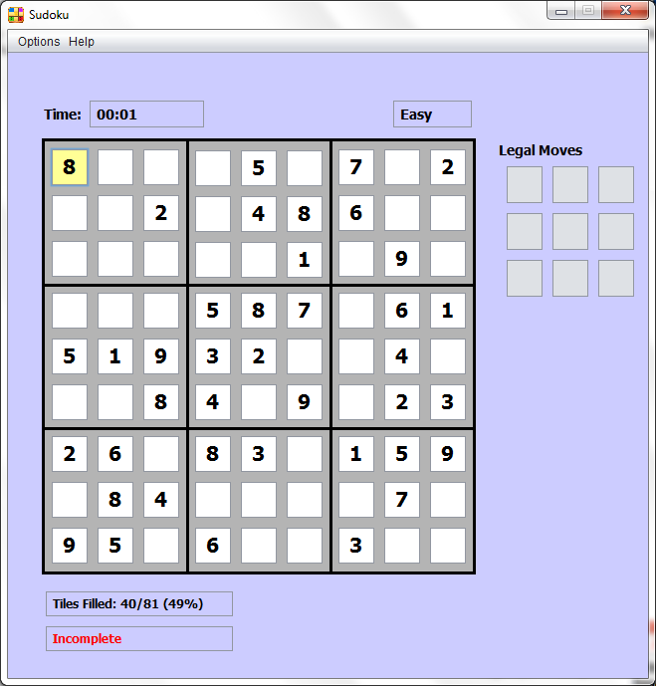

**Figure 4.3** – *A window similar to this one appears once you start a new game. This window and its components are covered later in section 4.2.*

### **4.1.2 Loading a Saved Game**

To resume a game you started earlier, click ‘Load Game’ from the home menu to load your saved game. You should see a window appear similar to the one shown in figure 4.3, and it should be the puzzle you started earlier. If you have no previously saved puzzle, or the save file doesn’t exist on your computer, a message will appear notifying you there is no saved game, as shown in figure 4.4. However, once you start a new game, that puzzle will become your saved puzzle, and you can resume it later if you quit out before completion.

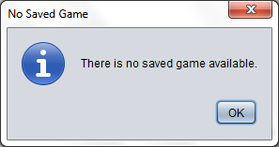

**Figure 4.4** – *This window appears when you attempt to load a saved game when one doesn’t exist.*

### **4.1.3 Viewing Your Statistics**

To view your best times, click ‘Statistics’ from the home menu. A new window will appear similar to the one shown in figure 4.5. On your first start-up, you’ll notice that the tables are empty, as it is shown in the figure. This means that you currently have no saved best times on the program. After completing a few puzzles, you’ll start acquiring best times and they will appear on the table.

Your best times are organized into five tabs, one for each difficulty. Each tab keeps track of your top ten times, as well as the date and time you achieved that time. To view your best times for a difficulty, simply click on the tab at the top of the table containing the desired difficulty to switch tables. When you’re done viewing your times, click ‘Back’ at the bottom left corner of the window to return to the home menu.

You can also reset your best times by difficulty simply by clicking ‘Reset’ at the bottom right corner of the window. Simply click the tab of the difficulty of the times you wish to reset to switch to that table, then click the reset button to reset your best times for the table currently on display. You will be asked to confirm the reset by clicking a yes or no button when prompted, as shown in figure 4.6. Click yes to reset your times, or no to cancel the reset. Be aware that once you reset your times, they are lost forever, so be sure you want to delete your times before confirming.

*The rest of this page is intentionally left blank.*

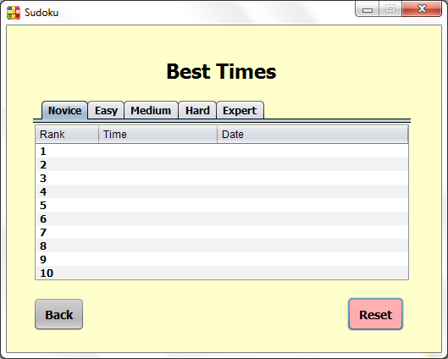

**Figure 4.5** – *This window appears when you click ‘Statistics’ from the home menu. Click a tab at the top to view your top ten times achieved for that difficulty along with the date and time you achieved them.*

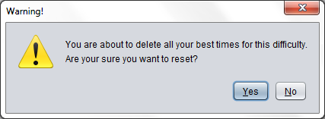

**Figure 4.6** – *This warning message appears when you click ‘Reset’ at the bottom right of the window. Click ‘Yes’ to reset your top times for the selected difficulty, or ‘No’ to cancel.*

### **4.1.4 Creating Your Own Puzzles**

Your Sudoku desktop application also allows you to create, edit and play your own Sudoku puzzles. From the home menu, click ‘My Puzzles’, then you will be taken to another window similar to the one shown in figure 4.7. This feature is explained more in-depth in section 5. To return to the home menu, click ‘Back’ at the bottom left corner of the window, or click File -> Go Back.

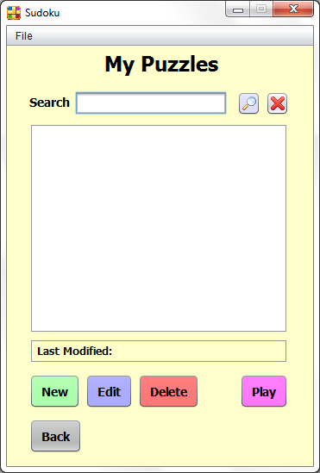

**Figure 4.7** – *This is the window that appears when ‘My Puzzles’ is clicked from the home menu. This window and its options and features are explained more in-depth in section 5.*

### **4.1.5 Changing the Game Settings**

To change the game settings, click ‘Settings’ from the home menu. A new window will appear as shown in figure 4.8. Here, you can configure your program’s settings by clicking the buttons next to each option. Click the on button to enable the corresponding game feature on the left, or off to disable it. Click ‘Back’ at the bottom left corner of the window to return to the home menu.

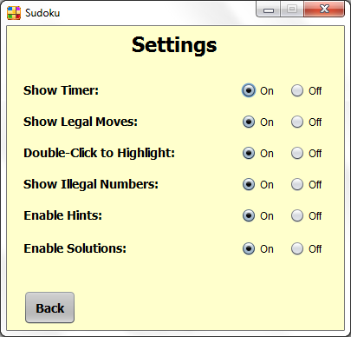

**Figure 4.8** – *This is where you can configure the program settings. Click the on button to enable the feature on the left, or off to disable it. Features are explained below.*

*Show Timer* – This feature displays the total time in-game (section 4.2.2).

*Show Legal Moves* – This feature will show or hide the panel of legal moves allowed in a selected tile (section 4.2.2).

*Double-Click to Highlight* – This feature allows players to highlight all common numbers on the board when the user double-clicks a tile with a number inside of it (section 4.2.3).

*Show Illegal Numbers* – This feature will highlight illegally inserted numbers in red (section 4.2.2).

*Enable Hints* – This feature allows users to obtain hints in-game (4.2.6).

*Enable Solutions* – This feature allows users to obtain the solution in-game (section 4.2.7).

### **4.1.6 Quitting the Game**

To quit the application, click ‘Quit’ from the home menu. You can also quit by closing any window you are currently in by clicking the red x at the top right corner of the window. Whenever you try to quit the application, a warning message will appear asking you to confirm by clicking a yes or no button (see figure 4.9). If you want to quit, click the yes button, or no to cancel.

Everything in the application is saved automatically when you quit, with the exception of editing a customized puzzle, as explained in section 5.1.4. Otherwise, feel free to exit the application whenever you wish to.

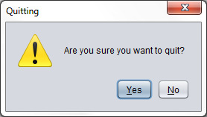

**Figure 4.9** – *This warning message appears when you attempt to exit the application. Click ‘Yes’ to exit the program, or ‘No’ to cancel.*

## **4.2 Playing the Game**

In this next section, you will now learn how to start and play a full game of Sudoku. You will learn how to play and the rules, how to start a new game, reset a game, and how to play on the application’s interface. You will also learn how to get hints on your puzzle, get the solution, and how to quit a puzzle.

### **4.2.1 Rules of Sudoku**

*If you already know how to play Sudoku, you can skip ahead to section 4.2.2. If not, read on.*

The goal of Sudoku is to fill the 9x9 board with the numbers 1 through 9 such that each row, column, and 3x3 grid that make up the whole grid all contain each of the nine digits. Each of these components must contain all nine numbers, and no duplicates are allowed in any row, column, or 3x3 grid. See figure 4.10 for a demonstration.

*The rest of this page is intentionally left blank.*

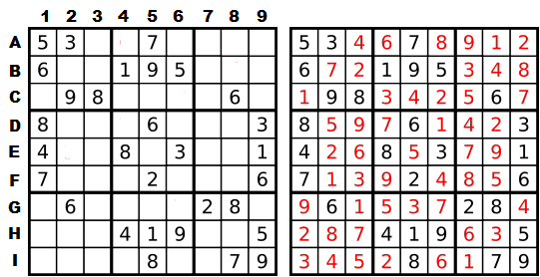

**Figure 4.10** – *On the left is an incomplete Sudoku puzzle. The goal is to fill the board with the numbers 1-9 such that each row (A-I), each column (1-9), and each 3x3 grid separated by the bold lines inside the grid (A1, A2, A3, B1, B2, B3, C1, C2, & C3 for example) contain the numbers 1-9 with no duplicates. On the right side is the completed version of the puzzle.*

On paper, some puzzles can be difficult to solve. With this application, you have some tools available to you to help you out, making solving them easier and faster (although if you want more of a challenge, refer to section 4.1.5 to turn off some of these features). Use the tools available and start off on the novice difficulty to learn the rules of Sudoku.

### **4.2.2 The Interface**

Start a new game as you learned in section 4.1.1. You will see a window as shown in figure 4.11. Refer to each letter next to each component in the figure and read the associated key to learn what the component is and what it does.

*The rest of this page is intentionally left blank.*

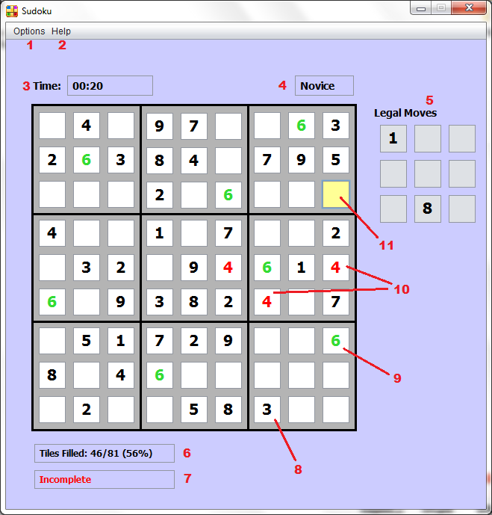

**Figure 4.11** – *The program interface during a game of Sudoku. Each component and tool are labeled with a number, and described below with section references.*

1.) *Options* – This tab located at the top of the window is where you can start a new game of Sudoku, reset the puzzle you are currently working on, or quit out of the puzzle and return to the home menu (sections 4.2.4, 4.2.5, and 4.2.8).

2.) *Help* – This tab located next to the options tab is where you can get hints for the puzzle, or request the solution of the puzzle (sections 4.2.6 and 4.2.7).

3.) *Timer* – This is the timer that keeps track of the total time you’ve spent working on the current puzzle. You can disable this feature in the settings menu (section 4.1.5).

4.) *Puzzle Difficulty* – The difficulty of the puzzle you are currently working on (novice, easy, medium, hard, or expert).

5.) *Legal Moves* – This component displays the numbers that can legally be inserted into the currently selected tile based on the puzzle’s current state. You can disable this feature in the settings menu (section 4.1.5).

6.) *Tiles Filled* – This labels the number of tiles and percentage you’ve filled in the puzzle so far.

7.) *Completeness* – Labels ‘Incomplete’ while the puzzle is unsolved, or ‘Complete!’ when the puzzle has been solved.

8.) Tiles that contain black numbers have been pre-filled. They are a part of the puzzle and cannot be edited.

9.) Users can highlight numbers inside the puzzle by double-clicking a non-empty tile. In this example, the user has double-clicked a tile with a 6 inside, and all 6s in the puzzle have been highlighted as a result (section 4.2.3). You can disable this feature in the settings menu (section 4.1.5).

10.) Tiles with red numbers indicates that the number is illegally inserted and conflicts with another tile in the puzzle. In this example, the 4 inserted is illegal due to the 4 in the sub-grid and the 4 in the row. You can disable this feature in the settings menu (section 4.1.5).

11.) The tile that is colored bright orange-yellow indicates that the tile is currently selected, and the user can insert numbers into that tile. Any tile can be selected, but not all can be edited (section 4.2.3).

### **4.2.3 Controls**

To play the puzzle, simply click a tile to select it, then press the numbers 1-9 to insert the number into that tile. Any other key you press will delete whatever number is in the tile. You can edit any tile that does not contain a black number.

To highlight all of one occurring number in the puzzle, simply double-click any tile containing your desired number. To un-highlight that number, double-click the tile again. Remember that this feature will not work if you have it disabled in the settings menu.

To access one of the options at the top of the window, simply click the tab once, then scroll to the option you want and click again.

### **4.2.4 Starting a New Puzzle**

If you wish to start a new puzzle and leave the one you are currently working on, simply click Options -> New Game. You will be asked to confirm when the message appears (see figure 4.12). Click ‘Yes’ to start a new game, or ‘No’ to continue your current puzzle. Note that if you click yes, your current puzzle will be tossed, and your progress on that puzzle will be lost. The application only saves one puzzle at a time, so be aware of this before confirming.

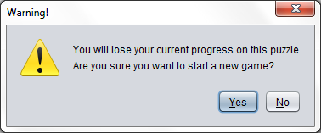

**Figure 4.12** – *This window appears when you request a new game. Click yes to start the new game, or no to continue the current puzzle.*