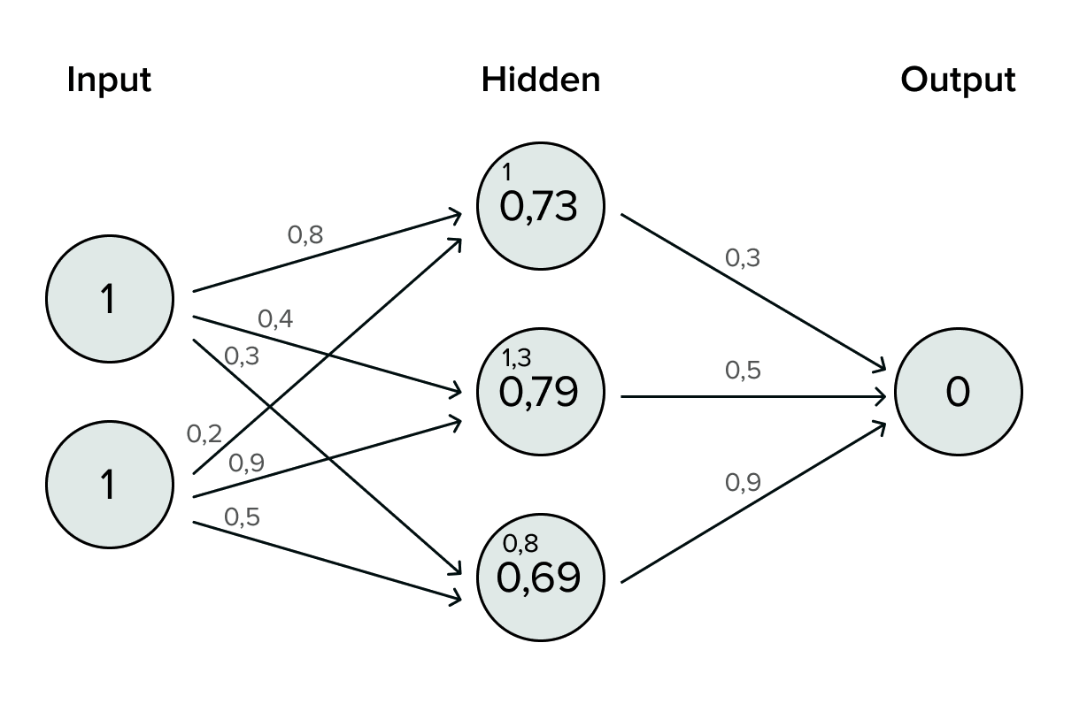

We have 2 input features (1, 1) and the weights are as follows: [[0.8, 0.4, 0.3],

[0.2,0.9,0.5]].

Forward Propagation Calculation:

Weighted sum = (1 \* 0.8) + (1 \* 0.2) = 1.0, then after applying the sigmoid function: sigmoid(1.0) ≈ 0.73105858