LABORATORY PRACTICE WORKSHOP 4

**PATH AND CLASSPATH CONFIGURATION**

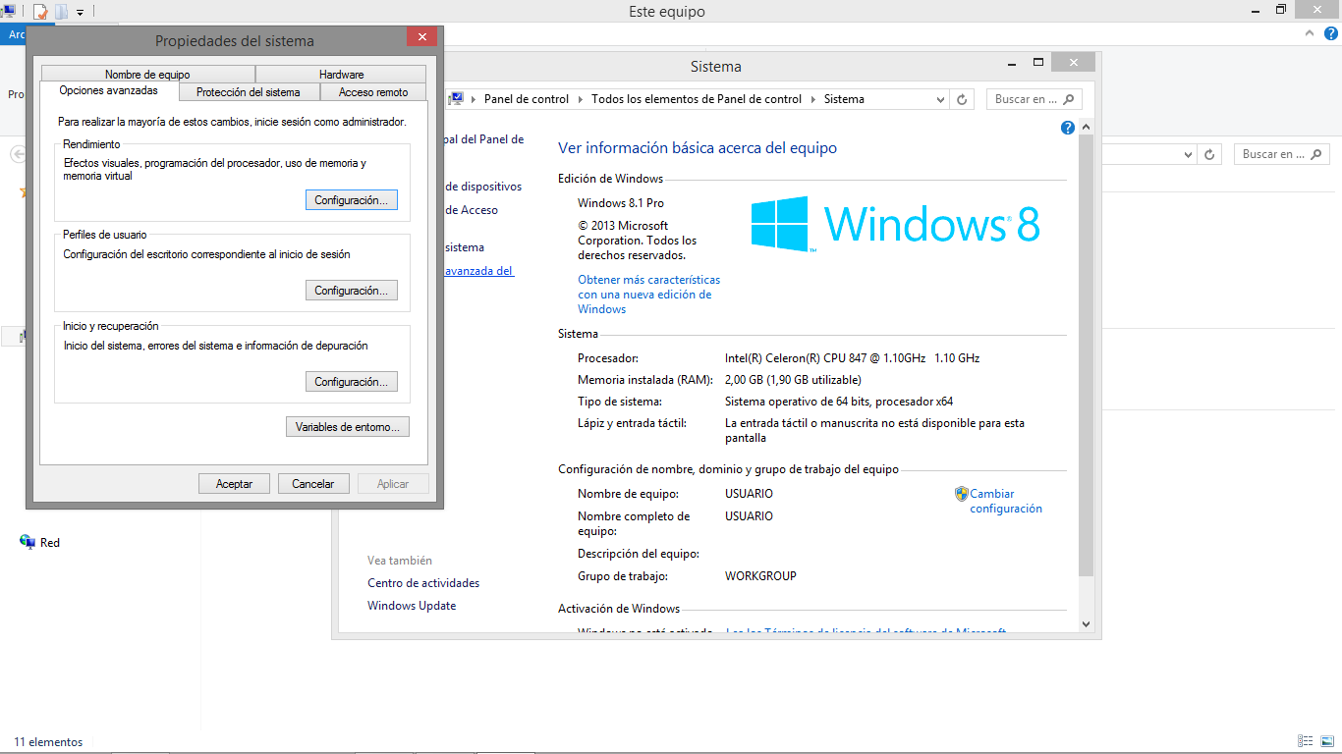  
WE ARE DIRECTED TO PROPERTIES OF THE SYSTEM AND VARIABLES OF ENVIRONMENT

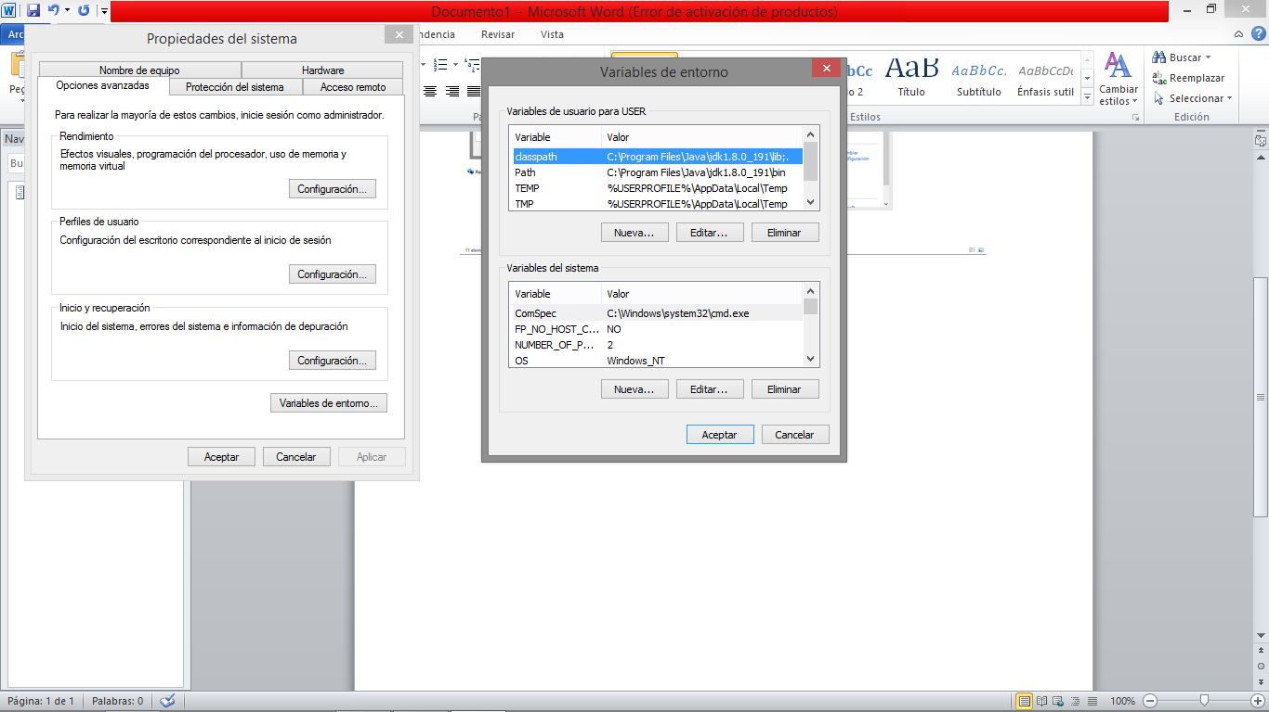

WE CREATE A NEW VARIABLE WITH THE NAME”PATCH”

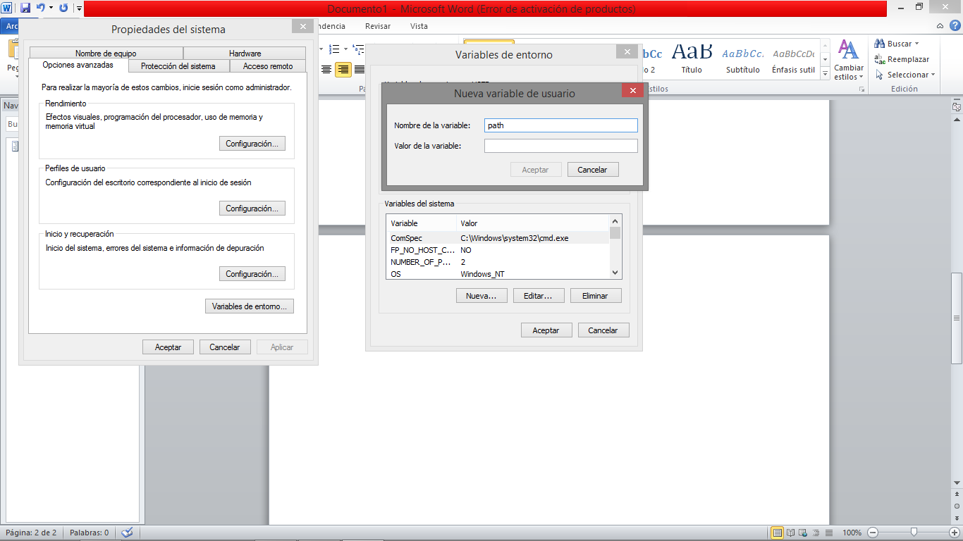

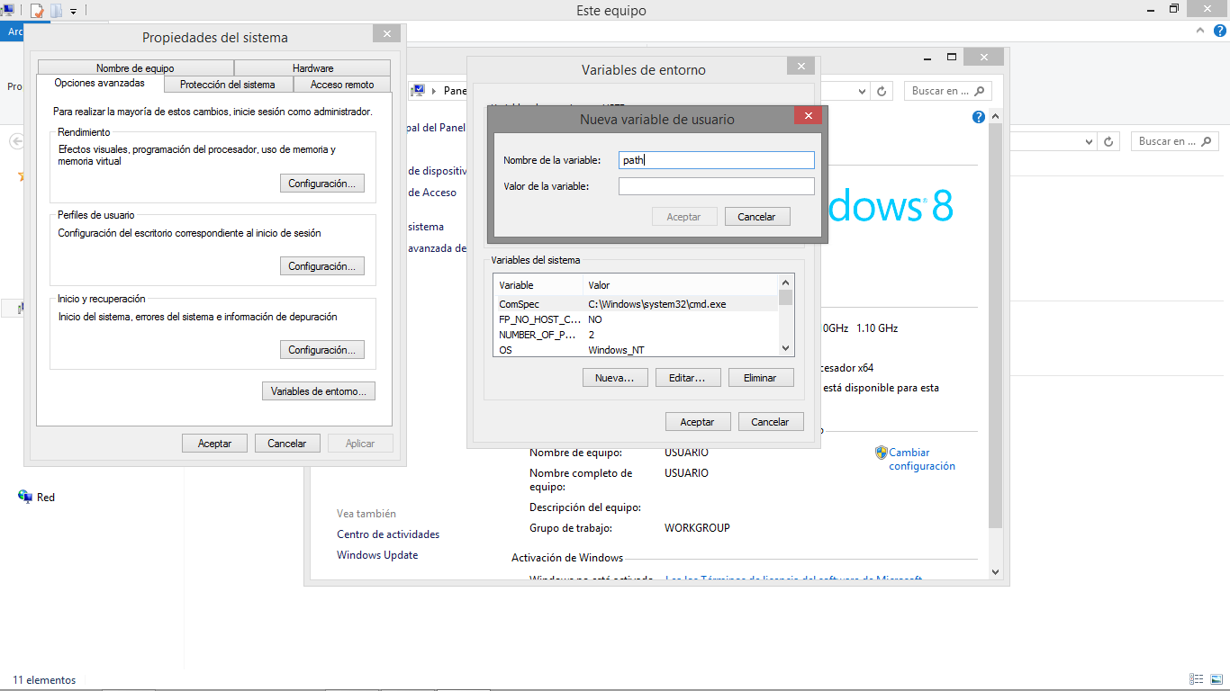

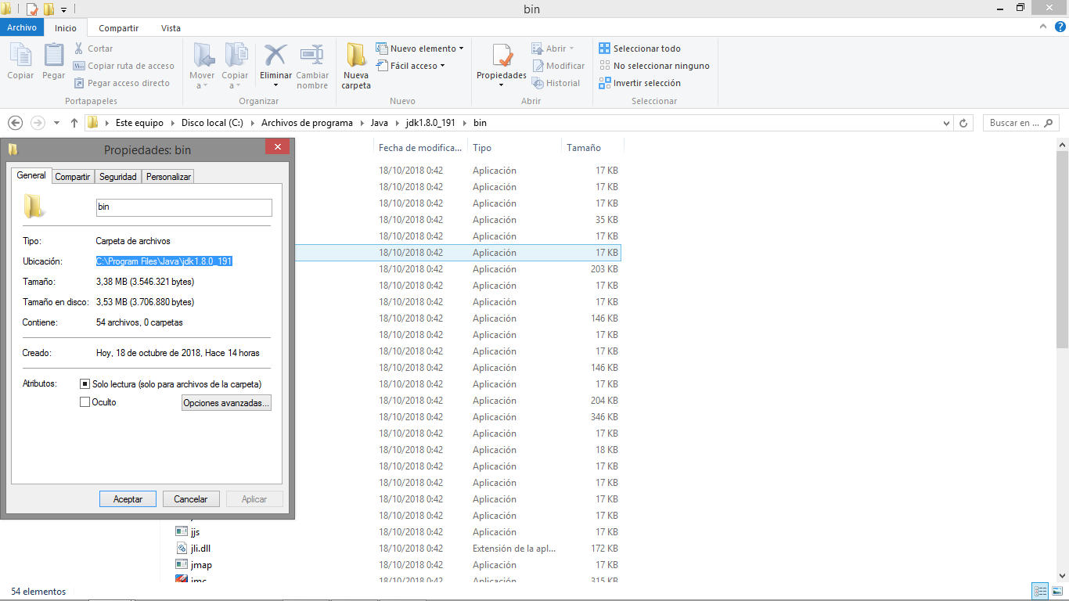

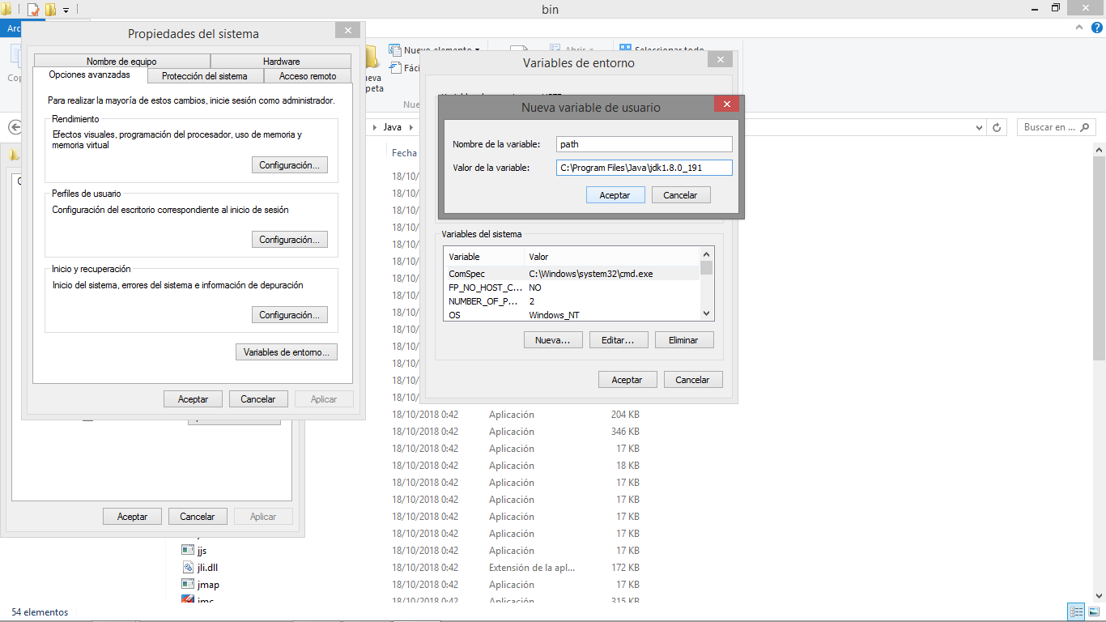

EXECUTE THE FOLLOWING COMMANDS IN THE CONSOLE TO VERIFY

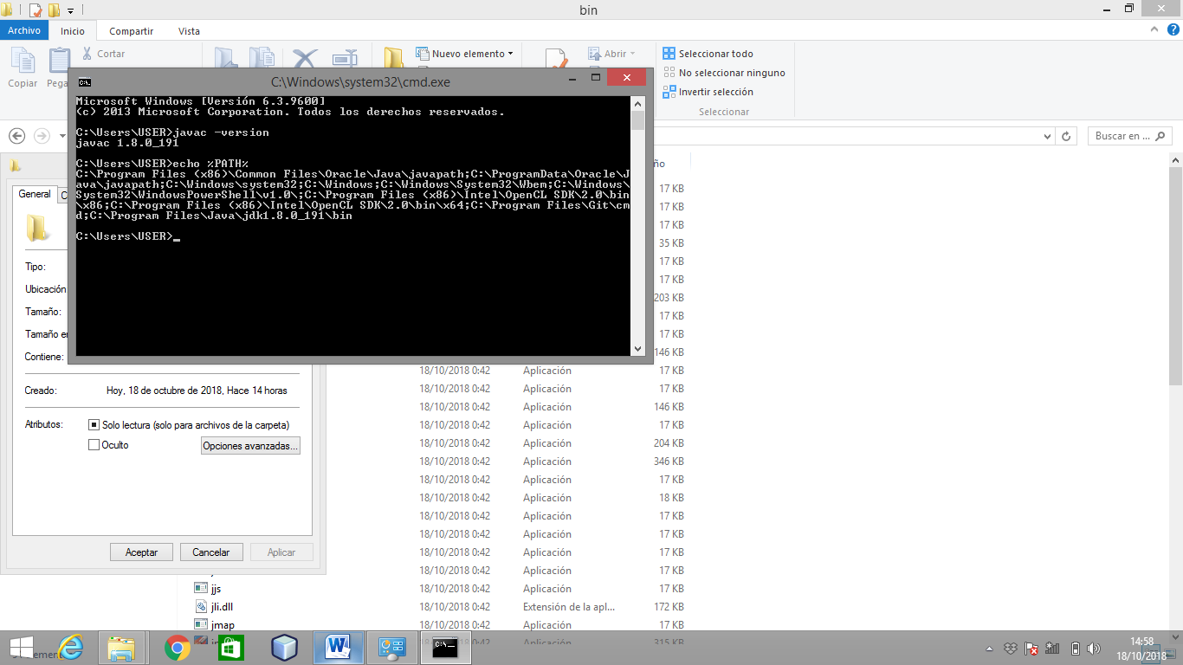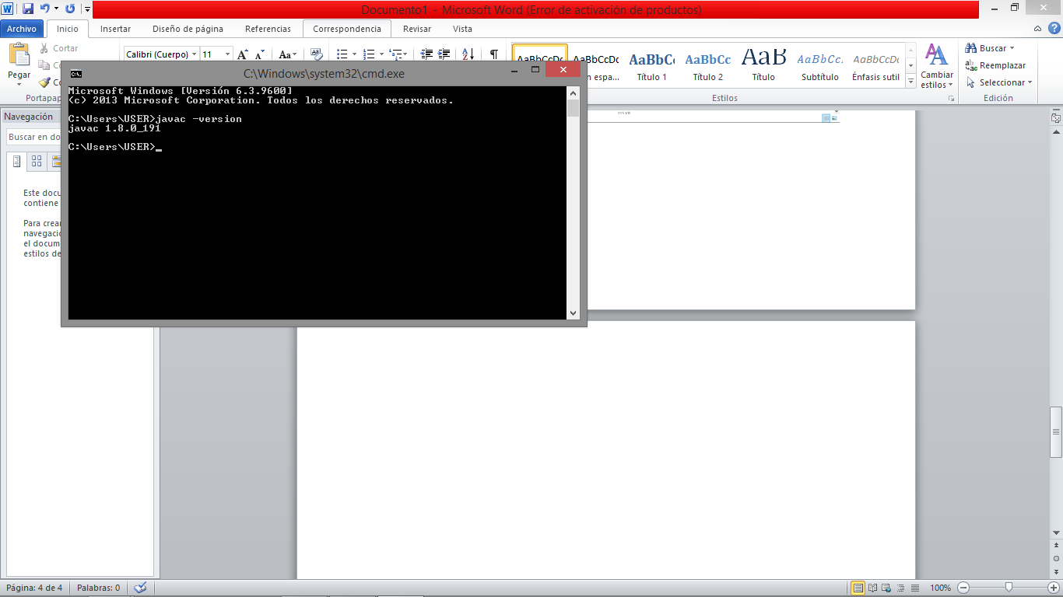

**LIB**

TO CONFIGURE THE CLASSPATH WE CARRY OUT THE SAME PROCESS ONLY WHEN WE ARE DIRECTED TO THE FOLDER

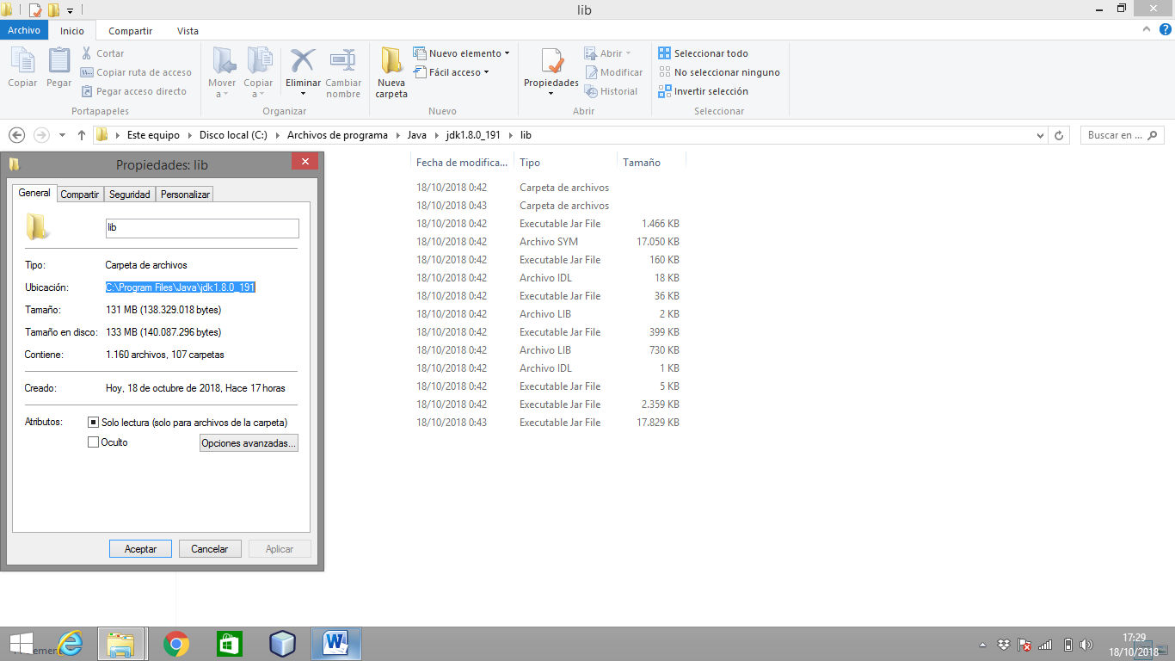

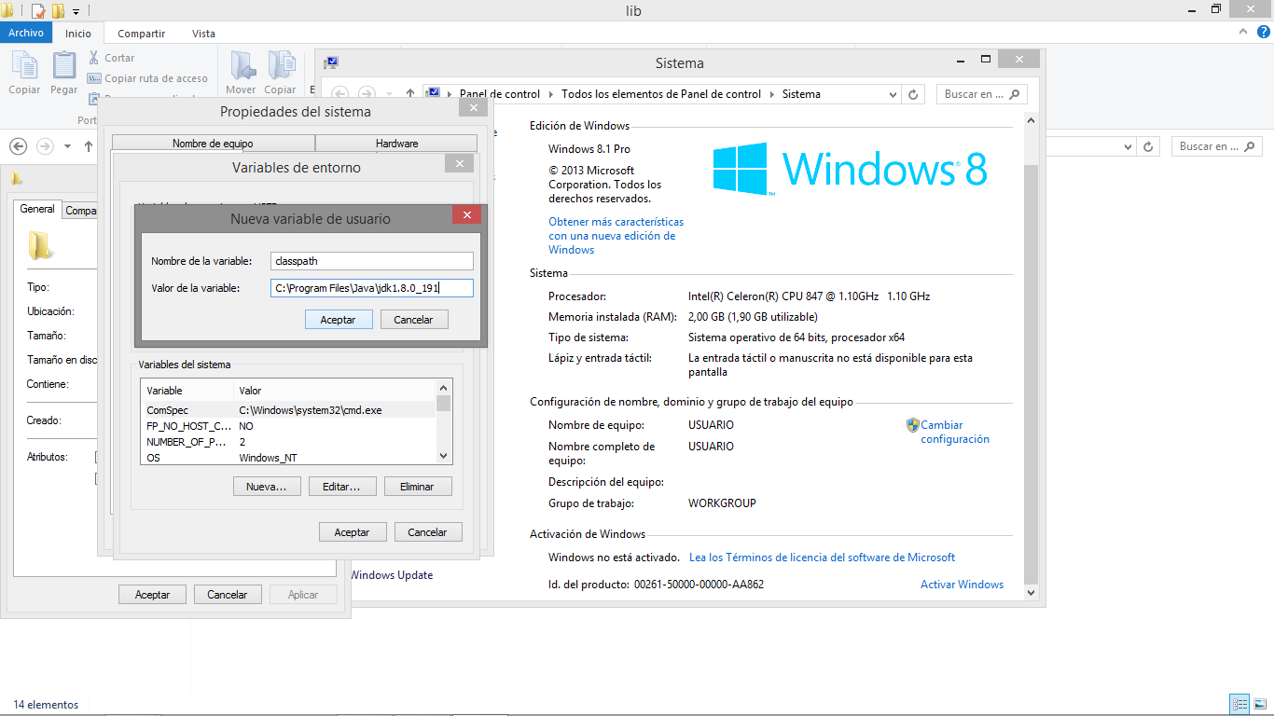

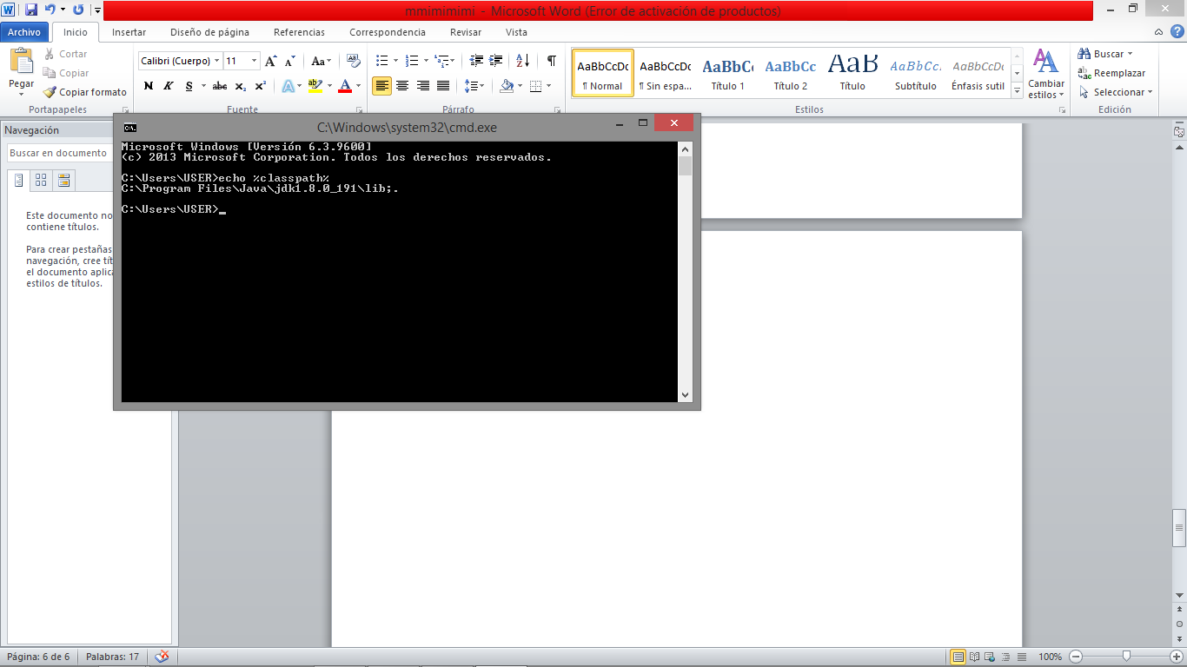

READY ALREADY CONFIGURED