Validating collision model predictions with citizen-science, private-sector and government collected datasets: a case for a unified data system and implications for management.
Casey Visintin¹, Rodney van der Ree², Michael A. McCarthy³

¹Quantitative and Applied Ecology Group, School of BioSciences, University of Melbourne, Parkville, VIC 3010, Australia - Email: cvisintin@student.unimelb.edu.au
²Ecology & Infrastructure International and School of BioSciences, University of Melbourne, Parkville, VIC 3010, Australia - Email: rvdr@unimelb.edu.au
³Quantitative and Applied Ecology Group, School of BioSciences, University of Melbourne, Parkville, VIC 3010, Australia - Email: mamcca@unimelb.edu.au
Corresponding Author: Casey Visintin, School of BioSciences, Bldg 122 - Rm 106A, University of Melbourne, Parkville, VIC 3010, Australia - Email: cvisintin@student.unimelb.edu.au, Phone: +61 4 34424084

Running Title: Collision risk model - validation
Word Count: XXXX
Number of Tables: X
Number of Figures: X (X colour figures, X supplemental)
Number of References: XX
Abstract

Keywords
animal, framework, multiple species, risk, species distribution model, speed limit, traffic volume, vehicle, wildlife-vehicle collision
Introduction
Models that make predictions are subject to uncertainty.

Authorities using models to determine management actions would benefit from knowing uncertainty.

One method to determine the reliability of the model predictions is validation.

Validation may be used to test the model sensitivity to changes in predictor variables.

We test the predictions of a wildlife-vehicle collision risk model with four external independent datasets.

Our aim is to demonstrate the importance of a unified data storage system to analyse and predict risks of wildlife vehicle collisions.
Materials and Methods
We used collision risk predictions for 644,715 road segments in the state of Victoria in south-east Australia for our validation study (Figure 1). The Victorian road authority (VicRoads) manages 25,256 kilometres of major roadway. Seventy-nine municipal districts control the remaining sealed roads (approx. 125,000 kilometres).

As Eastern grey kangaroos (Macropus giganteus, Shaw) are the second largest mammal (up to 85 kilograms for males) in Australia and share many management issues with ungulates found in North America and Europe (Croft, 2004; Coulson & Eldridge, 2010), we were able to obtain several datasets for analysis (Table 1).

The quantitative risk model used to generate the predictions relates collision risk to species occurrence and traffic volume and speed (Visintin et al., 2016).
Results
Mean predicted rates of collisions across Victoria road network increased with more data.

Discrimination ability of model was stable using different held-out validation data.

No trend was observed in validating model predictions with different combinations of data.

Model fit improved with more training data using aggregated independent validation data.

Calibration of model fit improved with more training data using aggregated independent validation data.
Discussion

Supporting Information
Data Accessibility
Model Datasets - Archived on Github
R Code - Archived on Github
Acknowledgements
Amy Amato (Wildlife Victoria) provided collision statistics collected by their organisation. Robert McDonald (AIG) provided aggregated insurance records of collisions. Matthew Annear (VicRoads) and Graham Thomas (City of Bendigo) provided carcass collection data for the Western District and Bendigo Region of Victoria, respectively. This project was supported by a University of Melbourne International Research Scholarship and the Australian Research Council Centre of Excellence for Environmental Decisions.
References

Tables
Table 1: Datasets used to fit models and validate predictions.
Source | Type | # of Records | Method of collection | Spatial Unit | Spatial Coverage | Temporal Coverage
City of Bendigo | Public municipality | 395 | Carcasses recorded by city public works department | Road segment | City | 8 years  2007-2014
VicRoads Western District | State government organisation | 815 | Carcasses recorded by independent contractor | Road segment | District | 2 years  2014-2015
Crashstats | State government organisation | 487 | Police reported wildlife strikes | Road segment | Whole of State | 7 years  2010-2016
Insurance Australia Group | Private corporation | 1344 | Public reported claims of wildlife strikes | Town | Whole of State | 3 years  2011-2013
Wildlife Victoria | Non-government organisation | 4245 | Public reported observations of wildlife strikes | Road segment | Whole of State | 6 years  2010-2015

Table 2: Discrimination ability of models expressed as receiver operator characteristic scores.
 |  | Data combinations used to model and make predictions
 |  | wildlife victoria  (original) | original  +  bendigo | original  +  western | original  +  crashstats | original  +  bendigo  +  western | original  +  western  +  crashstats | original  +  crashstats  +  bendigo
Data used to validate model predictions | bendigo | 0.87 | - | 0.85 | 0.87 | - | 0.85 | -
Data used to validate model predictions | western | 0.76 | 0.75 | - | 0.78 | - | - | 0.77
Data used to validate model predictions | crashstats | 0.8 | 0.8 | 0.83 | - | 0.82 | - | -

Figures
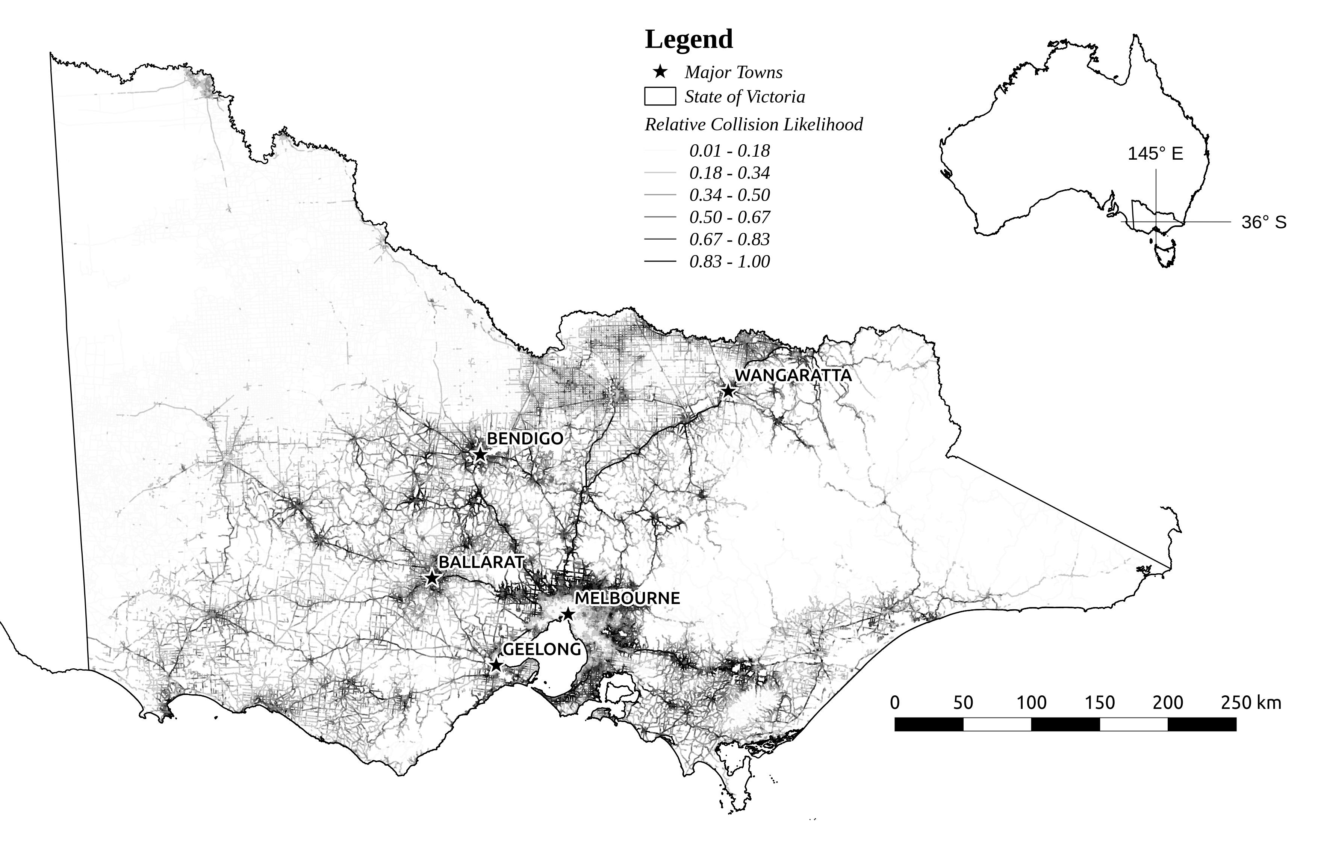
Figure 1: Study area (state of Victoria, south-east Australia) showing relative collision risk predictions on all sealed road segments. The inset shows the geographic location of Victoria in Australia. Darker, heavier lines indicate higher relative likelihoods of collision. Major towns (>25,000 residents) are shown as stars and labelled.
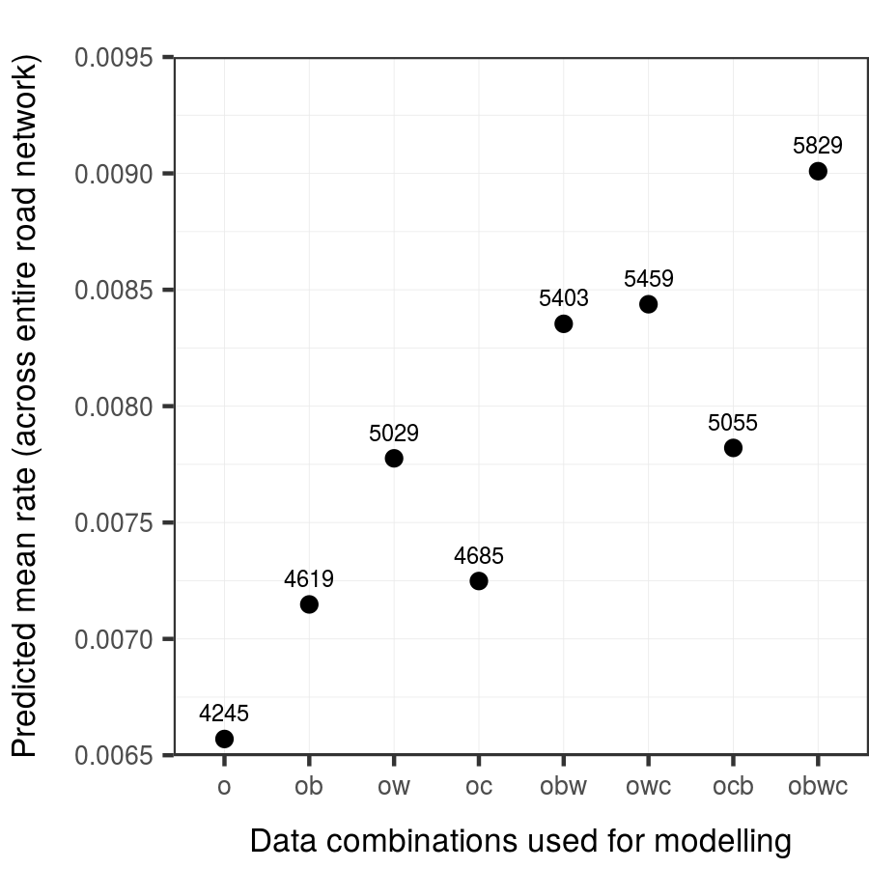
Figure 2:
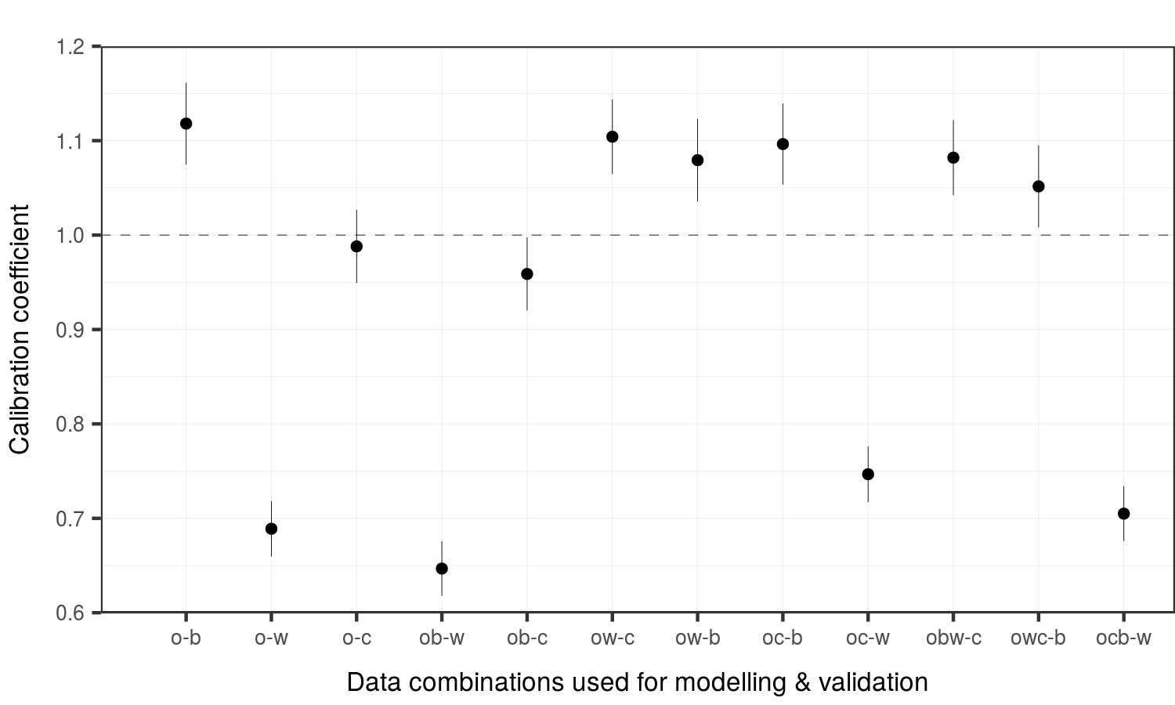
Figure 3:
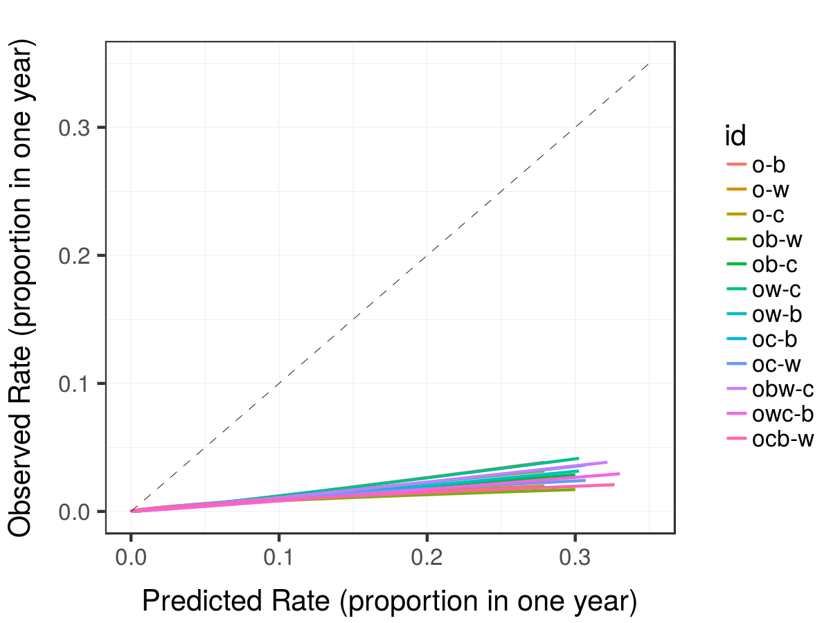
Figure 4:
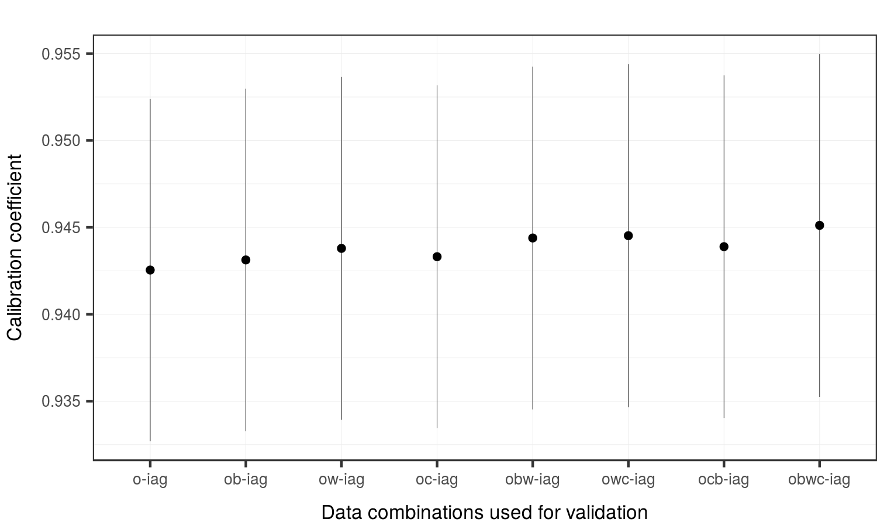
Figure 5:
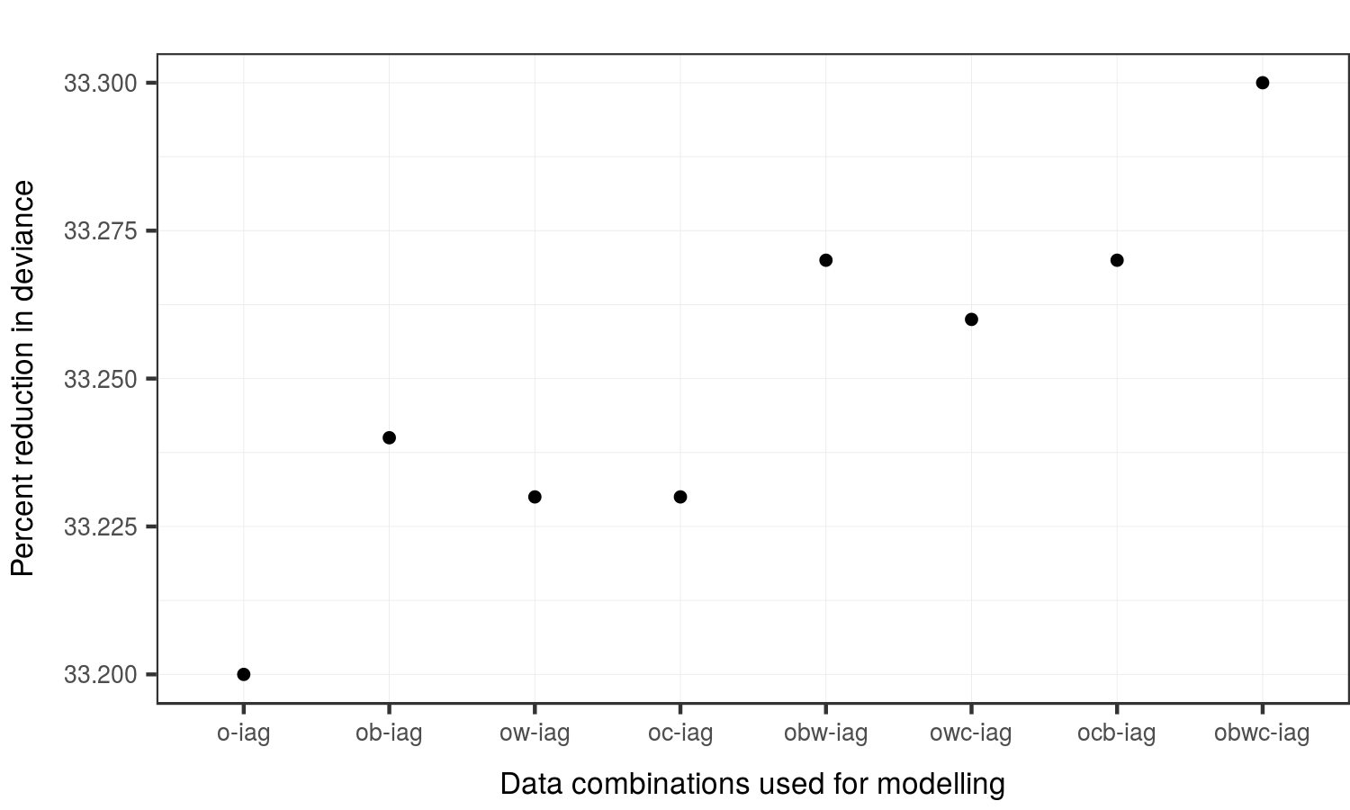
Figure 6:
Conclusions:
1) Mean predicted rates of collisions across Victoria road network increased with more data.
2) Discrimination ability of model was stable using different held-out validation data.
3) No trend was observed in validating model predictions with different combinations of data.
4) Model fit improved with more training data using aggregated independent validation data.
5) Calibration of model fit improved with more training data using aggregated independent validation data.

