

NAME: CALEB WAKAHIA
ADM NO: BSCCS/2024/49983
UNIT: Advanced Web Design and Development
COURSE: BACHELOR OF SCIENCE IN COMPUTER SCIENCE
DEPARTMENT: COMPUTING AND INFORMATICS
LECTURER : MICHAEL NYORO
TOPIC: WEEK 4

Task 1
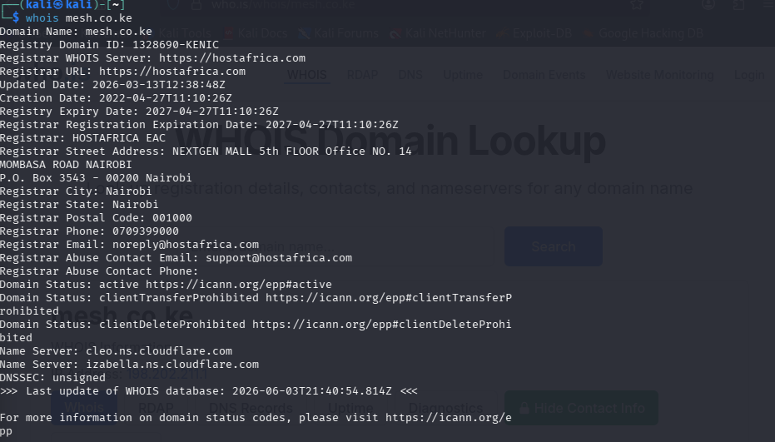
Figure 1 domain register, creation date, server names

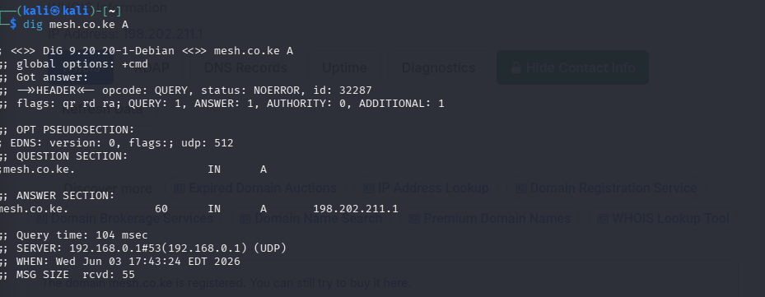
Figure 2 ip address for the domain

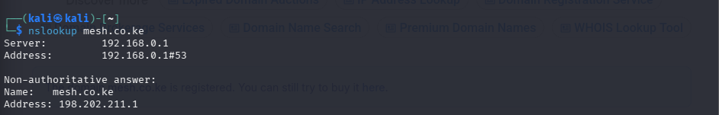
Figure 3 dns server details

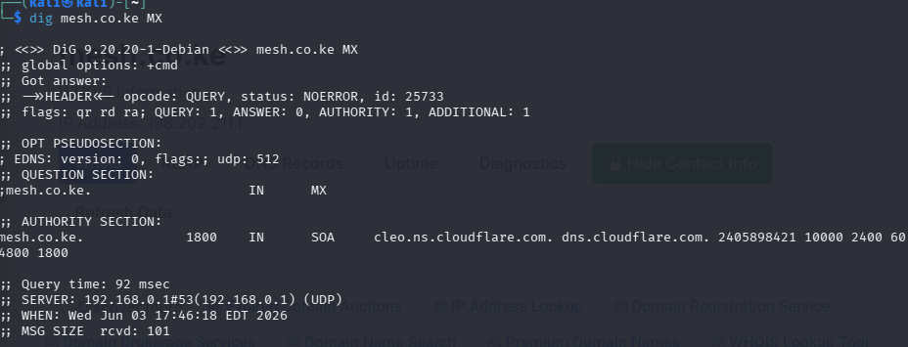
Figure 4 the email provider
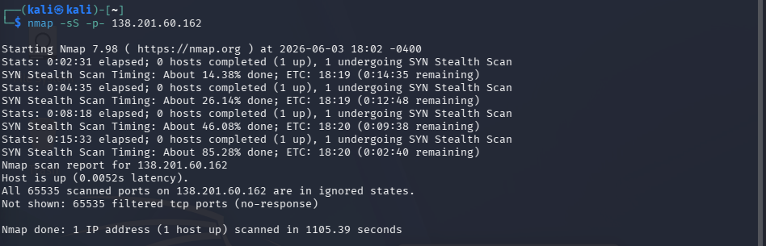
Figure 5 mesh.co.ke nmap scan for one of its ipaddress

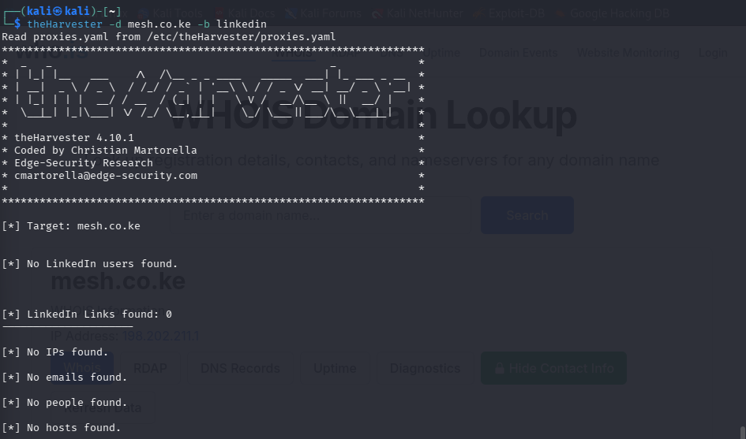
Figure 6 associated emails that can be found on linked in(employees)

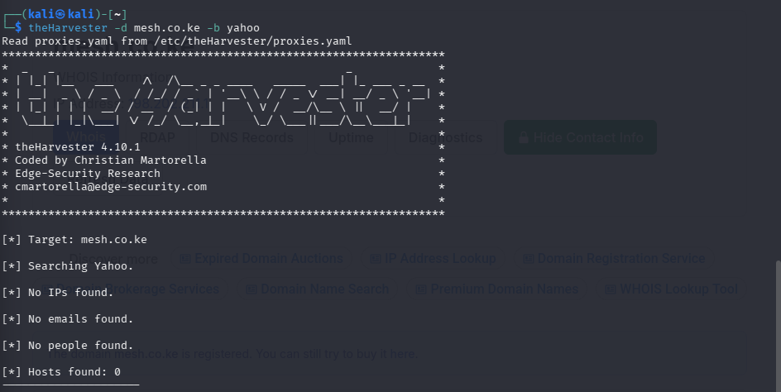
Figure 7 different email provider results after scanning

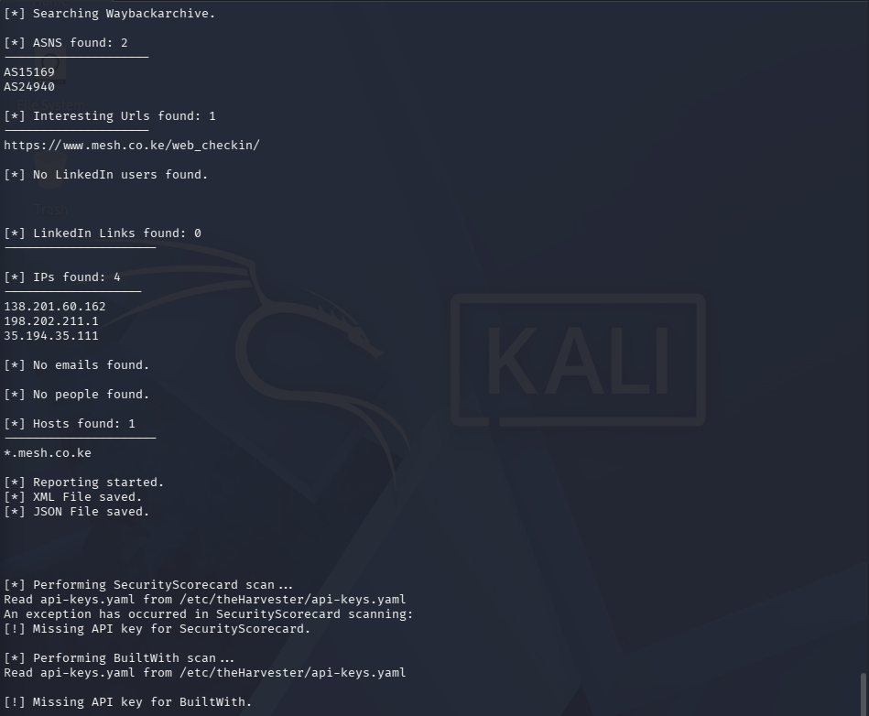
Figure 8 available ip address found

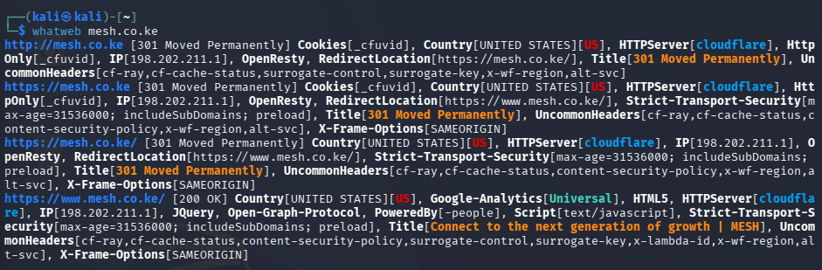
Figure 9 services used in mesh.co.ke

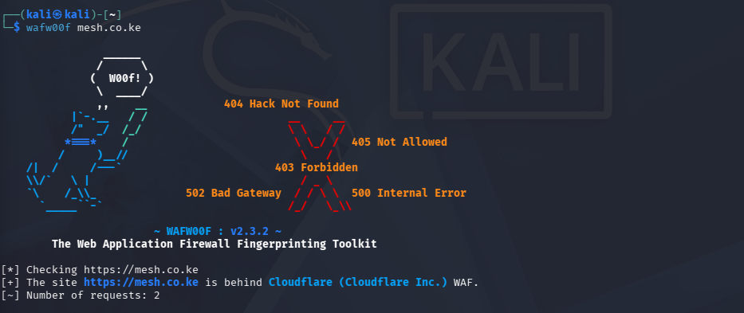
Figure 10 the firewall and the firewall provider


Figure 11 an nmap scan for mesh.co.ke ipaddress

Task 2

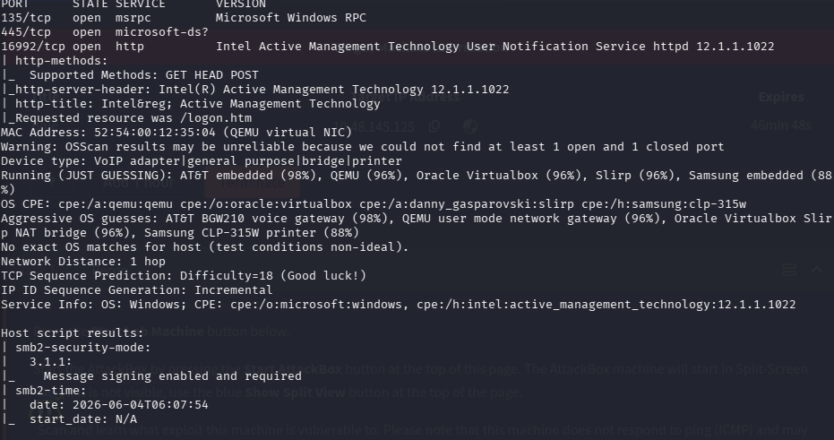
Figure 12 nmap scan of the ports of an ip address
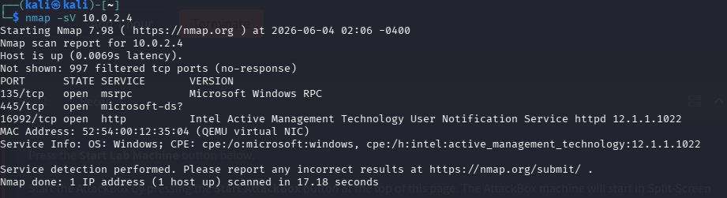
Figure 13services found in an attackbox ipaddress
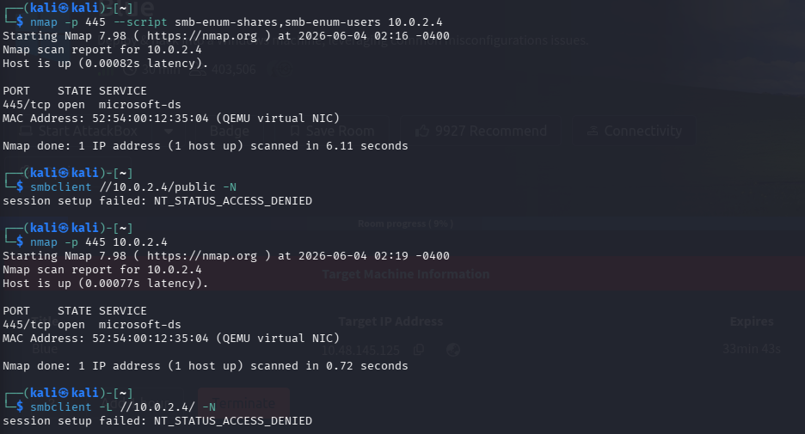
Figure 14 upon trying to enumerate and get the files in the ipaddress

Task 3
Exploiting a machine called “pickle rick”
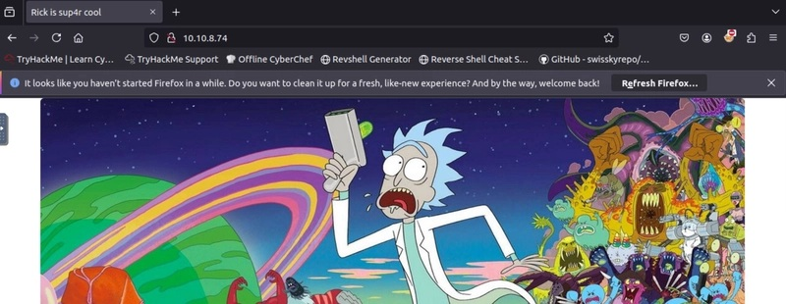
Figure 15 pickle rick room webpage upon looking up the provided ip address

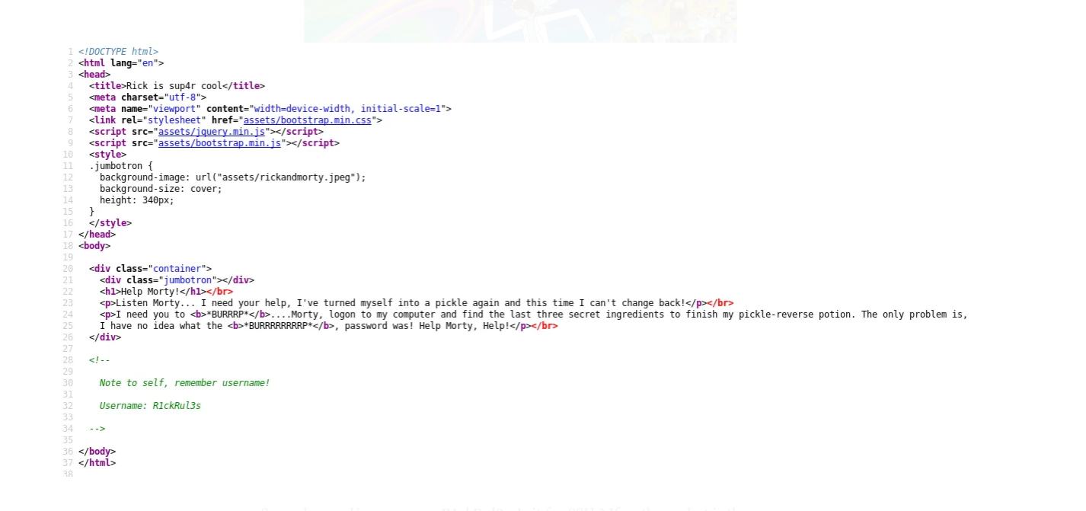
Figure 16the webpage source code

Figure 17after checking if the webpage have a robot.txt file

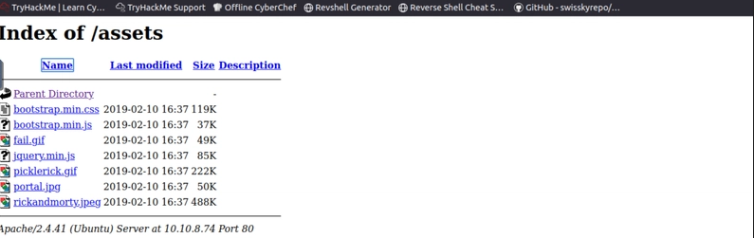
Figure 18 after going to the assets for the webpage

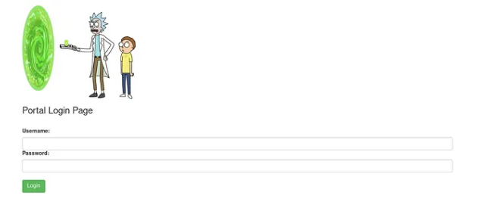
Figure 19 after going around the file this shows the portal.php and we use the R1ckRul3s as the username and Wubbalubbadubdub gotten above
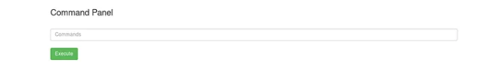
Figure 20 after login in to the page
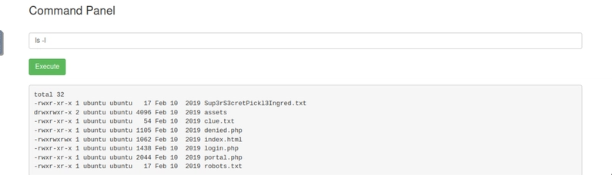
Figure 21 after i tried a simple cli command ls -l

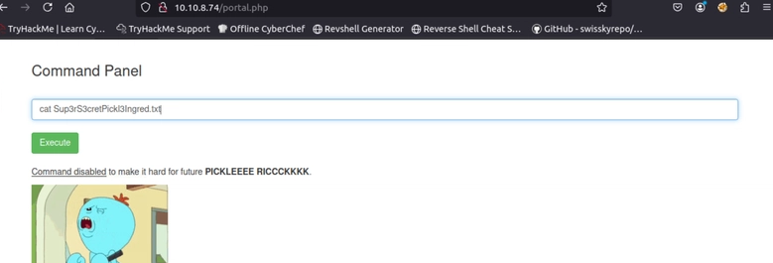
Figure 22i tried to see the super sectret txt

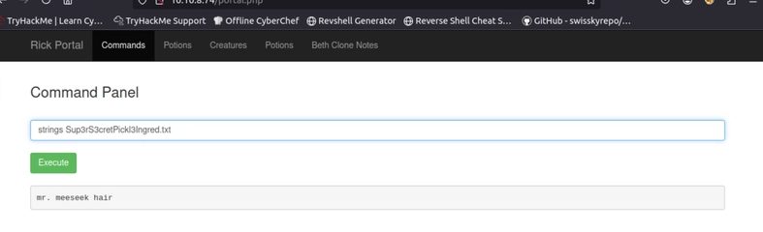
Figure 23 i tried to string the text and i found the first answer

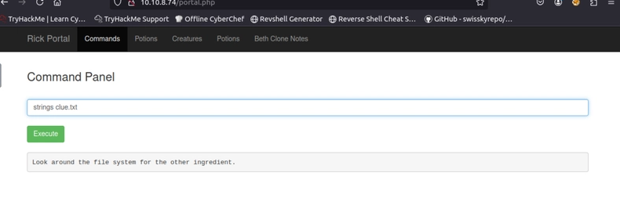
Figure 24 i tried to look for a clue in the clue.txt
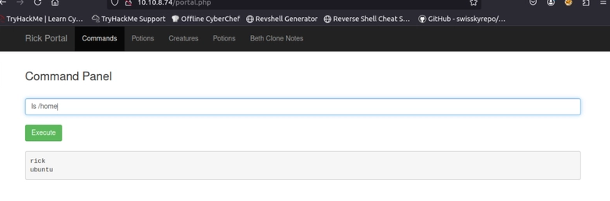
Figure 25trying to see if i can change the location
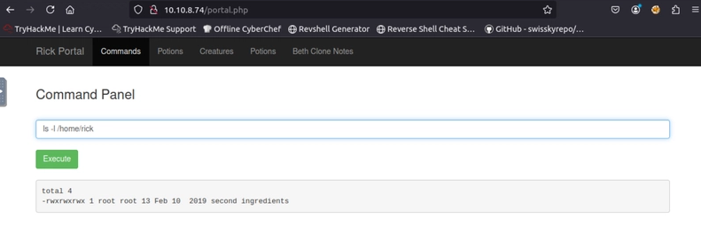
Figure 26 trying to view what was in rick
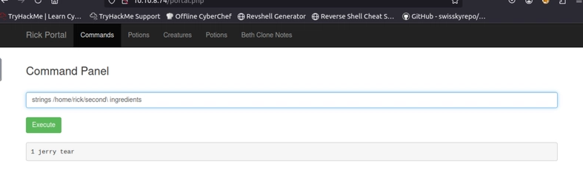
Figure 27 getting the second ingredient
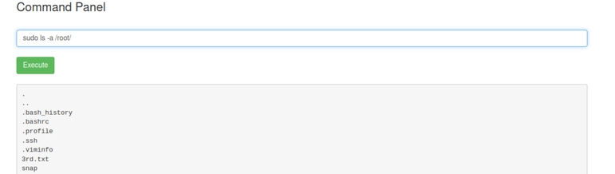
Figure 28 trying to sudo inside and fount sth interesting the 3rd text
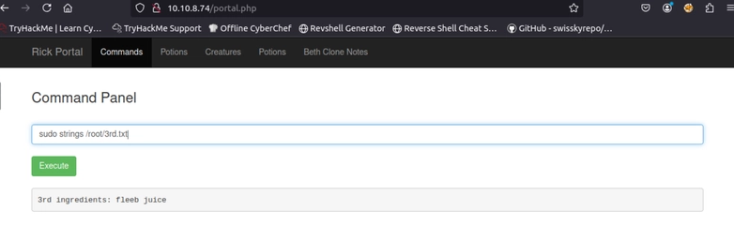
Figure 29 upon looking the 3rd text i found the last ingredient

