# ****Suicides by Method in Turkey (2022)****

# CS405 Assignment 1: Basic Data Visualization using SVG’s

**Report**

Alp Civan 28408

**Introduction**

This report presents a data visualization of suicide statistics in Turkey for the year 2022, derived from the dataset "Şekline ve cinsiyete göre intiharlar" available on the official website of the TUIK at https://data.tuik.gov.tr/Bulten/Index?p=Olum-ve-Olum-Nedeni-Istatistikleri-2022-49679. The dataset, which provides detailed information on suicides by method and gender from 2000 to 2022, serves as the basis for the data visualization.

**HTML Structure:** The HTML document consists of a structure with an html element containing head section which links to the CSS file (styles.css) and body sections. The body section contains the content of the web page, including headings, the chart, the legend and the footer.

**Content:** It includes several <h1> elements for headings and subheadings, which display the title and my name. Additionally, there is a <div> element with the class “chart-container” which is for the chart and the scales. And there is a <div> with the class “legend" for the legend. Finally, there's a <div> with the class “footer” to display the total number of suicides in Turkey in 2022 in an italic font below all of the content.

**SVG Elements:** Within the <svg> element with the “id=chart” the chart itself is created using svg elements. It includes 10 <rect> elements representing different methods of suicide. They are created for using them as a chart column. These <rect> elements are positioned using attributes like x, y, width and height and they are all styled with specific class names for them to have their specific colors matched with their legend’s color. A <line> element is also included as a horizontal scale at the bottom of the chart which presents the 0 point for the columns. Finally, 10 text elements are providing labels for the chart elements and they specify the exact number of suicides for each method.

**Legend:** A <div> element with the class “legend” is used to create a legend for the chart. Each method in the legend has a rounded square alongside a colored label (a <div> with the class “legend-label”). These squares and colored labels are used to explain the different methods in the chart.

**Footer:** At the bottom of the page, the footer displays the total number of suicides in Turkey in 2022, providing essential context for the chart.

**CSS Styles:** The CSS styles are used to format and style the HTML elements. They include font styles, background colors and styling for chart elements, scales and the legend. Special hover effects are also available to the elements (<rect> specifically) in the chart to change their colors when users hover over them.

**Methodology:** The chart is constructed using svg elements. Each method of suicide is represented by a <rect> element with specific dimensions. I calculated all of the height and y parameters one by one corresponding to their supposed coordinates on the chart (They should have a bottom on the 0 value and their top should represent the number and the percentage scales on the chart) Also, using <text> elements I added corresponding labels. The chart is divided into three main sections: the left scale for numerical values, the chart area displaying the data and the right scale for percentages. Finally, the legend is there for understanding the chart, using colors that match the chart elements.

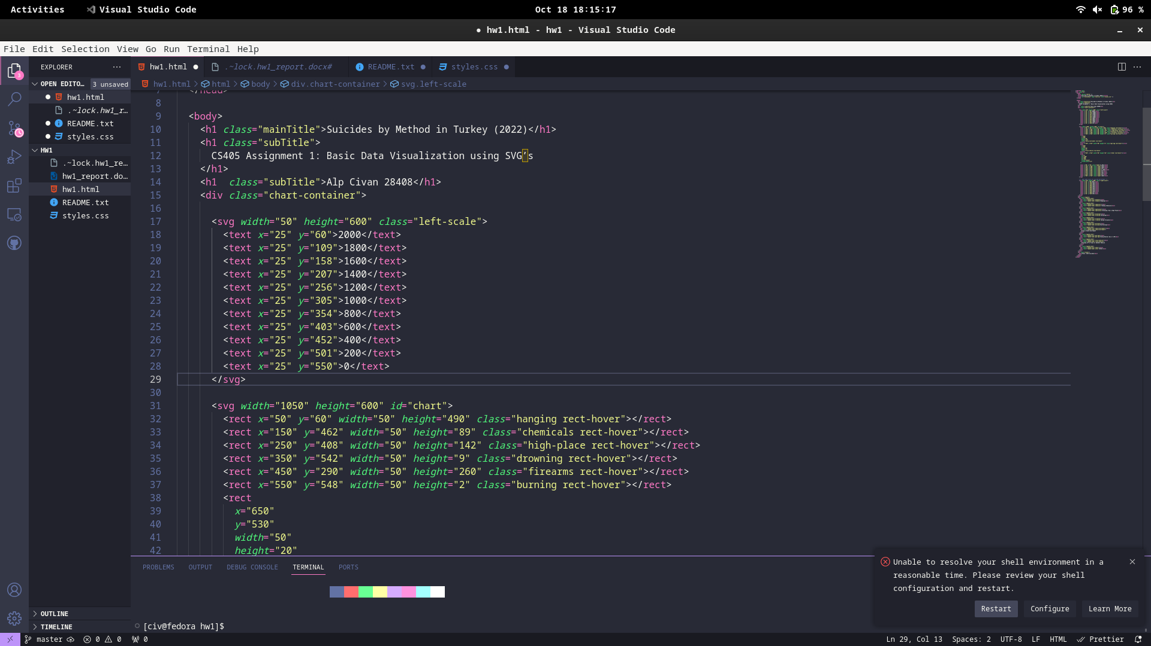

* Left Scale: This provides a numerical scale for the number of suicides with the help of <text> elements

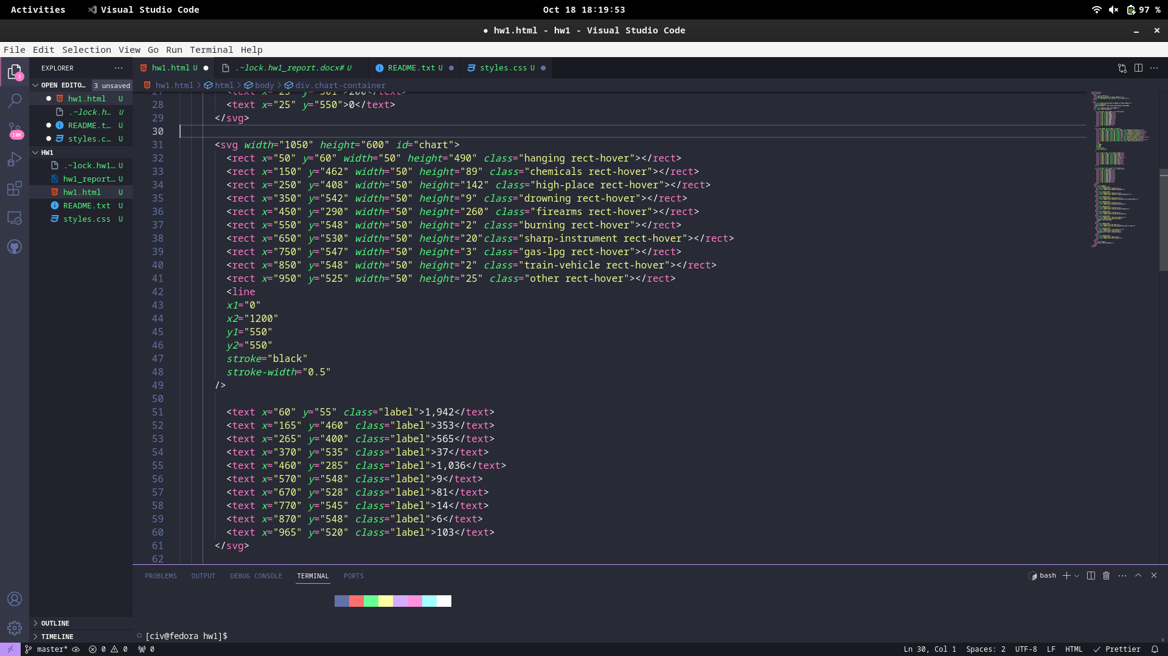

* Chart Area: This is where the main data visualization is displayed using <rect> elements. Also there is the horizontal <line> element which sets the 0 point of the chart. Finally, there are <text> elements showing the exact numbers of the corresponding column <rect> elements.

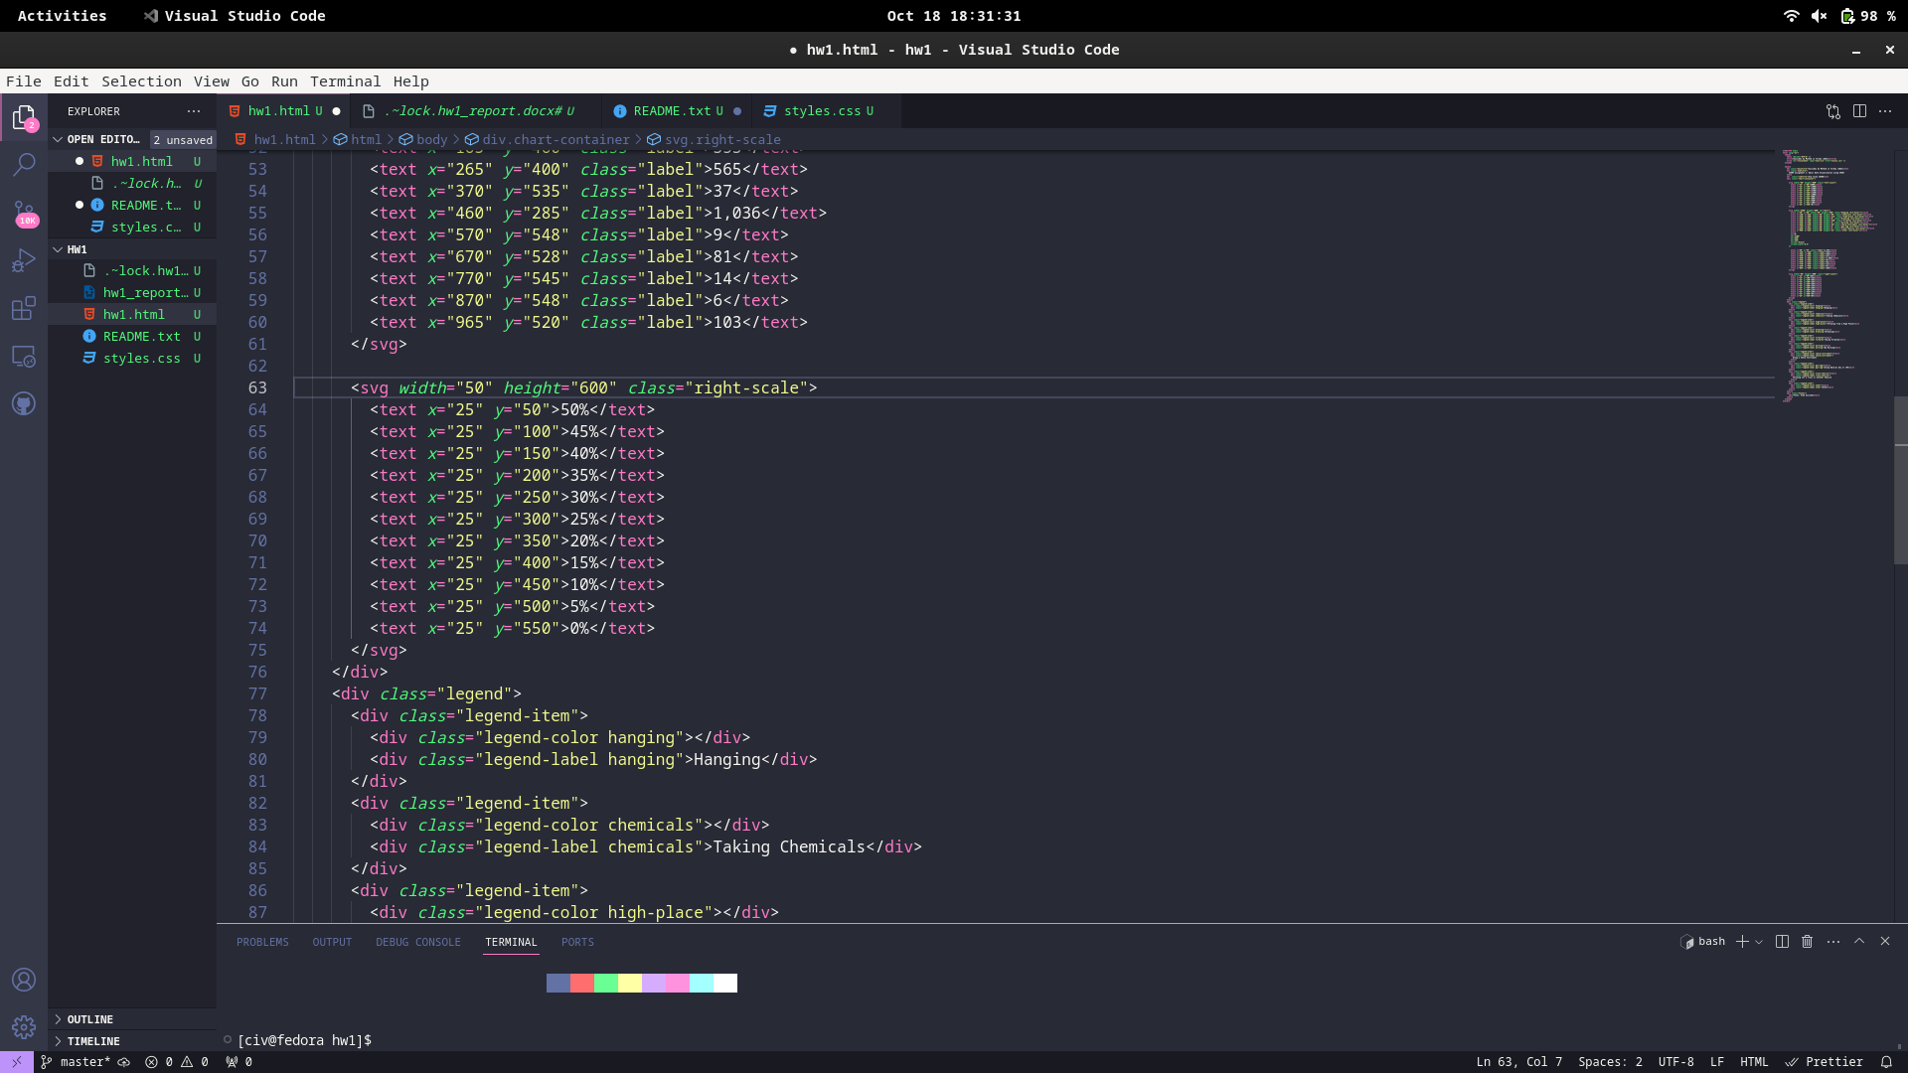

* Right Scale: This provides a scale for the percentage of suicides with the help of <text> elements

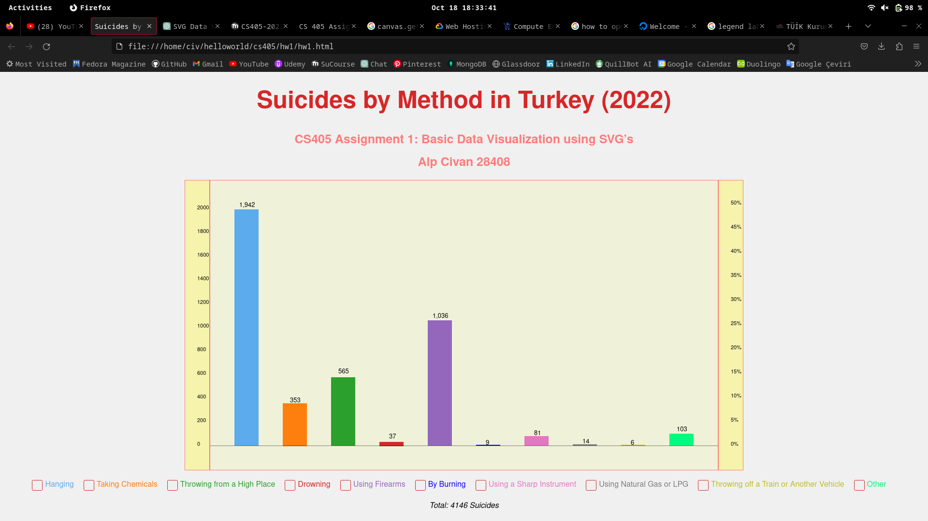Final Product