Unwilling unable paradigm

[Author Name(s), First M. Last, Omit Titles and Degrees]

[Institutional Affiliation(s)]

Author Note

[Include any grant/funding information and a complete correspondence address.]

Abstract

[The abstract should be one paragraph of between 150 and 250 words. It is not indented. Section titles, such as the word Abstract above, are not considered headings so they don’t use bold heading format. Instead, use the Section Title style. This style automatically starts your section on a new page, so you don’t have to add page breaks. Note that all of the styles for this template are available on the Home tab of the ribbon, in the Styles gallery.]

Keywords: [Click here to add keywords.]

Unwilling unable paradigm

Unwilling unable with chimps (Call et al., 2004).

# Methods

## Subjects

[To add a table of contents (TOC), apply the appropriate heading style to just the heading text at the start of a paragraph and it will show up in your TOC. To do this, select the text for your heading. Then, on the Home tab, in the Styles gallery, click the style you need.]

## Design

## Procedure

## Scoring and analysis

We scored the following response variables during test trials: the time the dogs spent sitting or laying down (rest), the time they spent with all feet further away than 50 cm from the acrylic glass barrier (time away), whether the dogs vocalized (ADD camera etc), and the dogs looked away from the experimenter / barrier. Looking away was scored when the dog's snout was moved away from the barrier such that it was approximately parallel to the orientation of the barrier.

We analyzed the duration response variables as proportions (relative to the entire duration of the test trial). The "looking away" and “vocalization” response variables were analyzed as binary variables (present / absent).  
For the proportion time response variables, we fitted generalized linear mixed models (GLMM) with beta error distribution (using R package glmmTMB; Brooks et al., 2017). For the binary response variable, we fitted a GLMM with binomial error distribution (using R package lme4; Bates et al., 2015). For all GLMMs we included the following predictor variables: condition (unwilling-teasing / unable-clumsy / unable-blocked), trial number within condition (1-4), order of conditions (1-3), age (in months), and sex. Dog ID was included as a random intercept. We also included all possible random slope components if possible. Following our preregistered contingencies plans, we removed the correlation between the random slopes and random intercept for the proportion time response variables due to convergence issues.

We z-transformed the covariates age, trial number within condition, and the order of conditions and centered all random slope components. Likelihood ratio tests (R function drop1 with argument 'test' set to "Chisq") with p-values smaller than .05 were used as criterion to make inferences about fixed effects.

To evaluate the model stability we removed one subject at a time and compared the resulting estimates. This procedure revealed the models to be stable with respect to fixed effects. For the beta models we also checked for overdispersion which was not an issue (dispersion parameter: time away: 0.74; sitting/laying down: 1.23). Additionally, we checked for collinearity among the predictor variables which was no issue either (maximal Variance Inflation Factor for all models: 1.00).

# Results

## Proportion of duration away from experimenter

We fitted a model with beta error distribution to analyze the proportion of time the dogs spent away from the experimenter. Condition had a significant effect on the proportion the dogs spent away from the experimenter. The dogs were spent significantly more time away in the blocked condition compared to the clumsy (z=-8.83, p<0.001) or teasing condition (z=-3.89 , p<0.001) and they also spent more time away in the teasing condition compared to the clumsy condition (z=-4.58 , p<0.001). Besides, the dogs spent more time away with increasing trial number (within condition) and they spent less time away with increasing block number (order of conditions). There was no significant effect of age and sex on the time the dogs spent away from the experimenter.

Table Results of the GLMM 01 with time away as response variable

|  |  |  |  |  |  |  |  |
| --- | --- | --- | --- | --- | --- | --- | --- |
|  | Estimate | SE | LowerCI | UpperCI | χ2 | df | P |
| (Intercept) | -0.94 | 0.16 | -1.26 | -0.66 |  |  |  |
| Condition - clumsy1 | -1.21 | 0.14 | -1.48 | -0.97 | 84.51 | 2 | <0.001 |
| Condition - teasing1 | -0.63 | 0.16 | -0.96 | -0.33 |  |  |  |
| Trial | 0.25 | 0.05 | 0.16 | 0.34 | 27.25 | 1 | <0.001 |
| Order | -0.16 | 0.06 | -0.26 | -0.04 | 7.33 | 1 | 0.007 |
| Age | 0.06 | 0.1 | -0.15 | 0.27 | 0.31 | 1 | 0.579 |
| Sex2 | 0.24 | 0.22 | -0.18 | 0.66 | 1.18 | 1 | 0.277 |

Notes: Reference category: 1blocked, 2female; All covariates we z-transformed.

## Proportion of duration sitting / laying down

## Looking away

## Vocalisation

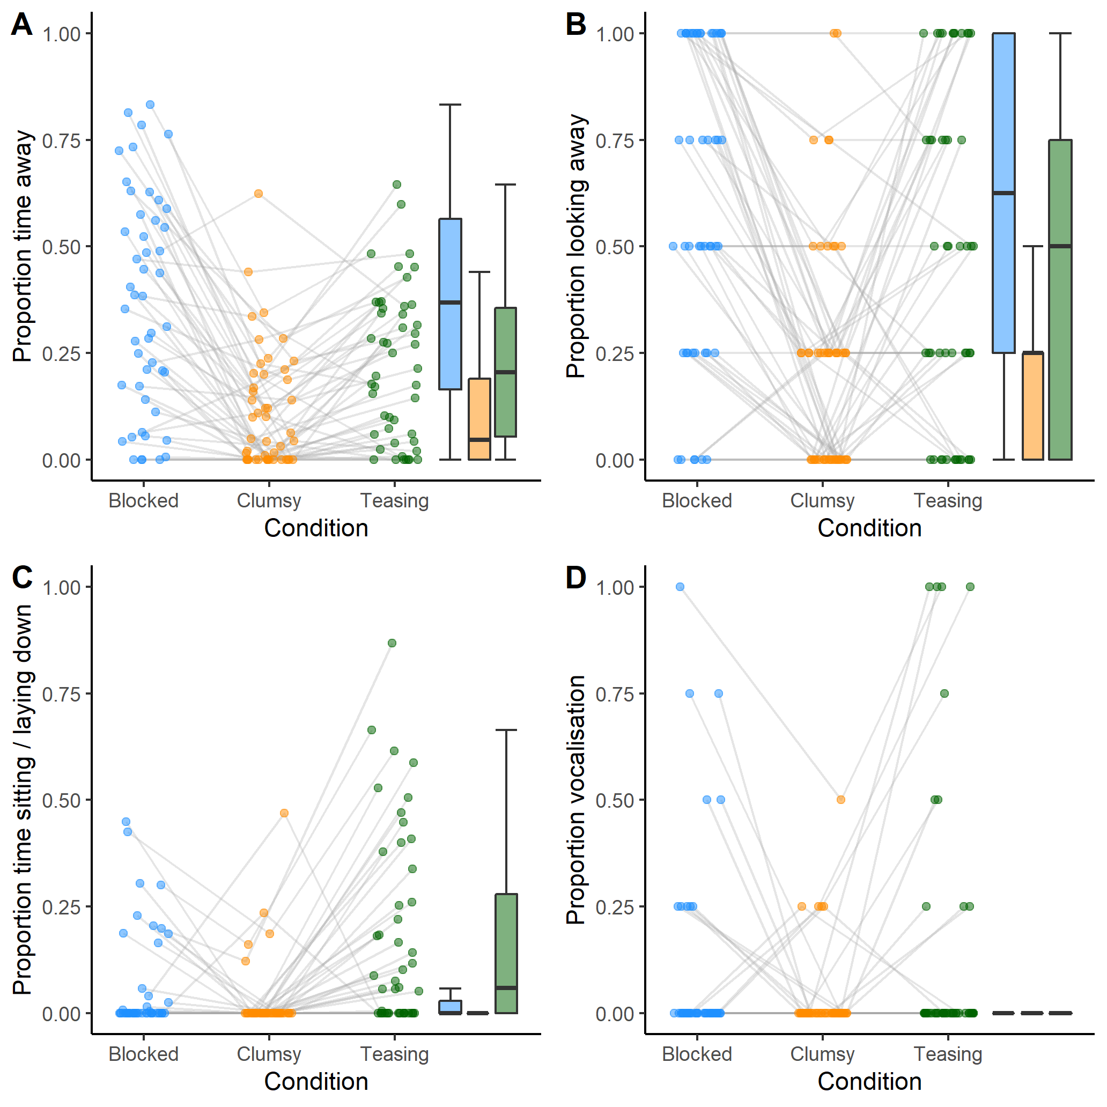

Figure Visualization of dogs’ performance in the test trials. A. Proportion of time away from experimenter, B. Proportion of trials looking away, C. Proportion of time sitting or laying down, D. Proportion of trials with vocalization. The dots represent individual mean values; the grey lines connect the values of the same individuals across conditions. On the right side a box plot is shown (blue: blocked condition; orange: clumsy condition; green: teasing condition).

# Discussion

References

Bates, D., Mächler, M., Bolker, B., & Walker, S. (2015). Fitting Linear Mixed-Effects Models Using **lme4**. *Journal of Statistical Software*, *67*(1), 1–48.

Brooks, M. E., Kristensen, K., Benthem, K. J. van, Magnusson, A., Berg, C. W., Nielsen, A., Skaug, H. J., Maechler, M., & Bolker, B. M. (2017). GlmmTMB Balances Speed and Flexibility Among Packages for Zero-inflated Generalized Linear Mixed Modeling. *The R Journal*, *9*(2), 378–400.

Call, J., Hare, B., Carpenter, M., & Tomasello, M. (2004). ‘Unwilling’ versus ‘unable’: Chimpanzees’ understanding of human intentional action. *Developmental Science*, *7*(4), 488–498.