CLASS : S.E. COMP SUBJECT : DEL

EXPT. NO. : 6 DATE :

TITLE : RIPPLE COUNTER CIRCUIT

OBJECTIVE :

- Design and Implement 3-bit Asynchronous (Ripple) UP Counter circuit using IC-74LS76
Draw Timing Diagram.
- Design and Implement 3-bit Asynchronous (Ripple) DOWN Counter circuit using IC-74LS76
Draw Timing Diagram.
- Design and Implement MOD-N Asynchronous (Ripple ) UP Counter circuit using IC-74LS76
Draw Timing Diagram.

APPARATUS :
Digital-Board, GP-4 Patch-Cords, IC-74LS76, IC-74LS32, IC-74LS04/IC-74LS08 and Required Logic gates if any
THEORY :
Counter is a Sequential Logic device which can be use to count the number of pulses given to the circuit. Counter can be classified into two category one is Synchronous and other is Asynchronous (Ripple) In case of Asynchronous counter output of first flip-flop goes to the clock of next and so on, and input of all flip-flop is connected to VCC for IC-74LS76.
All set and reset pin is connected to VCC.Asynchronous counter is easy to design as compared to Synchronous Counter. Synchronous Counter is faster than Asynchronous Counter.IC-74LS76 is Dual M/S-JK filp-flop, which means in one IC there are two M/S-JK filp-flop are contained.

PIN Diagram :

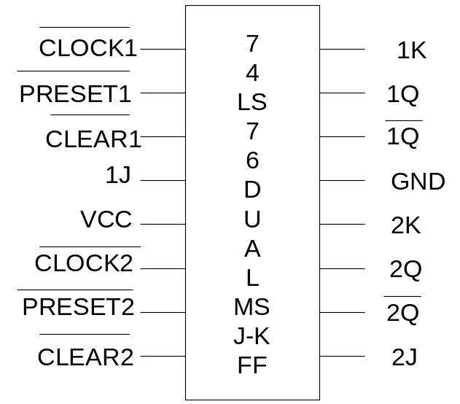

PROCEDURE :

- Make the connections as per the Logic circuit of 3-bit Ripple UP Counter circuit using IC-74LS76 and Verify its Truth Table.
- Make the connections as per the Logic circuit of 3-bit Ripple DOWN Counter circuit using IC-74LS76 and Verify its Truth Table.
- Make the connections as per the Logic circuit of MOD-N Ripple UP Counter circuit using IC-74LS76 and Verify its Truth Table.

Design of 3- bit Asynchronous UP- Counter
Logic Diagram:

Observation Table:

CLOCK PULSE | Output
CLOCK PULSE | Q_{A} | Q_{B} | Q_{C}
0 | 0 | 0 | 0
1 | 0 | 0 | 1
2 | 0 | 1 | 0
3 | 0 | 1 | 1
4 | 1 | 0 | 0
5 | 1 | 0 | 1
6 | 1 | 1 | 0
7 | 1 | 1 | 1

Design of 3- bit Asynchronous DOWN- Counter
Logic Diagram:

Observation Table:

CLOCK PULSE | Output
CLOCK PULSE | Q_{A} | Q_{B} | Q_{C}
0 | 1 | 1 | 1
1 | 1 | 1 | 0
2 | 1 | 0 | 1
3 | 1 | 0 | 0
4 | 0 | 1 | 1
5 | 0 | 1 | 0
6 | 0 | 0 | 1
7 | 0 | 0 | 0
Design of ( MOD - N = )Asynchronous UP-Counter

K-MAP for RESET LOGIC
Dec.Equ. | OUTPUT |  |  | RESET LOGIC
Dec.Equ. | Q_{A} | Q_{B} | Q_{C} | Y
0 | 0 | 0 | 0
1 | 0 | 0 | 1
2 | 0 | 1 | 0
3 | 0 | 1 | 1
4 | 1 | 0 | 0
5 | 1 | 0 | 1
6 | 1 | 1 | 0
7 | 1 | 1 | 1

Logic Diagram:
Logic Gates / MSI Device required for Implementation:

Sr.No. | Title | Name of the IC | Number of Gates required | IC  Required
01 | 3-bit Ripple Up Counter
02 | 3-bit Ripple DOWN Counter
03 | (MOD-N= )  UP -Counter

CONCLUSION:

REFFRENCE:

- R.P.Jain “Modern Digital Electronics” TMH 4th Edition
- D.Leach,Malvino,Saha,”Digital Principles and Applications”,TMH

Subject teacher Sign with Date Remark

