**AIM:**

To create an application to analyze Stock Market Data using R language.

## PROCEDURE:

**1a.**Toanalyze stock data, Stock data can be obtained from Yahoo! Finance (http://finance.yahoo.com) by using the quantmod package provides easy access to Yahoo! Finance.

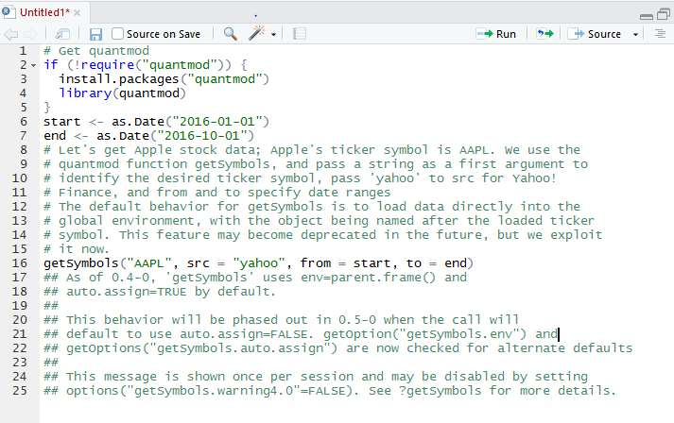

**1b**.getSymbols() can create a object called AAPL in the global environment.



**2a**.The class of AAPL object can be obtained with the command



**2b**.AAPL is of the xts class (which is also a zoo-class object). xts objects (provided in the xts package) are seen as improved versions of the ts object for storing time series data.



**3a.**In this stock data’s are stored based on time-based indexing and can provide custom attributes, along with allowing multiple (presumably related) time series with the same time index to be stored in the same object.



**3b**.Yahoo! Finance provides six series with each security. Open is the price of the stock at the beginning of the trading day, high is the highest price of the stock on that trading day, low the lowest price of the stock on that trading day, and close the price of the stock at closing time. Volume indicates how many stocks were traded. Adjusted is the closing price of the stock that adjusts the price of the stock for corporate actions.

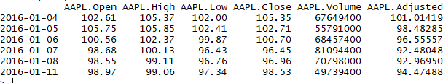

**4a**.Stock data series can be visualized using base R plotting with



**4b**.Visualization is obtained as

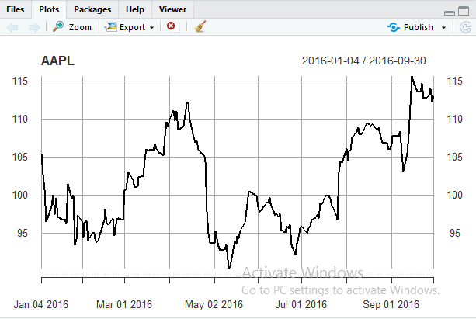

**5a**. Financial data is often plotted with the function called candle Chart() from quant mod to create a chart.



**5b**.With this function, plotting of variables with separate lines as follows

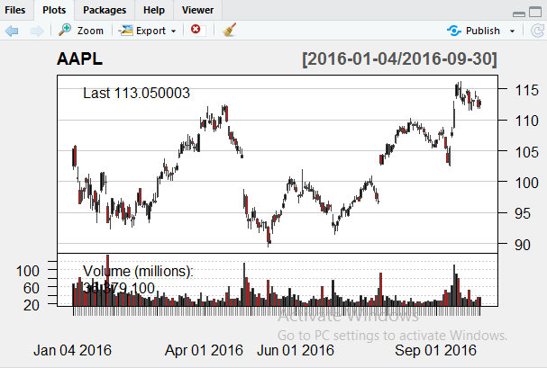

## RESULT:

Thus, an application to analyze Stock Market Data using R language is created successfully.