***Message Bridge***

***b/w***

***Weblogic JMS***

***&***

***Websphere MQ***

[Oct] 2016



Document Control

|  |  |
| --- | --- |
| Author: Nguyen My | Group: BPD |
| Created on : Oct 26, 2016 | Revision No : 0.1a |
| Document Name | Message_Bridge_Weblogic_JMS_Websphere_MQ_v1.0 |

Table of Contents

1. Introduction 3

2. Pre-Requisites 3

3. Setup 3

3.1 Maintenance in Websphere 3

3.1.1 Create Queue Manager 3

3.1.2 Create Local Queue 7

3.1.3 Create Channel of Type “Server-connection” 9

3.1.4 Create .binding file 13

3.2 Maintenance in WebLogic 26

3.2.1 Create JMS Server 26

3.2.2 Create JMS Module 27

3.2.3 Create Connection Factory 27

3.2.4 Create Source and Destination Message Bridge 27

3.2.5 Create Message Bridge 29

4. Testing the setup 32

4.1 Pre-requisite 32

4.2 Testing 33

4.2.1 Message forwarding from Weblogic to Websphere 33

4.2.2 Message forwarding from Websphere to Weblogic 35

5. Troubleshooting 39

5.1 Debugging 39

6. References 40

# Introduction

It is often a requirement to establish queue based message interface between FCUBS and external systems using IBM MQ. The external system would put/get message from IBM MQ queues. FCUBS gateway’s queue based interface natively works on JMS queues (popularly on Weblogic application server). One of the methods to achieve sending and receiving message to/from IBM MQ is by using message forwarding feature known as “Message Bridge”

Using this feature, respective applications can talk to their preferred queue management systems (i.e. Weblogic for FCUBS and IBM/MQ for external system), while the messages will be implicitly forwarded between the queue management systems

Steps on creating Message Bridge to forward message from Weblogic to Websphere MQ and vice versa on the same computers/servers **(.binding mode)** and on different computers/servers (**client mode)** are elaborated in this document.

The document also describes how to test the setup and gives some tips on troubleshooting

# Pre-Requisites

Below are the Software versions used in the setup described in this document

* WebLogic Server Version: 10.3.0.0
* WebSphere MQ 7.5.0.2

# Setup

## Maintenance in Websphere

### Create Queue Manager

Name used in this example is **TEST_QM**

Queue Manager 🡪 New 🡪 Queue Manager

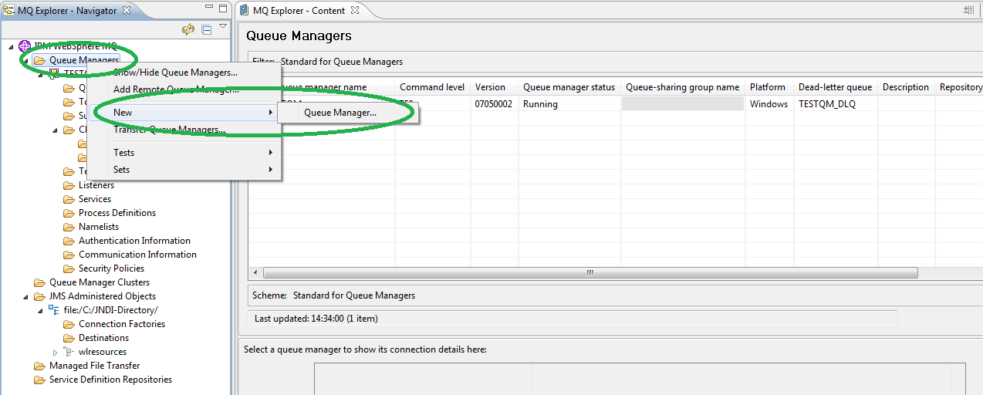

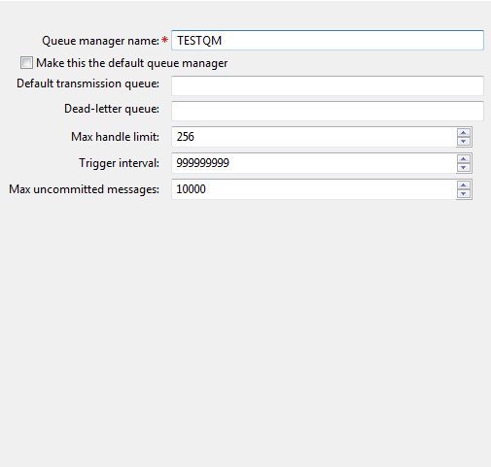

On other pages, just accept default values (Queue manager name is changed for the purpose of illustration as it is already existing in the WS at the time this manual is written)

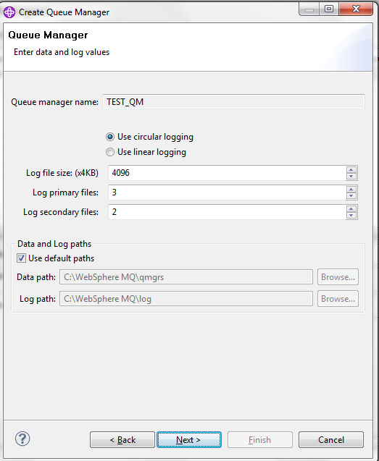

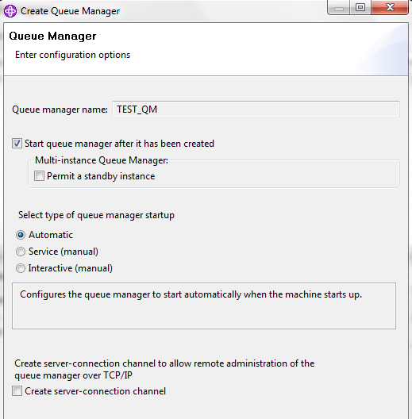

Important fields are highlighted

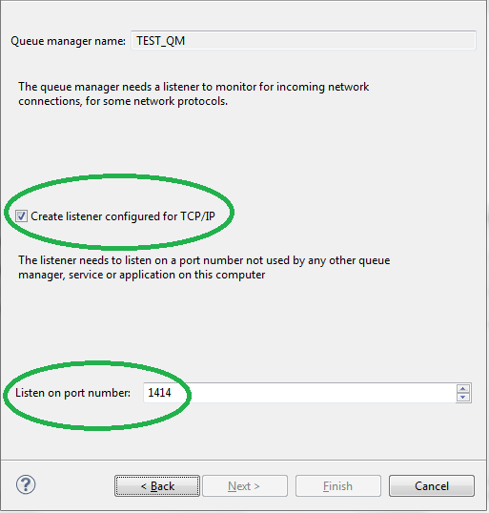

!!! **This port number** would be used when we create the connection factory in case of bridging different computers/servers

Click on Finish to complete the creation of Queue Manager

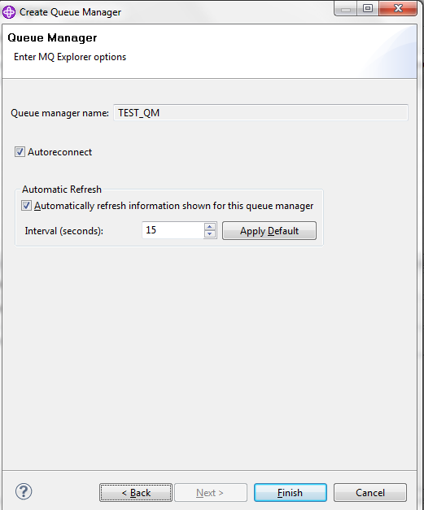

The queue manager after created should be UP with green up arrow as shown in below screenshot

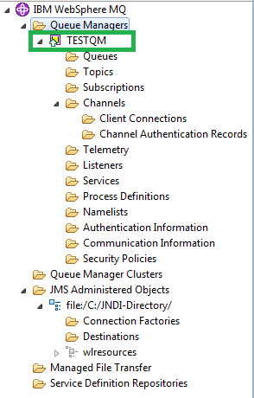

### Create Local Queue

Name used in this example is **TestQ**

Under new Queue Manager, click on Queues 🡪 New 🡪 Local Queue

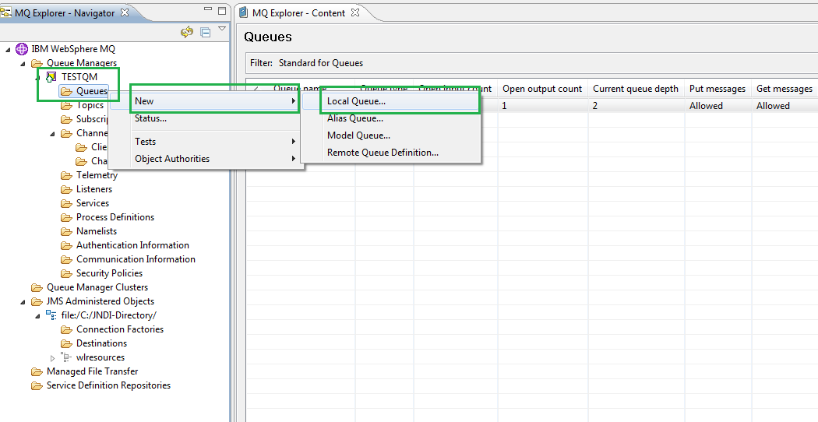

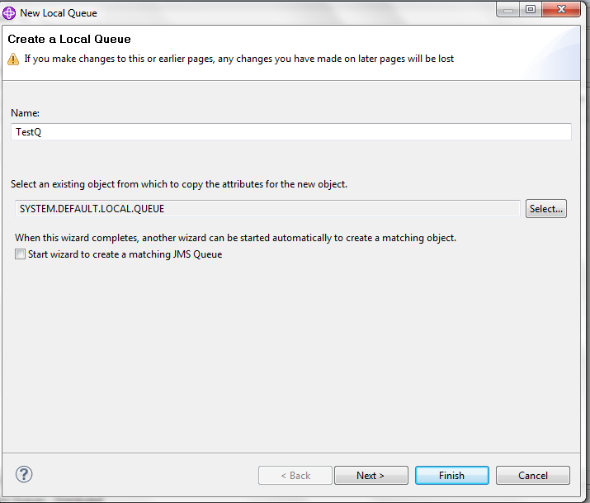

Leave default values and click on Finish

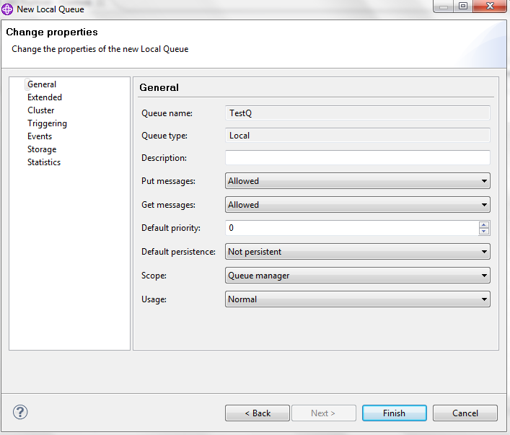

After creation, it should be like below

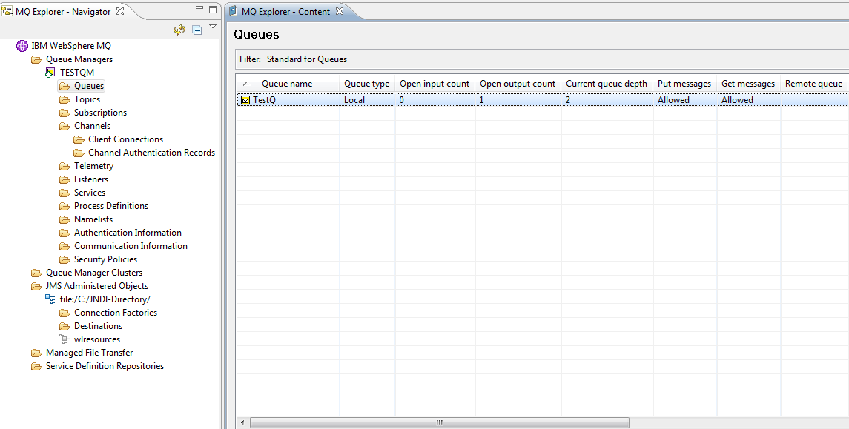

### Create Channel of Type “Server-connection”

Name used in this example is **TESTSERVERCONNCHAN**

Queue Manager 🡪 Channels 🡪 New 🡪 Server-connection Channel

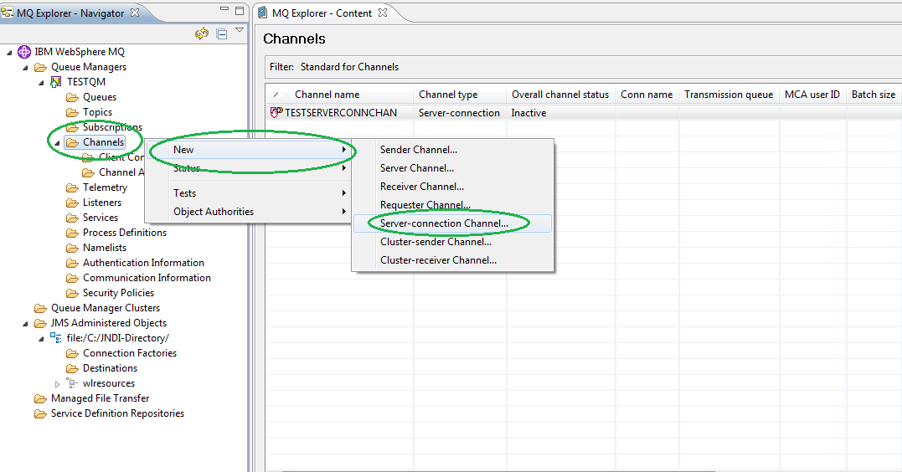

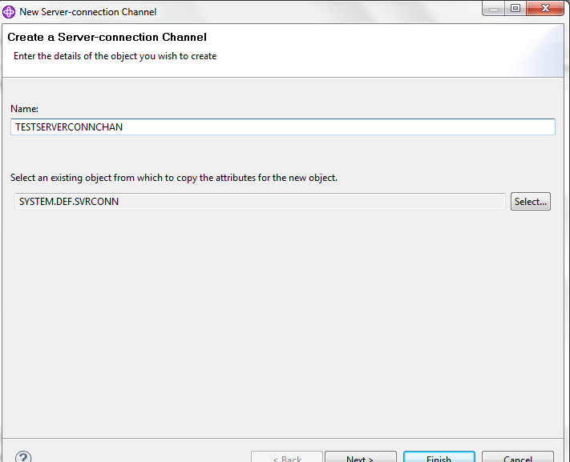

Leave other values as default and click on Finish:

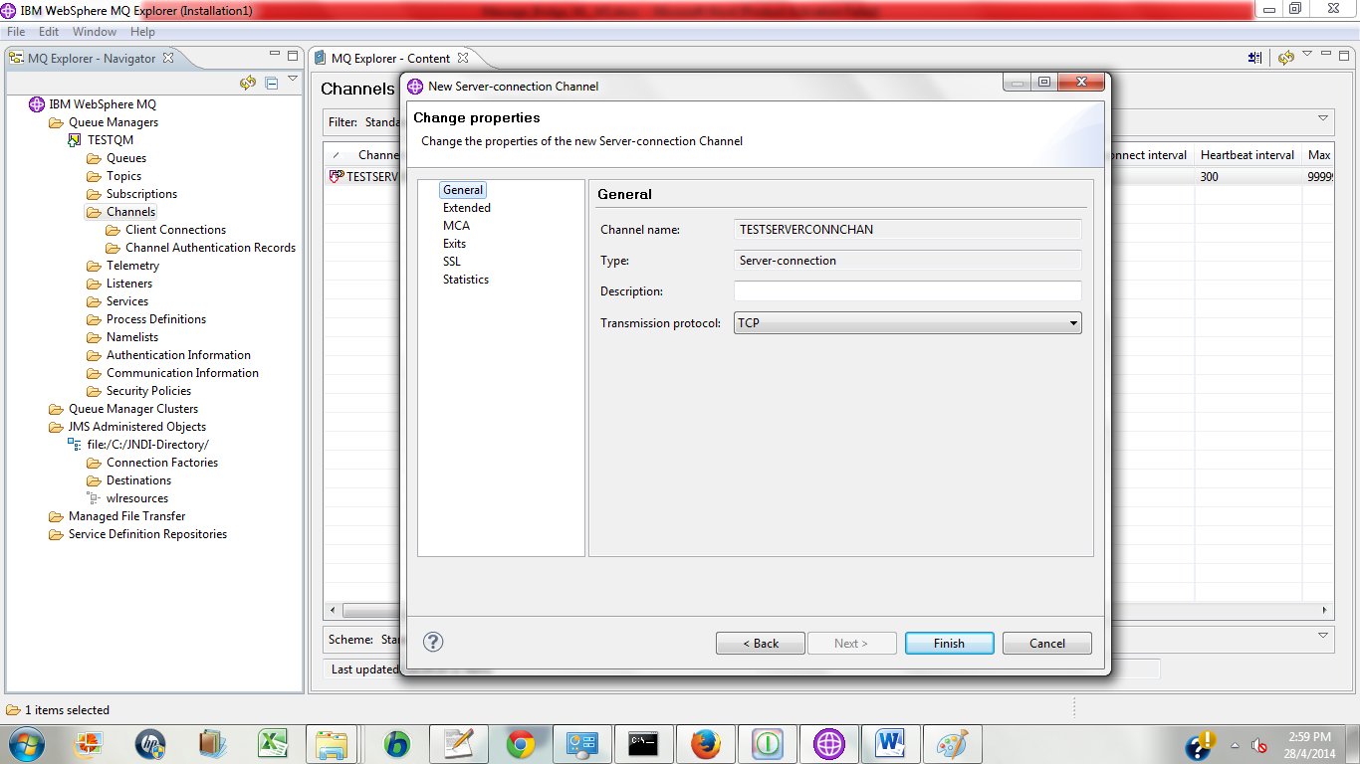

You would see it as below:

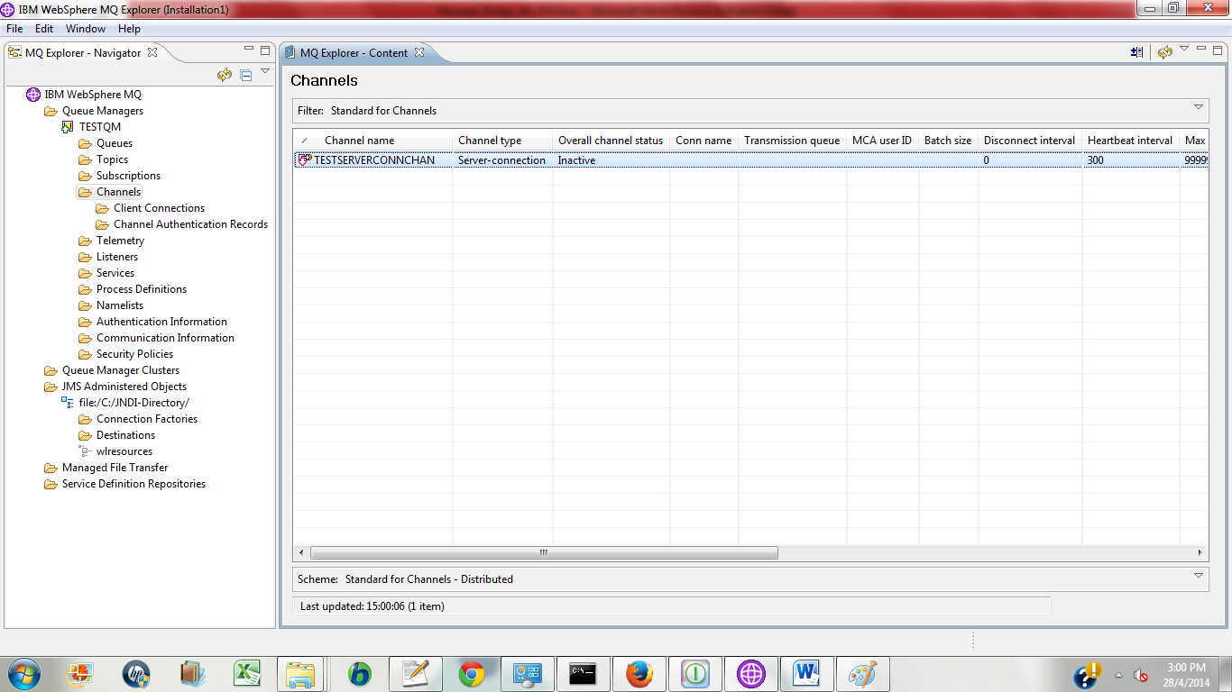

!!! As in the above screenshot, the overall channel status is In-active, it is due to the MCA user ID is blank. MCA user ID is the user who has the right to control on queue and created by Websphere administrator. So he – the administrator would be in the right position to tell us what is the username to be used here.

In case of bridging WS and WL on different computers, we will be able to figure out the right MCA user by using the user id who is current running WS and the computer name.

User id:

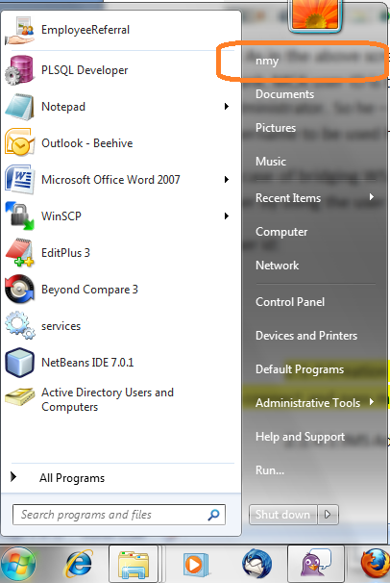

Computer name:

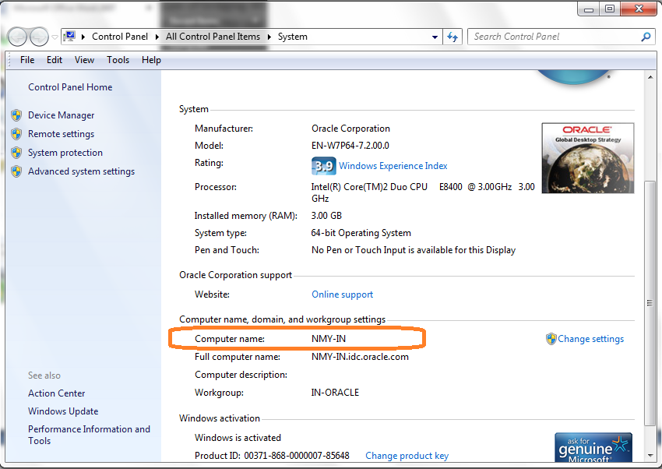

Hence the MCA user id would be: **nmy@nmy-in**.

We can input this info by double-clicking on the channel, going to MCA section and input the MCA user as mentioned in below screenshot. Upon that, the status would be Running.

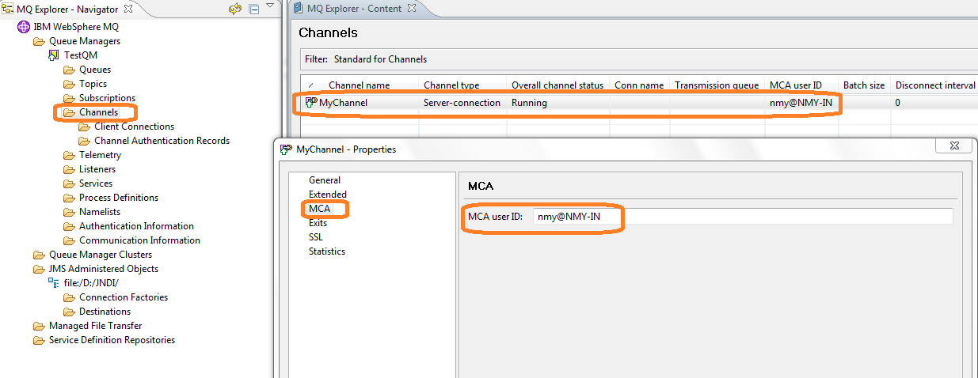

### Create .binding file

.binding file would contain all the key information to be used by WL to connect and pass message to Websphere

#### JMS Administered Objects -> Add Initial Context

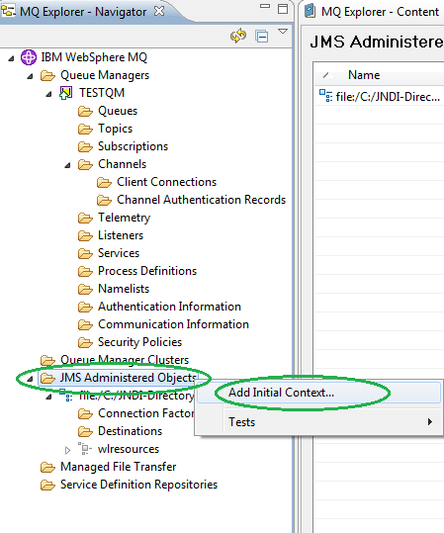

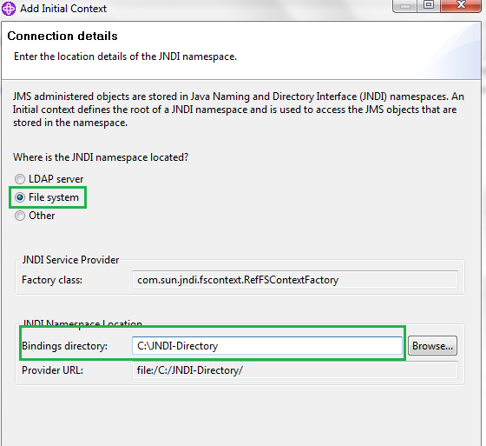

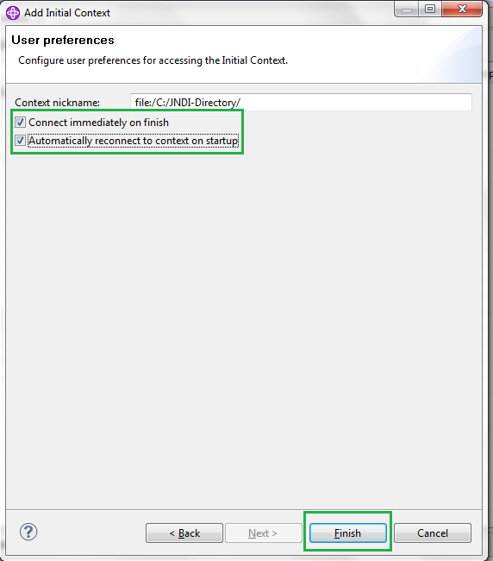

After creation, it should be as below:

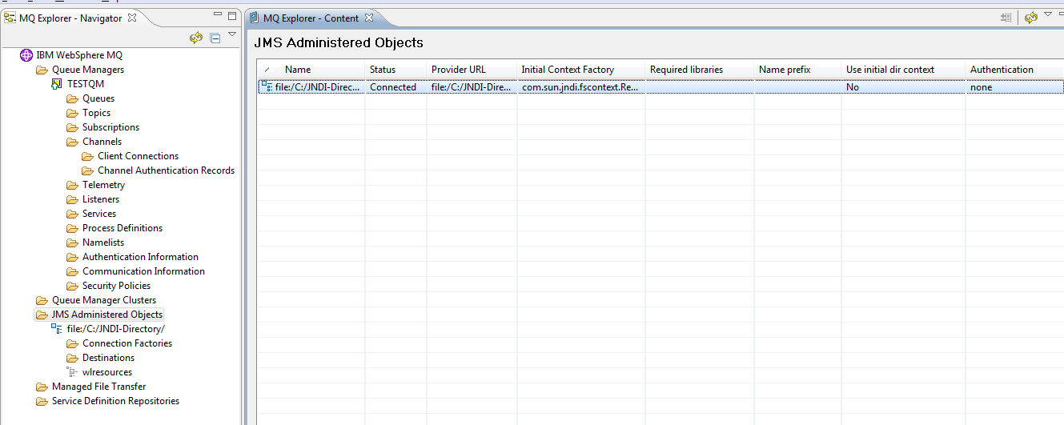

#### Create Connection Factory

Name used in this example is MQCF

Under new Initial Context (file:/C:/JNDI-Directory as in current example), New 🡪 Connection Factory

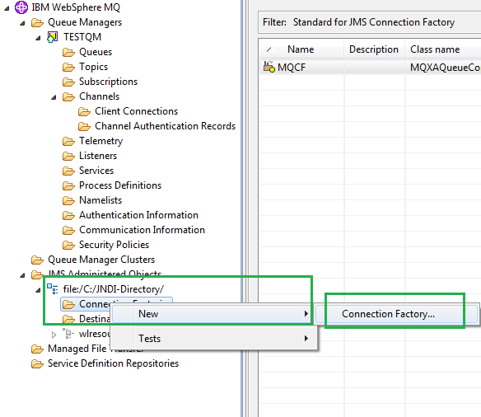

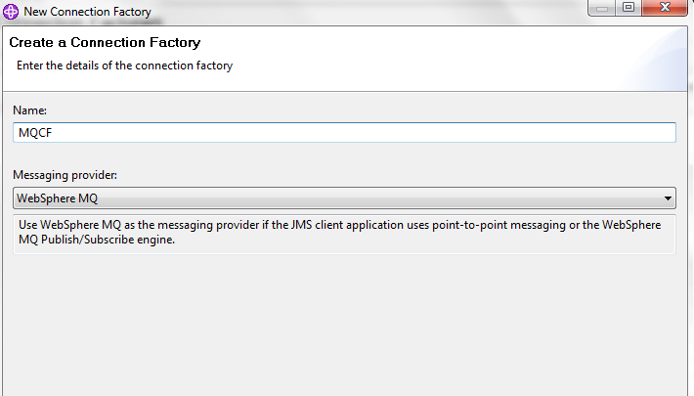

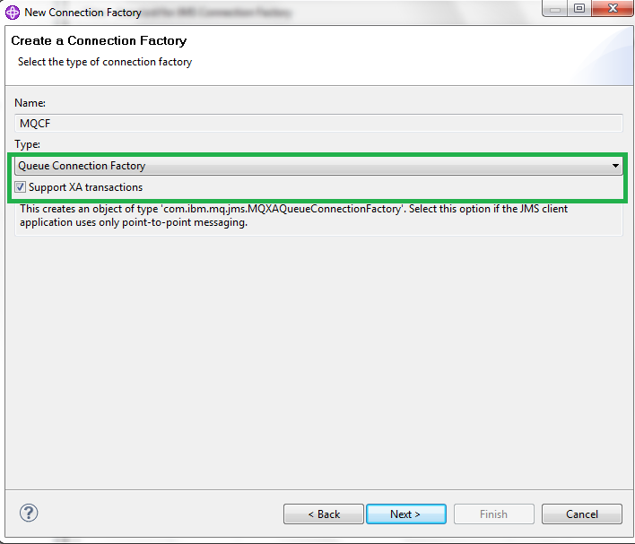

As in current example, the WL and WS are on the same computer hence the transport mode is selected as Binding.

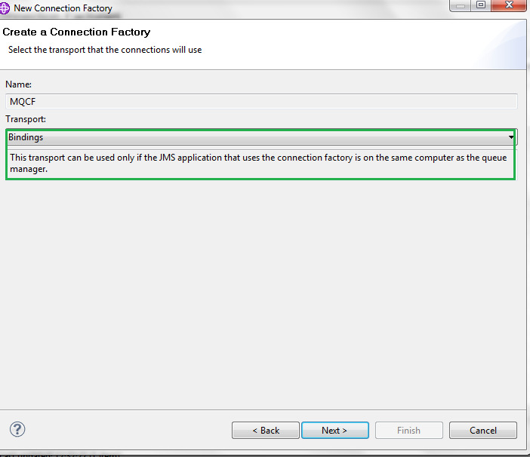

!!! In case it is on different servers or computer then we should choose the transport mode as **MQ CLIENT** as in below screenshot

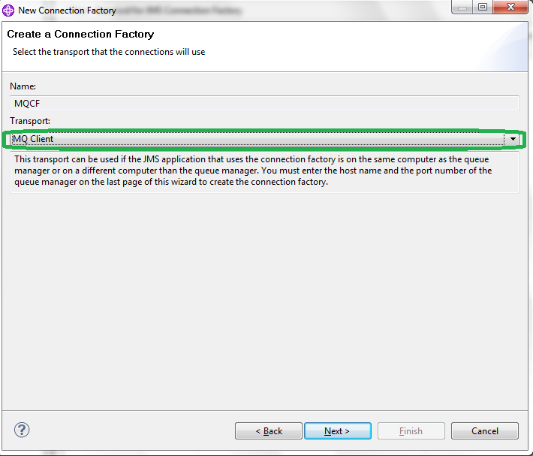

In both cases (same or different computers), click on Next for below screenshot

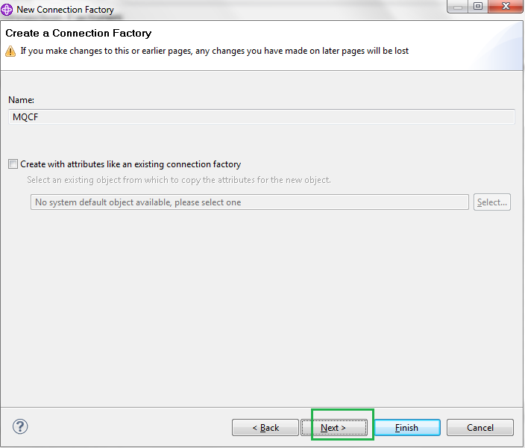

In section General, select Service Provider value 7 as we are using WS MQ 7

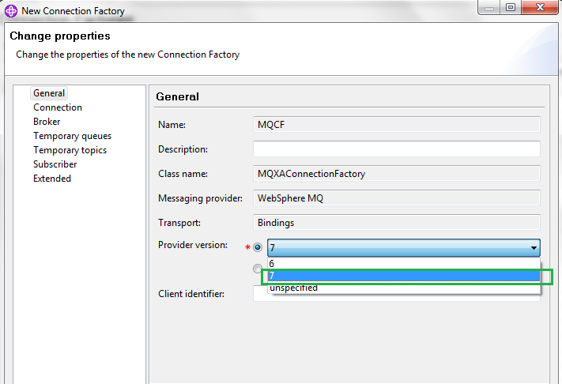

In tab Connection, we need to choose the queue manager **TESTQM** which we created earlier for field Base Queue Manager and then click on Finish

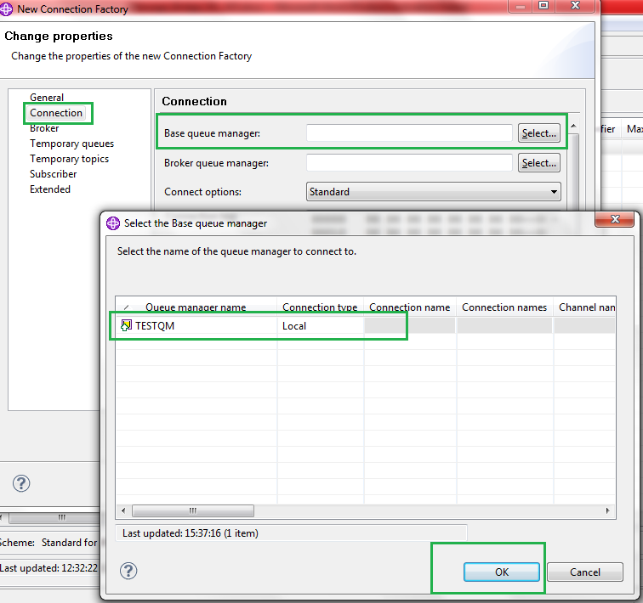

!!! In case of different computers, we need to input the **IP and port** (the same as mentioned at the time of Queue Manager Creation) of computer in which WS is running.

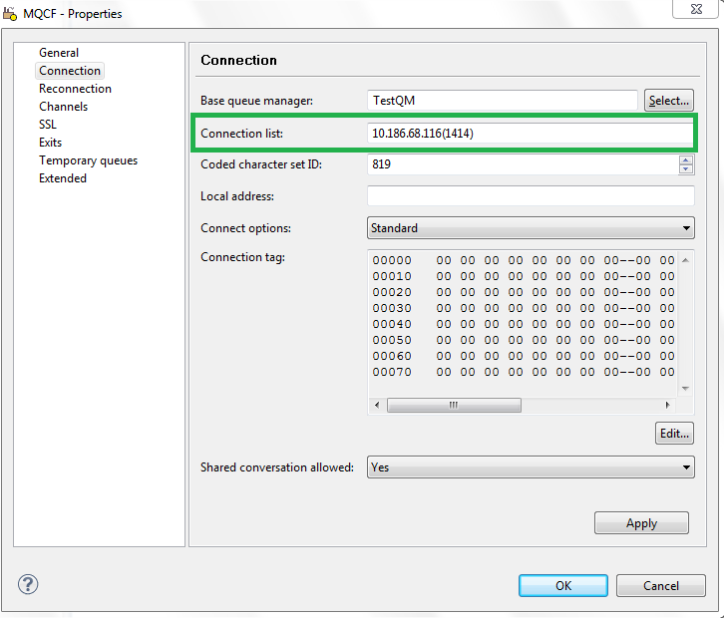

We would be able to see queue connection factory created as below for Bindings mode

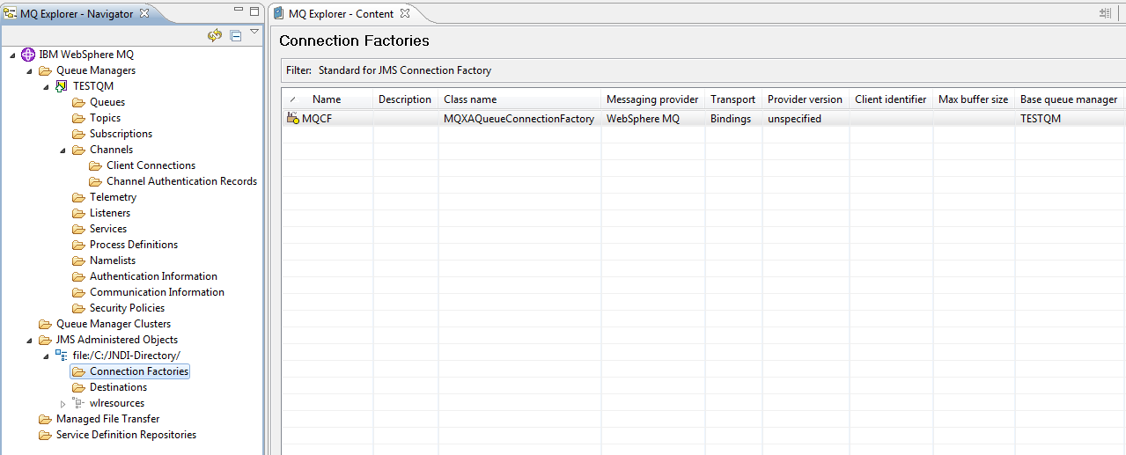

!!! And for CLIENT MODE

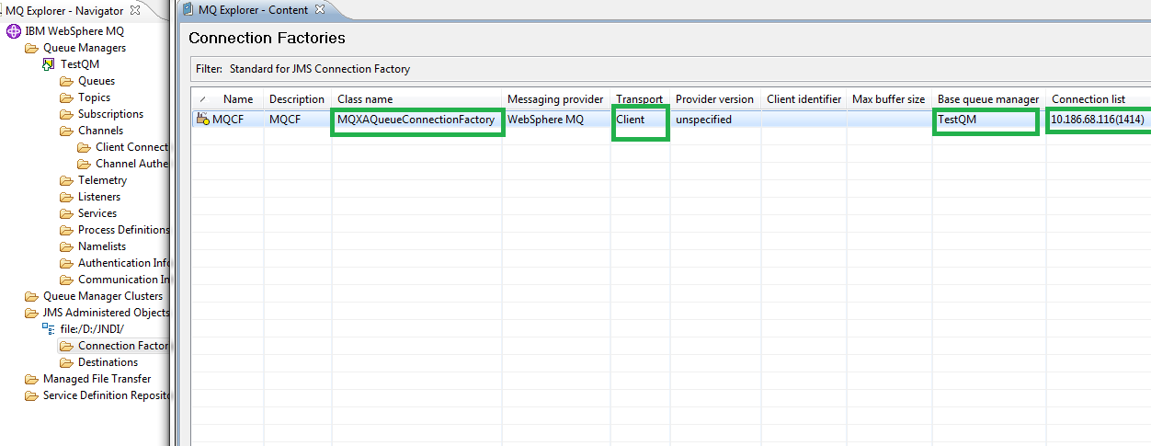

#### Creation of Destination

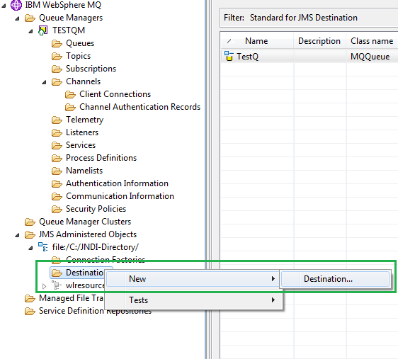

Put a name and click on Next

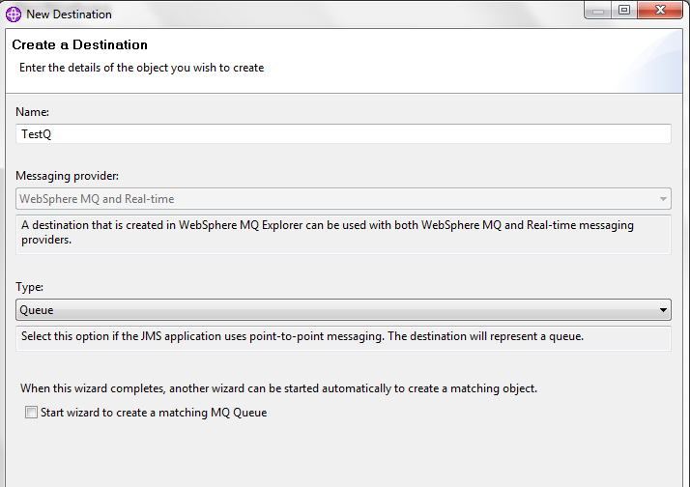

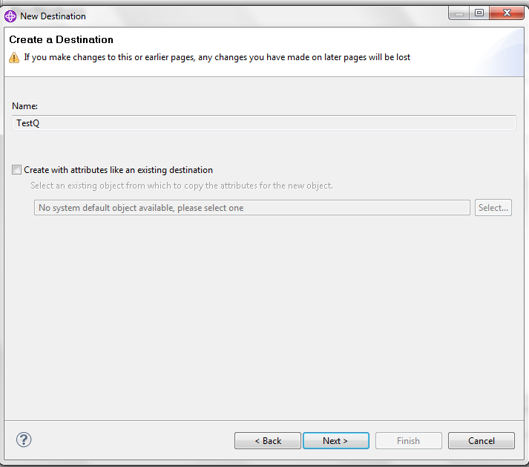

We need to select Queue Manager **TestQM** and Queue **TestQ** in following screen:

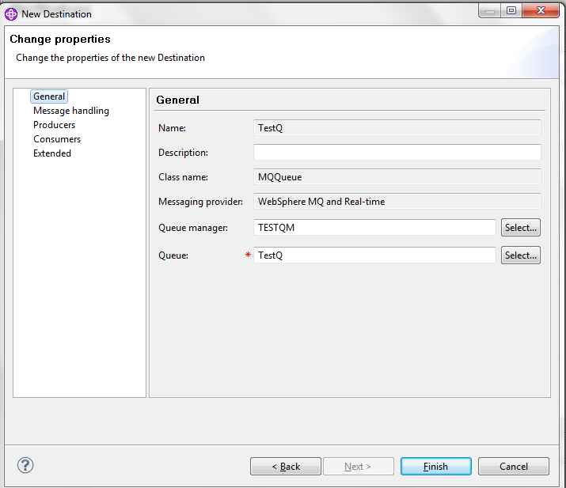

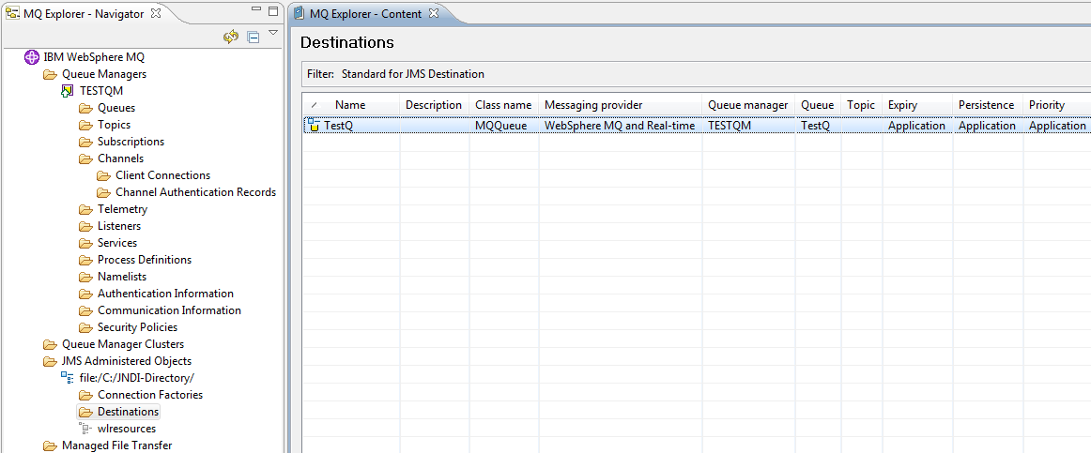

Now if we look at the directory C:\JNDI-Directory, we will see the .binding file. This file would be used in next section in WL to create communication link to WS.

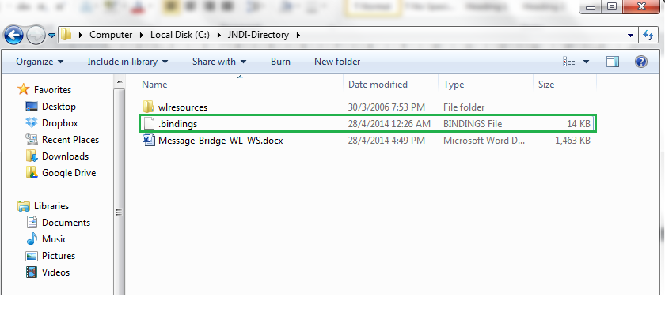

Here is the binding file of the above maintenance (before used, please rename it to .bindings)



!!! Here is the binding file generated in case of bridging WL and WS on different computers



**Note:** On windows, you may encounter error such as Please input file name. So you should open file in Notepad++ or whatever editor and then choose Save As, File Type as All files and then you would be able to save it with full name .bindings.

## Maintenance in WebLogic

In both cases of bridging same/diff computers, there would be no difference in maintenance for WL

### Create JMS Server

This step involves the creation of Persistent Store which is here named FileStore and type is FileStore also

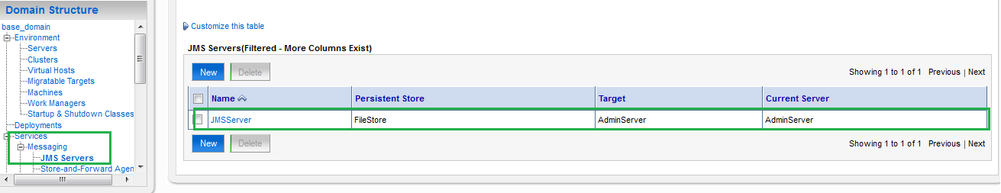

### Create JMS Module

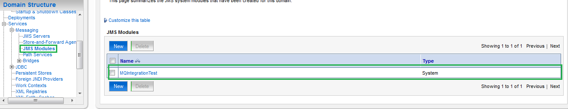

### Create Connection Factory

In the above module, create one Connection Factory and one Queue which would be used in Source Message Bridge later (involving the creation of Sub-deployment)

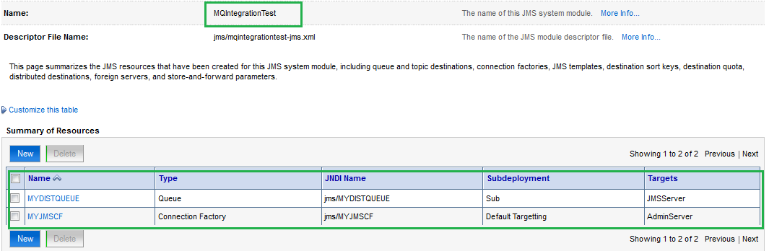

### Create Source and Destination Message Bridge

#### Source Message Bridge

i.e. message will flow out from Weblogic

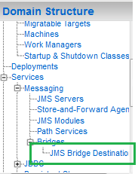

Click on New and fill in information as below:

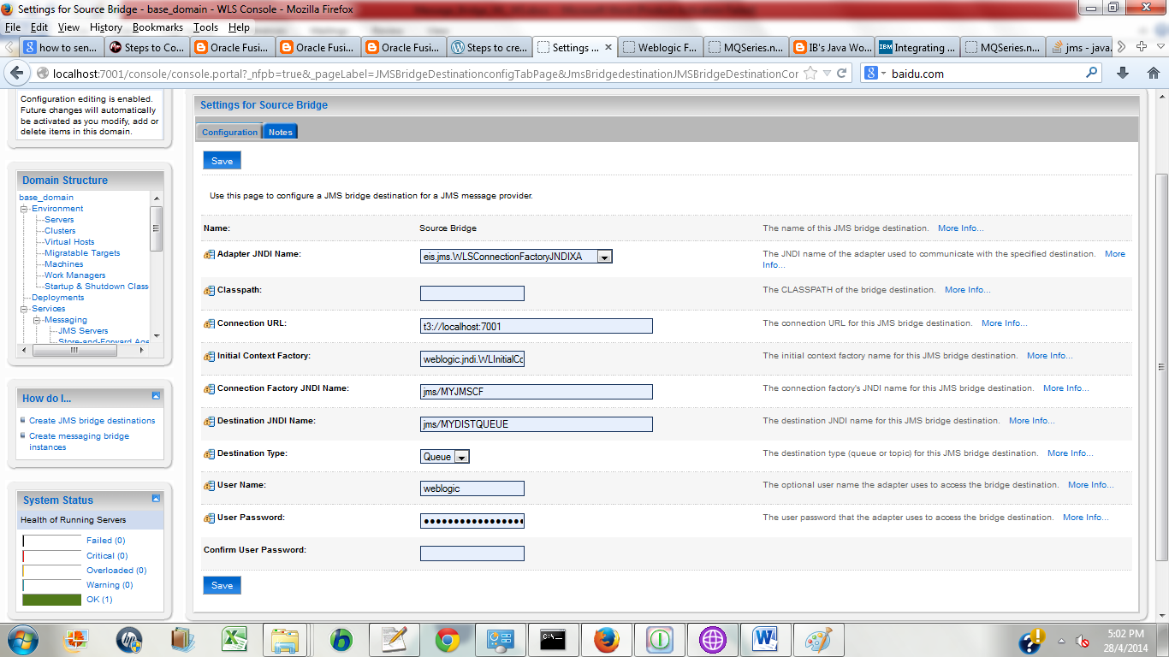

Adapter JNDI Name: eis.jms.WLSConnectionFactoryJNDIXA   
Classpath: Blank  
Connection URL: t3://localhost:7001 (as its from weblogic hence it follows t3 protocol)

Intial Context Factory: weblogic.jndi.WLInitialContextFactory (this is meant for WL)  
Connection Factory JNDI Name: jms/MYJMSCF (Queue connection factory we created in WL)  
Destination JNDI Name: jms/MYDISTQUEUE (Queue we created in WL)  
Destination Type: QUEUE

#### Destination Message Bridge

i.e. destination in which message will reach

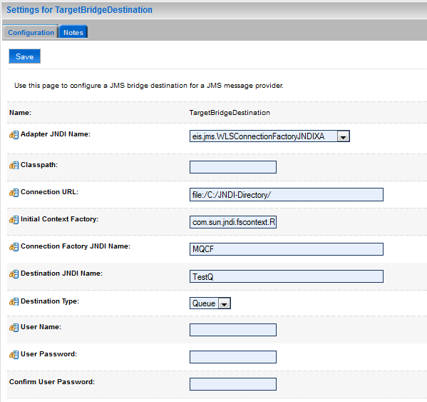

Adapter JNDI Name: eis.jms.WLSConnectionFactoryJNDIXA   
Adapter Classpath: blank  
Connection URL: file:/C:/ JNDI-Directory/   (location of .binding file)   
Initial Context Factory: com.sun.jndi.fscontext.RefFSContextFactory (this is meant for WS)   
*Connection Factory JNDI Name: MQCF (Queue connection factory created in WS)  
*Destination JNDI Name: TestQ  (Queue created in WS)

### Create Message Bridge

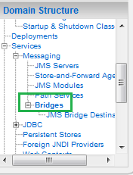

Click on New and input information as below:

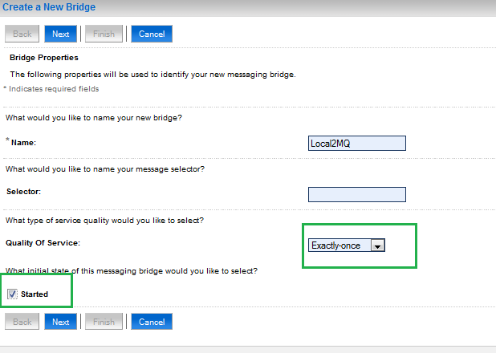

Select Source Bridge as existing Source Destination

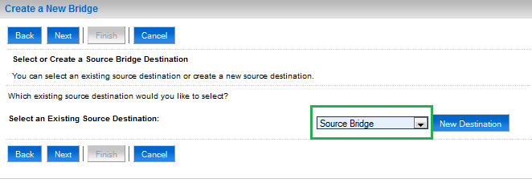

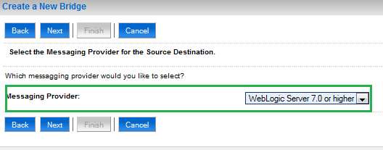

Select Target Bridge Destination as existing Target Destination

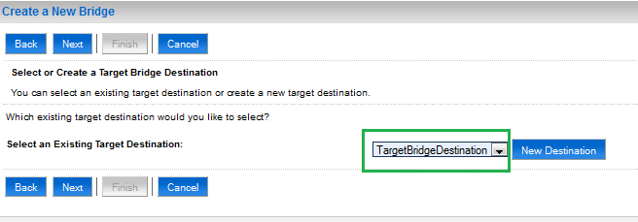

As the destination is of WS hence the Message Provider would be selected as Other JMS

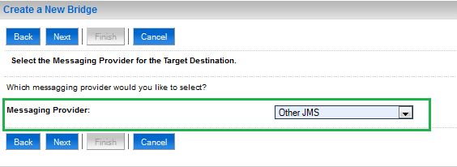

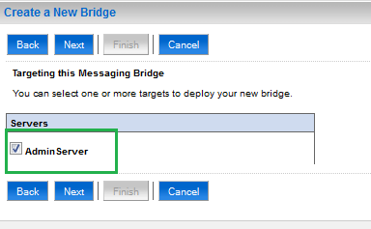

After that, we will click on Finish on next screen and back to the main menu, we will see message bridge created as below:

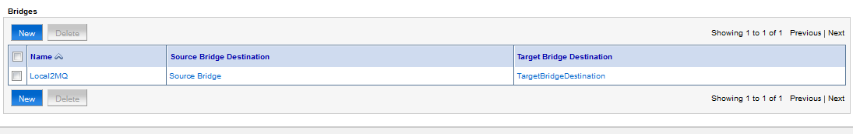

Click on Local2MQ to edit some parameters:

**QOS Degradation Allowed to be ticked**

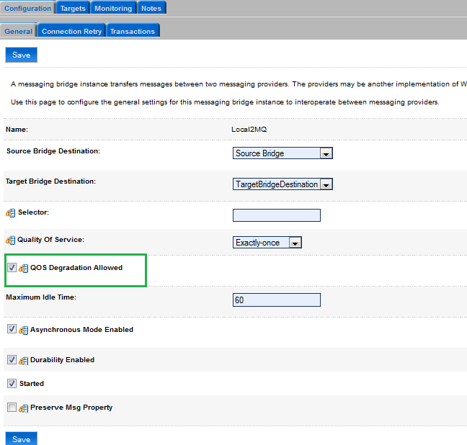

# Testing the setup

## Pre-requisite

Before testing, we need to copy jar library of files of WS into lib directory of domain of WL

Lib of WS (whatever .jar files ) is located at C:\WebSphere MQ\java\lib

(here is just a list of jar file names

com.ibm.mq.fta.jar;com.ibm.mq.jar;com.ibm.mq.jms.Nojndi.jar;com.ibm.mqetclient.

jar;com.ibm.mqjms.jar;commonservices.jar;connector.jar;fscontext.jar;jms.jar;jndi.jar;jta.jar;

providerutil.jarrmm.jar;)

Copied to …\user_projects\domains\<base_domain>\lib (here base_domain is domain name)

## Testing

### Message forwarding from Weblogic to Websphere

Log into WL 🡪 JMSModule 🡪 click on MYDISTQUEUE 🡪 go to tab Monitoring 🡪 tick on the below record belonging to the queue and click on Show Message

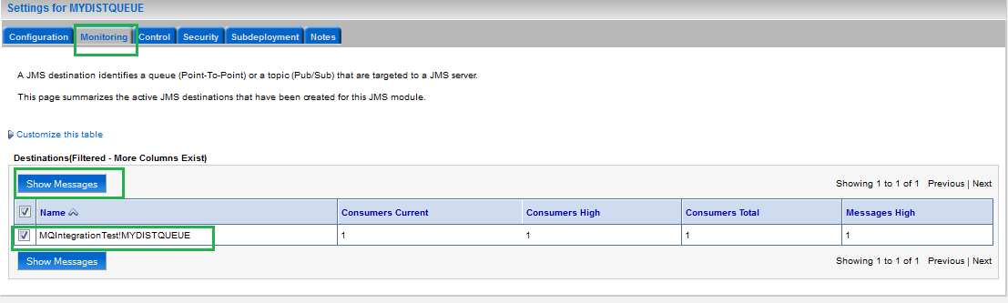

Click on New of next page and input content of message (below values are random, not required to be in any format)

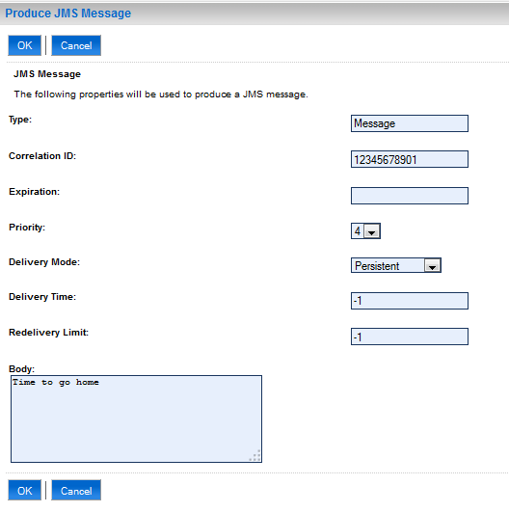

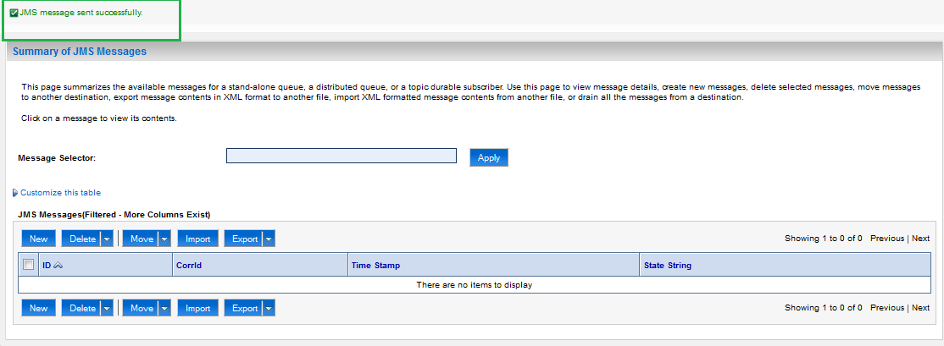

Once click on OK, go to WS Explorer to check in the local queue TestQ whether any message coming or not

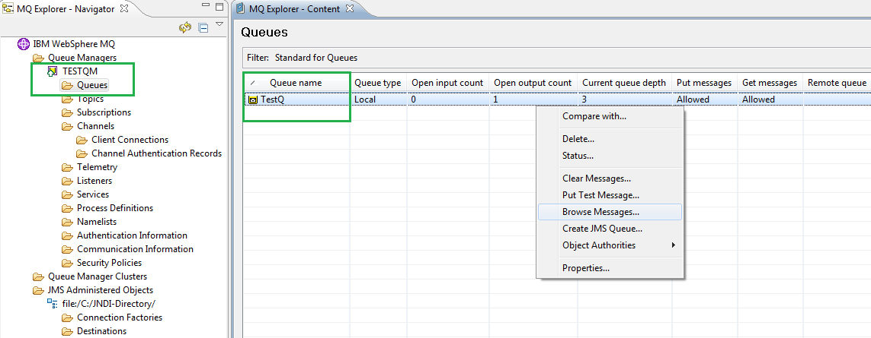

It’s there

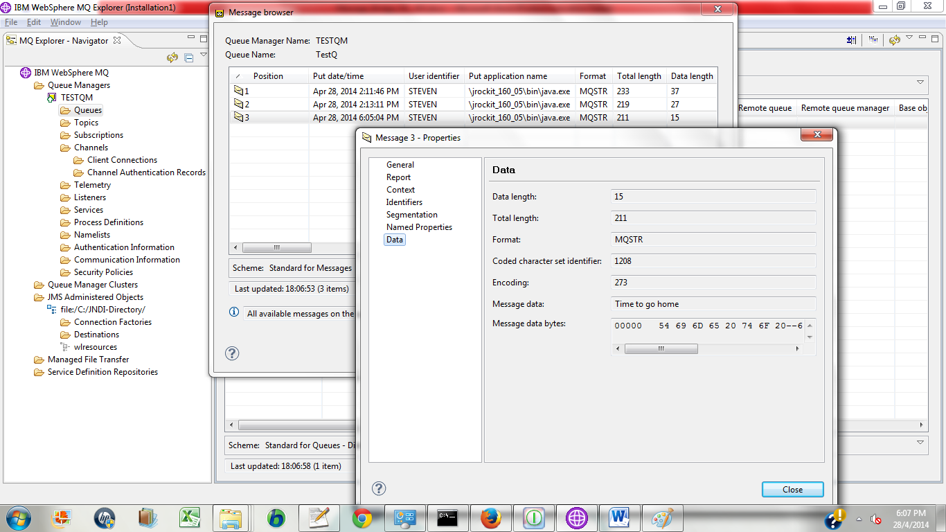

The flow of message forwarding from Weblogic to Websphere has been completed with example.

### Message forwarding from Websphere to Weblogic

This section will show quickly the maintenance of message from Websphere to Weblogic.

Basically, the scenario is that once message is put into Websphere local queue, it would be forward to Weblogic queue and process at this side (saying MBD at WL side will pick up message and pass to database for processing then send back to some other destination queue for example.)

#### Additional maintenance in Websphere

- One local queue TestQWS (same setting as local queue TestQ in earlier section)

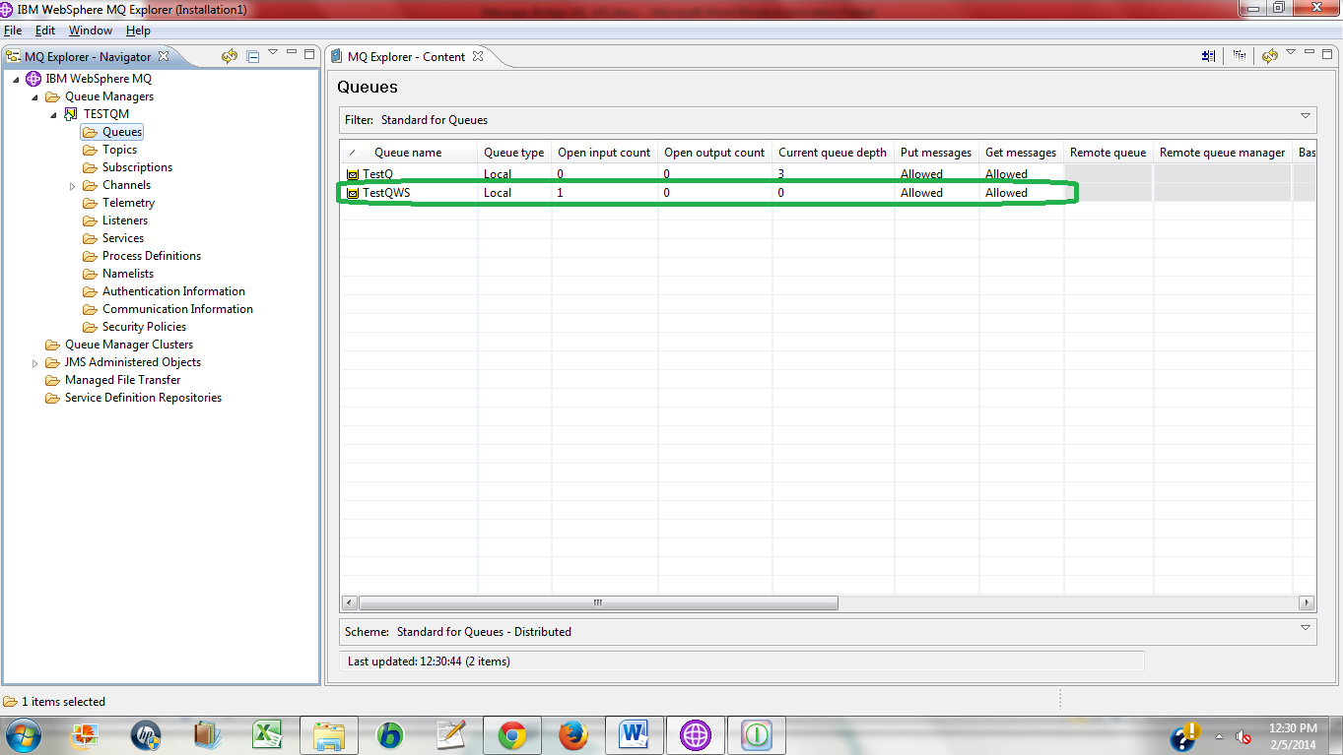

- One queue connection factory MQCFWS (same setting as MQCF in earlier section)

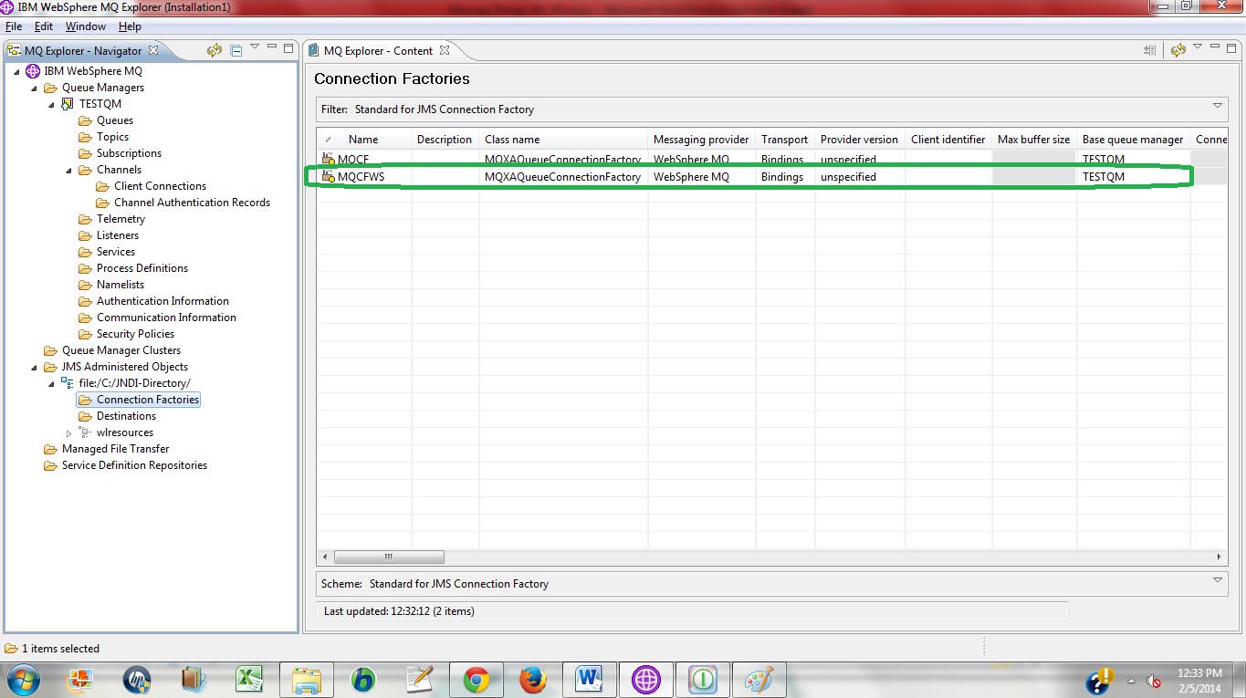

- One destination TestQWS (same setting as destination TestQ in earlier section)

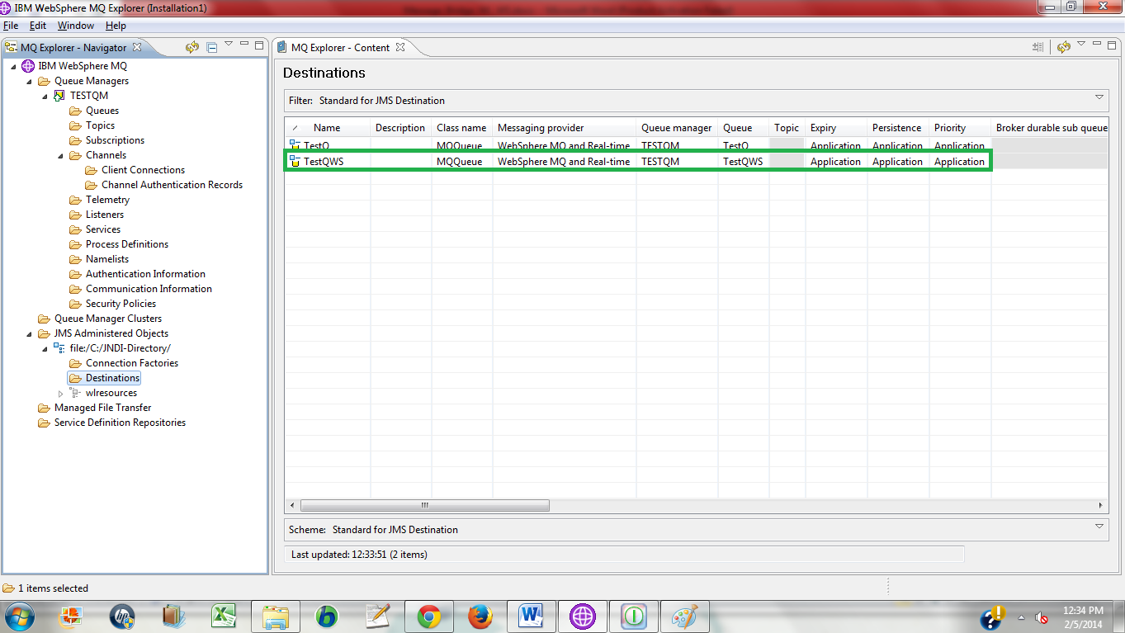

Here is the binding file of both above maintenances (before used, please rename it to .bindings). It includes the maintenance from WL to WS and vice versa.



#### Additional maintenance in Weblogic

- Local queue MYDISTQUEUEWS with JNDI as **MYDISTQUEUEWS** and queue connection factory MYJMSCFWS with JNDI as **jms/MYJMSCFWS** as shown in below screenshot

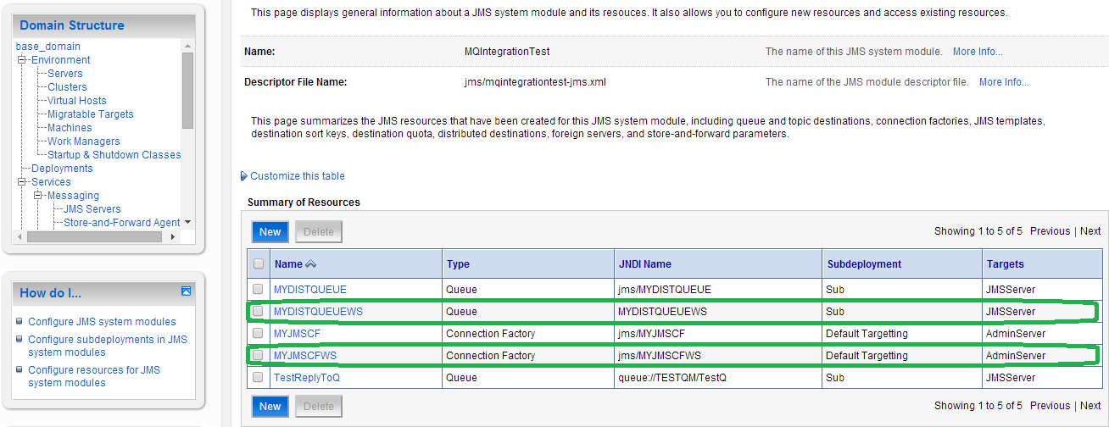

- One bridge source SourceWS and destination DestinationWS:

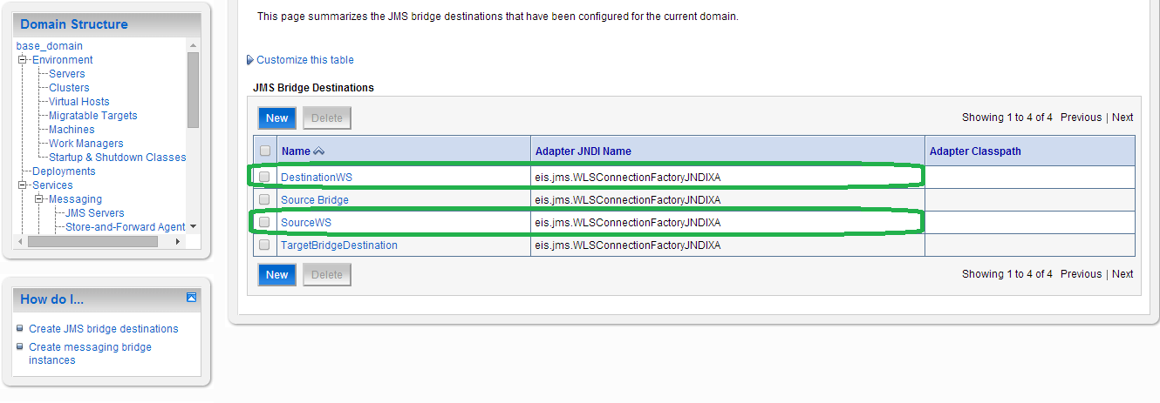

The configuration of bridge source is as follows: Source here means where message would flow out.

As it is located as Websphere hence

Initial Context Factory: com.sun.jndi.fscontext.RefFSContextFactory

Connection URL: file:/C:/JNDI-Directory/

Connection Factory JNDI Name: MQCFWS (queue connection factory created in WS)

Destination JNDI Name: TestQWS (queue created in WS)

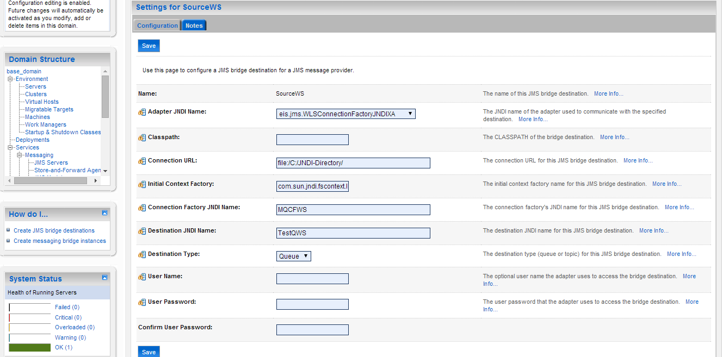

The configuration of bridge destination is as follows: Source here means where message would reach

Initial Context Factory: weblogic.jndi.WLInitialContextFactory

Connection URL: t3://localhost:7001

Connection Factory JNDI Name: jms/MYJMSCFWS (queue connection factory created in WL)

Destination JNDI Name: MYDISTQUEUEWS (queue created in WL)

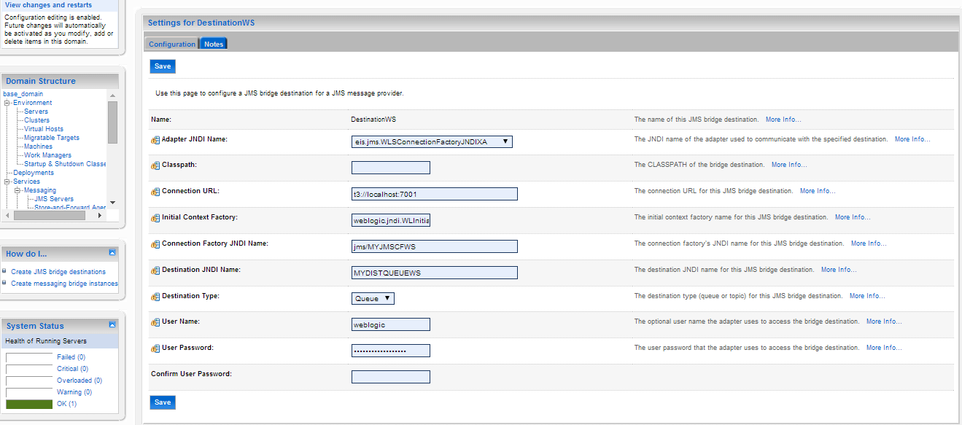

Now we would create bridge **MQ2local** to link both mentioned source and destination

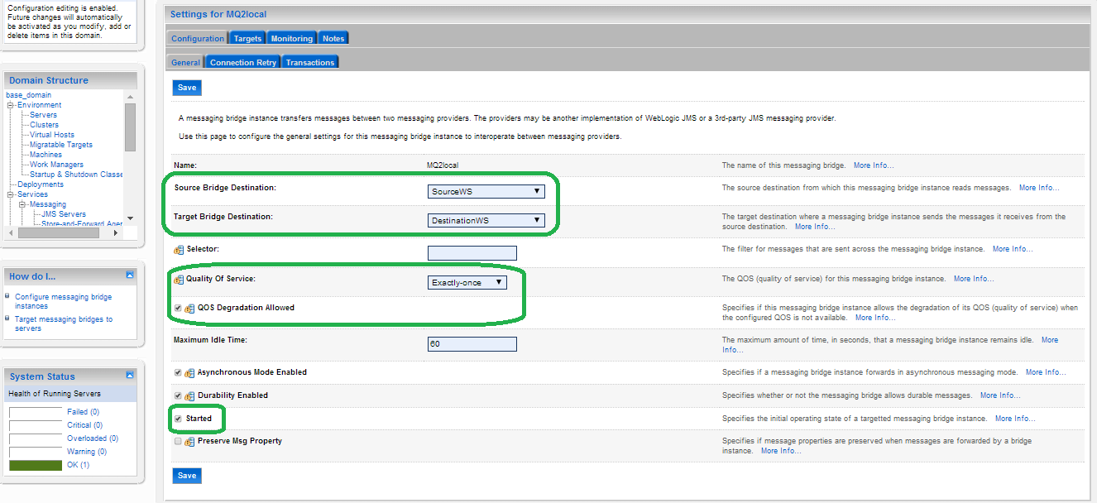

And target to AdminServer

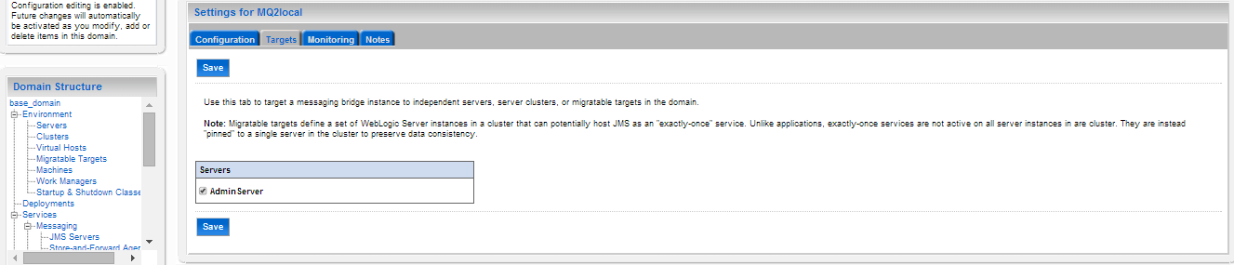

# Troubleshooting

## Debugging

1. If there is any error after starting up WL, it’s necessary to check Admin.log and <domain>.log

2. After doing configuration in WL and WS, we need to restart computer/server

3. If there is a need to debug from WL in case the debug in step 1 does not help much, we need to turn on the debug in WL server by:

Go to Servers 🡪 click on AdminServer in our case as all of components are targeted to this server

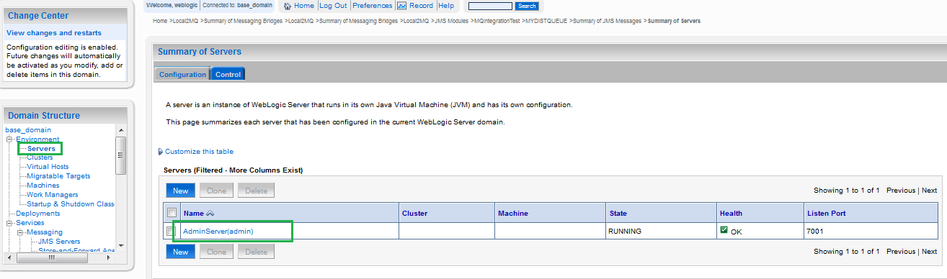

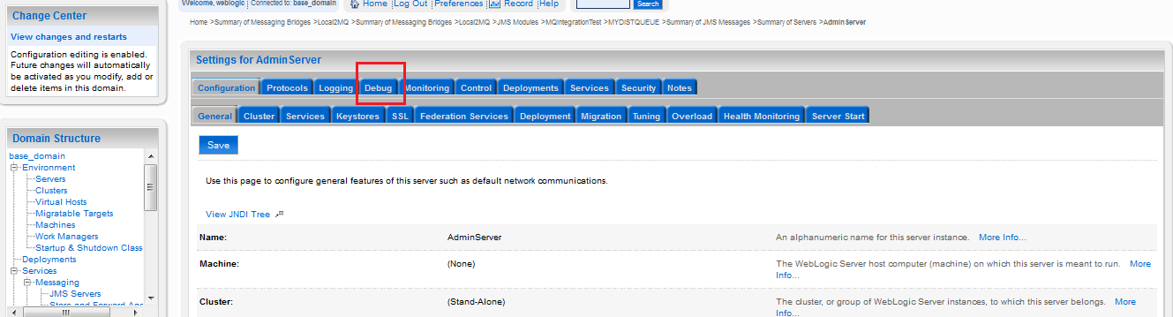

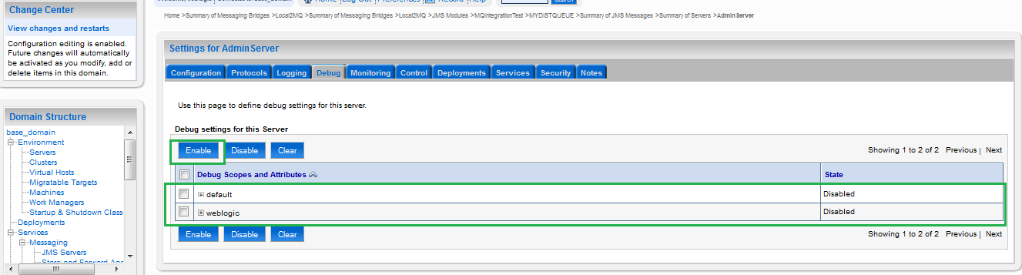

# References

|  |  |
| --- | --- |
| Sl No | Link |
| 1 | <http://middlewaremagic.com/weblogic/?p=4739> |
| 2 | <http://rohith-oracle.blogspot.sg/2012/10/weblogic-bridge-for-ibm-mq.html> |
| 3 | <http://rohith-oracle.blogspot.sg/2012/12/weblogic-bridge-for-ibm-mq.html> |
| 4 | <http://rohith-oracle.blogspot.sg/2012/10/creating-file-based-jms-queue-on_9.html> |
| 5 | <http://wls4mscratch.wordpress.com/2010/06/22/steps-to-create-jms-bridge-between-wls-and-ibm-websphere-mq/> |



Message Bridge bw Weblogic JMS & Websphere MQ

[Oct] [2016]

Oracle Corporation

World Headquarters

500 Oracle Parkway

Redwood Shores, CA 94065

U.S.A.

Worldwide Inquiries:

Phone: +1.650.506.7000

Fax: +1.650.506.7200

www.oracle.com/ financial_services/

Copyright © 2014 Oracle Financial Services Software Limited. All rights reserved.

No part of this work may be reproduced, stored in a retrieval system, adopted or transmitted in any form or by any means, electronic, mechanical, photographic, graphic, optic recording or otherwise, translated in any language or computer language, without the prior written permission of Oracle Financial Services Software Limited.

Due care has been taken to make this document and accompanying software package as accurate as possible. However, Oracle Financial Services Software Limited makes no representation or warranties with respect to the contents hereof and shall not be responsible for any loss or damage caused to the user by the direct or indirect use of this document and the accompanying Software System. Furthermore, Oracle Financial Services Software Limited reserves the right to alter, modify or otherwise change in any manner the content hereof, without obligation of Oracle Financial Services Software Limited to notify any person of such revision or changes.

All company and product names are trademarks of the respective companies with which they are associated.