AI Assisted Coding

Assignment – 16.3
Name: C. Vaishnav Reddy
Rollno:2303A52203
Batch:45
Task1:
Create schema and queries for a Hospital Management System.
Instructions:
• Tables: Doctors, Patients, Appointments.
• Use AI to define constraints (unique IDs, valid dates).
• Generate queries:
• List all appointments for a specific doctor.
• Retrieve patient history by patient ID.
• Count total patients treated by each doctor.
Expected Output:
• Normalized schema and SQL queries with joins.
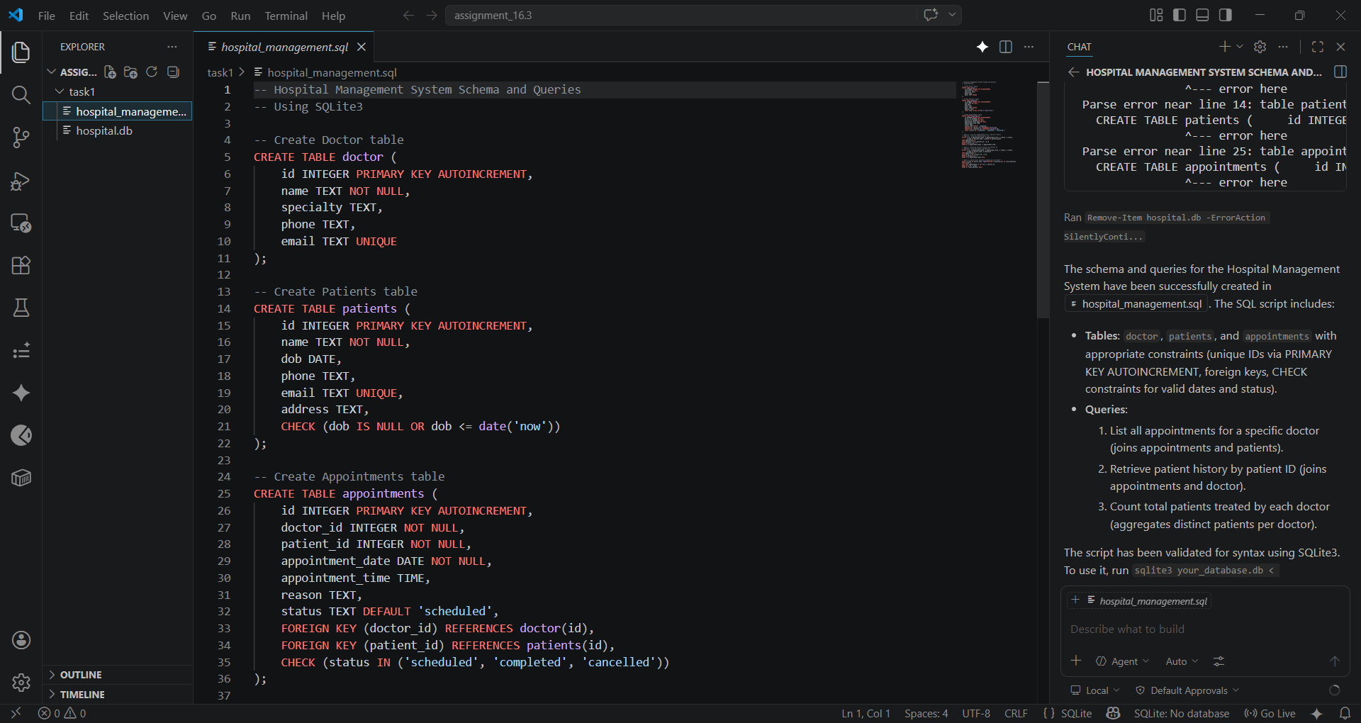
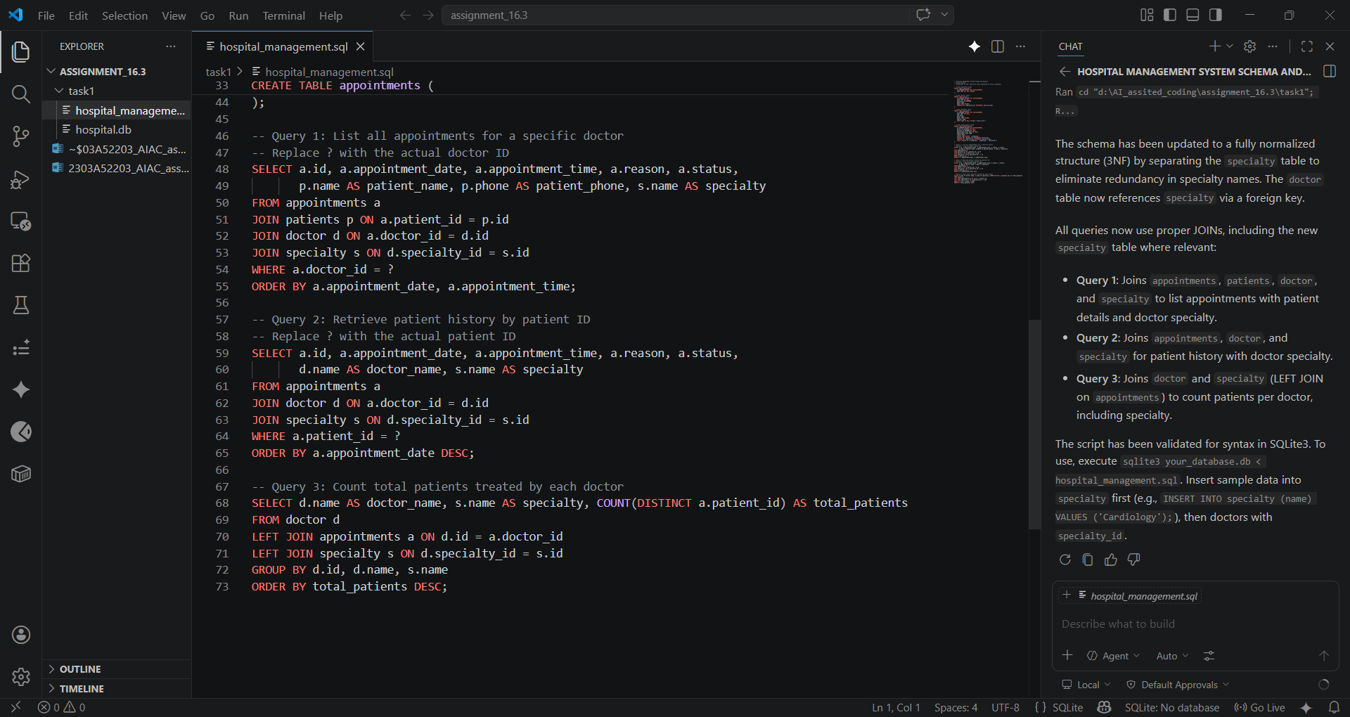
Task 2 – Real-Time Application: Online Shopping Database
Scenario:
Design a database for an E-commerce platform.
Requirements:
• Tables: Users, Products, Orders, OrderDetails.
• Generate queries to:
• Retrieve all orders by a user.
• Find the most purchased product.
• Calculate total revenue in a given month.
• AI should also suggest normalization improvements and query
optimization.
Expected Output:
• Complete schema with relationships + SQL queries for analytics.
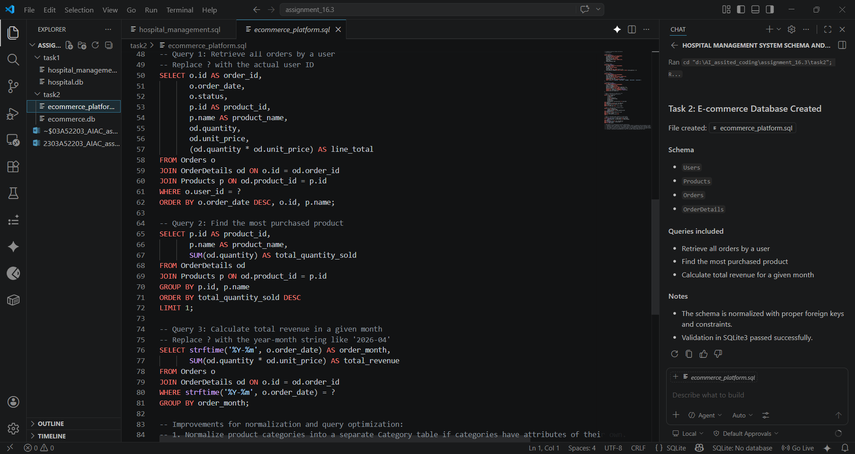
Task 3 – Library Database
Task:
Design schema for a Library Management System.
Instructions:
• Tables: Books, Members, Loans.
• Use AI to suggest indexing strategy for faster queries.
• Generate queries:
• Retrieve all books currently issued.
• Find overdue books (loan date > 30 days).
• Count number of books loaned by each member.
Expected Output:
• Schema + SQL queries demonstrating joins and conditions.
