FINAL PROJECT REPORT

Electrical and Computer Engineering Department Spring 2022

Last level cache simulation in Python

Sandeep Chintakunta Venkata
Mounika Chevuturi

INTRODUCTION:
For Python Project we had picked a cache simulation from MSD and enhanced its performance and the usage. With Python Object oriented it was ease and fun to have class structure and had more encapsulation of memory and methods which resulted us the robust and faster simulation. In c code used to run huge traces for Minutes but with python able to it in Seconds.s
Our Lower Level cache (L2) has a total capacity of 16MB, 64-byte lines, and an 8-way set associative architecture. To ensure cache coherence, a write allocate policy is used, which employs the MESI protocol. A pseudo-LRU technique is used to implement the replacement policy. A higher level cache (L1) is 4-way set associative and employs 64-byte lines. It has a write-once policy, which means that the initial line write is written through, and subsequent writes to the same line are written back. In response to our lower level cache bus actions, our system maintains inclusiveness and returns snoop results returned by the lower level cache. Because our design is repeatable and easy to update, our simulated cache operates correctly for all return values.

DESIGN:
Design is categorized into the following
Main: Inputs for a design control and configuration files.
Cache_memory: Structures to point the cache lines and sets
Bus_operation:
Contains all the communications LLC does with system bus and to the next level cache
Cache_operation:
- Decodes the address into sets and tags based on input parameters
Initialize the cache by allocating the required memory as per the config.
- Read requests: Determines cache operation and performs read and read with writes. Directs evicts if needed.Updates MESI states and PLRU bits.
- Write requests: Updates PLRU bits and MESI states. Call read with write if needed.
- All Snoop requests: Calls updateMESIsnoop by passing respective snoop.
- Reset of the cache: Invalidates all the cache lines in all the sets.
- Print all the information of the cache line in each set if all lines are valid.
- Update MESI state for transaction This changes the state when the read and write transactions occurred and also performs relevant bus operation.
- Update MESI State for snoop requests: This is used to update the MESI state for all the snoop requests And also invalidates and flush when required.
- UpdatePLRU: Updates bits of an abstracted Least Recently Used Tree per given way of cache line tag. 0 is for left traversal, 1 for right traversal.
- Which way to evict: If else branching to simulate traversal of abstracted Pseudo LRU directed opposite the PLRU bits.
- Flush : This is used when flush data when required and sends the data to the DRAM through bus.
- Void way: This is used for invalidating or evicting the way

Cache_performence:
- Counters: We are using counters to validate number of operations.
- Hit and miss ratios : calculate the performance values based on Hits/Misses/Eviction counters
- AMAT: Calculating AMAT by assuming HIT as 5 cycles and MISS as 100 cycles

Logger:
Displays all the logs based on the debug mode levels. This can be update in logger.py
- Level 0: Displays the response of operation & performance results
- Level 1: Displays all the Bus operations.
- Level 2: Displays basic details of cache operation
- Level 3: Displays all details of cache operation
- Level 4: Displays all the performance data information

BLOCK DIAGRAM:

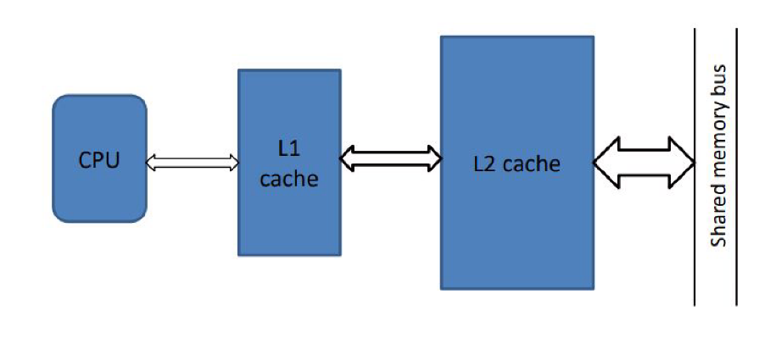

COMMUNICATION:
LLC needs to communicate with the higherlevel cache as well as the BUS we take care all this communications during the state change keeping in the mind of multi level cache.We need to get the data from L1 whenever our LLC cache MESI state is modified as L1 can have updated data.

Transcripts:
Out of Cache With 32 sets and 8 way displaying a 2 dimensional cache.
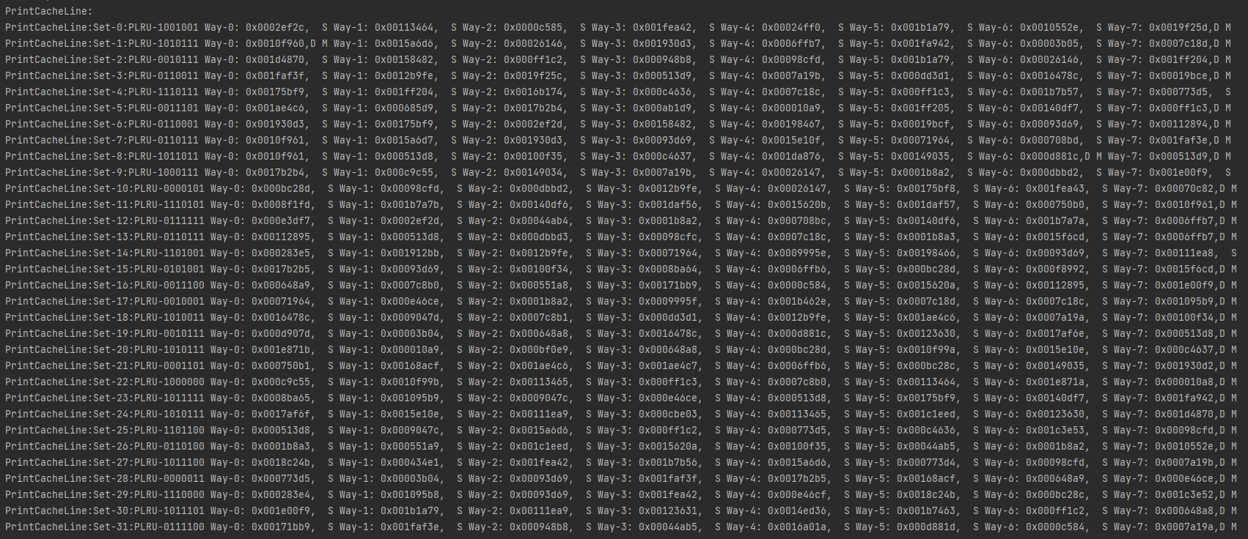

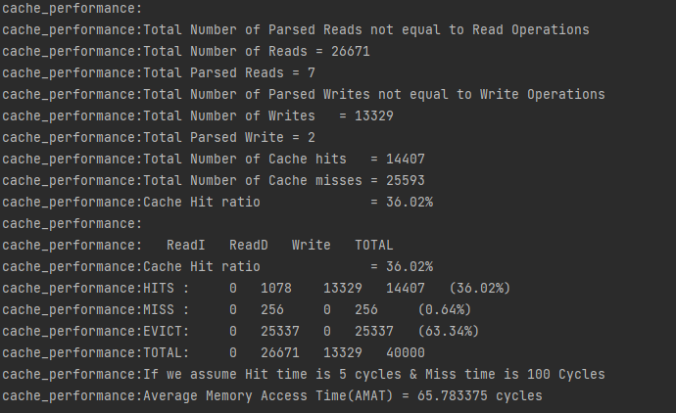

TESTING:
- trace_mesi.file to verify all the MESI state transitions and bus operations during it.
- For MESI transaction change checking following scenarios.
- I-E-E-M , I-S-S-M-M, I-M
- For MESI snoop requests change the following scenarios covers all.
- M-S-S-I, M-I, E-S-I

- Trace_plru.file to verify access and replacement of Pseudo LRU.
- Read operations to fill each way of a single set until full, then subsequent reads again into each of the filled ways to evict once from each. PLRU bits display in sequential order from root, counting up from the left to right leaves. Evicts from a full set show evict way order of 1, 5, 3, 7, 2, 6, 4, 8.

- Trace_op89.file to verify the operation 8 and 9 to reset and print cache.
- Made sure after reset this is not printed when print operation is executed
- Cc1.din used to compare performance for different cache lines.

COUNTERS
- Hit Counts: Elaborate various types of hit counts
  - IreadHitCount, DreadHitCount, DwriteHitCount;
- Miss Counts with empty cache line
  - IreadMissCount, DreadMissCount, DwriteMissCount;
- Evict Counts when eviction is caused.
  - IreadMissEvictCount, DreadMissEvictCount, DwriteMissEvictCount;
- Total individual Operational Counts
  - IreadCount, DreadCount, DwriteCount;

CODE REFERENCE:
We has a team worked on version control for our development to sync and effectively work on the final project here is our repository details
- C code Reference: https://github.com/cvsandeep/MSD-Cache
- Python Code reference: https://github.com/cvsandeep/Cache_python

Difficulty:
- Cache Memory allocation was a tough part, when 1 set of data is updated its updating all the sets.
- Object oriented gave ease to use but faced trouble for static methods

