**Submitted by: Chirakkal Variam, Sudheer Kumar**

**Date : 1/18/2019**

**Smart Contract for Movie Ratings**

DESCRIPTION

An entertainment industry has hired you as a Blockchain developer to create a decentralized movie rating application. You need to build a smart contract for movie ratings and test it on a local Blockchain network.

**Actions to Perform:**

* Create a mapping field to store the movie reviews
* Use an array to store the list of movies
* Create a function that returns the total ratings a movie has received so far
* Develop a constructor that will be called once you deploy the contract on Blockchain
* Compile the smart contract using an IDE or a solidity compiler
* Deploy it on Ropsten test network

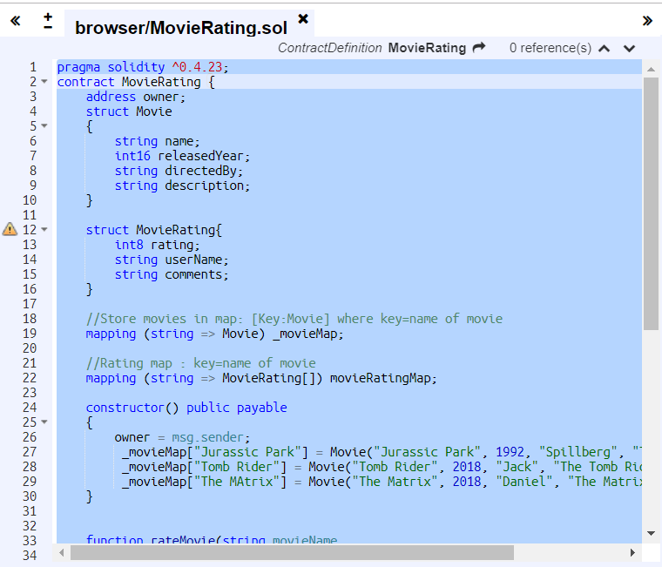

1. Compiled the solution:

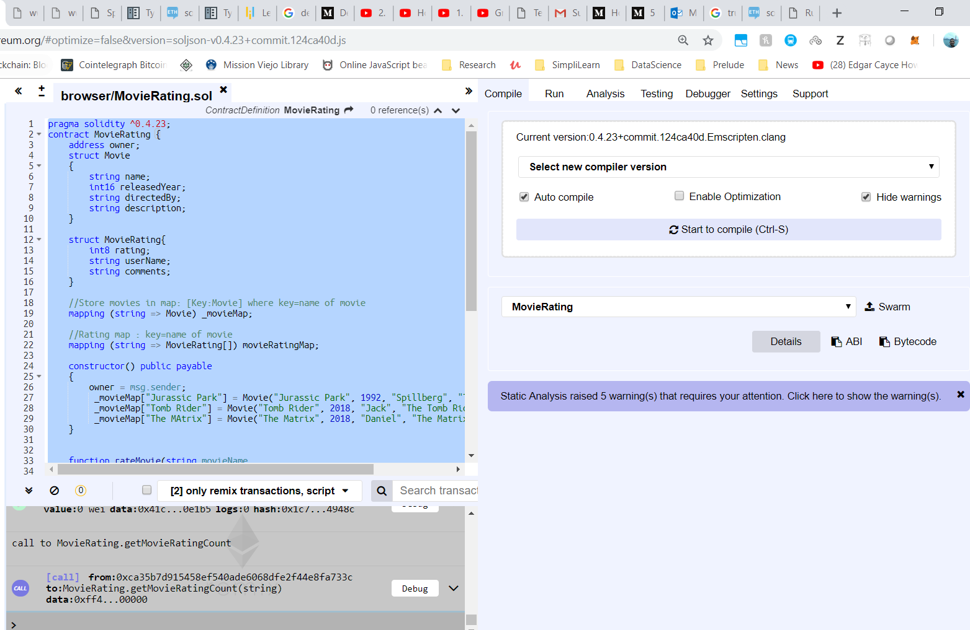

1. Deploy the solution to Ropsten. Open the Metamask and I have 4.99 ETH.

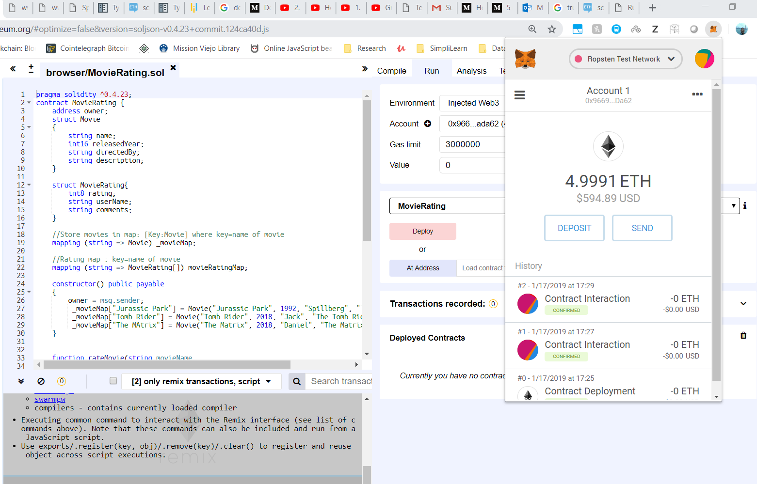

1. Click on Test Faucet to get more Ether:

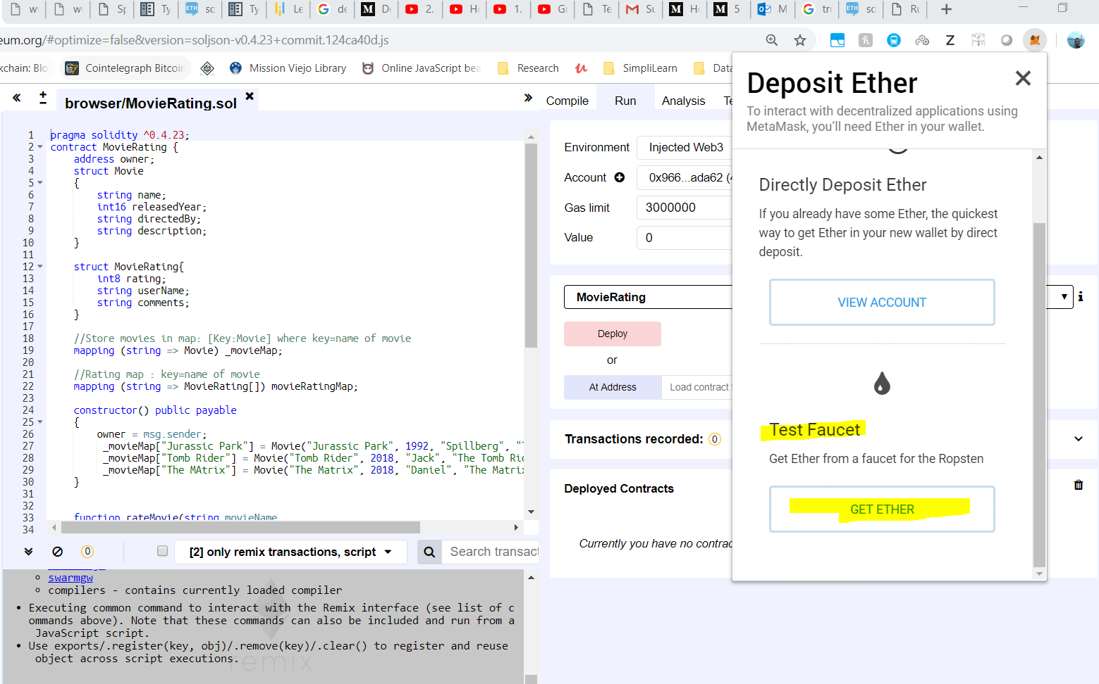

1. Click on “request 1 ether from faucet”

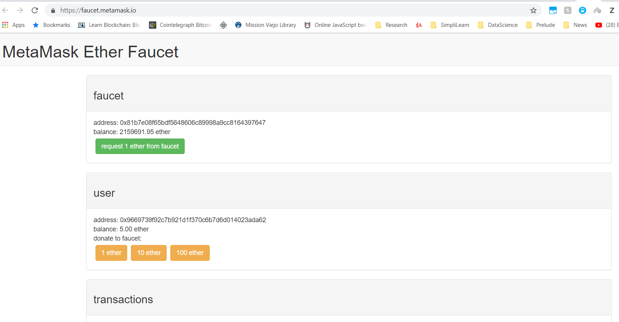

For me the request is failing today. Hence moving ahead with my existing funds.

1. Deployment:
   1. Select Environment as Injected Web3 and choose the Ropsten account having 4.99 ETH balance. Click on Deploy and you get a confirmation message from Metamask.

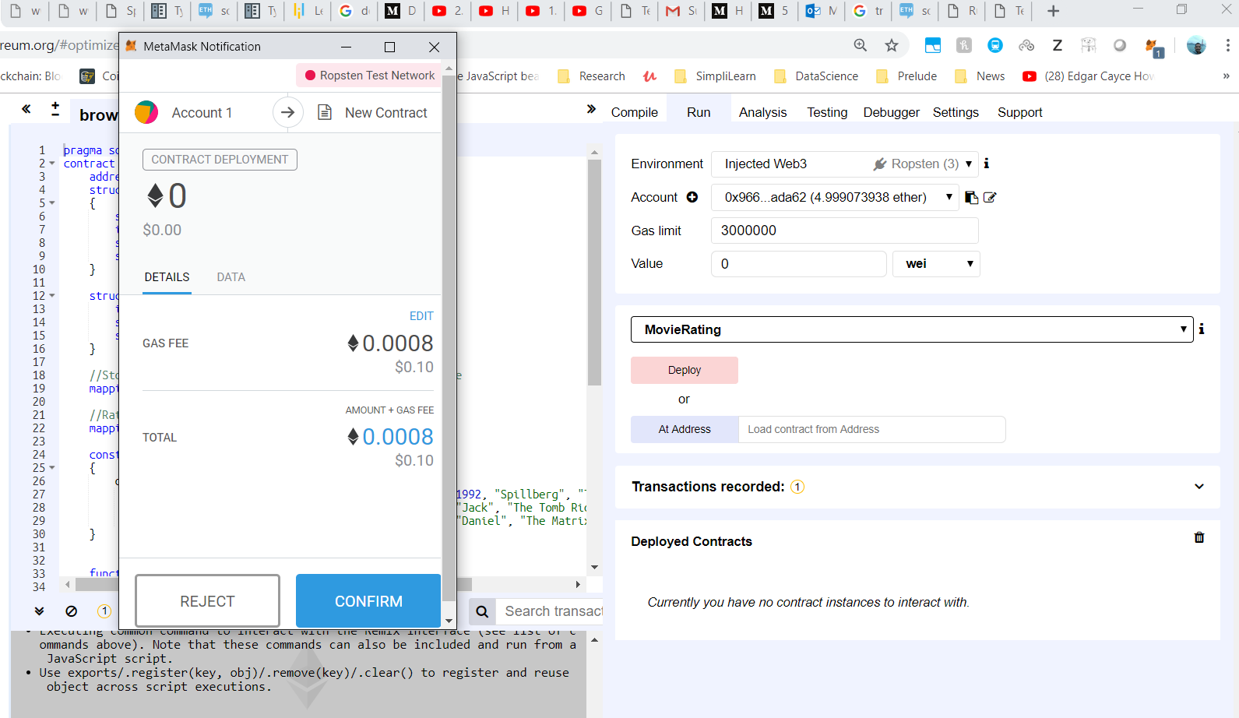

* 1. Click confirm and after a while, the contract is deployed on to Ropsten.

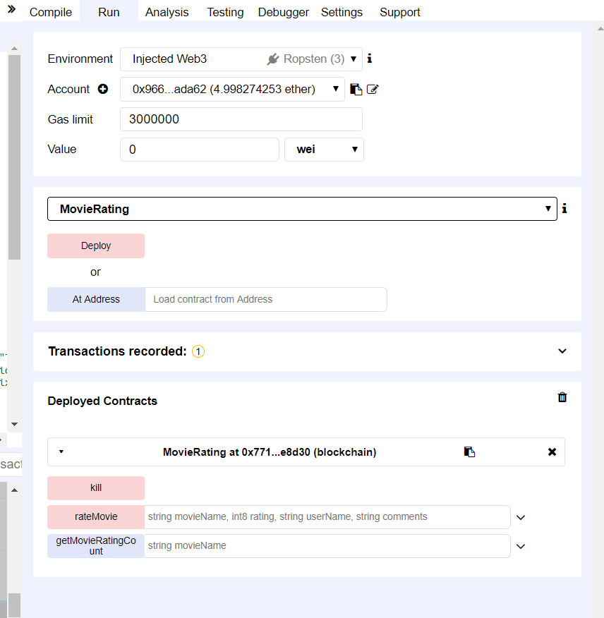

1. Testing:
   1. Click on the rateMovie and following are the movies available as part of block chain.

_movieMap["Jurassic Park"] = Movie("Jurassic Park", 1992, "Spillberg", "The Dinasor movie");

_movieMap["Tomb Rider"] = Movie("Tomb Rider", 2018, "Jack", "The Tomb Rider");

_movieMap["The MAtrix"] = Movie("The Matrix", 2018, "Daniel", "The Matrix");

* 1. Enter the values as shown below and click transact button. Metamask pops up with Gas information and ready for confirmation.

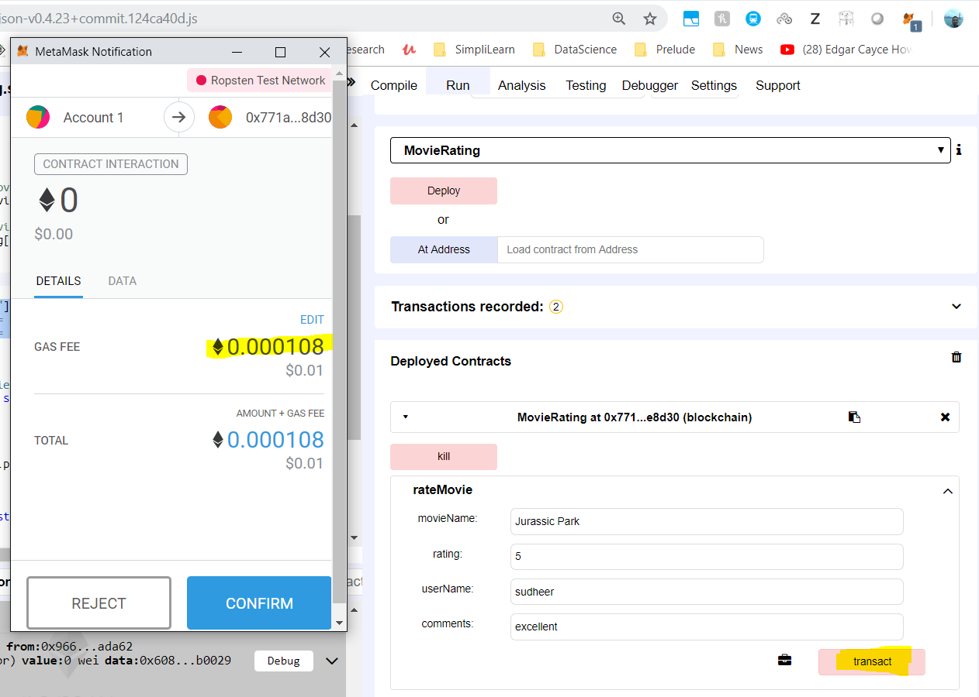

* 1. Once confirmed, after a while the Metamask, confirmation popup is displayed.
  2. Click on the Etherscan link to view the transaction.

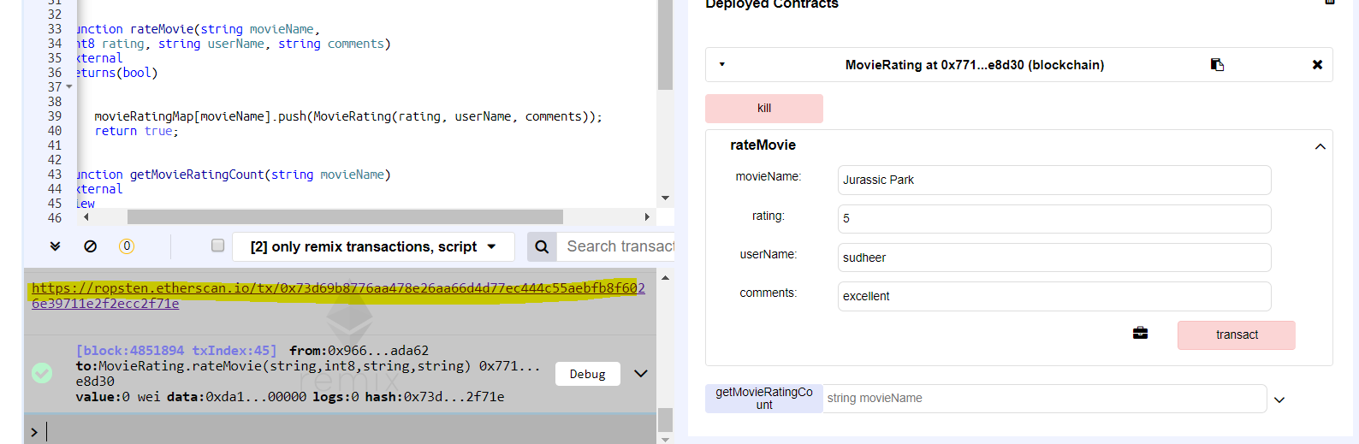

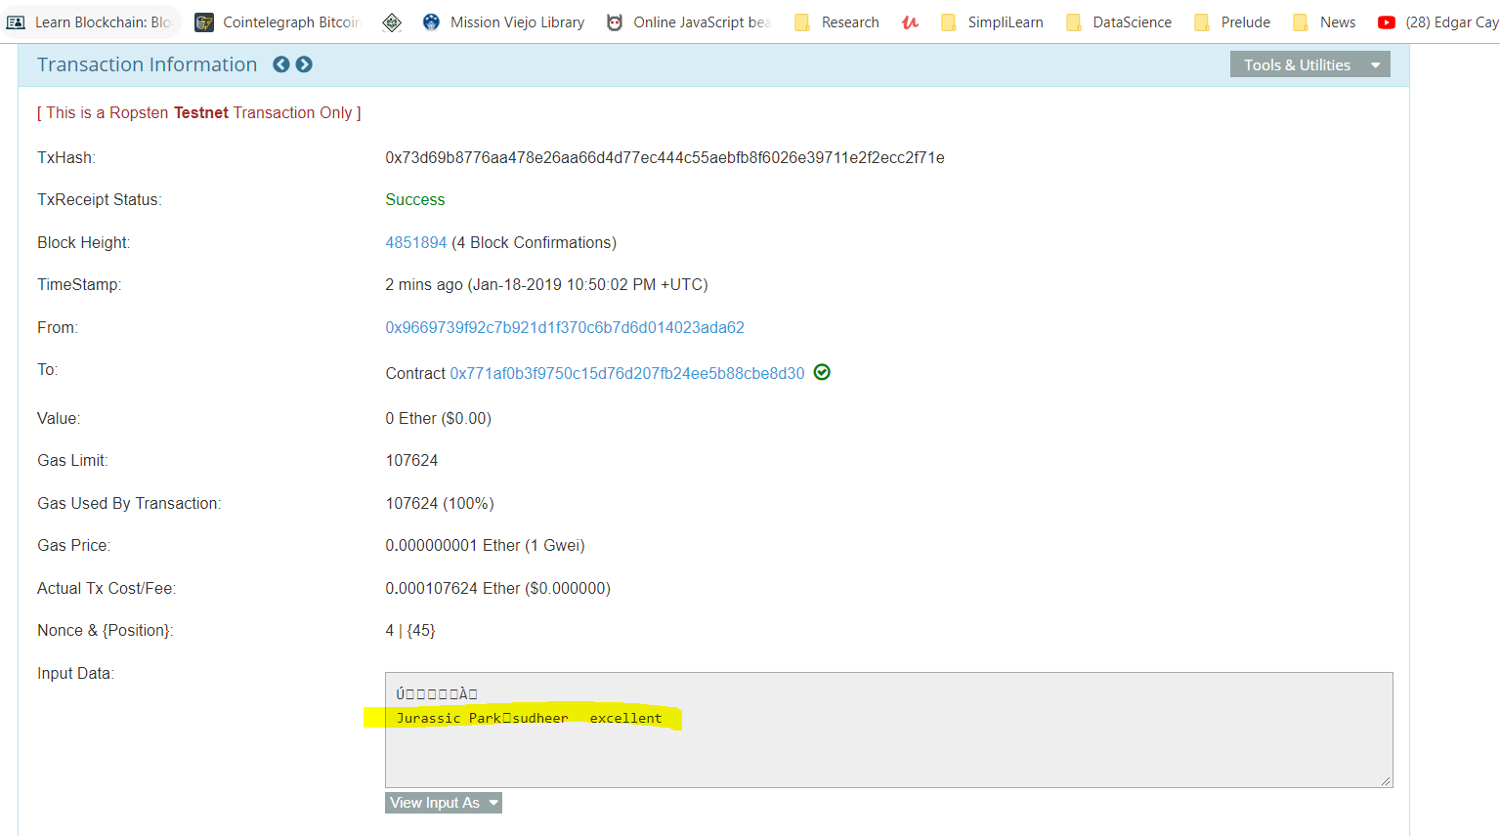

* 1. Now test getReviewCount method. The result is displayed immediately w/o any meta-mask confirmation as it is “view” method and no cost associated with it.

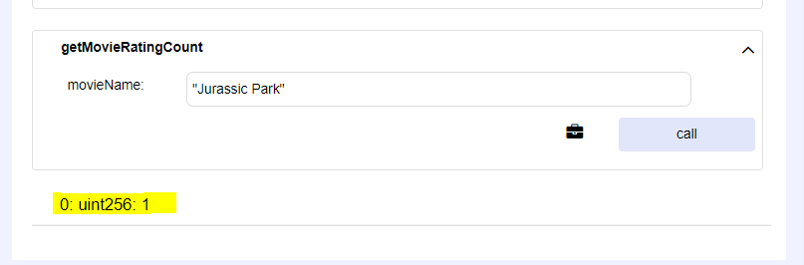

* 1. Add another review and the count increases.

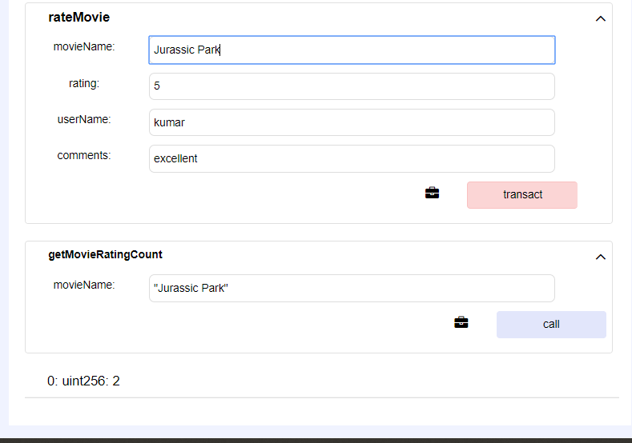

* 1. Add Review for another Movie and get the rating count.

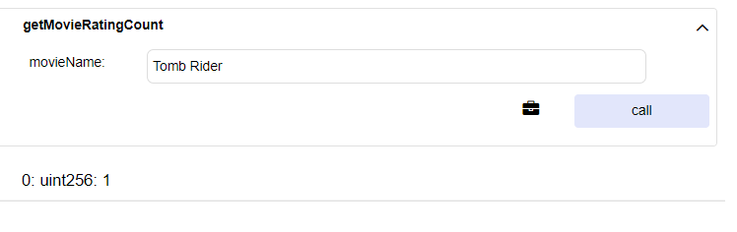

* 1. Now give a movie name that is not existing in the MovieDB and you get count : 0

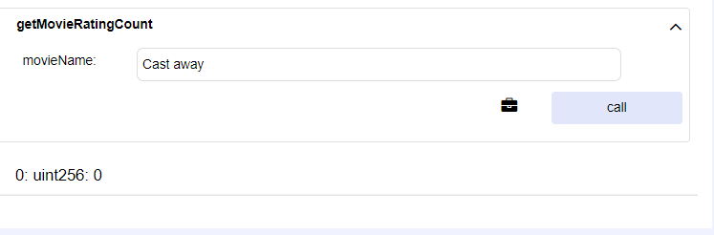

* 1. Finally self destruct the deployed contract calling kill(). It does throw confirmation.

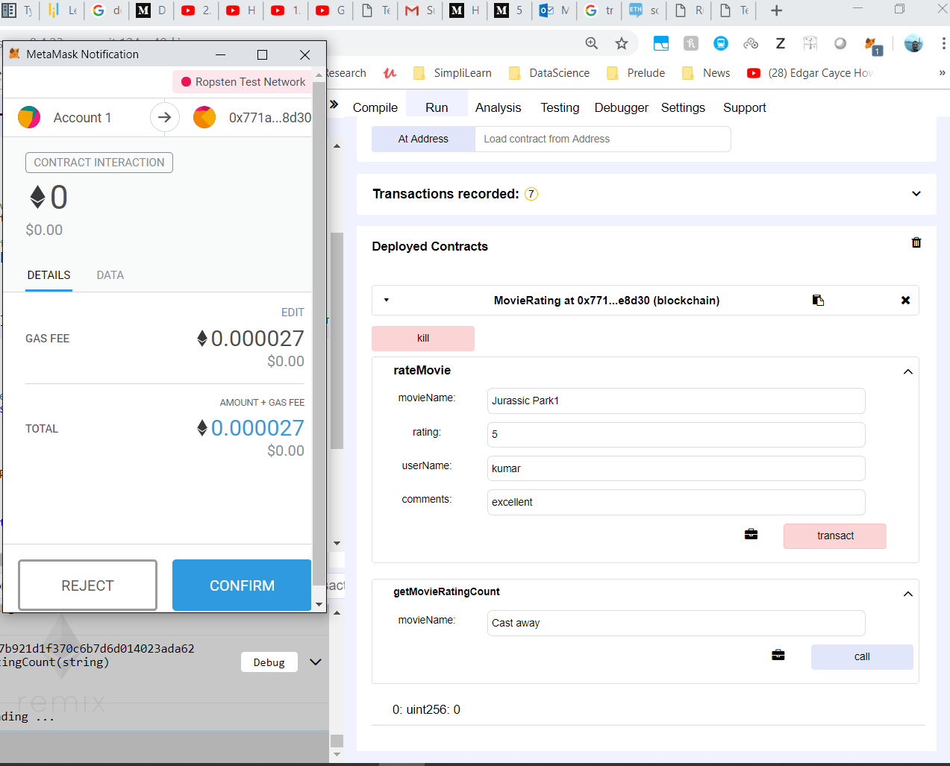

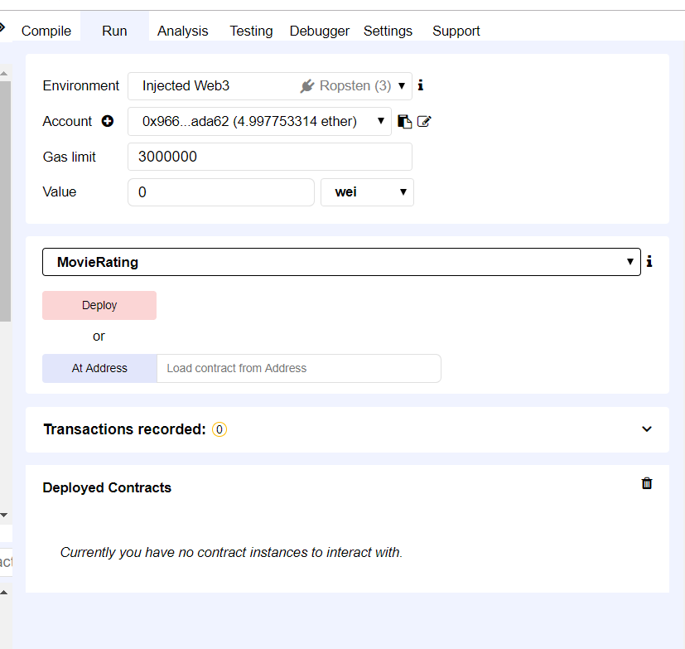

* 1. That completes the testing of the contract using Remix.