**Web 2 – JavaScript Level 5 - Click Event Assignment**

Use the provided **5-FPW_Assignment_Lab_Template.zip** folder to begin this assignment. You will have a web page called **fpwStage03.html** that you should not need to change along with three folders (***css***, ***images***, and ***js***).

1. Update the **1870primary.css** file (in the ***css*** folder) selecting the **<div id=”imageTabs”>** and adding styles to position the div *absolutely* so the numbered tab images appear as shown below:

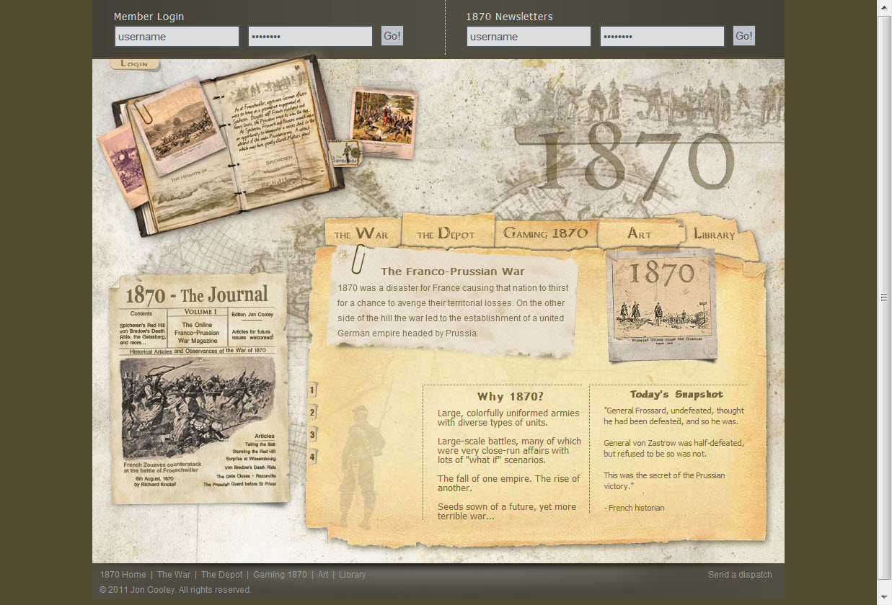

1. Create an external JavaScript file under the ***js*** folder named **imagePicker_yourname.js** (note: this naming convention will be graded to see if you are following the specs). In this JavaScript file do the following:
2. Define an object named **ImagePicker** which will contain our code and call **Core.start()** following the object definition to run the **ImagePicker** object’s **init()** method.
3. In the **init()** method of your **ImagePicker** object, get a reference to the image having an id of “***pic***” storing it in a variable named **imagePic**.
4. Then, get a reference to **<div id=”imageTabs”>** storing it in a variable named **imageTabsDiv**.
5. Get references to all <img> tags in the imageTabs <div> storing them in a node list variable named **imageTabsList**.
6. Step through the **imageTabsList** node list one element at a time using a **for loop** and assign a **click event** handler method called **imageTabClick()** to each element in the node list. Use the older event handler format: ***elementReference.onevent = handlerFunctionName;*** (note: since the ***handlerFunctionName*** is a method of our object, be sure to reference it as ***objectName.methodName***).
7. In the **imageTabClick()** method (function) definition, use the ***this*** keyword to reference the tab image that was clicked and call its **getAttribute(“attributeName”)** method to get the path ***to the image associated with that image tab*** storing it in a variable named **imgPath** (hint: the ***longdesc*** attribute for the tab image contains this path in the .html file).
8. Use the **imgPath** variable to perform the image rollover (on the **imagePic** image that you created a reference to above in **part b**) to the image associated with the image tab that was clicked.

**Image tab #1 is clicked**

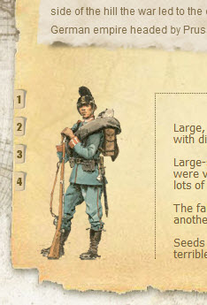

1. Back in the **init()** method, write some code to randomly pick one of the four images to display initially once the page is loaded. The paths to these images are the values of the image tab’s ***longdesc*** attribute in the .html file.

Hint: generate a random number to use as an index into the **imageTabsList** node list then using the **getAttribute()** method to get the ***longdesc*** attribute’s value.

1. Zip up your files into a zipped folder named **5-Assignment_Lab_Yourname.zip** and submit via the Dropbox for this assignment in Canvas.