Alexander Cannell

2/16/2013

CSIS 3100

Professor Wu

A2: financial analysis toolkit Exercise Project 1-4

1. Suppose you are studying two hardware lease proposals. Option 1 costs $4,000, but requires that the entire amount be paid in advance. Option 2 costs $5,000, but the payments can be made $1,000 now and $1,000 per year for the next four years. If you do an NPV analysis assuming a 14% discount rate, which proposal is less expensive? What happens if you use an 8% rate?

So when we do NPV, We can see that if we have a discount of 14% you should take the second option, but if you have an 8% discount you should take the First option.

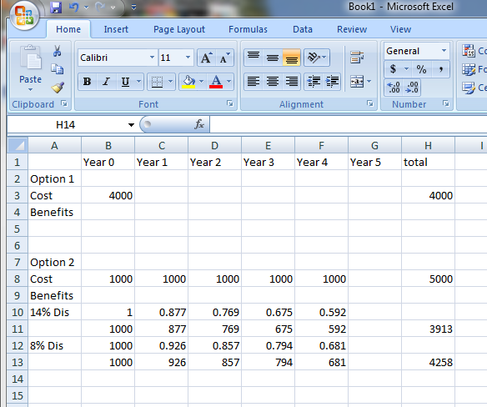

1. Assume the following facts:

A project will cost $45,000 to develop. When the system becomes operational, after a one year development period, operational costs will be $9,000 during each year of the system’s five year useful life. The system will produce benefits of $30,000 in the first year of operation, and this figure will increase by a compound 10% each year. What is the payback period for this project?

The payback period will be during year two.

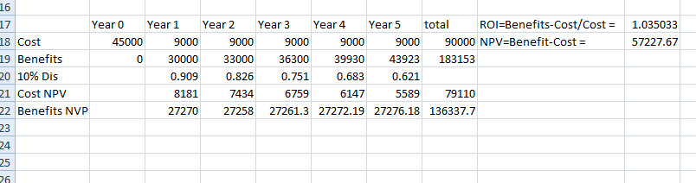

1. Using the same facts as in Project 2, what is the ROI for this project?

ROI=Benefits-Cost/Cost = 1.035033 or 104%



1. Using the same facts as in Project 2, what is the NPV for this project?

NPV=Benefit-Cost =57227.67

