Re-analysis of GSE7877: Small Gene-Level Effects and Consistent Changes in Translation and Energetic Pathways

1. Dataset, study context, and biological question
I re-analyzed GEO dataset GSE7877, a human skeletal-muscle transcriptomics study on platform GPL5216 ("Buck Institute_Homo sapiens_25K_verC"). The experiment profiled vastus lateralis biopsies from 12 young healthy men in a randomized, placebo-controlled crossover design. Each raw array was a direct two-color comparison between placebo (Cy5/635) and the active supplementation condition (Cy3/532) after 10 days of treatment.
The GEO entry and the linked paper framed the study as evidence that short-term creatine monohydrate supplementation activates transcriptional programs related to signaling, osmosensing, and muscle growth. I wanted to see how much of that story still holds when the raw data are processed again from scratch. In practical terms, the question was straightforward: does an independent re-analysis support a broad anabolic-style transcriptional response, or is the reproducible signal narrower?
One caveat needs to stay explicit. The intervention was not pure creatine monohydrate. The study used CELL-Tech, a commercial creatine-containing product with a large dextrose load and additional ingredients. So the transcriptomic response here belongs to that regimen, not to isolated creatine in general.

2. Data preparation and preprocessing
The local inputs were raw two-color GenePix GPR files from a custom spotted cDNA array, so a two-color limma workflow was the right fit. RNA-seq count methods would not have been appropriate here. The pipeline included raw foreground/background import from GSE7877_RAW/*.gpr.gz, removal of control spots, normexp background correction with offset, printtiploess within-array normalization, and collapsing replicated non-control spots to accession-level gene measurements using the GEO platform annotation.
The native GenePix ratio is 635/532, while GEO metadata indicate placebo on Cy5/635 and supplement on Cy3/532. I therefore reoriented all final log-ratios to log2(supplement / placebo) before interpretation. After control removal and annotation-based collapsing, 13,446 genes remained for testing.

3. QC, provenance, and sample-identity checks
PCA on the normalized gene-level matrix did not show one clean treatment-driven cluster. The samples were broadly dispersed, and the raw array headers showed two scan dates and two scanners. That made a technical sensitivity analysis worth doing.
The main QC issue was a metadata-provenance anomaly. When I compared the normalized raw-array profiles with the processed GEO sample tables, only the first three raw files matched their nominal GEO accessions directly. The other nine matched different GEO accessions instead. Even so, the best-match correlations stayed extremely high (0.984-0.993), which looks much more like relabeling of whole-array objects than corruption of the expression values. The relevant outputs are results/raw_to_geo_sample_mapping.tsv, results/raw_to_geo_processed_correlation_matrix.tsv, and figures/raw_to_geo_processed_correlation_heatmap.pdf.
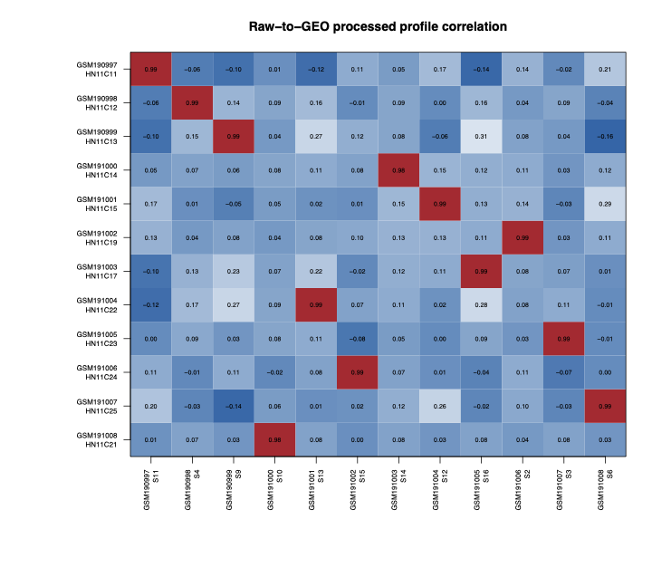
Figure 1. Raw-to-processed correlation heatmap showing that most raw arrays match different GEO accessions than their nominal labels.
I also checked contrast orientation explicitly. For all 12 arrays, the matched correlation stayed positive in the current log2(supplement / placebo) orientation and became negative after sign-flipping. That means the accession-label mismatch did not reverse the biological contrast. The summary files are results/orientation_sanity.tsv and figures/orientation_sanity_check.pdf.
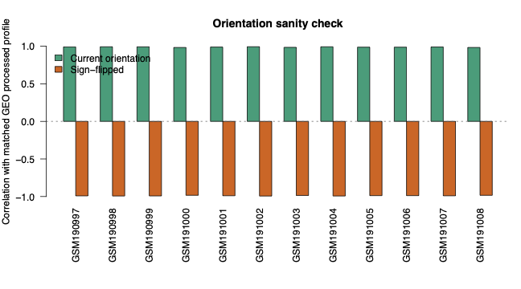
Figure 2. Orientation sanity check showing that the selected contrast remains positive without sign-flipping and reverses after sign-flipping.
I do not want to understate this metadata problem. It is real and it belongs in the interpretation. At the same time, it does not nullify the main comparison, because each raw array is still a direct within-array treatment contrast.

4. Selected contrast and rationale
The assignment requires one main contrast. I used the creatine-containing supplement versus placebo comparison in vastus lateralis muscle. That is the cleanest contrast supported by the assay itself, because each array already encodes a paired treatment comparison. I did not recast the data into a pseudo-single-channel design.

5. Differential-expression model selection
I compared four DEG models: a naive one-group model, a scan-date adjusted model, a scanner-adjusted model, and a model adjusted for both scan date and scanner. The main report uses the combined scan-date + scanner model. That choice keeps the within-array treatment interpretation intact while absorbing the clearest technical structure visible in the raw data. The technical covariates were centered, so the main coefficient can still be read as the average treatment effect rather than the effect inside an arbitrary reference batch.
The number of DEGs contracted as technical adjustment became stricter: 37 in the naive model, 26 after scan-date adjustment, 17 after scanner adjustment, and 16 in the combined model. That drop matters, but it does not mean the models tell completely different stories. Effect sizes were very stable across them. Pairwise logFC correlations ranged from 0.990 to 0.999, and pairwise moderated-t correlations from 0.989 to 0.999. The DEG sets themselves were less stable, which is what I would expect in a small microarray study near the significance boundary. For the final model, Jaccard overlap was 0.83 with the scanner-adjusted model, 0.62 with the scan-adjusted model, and 0.43 with the naive model. The supporting outputs are results/model_sensitivity.tsv, results/model_logFC_correlations.tsv, results/model_t_correlations.tsv, results/model_deg_overlap.tsv, and the three model-comparison heatmaps in figures/.
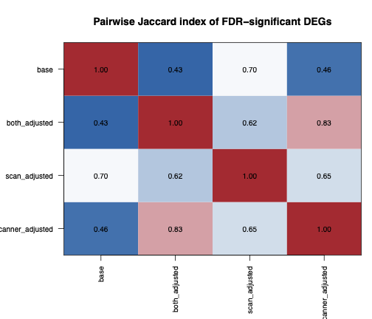
Figure 3. Jaccard overlap of DEG sets across the four technical models. The ranked statistics are more stable than the thresholded DEG lists.

6. DEG results and DEG classification
With the final combined model, I found 16 DEGs at FDR < 0.05: 8 upregulated and 8 downregulated. The most upregulated genes included PRPF8, BID, MKL1, CASR, TFDP2, and WNT2. The strongest downregulated genes included LOC348180, IMP4, BMP2K, TNS3, ASCL1, and CEP68.
I classified DEGs by sign after multiple-testing correction: Up if adj.P.Val < 0.05 and logFC > 0, and Down if adj.P.Val < 0.05 and logFC < 0. I did not impose an extra fold-change threshold. In a study this small, the moderated statistics already carry most of the evidentiary weight.
At gene level the picture is mixed. I do not see one clean muscle-specific induction program here, which makes the pathway-level results easier to trust than any single-gene story.

7. Enrichment analysis and pathway robustness
Because the conservative DEG list is short, I used ranked gene-set testing with camera on the full gene list from the final model rather than relying only on thresholded DEGs. This is where the analysis became more coherent.
The main pattern was consistent across databases:
- Reactome: downward shifts in RIBOSOME_ASSOCIATED_QUALITY_CONTROL, EUKARYOTIC_TRANSLATION_INITIATION, SELENOAMINO_ACID_METABOLISM, and RESPONSE_OF_EIF2AK4_GCN2_TO_AMINO_ACID_DEFICIENCY
- GO Biological Process: lower CYTOPLASMIC_TRANSLATION, ELECTRON_TRANSPORT_CHAIN, ATP_SYNTHESIS_COUPLED_ELECTRON_TRANSPORT, and OXIDATIVE_PHOSPHORYLATION
- Hallmark: significant downregulation of OXIDATIVE_PHOSPHORYLATION, with weaker but directionally similar decreases in MYC_TARGETS_V1 and MYOGENESIS
- KEGG: downregulation of RIBOSOME and OXIDATIVE_PHOSPHORYLATION
I also checked whether this depended on the exact DEG model. A representative set of pathways stayed downward in all four models even though the DEG counts changed. Those results are in results/pathway_stability.tsv and figures/pathway_stability_across_models.pdf. As a second check, I ran fry on the key pathways. The same axis of signal remained: GOBP_CYTOPLASMIC_TRANSLATION, REACTOME_RIBOSOME_ASSOCIATED_QUALITY_CONTROL, REACTOME_EUKARYOTIC_TRANSLATION_INITIATION, HALLMARK_MYC_TARGETS_V1, and KEGG_RIBOSOME all held up in that validation (results/pathway_validation_fry.tsv).
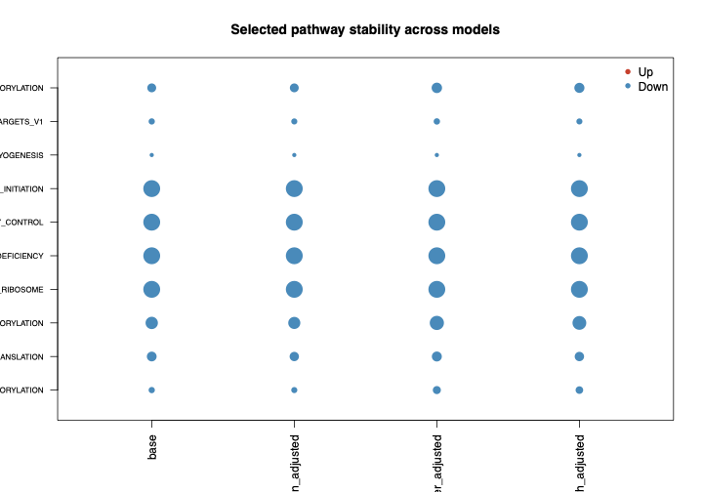
Figure 4. Pathway-direction stability across the four technical models. The selected translation and energetic pathways remain downward in every model.
Taken together, the pathway-level result is fairly plain. After adjusting for the identifiable technical structure, the strongest reproducible signature is not a broad induced anabolic program. It is a coordinated downward shift in translation/ribosome and oxidative-phosphorylation transcript modules.

8. Pathway of interest
I chose Reactome: Eukaryotic Translation Initiation as the pathway of interest for three reasons:
- it is one of the strongest Reactome hits in the final model
- it keeps the same direction across model variants
- it runs against the original paper's more activation-oriented narrative
The supporting visuals are figures/pathway_barcode_translation_initiation.pdf and figures/pathway_heatmap_translation_initiation.pdf. Both show the same thing at a glance: translation-initiation genes tend to sit lower in the supplement condition.
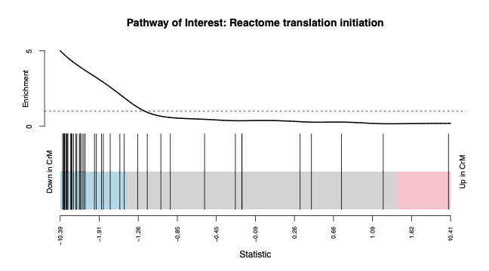
Figure 5. Barcode plot for Reactome Eukaryotic Translation Initiation. Genes from this pathway accumulate on the negative side of the ranked statistic.
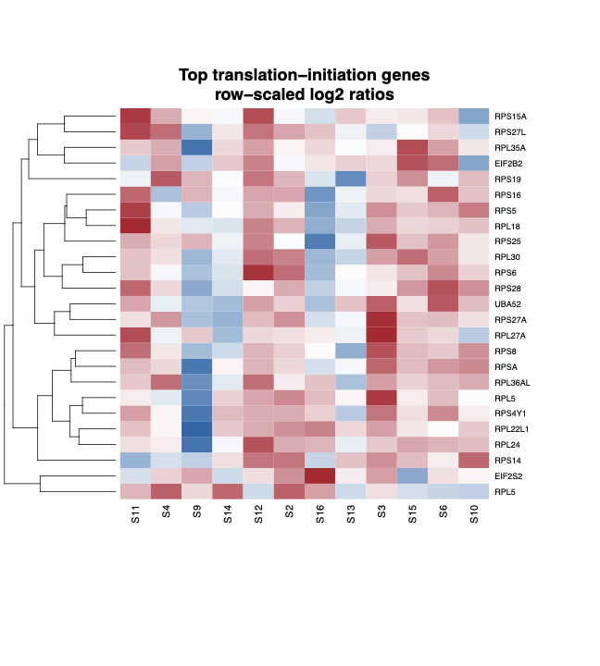
Figure 6. Heatmap of genes from Reactome Eukaryotic Translation Initiation. Most genes in the pathway shift downward in the supplement condition.

9. Biological interpretation / assumption
The original paper and GEO description lead the reader to expect activated growth or signaling pathways in supplemented muscle. My re-analysis does not support a large, clean anabolic induction program. What it supports is smaller and, to me, more believable: a compact gene-level perturbation with mixed regulatory hits, and a stronger pathway-level shift toward lower relative abundance of translation/ribosome and oxidative-phosphorylation transcripts.
I think the safest biological reading is some form of adaptive remodeling rather than acute anabolic activation. An osmotic or energetic interpretation is still plausible for a few concrete reasons:
- the original paper discussed cell swelling and signaling
- MKL1/MRTF has clear links to cytoskeletal and myogenic regulation
- nutrient-stress and translation-control programs sit near the top of the enrichment results
Other explanations remain open. The transcript changes may not map cleanly onto protein synthesis or mitochondrial function. Small shifts in biopsy composition or extracellular space could matter. And because the intervention was a mixed supplement, some of the signal may not be attributable to creatine itself. The narrowest defensible summary is that short-term supplementation in resting human skeletal muscle is associated with a coordinated transcript-level shift in translation and energetic modules, while the mechanism behind that shift is still unresolved.

10. Limitations
Several limits shape the interpretation:
- the active product was a creatine-containing mixture, not pure creatine alone
- the platform is an older custom cDNA array with limited modern annotation
- public metadata did not identify which subjects received the supplement first, so period, sequence, and carryover effects could not be modeled explicitly
- the raw GEO supplement files and processed GEO sample tables showed a substantial accession-label mismatch, even though the matched profiles remained nearly identical and preserved contrast orientation
- the DEG list is less stable than the pathway-level signal
- transcript-level decreases in translation- or OXPHOS-related modules should not be treated automatically as reduced muscle protein synthesis or reduced mitochondrial function without orthogonal protein or physiological data
- I did not independently re-analyze the physiological and targeted protein layers from the original study, because the assignment was scoped to one transcriptomic contrast

11. Short conclusion
This re-analysis supports a more cautious reading of GSE7877 than the original paper. Once the two-color design, provenance checks, and technical sensitivity are handled explicitly, the cleanest result is not a dramatic anabolic transcriptional response. The gene-level effect is small. The stronger and more reproducible signal is a downward shift in translation/ribosome and oxidative-phosphorylation transcript programs in supplemented resting muscle. That pattern persists across databases and across alternative technical models, but the mechanism remains open.

12. Selected references
- Safdar A, Yardley NJ, Snow R, Melov S, Tarnopolsky MA. Global and targeted gene expression and protein content in skeletal muscle of young men following short-term creatine monohydrate supplementation. Physiol Genomics. 2008. PMID: 17957000.
- Li S, Czubryt MP, McAnally J, et al. Myocardin-related transcription factors are required for skeletal muscle development. Development. 2015. PMCID: PMC5004908.
- Deval C, Talvas J, Chaveroux C, et al. Amino-acid limitation induces the GCN2 signaling pathway in myoblasts but not in myotubes. Biochimie. 2008. PMID: 18706471.
- O'Connor RS, Mills ST, Jones KA, Ho SN, Pavlath GK. A combinatorial role for NFAT5 in both myoblast migration and differentiation during skeletal muscle myogenesis. J Cell Sci. 2007. PMID: 17164296.

