Machine music unit

Motivation

The source of motivation for the students to make ‘machine music’ in this unit is the article ‘Designing and carpet’ from School Journal 1980, Part 4 No. 1.

Design ideas
The ideas and concepts behind the design and making of the carpet – textures, colours, weaves, and designs – outlined in the article can be translated into music elements and structures, such as rhythm patterns, dynamics, tone colours, and textures.

Machine graph
The carpet design grid can be used as a graphic way to represent sounds on a musical score, and interpreted in sound as a piece of music that reflects the working of a carpet-making machine. For example:
- colours can be interpreted by different sound sources (different tone colours)
- weaves and textures can be interpreted as layers of sound
- sounds of carpet-making machine can be replicated through rhythmic devices.

Look and feel
Even the overall impact of the carpet – its look and feel – can also be interpreted in sound by using dynamics and different ways of producing sound on the instruments selected.

‘Designing a carpet’
Read and discuss ‘Designing a carpet’ (copy follows) with the students. Encourage them to imagine ways of creating musical interpretations of the carpet design grid, and a carpet-making machine.
From School Journal 1980, Part 4 No. 1

DESIGNING A CARPET

by Judith Holloway

Anne Warmington designs carpets. She works in the design studio of a big carpet factory. Each year she and her team work out dozens of designs for different kinds of carpet.

She is creating a new design. She wants the carpet to remind people of grass and leaves, and pebbles and water. The carpet will be almost four metres wide, so one side of her design has to match up with the other, and the top with the bottom.

Tufts and loops
The design is for a tufted carpet, which is made by a machine with needles pushing tufts of yarn through a sheet of backing material, such as hessian.

A mixture of cut and uncut loops in the carpet makes rough and smooth textures that are pleasant to look at and to touch.

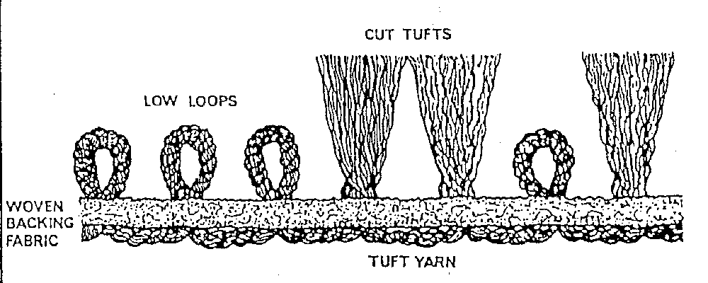

Using felt pens, Anne copies her design onto a peg-board. The colours are a code. They tell which tufts are to stay looped, and which are to be cut.

The colours also tell which tufts will be high, and which will be low.

Anne has three colours in her design. So threads of three colours will repeat the design – ABC, ABC – across the width of the carpet. When she wants one colour to show up, she makes the tufts of that colour high, and the tufts of the other colours around it low. Where she wants two colours to show equally, she makes their tufts the same height.

Trial
Anne takes the peg-board to Mrs Hawkins, who makes a trial patch of the carpet by hand. Using a special needle, she pushes a loop of the thread through each hole in the backing material, which means that the thread zigzags from hole to hole. (This is always done in carpets of more than one colour to avoid straight lines of one colour appearing – that would be eye-catching, and spoil the overall appearance of the carpet.)

Mrs Hawkins turns the board over, so that they can see the pattern as it will look on the finished carpet.

Design grid
The next part of Anne's job is to draw up plans for the carpet, so that the machine in the factory can be fitted out to make this new design.

She draws the design onto a sheet of acetate marked out in squares like graph paper. Each square represents one tuft in the carpet. Again, the colours are codes telling where the tufts are high or low, looped or cut.

The finished sheet is a set of instructions for the pattern of the whole carpet.
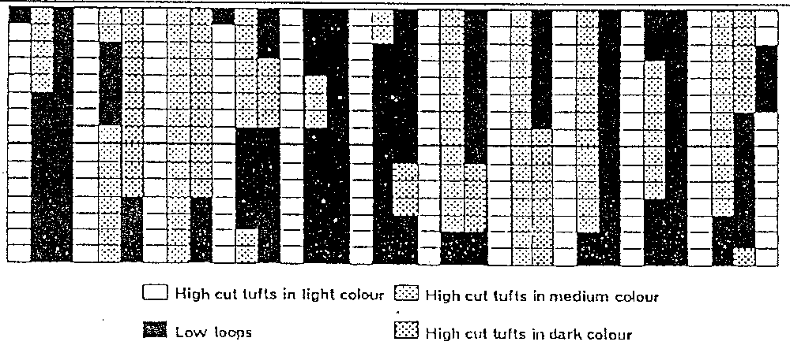

When the machine starts to make the carpet, a row of more than nine hundred needles push the tufts into the backing – and do five hundred rows in a minute.

The carpet comes off the end like a moving wall.

The design measures a metre from top to bottom, and has two hundred and eighty-eight rows in it – see if you can work out from that how much carpet the machine can make in an hour.

Material from ‘Designing A Carpet’ (adapted) is reproduced by permission of the publishers Learning Media Ltd, PO Box 3293, Wellington, New Zealand.
Copyright © Crown, 1980.

