Two-factor authentication & passkeys
MakeReady by G54 — Help Center · Account & Security · Applies to: Everyone
Protect your account with an authenticator app, passkeys / security keys, and recovery codes.
Two-factor authentication (2FA) adds a second check at sign-in so a stolen password isn't enough to get in. Open it from your initials avatar in the top-right, or go to Account Security.
Important — 2FA is required for every MakeReady user. When your account is first set up you'll be brought straight to this page — a banner reads “One more step to finish setting up your account.” Add one method (an authenticator app or a passkey) and a “Continue to MakeReady →” button takes you into the app. You can't use the rest of MakeReady until at least one method is enrolled.

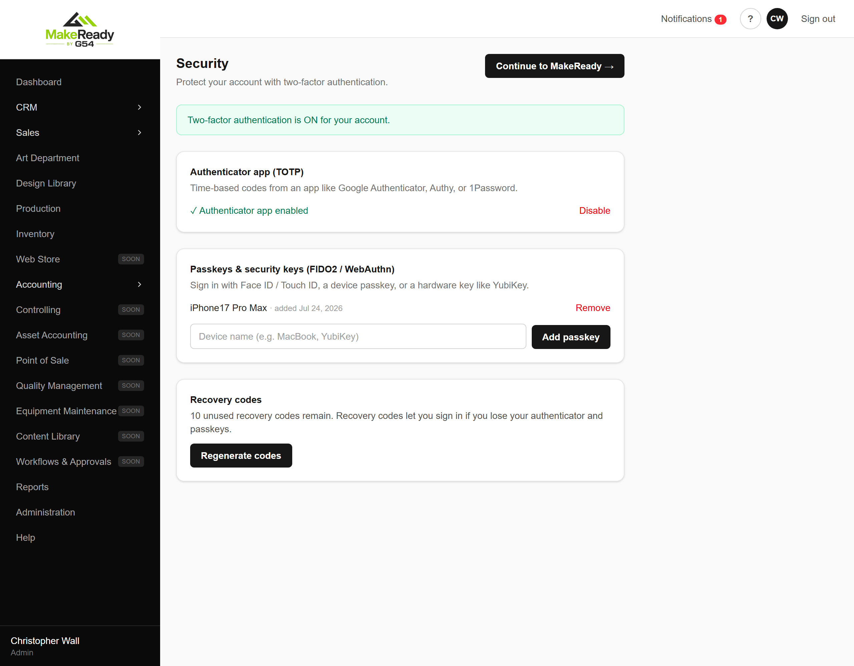
The Security page. A banner shows whether 2FA is on.
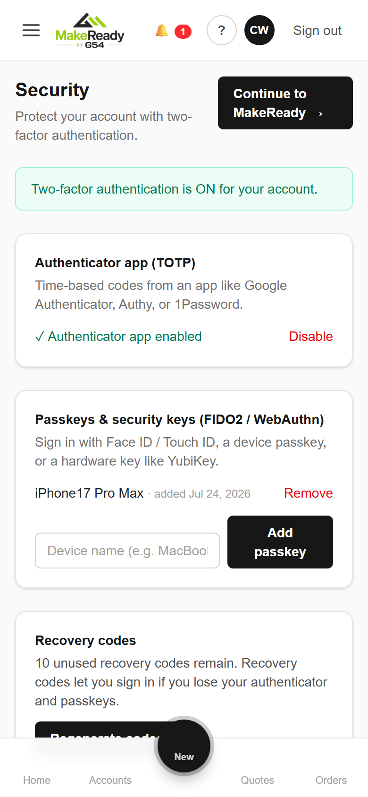
The Security page on a phone.

Authenticator app (TOTP)
- Click “Set up authenticator app”.
- Scan the QR code with Google Authenticator, 1Password, Authy, or similar (or copy the manual key if you can't scan).
- Enter the 6-digit code and click “Verify & enable”. You'll see “✓ Authenticator app enabled”.

Passkeys & security keys (FIDO2 / WebAuthn)
- Type a name for the device (e.g. “MacBook” or “YubiKey”) in the “Device name” field.
- Click “Add passkey” and complete your device's Face ID / Touch ID / security-key prompt.
- The passkey now appears in your list. Remove any you no longer use with “Remove”.
Tip — Passkeys are the fastest and most phishing-resistant option — at sign-in just choose “Use a passkey / security key” and confirm with your device.

Recovery codes
Recovery codes let you get in if you lose your authenticator and passkeys. Click “Generate recovery codes”, then save them somewhere safe (or “Download .txt”). Each code works once, and they're shown only at generation time. Regenerating replaces the old set.
Important — 2FA is required org-wide, so you'll be sent to this page and can't use the rest of the app until you enroll at least one method.

Too many code attempts
For safety, MakeReady allows only a handful of code or recovery-code attempts per sign-in. If you exceed them, the pending sign-in is cancelled and you'll need to enter your password again before retrying. Repeated wrong passwords still lock the account for 15 minutes.
Source: makeready.g54.com/help/two-factor-authentication · Exported for offline use.

